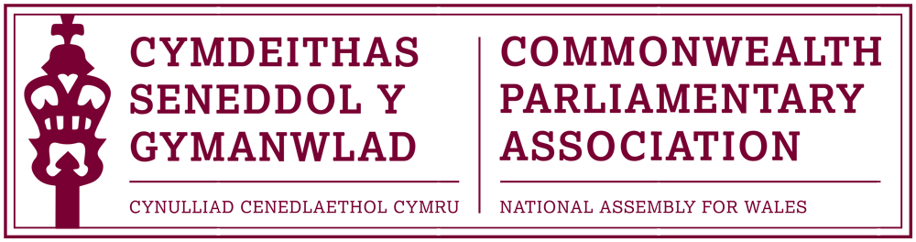

BRANCH EXECUTIVE MEETING

Meeting Date: Wednesday 13 July 2016

MINUTES

Present:
Rhun ap Iorwerth AM, Chair
Mohammad Asghar AM
David Rowlands AM

Al Davies, Acting Branch Secretary

AGENDA

Introduction.
The Chair welcomed Members present to this first CPA Wales Branch Executive Committee Meeting of the Fifth Assembly, noting that with the exception of Mohammad Asghar AM, that all other Members were new to the ExCo. The Chair stated that he placed great importance of Wales’ place within the Commonwealth and saw many opportunities and potential through our membership of the CPA to build new links and further develop existing relationships.

Reference was made to the background brief on the CPA which had been distributed to Members, which it was hoped would prove helpful.

- APOLOGIES FOR ABSENCE.

It was subsequently noted that communication of the meeting had regrettably not reached Rhianon Passmore in time.

- MINUTES OF THE LAST MEETING – Paper CPA 01-16M

The Minutes of the last Branch meeting, which took place in March, had been approved as a correct record by the former Branch Chair.

The Chair noted that it was his intention to start afresh and look forward with the Branch’s work for the 5th Assembly but made Members aware that past Branch Minutes and Reports were available as a record on the Branch webpage.

- REVIEW OF RECENT ACTIVITIES

Feedback and follow-up of recent Meetings, Visits,
Events and Conferences

- Commonwealth Day Reception
Senedd Oriel
Tuesday 15 March 2016

The Branch hosted lunchtime Commonwealth Day reception in the
Senedd had included addresses by the former Branch President and
Chair as well as British Council Wales Director Jenny Scott. The
reception had been closed by Signobile Moyo, the young woman from
Cardiff University who had been selected to represent our Branch at the
official Commonwealth Day Programme in Westminster the previous
day.

The Chair noted that, whilst the Senedd reception had been well-
received, the turnout had been very disappointing. Members
agreed that it would be appropriate for the Branch to continue hosting
this annual event but that this issue of attendance would need to be
looked at and discussed further at a future meeting.

- Event with Baroness Scotland
– Secretary General of the Commonwealth
Temple of Peace, Cardiff
Tuesday 22 March

This event with the recently elected Secretary General of the Commonwealth, Baroness Scotland, was noted. The Branch had been represented by former Branch Chair Joyce Watson AM.

- 46th BIMR Conference
St Helia, Jersey
15-18 May 2016

The Regional Annual Conference, hosted by the CPA Jersey Branch, had been attended by former Branch Executive Members Joyce Watson AM and Simon Thomas AM. The conference theme was “Parliaments and Public Engagement” and included presentations and discussions on “e-government” and “engaging with young people”. The Chair noted that these were important themes and ones the Branch could pursue further in future.
Unfortunately, due to developments in Cardiff Bay following the Assembly election, the delegation had been required to return to Cardiff half-way through the conference.

5. FORWARD PLANNING

Forthcoming Meetings, Visits, Events and Conferences

2016

- 62nd Commonwealth Parliamentary Conference
Dhaka, Bangladesh
1-10 September

Following an invitation for Assembly Members to apply to attend the annual CPC, one application had been received, by Mohammad Asghar AM.

The Chair advised that there had however been some uncertainty over whether the conference would go ahead, in view of concerns raised by CPA colleagues, over security for delegates during the Conference period, in the wake of the recent terrorist attacks in Dhaka.

It was noted that Joyce Watson AM, who was due to attend, would not be attending the conference if it went ahead in Bangladesh. It was agreed that the Branch would await a definite decision on whether the conference would take place before making a call upon its final delegation; and would liaise by email over the summer recess if required.

- First Commonwealth Women Leaders’ Summit
London, UK
14 July
Joyce Watson AM would, later that day, be attending the inaugural Commonwealth Women Leaders’ Summit in London. The Branch noted that it would be of interest to receive feedback from Joyce, following the Summit.
The Chair asked to note on record the Branch’s congratulations to Joyce Watson AM who had last month been elected as Chair of the British Isles and Mediterranean Region Commonwealth Women Parliamentarians for a three year term.

- CPA Commonwealth Women Parliamentarians Conference
Kampala, Uganda
8-12 August

The Chair stated that the Chairperson of the International Commonwealth Women Parliamentarians, Speaker of the Ugandan Parliament Rebecca Kadaga, would be hosting a Gender Advocacy Conference in Kampala next month. Joyce Watson AM, as our Regional CWP Chair, has been invited to attend and speak at the conference. Invitations had also been extended to up to three other women parliamentarians from within the Region.
The Chair offered the Branch’s best wishes to Joyce at the Conference and noted support for other CPA Wales Branch Women Members to have the opportunity to fill any additional available places.

- 8th Commonwealth Youth Parliament
British Columbia, Canada
6-10 November
The Chair confirmed that our Branch had expressed an interest in being represented at this Commonwealth Youth Parliament in British Columbia, following the success and very positive feedback received by the Young People who had represented us at previous Youth Parliaments in Australia and London.

It was noted that there was also the possibility of our Branch being able to participate as Mentors at the CYP by qualifying Members. Members agreed that the Branch would take no actions to advertise and select suitable conference participants until confirmation of guaranteed available places was received, hopefully later in July.

2017 – Longer-term forthcoming events, for information only at this stage

- 4th BIMR CWP Conference
Belfast, Northern Ireland
February (dates tbc)

- 47th CPA (BIM) Regional Conference
Gibraltar
May/June (dates tbc)

These future conferences were noted with the Chair commenting that the next Regional conference in Gibraltar should be of particular interest in the context of the recent EU Referendum.

  - FUTURE MEETING DATES:

The next Branch Meeting would be arranged for late September/early October. Members discussed suitable meeting times and it was agreed that Wednesday lunchtime was generally convenient.

  - NEW ITEMS / ANY OTHER BUSINESS
Hosting of 2018 BIMR CWP Conference
The Chair discussed with Members that it would be appropriate for Joyce Watson AM, as the BIMR CWP Chair, to host a conference in Wales during her tenure as Chair. As the CPA Northern Ireland Branch had already agreed to hold a conference in 2017, the Branch approved Joyce being able to commit to hosting the 2018 BIMR CWP at the Assembly. This should be communicated to Joyce immediately so that she could announce this at the Women Leaders’ Summit which she was attending later that day.

Selection of Branch Delegations at CPA Conferences
A short discussion took place about the selection of Assembly Members to attend CPA conferences and whether Branch Executive Members should be prioritised for these opportunities. The Chair advised that, whilst it would on occasion be appropriate to target particular audiences, his intention was to make the work and opportunities of the CPA Wales Branch to be as open and inclusive as possible.

END OF BUSINESS

July 2017

