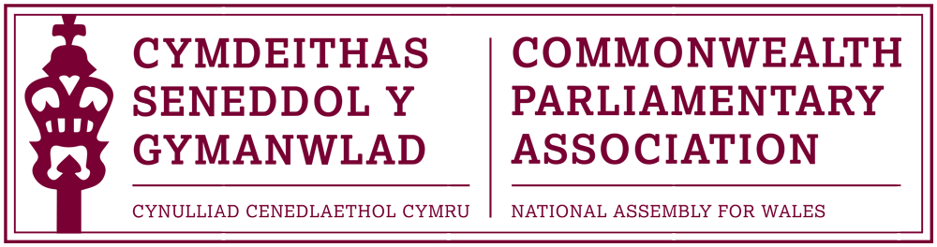

BRANCH EXECUTIVE MEETING

Meeting Date: Wednesday 22 March 2017

MINUTES

Present:
Rhun ap Iorwerth AM, Chair
Mohammad Asghar AM
David Rowlands AM

Al Davies, Acting Branch Secretary

AGENDA

- APOLOGIES FOR ABSENCE.

Apologies were received from Rhianon Passmore AM

- MINUTES OF THE LAST MEETING – Paper CPA 03-16M

The Minutes of the last Branch meeting were approved as a correct record.

- MATTERS ARISING FROM MINUTES

Proxy Voting at CPA Elections.
It had been queried at the last previous meeting whether voting by Proxy could be possible by Branches unable to attend CPCs in person. The Branch Secretary had since looked into this and the CPA Secretariat had confirmed that this was not permitted under the rules of the Association’s constitution. Branch Members agreed not to pursue this further.

- REVIEW OF RECENT ACTIVITIES

Feedback and follow-up of recent Meetings, Visits,
Events and Conferences

2016

- 62nd Commonwealth Parliamentary Conference (CPC)
London, UK (DOC2)
11-17 December 2016

BIMR CWP Chair and Branch Member Joyce Watson AM had attended last December’s CPC in London (which had been a short notice replacement for the intended CPC in Bangladesh).
Joyce had stood for the position of Commonwealth Women Parliamentarians Chair, but had unfortunately been unsuccessful.
Rhianon Passmore was also able to attend part of the conference.
Minutes of the Regional AGM were distributed for reference.

- Laura Elliott (Branch Participant at CYP) meeting with Branch
Chair and President
18 January 2017

The Chair noted that he and the Llywydd had met Laura Elliott to discuss her experience as our Branch’s representative at last November’s Commonwealth Youth Parliament held in Victoria, British Columbia. The experience had clearly had a very positive effect on Laura and she was keen to encourage other young people to take advantage of future CYPs. Laura’s finalised report has been circulated for reference and has been posted on our Branch webpages.

The Chair requested that a note of thanks be sent to Laura for her report and positive representation of the Branch.

2017

- Commonwealth Women Parliamentarians -
Working Group Meeting - Wilton Park, UK
24-27 February 2017

This CWP Working Meeting had been attended by Joyce Watson AM, in her capacity as the Region’s CWP Chair. Joyce had reported the meeting to have been well organised and worthwhile.

- Québec’s Agent-General in London – Christos Sirros
Senedd
8 March
The Chair noted that he had been pleased of the opportunity to meet with Quebec’s AG as part of his visit to Wales, during which he had also met with the Llywydd and the First Minister. A positive meeting included discussions around official languages, Brexit and the importance of developing and strengthening bilateral links as well as other matters of mutual interest.

- Commonwealth Day Programme
Westminster, London
13 March

Our Branch had been represented at this month’s Commonwealth Day programme in Westminster by two young people – Samantha Ellis and Matthew Walker. Both had been shortlisted in the applications for the last year’s CYP conference.

Both Samantha and Matt had understood to have thoroughly enjoyed their experience and had been asked to produce a report of their attendance on the programme.

The Chair also noted that a Branch event to mark Commonwealth Day in the Senedd was usually held. This had unfortunately not been possible this year, due to our short-notice hosting of the CWP conference. It was intended that this would, however, be remedied for next year and future Commonwealth days.

5. FORWARD PLANNING

Forthcoming Meetings, Visits, Events and Conferences

- 4th BIMR CWP Conference – Draft Programme (DOC 5)
National Assembly for Wales
6-7 April

Following the cancellation of the planned conference in Belfast, due to the difficulties in Northern Ireland, our Branch had been approached to take on this year’s Regional Commonwealth Women Parliamentarians Conference -a year earlier than planned. The Branch had agreed to this request and the conference – the theme of which would be “Women in the Economy” - would take place on the Assembly estate between 6-7 April. Al had been working on the programme, in consultation with Joyce Watson and her office, and a high level draft had been circulated to Members.

Approximately 30 Parliamentarians were expected at the conference, representing every Branch of the BIMR Region, with the exception of the Falkland Islands and St Helena. Joyce had also issued invitations, on behalf of the Branch, to each one of the Assembly’s party groups, to nominate a woman AM to participate fully in the conference. Rhianon Passmore and Ann Jones would also represent the CPA Wales Branch.

Members were asked to note and publicise that a welcome reception at the Pierhead on the evening of Thursday 6 April - at which the Llywydd and the Branch Chair would host - was open to all Women AMs as well as to Members of the the Branch Executive Committee.

- CPA Fundamentals Programme
Montreal, Quebec (Canada)
23-30 April

Following her application, Rhianon Passmore would be representing our Branch and attending this CPA programme, aimed at new and recently elected parliamentarians, in Montreal. Rhianon had already began the online course which complemented the training course in Quebec.

- 47th CPA (BIM) Regional Conference
Gibraltar
21-24 May

All Branch Executive Committee Members had confirmed their availability to attend this year’s Regional conference and Registration forms had been forwarded to the Gibraltar Branch.
No Draft Programme had been released, but is expected to be circulated within the next fortnight. The Conference theme has been confirmed as “Small Branches” but would also focus upon BREXIT and the role of the Commonwealth.

- Inaugural Conference for Commonwealth Parliamentarians
with Disabilities
Nova Scotia, Canada
30 August – 2 September (tbc)

Provisional dates for this conference had been released, however there was no further information at this stage.

- 63rd Commonwealth Parliamentary Conference (CPC)
Dhaka, Bangladesh
Dates TBC

Following the cancellation of last year’s conference, the CPA and the Bangladesh Branch announced their intention to host the conference in Dhaka this autumn with further information to follow.

  - FUTURE MEETING DATE(s):

TBC

7. NEW ITEMS / ANY OTHER BUSINESS

The following Papers were noted:

i) 8th Commonwealth Youth Parliament - Report by Laura Elliott
(DOC 3)
ii) Report of CPA UK and National Assembly of Guyana Parliamentary
Forum on Anti-Corruption (DOC 4)

- Appointment of New Private Office Manager
(International & Communications)

The Chair noted for Members’ Information that, following a successful recruitment process, Enfys Roberts had been appointed to the Private Office and would support the Assembly’s International Relations. Enfys would, where possible, be attending future Branch meetings and would also be available, as well as the Branch Secretary, to assist Members with CPA matters.

END OF BUSINESS

March 2017

