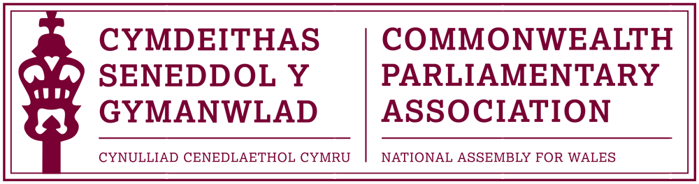

BRANCH EXECUTIVE MEETING

Meeting Date: Wednesday 12 July 2017

MINUTES

Present:
Rhun ap Iorwerth AM, Chair
Mohammad Asghar AM
Rhianon Passmore AM

Al Davies, Acting Branch Secretary

AGENDA

- APOLOGIES FOR ABSENCE.

Apologies were received from David Rowlands AM

- MINUTES OF THE LAST MEETING – Paper CPA 01-17M

The Minutes of the last Branch meeting were approved as a correct record.

- MATTERS ARISING FROM MINUTES

Report from Commonwealth Day Programme Participants
The previous Minutes noted that a report had been expected by Samantha Ellis and Matthew Walker, the Branch’s selected participants in this year’s Commonwealth Day Programme.

Unfortunately, despite numerous attempts to chase this up, no report has been forthcoming which was both disappointing and unprecedented.

The Chair requested that a final official letter from the Branch should be sent to both participants to try and obtain the reports.

- REVIEW OF RECENT ACTIVITIES

Feedback and follow-up of recent Meetings, Visits,
Events and Conferences

2017

- 4th BIMR CWP Conference (DOC 2)
National Assembly for Wales
6-7 April

The Chair noted official congratulations, on behalf of the Branch, to Joyce Watson AM and all involved in the delivery, at very short notice, of a very successful Regional CWP Conference. The conference on the theme of “Women in the Economy” had received much positive feedback from both participants and invited speakers for its creative and innovative approach. A full conference report had been drafted by the BIMR Secretariat which had been circulated. There was also a dedicated webpage as a legacy of the conference which included full videos of the main sessions as well as photographs and a commissioned short “highlights” film package.

- CPA Mid-Year Executive Committee Meeting
Darwin, (NT) Australia
25-28 April

The Chair noted that he had been pleased to agree to a short-notice request by the Regional Secretary to stand in for the CPA Northern Ireland Branch and represent the BIM Region at the CPA Mid-Year Executive Committee Meeting in Darwin, Australia.
A number of the topics which had been under discussion at the meeting, included:
- the resolution of the longstanding CPA Status issue
- the proposed reforms to the annual Commonwealth Parliamentary Conference (CPC).
- Streamlining the CPA’s focus to its programmes
Further information and Minutes of the ExCo Meeting can be found on the CPA HQ website here
- CPA Fundamentals Programme
Montreal, Quebec (Canada)
23-30 April
Rhianon Passmore AM had attended this course in Montreal, as part of the wider Fundamentals Programme which included online modules.
Rhianon discussed her experience on the course which she described as very positive, albeit very intensive. She noted that she would recommend participation in future CPA Fundamental Programmes to other appropriate Members, but would stress that it was a considerable commitment, and should only be taken by those who were aware of the requirements on participants in advance.
Members noted, as encouraging, to hear Rhianon’s view that the programme had reinforced her opinion of how the National Assembly for Wales was an exemplar in parliamentary practice
The Chair noted his thanks to Rhianon for her formal report on the programme which would be posted on the Branch webpages.

- Cayman Islands Election Observer Mission
18-28 May
Two Assembly Members had applied for the opportunity to participate in this EOM; however neither had been successful on this occasion.

- 47th CPA (BIM) Regional Conference
Gibraltar
21-24 May
All four Branch Executive Committee Members, as well as Joyce Watson as the Regional CWP Chair, had attended this annual Regional Conference in Gibraltar.
The conference location of Gibraltar had provided an interesting context to the discussions which had focussed heavily on Brexit. Members noted how the host Branch had effectively marketed Gibraltar as part the conference and that the meeting had also presented a good networking opportunity for parliamentarians.
All plenary secretaries had now submitted their session reports and a formal conference report would be drafted by the BIMR Secretariat/Gibraltar Branch.

- CPA UK Modern Slavery Project Africa Region Workshop
Uganda
4-6 July
Our Branch had been invited to nominate a Member to participate in this CPA UK- run workshop in Uganda. Although there had been some initial interest, it had not unfortunately been possible to nominate a Member on this occasion.

5. FORWARD PLANNING

Forthcoming Meetings, Visits, Events and Conferences

2017

- Inaugural CPA Conference for Parliamentarians with Disabilities
Nova Scotia, Canada
30 August – 2 September

Branch Vice-President, Ann Jones AM had now formally registered for this this Conference and a draft programme had been received. Ann would be accompanied by Enfys Roberts and an official conference report would be drafted for the Branch’s consideration following the summer recess.

- Participation in CPA Training Programme for New Parliamentarians at the Parliament of The Gambia
Banjul
September (TBC)
Our Branch had been approached by the CPA UK Branch for an opportunity for up to two Members and a Clerk to participate in this training programme originally intended for July.
CPA Wales had been unable to provide any Members for these dates, however this programme has now been put back until September offering the possibility of participation at this later date.

- 9th Commonwealth Youth Parliament
(British) Virgin Islands
9-13 October
Following the successful participation and feedback from past CYPs, the Branch was keen to enable young people to once again apply for the opportunity to represent Wales at the Commonwealth Youth Parliament.
This year’s CYP would take place in the British Virgin Islands and CPA Wales was pleased to have been guaranteed one place – with the possibility of a second.
The Branch Secretary and colleagues from the Assembly’s Education and Youth Engagement team had been working on a campaign to encourage application for this year’s CYP – based around young people being invited to submit video applications. This new approach had proven to be very successful, attracting over 2,000 visitors to the application page via the Assembly’s Social Media channels and resulting in over 30 Applications
Members were pleased with this response and agreed that up to five shortlisted candidates be invited for a short interview with Branch Executive Members on 20 July.

- 14th Canadian Parliamentary Seminar (DOC 3)
Ottawa
15-21 October.
The Chair spoke highly of the Canadian Parliamentary Seminars, which he himself had previously attended as a newly elected parliamentarian.
Having considered applications received, Members selected Lee Waters AM to represent the Branch at this Parliamentary Seminar

- 63rd Commonwealth Parliamentary Conference (CPC)
Dhaka, Bangladesh
1-8 November

The Chair noted that we had formally received correspondence from the CPA Bangladesh Branch inviting our Branch to nominate one delegate.
The Branch selected Mohammad Asghar AM, who had originally been nominated to attend the Dhaka conference in 2016.
Joyce Watson AM would also attend in her capacity as the BIMR CWP Chair and a member of the CWP Steering Committee.

- Visit of the CPA Secretary General to Wales
Dates to be confirmed

It was noted that Al Davies had been in touch with the CPA Secretariat to discuss the possibility of a visit by the Secretary General, Mr Akbar Khan. The Secretary General had already visited Scotland and Northern Ireland and was keen also to visit us here in the Senedd, as part of a wider programme to include visits to schools/colleges to deliver the “CPA Roadshow”.
Branch Members were very supportive of this and asked that a visit by the Secretary General to the Assembly be organised as soon as practical.

  - FUTURE MEETING DATES:

      - Interviews for 9th CYP Shortlisted Candidates – 20 July
      - Annual General Meeting – September/October (TBC)
      - Branch Executive Committee Meeting – October/November (TBC)

7. NEW ITEMS / ANY OTHER BUSINESS

- Participation in CPA Election Observer Missions

The Chair brought to the attention of the Branch the offer, previously noted by the Regional Secretary Andrew Tuggey, for BIMR Branches to fund Members’ participation in Election Observer missions.

This would be for the cost of airfare only and would provide Members with a way of gaining the required experience to then be able to put themselves forward for future EOM and as Head of Election Observer Missions.

The Branch was pleased to support this in principle.

- Visit of Pakistan High Commissioner to the Assembly

Mohammad Asghar AM noted that he had been informed of the provisional visit of the Pakistan High Commissioner to the Assembly during the first week of recess, and that he would be pleased to host this visit; should it be confirmed.

END OF BUSINESS

July 2017

