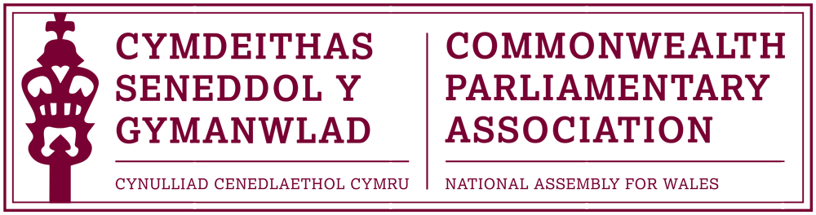

BRANCH EXECUTIVE MEETING

Meeting Date: Tuesday 7 December 2016

MINUTES

Present:
Rhun ap Iorwerth AM, Chair
Mohammad Asghar AM
David Rowlands AM
Rhianon Passmore AM
David Melding AM

Al Davies, Acting Branch Secretary

AGENDA

- APOLOGIES FOR ABSENCE.

None.

- MINUTES OF THE LAST MEETING – Paper CPA 02-16M

The Minutes of the last Branch meeting were approved as a correct record, subject to a minor amendment to note that Rhianon Passmore AM had not been made aware of this meeting taking place.

- MATTERS ARISING FROM MINUTES

There were no matters arising.

- REVIEW OF RECENT ACTIVITIES

Feedback and follow-up of recent Meetings, Visits,
Events and Conferences

- First Commonwealth Women Leaders’ Summit
London, UK (DOC 2)
14 July

The Chair referred Members to the short report by Joyce Watson, for which he noted the Branch’s thanks, of her attendance at this Summit, which had been received and circulated to Branch Members for information.

- CPA Commonwealth Women Parliamentarians Conference
Kampala, Uganda
8-12 August
The Chair informed Members that this conference, which was due to be attended by Joyce Watson in her capacity as the CPA Regional CWP Chair, had been cancelled at very late notice. This was apparently due to a low number of confirmed attendees.
Our Branch was subsequently at a financial loss because of this and had (upon the advice of the CPA Secretariat) contacted the Ugandan Branch to seek compensation towards our funds for Joyce’s flights. There had unfortunately been no resolution of this matter and the Branch had now, reluctantly, accepted this loss.

- BIMR CWP Steering Committee Meeting (DOC 3)
Senedd, Cardiff
14 October
Joyce Watson had hosted this meeting – the first Standing Committee of our Regional Commonwealth Women Parliamentarians as Chair – at the Senedd. Minutes of that meeting had been distributed to Members.
The meeting had focussed upon preparations and development for the programme of the 4th CWP Conference which was due to take place in Belfast.
*It was noted that CPA Wales’ offer to host the 5th^{h} BIMR CWP Conference at the Assembly was accepted and this would take place in February/March 2018.
- 8th Commonwealth Youth Parliament
British Columbia, Canada
6-10 November

Following a high level of interest and applications from young people across Wales, Laura Elliott had been selected by Members from a shortlisted group of interviewed candidates to represent our Branch at this year’s CYP.
Very positive feedback had been received from Laura of her experience and she had participated in an excellent BBC Wales Radio interview the previous week about her participation in the conference
Laura was currently drafting her formal report to the Assembly which would be circulated to Members and published on the Branch webpages. The Chair also noted that arrangements had been made for Laura to come into the Assembly on 18 January to meet with the Llywydd and himself to discuss her report and her feedback and findings of the Commonwealth Youth Parliament.

As an aside, Members present commented that it would be helpful in future to be made aware of any social media handles and hashtags for such events so that they could support and publicise through their own accounts. This was duly noted.
- CPA UK & National Assembly of Guyana
Parliamentary Forum on Anti-Corruption
Parliament of Guyana
9-11 November
Guest Speaker: David Melding AM
The Chair noted his thanks, and that of the Branch, to David Melding AM for making time to come and speak of his experience and participation in last month’s Parliamentary Forum on Anti-Corruption in Guyana (South America) for which he had been selected.
David noted that this had been a positive and rewarding experience and that the small delegation, led by the Rt Hon. Sir Kevin Barron MP and had also included Lord Wood of Anfield, supported by Eve Samson, Clerk of EU Scrutiny Committee, House of Commons and Rachael Atkins, CPA Americas, Caribbean and Europe Programme Manager, had worked together well.

The forum had received widespread media coverage in Guyana and it was clearly of great importance to the country.

David had led on four sessions and noted the importance of thorough preparation which had paid off during the forum. The Guyanese had been interested in practice as well as theory and the experiences and functions of the National Assembly for Wales that he had been able to relay had been well received. An example of this was the Nolan Principles and how they had been applied to past Standards cases at the Assembly. The fact that both Assemblies were of a similar size had also been useful for the Assembly of Guyana to relate to.
David thanked the Branch for the opportunity. He stated that this had not been his first application to participate in a CPA UK outward programme and therefore encouraged other AMs, potentially interested in similar opportunities, to persevere if not immediately successful.
An official CPA Report of the Forum would be produced and this would be circulated to Members as well as being posted on the CPA Webpages.

5. FORWARD PLANNING

Forthcoming Meetings, Visits, Events and Conferences

2016

62nd Commonwealth Parliamentary Conference
London, UK
11-17 December
As had been previously discussed, and anticipated, the planned Annual
CPA Conference in Dhaka, Bangladesh had been cancelled because of
security fears, following this summer’s terrorist attacks in the
capital.
This late replacement conference in London had been organised by
the CPA Secretariat and was smaller in scale and shorter in duration
than standard conferences.
Joyce Watson AM would attend the conference in her capacity as BIMR
CWP Chair. She would also be standing for the election of
International CWP Chair (for a 3 year term), to take place on
16 December. The Chair, on behalf of the Branch, wished Joyce well at
the election.
Given that only women parliamentarians were able to vote at this
election, it was agreed that the Branch’s only official delegate place be
offered to Rhianon Passmore AM on this occasion, so that she could
support Joyce as well as to attend whichever other parts of the
conference she could.
The Chair questioned, however, why there were no mechanisms in place
for proxy voting at this and other CPA elections. The Branch
Secretary would take this up with the CPA Secretariat and report back on
this matter.
2017
- 4th BIMR CWP Conference
Belfast, Northern Ireland
3- 5 March
Confirmation had been received of these dates for the next Regional Commonwealth Women Parliamentarians Conference in Belfast.
The CPA Wales Branch had been be allocated three guaranteed places with the possibility of an additional place upon request.
- 47th CPA (BIM) Regional Conference
Gibraltar
21-24 May
The Chair informed Members that, whilst no formal invitation had yet been received, a diary marker has been issued for the above dates in May.

The CPA Wales Branch would be invited to send four Members to this conference in Gibraltar and the Chair stated that first refusal should, on this occasion, be made to Members of the Branch Executive Committee.

- Inaugural Conference for Commonwealth Parliamentarians with Disabilities
Nova Scotia, Canada
August / September (tbc)
An early notification had been issued of the CPA Nova Scotia Branch, in cooperation with the CPA Secretariat’s, intention to host this inaugural conference which would be open to Parliamentarians with Disabilities.
The Branch Secretary would monitor any development of this conference. Members noted that Branch Vice-President (DPO Ann Jones AM) had expressed an early interest in attending the conference, of which Members were very supportive.

  - FUTURE MEETING DATE:
February / March 2017

7. NEW ITEMS / ANY OTHER BUSINESS

- Commonwealth Visitors and Engagement with Branch Members
Members noted that the recently appointed Canadian High Commissioner to the UK, Her Excellency Mrs Janice Charette, had visited the Assembly the previous day, as part of a two day visit to Wales. Her programme at the Assembly had included meetings with party leaders and representatives.

Members questioned why the Branch had not had the opportunity to meet with the High Commissioner on this occasion and asked for this to be considered as part of future visits by diplomats and parliamentarians from Commonwealth countries where practical.

December 2016

