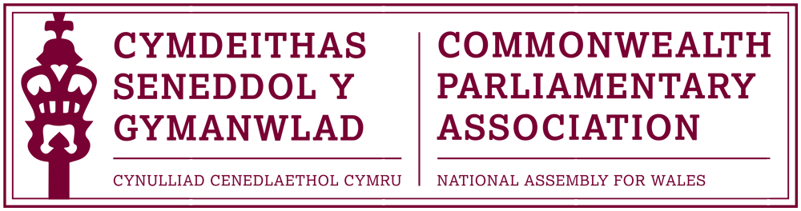

BRANCH EXECUTIVE MEETING

Meeting Date: Tuesday 5 December 2017

MINUTES

Present:
Rhun ap Iorwerth AM, Chair
Mohammad Asghar AM
David Rowlands AM
Rhianon Passmore AM

Al Davies, Acting Branch Secretary
Enfys Roberts, Private Office/International Team

- APOLOGIES FOR ABSENCE.

None

- MINUTES OF THE LAST MEETING – Paper CPA 02-17M (DOC 1)

Minutes of the last Branch meeting were approved.

- MATTERS ARISING FROM MINUTES (DOC 2)

It was noted that an outstanding report of this year’s Commonwealth Day had now been received by Matthew Walker. Members were grateful for Matt’s report but noted disappointment that no contribution had been received by Samantha Ellis who had also participated in the programme.

- REVIEW OF RECENT ACTIVITIES

Feedback and follow-up of recent Meetings, Visits,
Events and Conferences
2017

- Inaugural CPA Conference for Parliamentarians with Disabilities
Nova Scotia, Canada
30 August – 2 September (DOC 3)

A report of the Conference had been circulated for which Members noted their thanks.
Enfys Roberts from the Private Office/International Team, who had accompanied the Branch Vice-President Ann Jones AM, spoke to the report. Enfys gave an overview of the conference, which had been well received, and discussed the next steps forward in hopefully establishing a network for Parliamentarians with Disabilities within the CPA, for which Members noted their full support.

- 9th Commonwealth Youth Parliament
(British) Virgin Islands
9-13 October

The Chair reminded Members that the 9th CYP had originally been intended to take place in the Virgin Islands in October but that, due to the devastating hurricane which had affected the BVI and wider Caribbean region, the conference could not go ahead. The thoughts and sympathies of the Branch were with the people of the BVI and all those affected by this natural disaster at this difficult time.

- 14th Canadian Parliamentary Seminar (DOC 4 )
Ottawa
15-21 October

The Branch noted and thanked Lee Waters AM for his useful and interesting report of his recent participation in the Canadian Parliamentary Seminar, aimed at new or recently elected Members.

- 63rd Commonwealth Parliamentary Conference (CPC)
Dhaka, Bangladesh
1-8 November
The Chair thanked Mohammad Asghar AM for the report of his recent attendance, on behalf of the Branch, at the annual CPC which had been hosted by the CPA Bangladesh Branch in Dhaka.
Oscar provided Members with a supplementary overview of the conference and of his participation and contribution at the conference.
Joyce Watson AM, who was due to participate as the Regional CWP Chair, was unfortunately unable to attend. Joyce was however, in abstentia, voted as the Vice-Chair of the International Commonwealth Women Parliamentarians for the next year for which Members congratulated her.
Oscar also discussed with Members his subsequent visit to Lahore, Pakistan where he had arranged a range of meetings to discuss subjects including tourism, education and skills training.

5. FORWARD PLANNING

Forthcoming Meetings, Visits, Events and Conferences

2017
- Visit of Quebec Agent General to the UK
National Assembly for Wales
13 December
It was noted that the recently elected Quebec Agent General would visit the Assembly for a short programme the following week, and would meet with the Llywydd as well as with the First Minister.
2018
- BIMR CWP Pre-Election Meeting
Jersey
1-2 February
Joyce Watson AM and the other Steering Committee Members of the Region had been invited to participate in a pre-election outreach session in Jersey, organised by the BIMR Secretariat.

- 9th Commonwealth Youth Parliament
Jersey
28 February – 1 March

Following the cancellation of the CYP in the BVI, the Branch welcomed the news that the CPA Jersey Branch had stepped in and volunteered as a substitute for the conference.

It was agreed that the Branch would now be represented at the rescheduled 9th CYP in Jersey by Brett John with an additional place to be offered to Ben Sawyers.

Lucia Jones, who had originally been selected to attend the CYP in the BVI was now unable to attend during the rescheduled dates. Members therefore agreed that Lucia would be offered a guaranteed place to represent the Branch at the 10th CYP Conference, provisionally scheduled to take place in the CPA India Region in the autumn of 2018.

- Commonwealth Day Observation Programme
Westminster
12 March,

It was confirmed that the Branch had, once again, been invited to nominate two young people to participate in March’s 2018 Commonwealth Day Observation Programme in Westminster, organised by the CPA Secretariat. The Branch Acting Secretary was working with the Assembly’s Education/Youth Parliament team to select suitable participants.

- Commonwealth/International “Wales and the World” Event
Senedd (evening reception)
13 March

The Chair made Members aware of this planned Senedd event, in collaboration with the British Council Wales, to celebrate Commonwealth Day and Wales’ relationship with the world. Members discussed suggestions for content, including suitable entertainment at the reception.

- 5th BIMR Commonwealth Women Parliamentarians Conference
London, UK
Dates TBC

The Chair notified Members that, in the absence of the CPA Northern Ireland Branch’s ability to host the Regional Women Parliamentary Conference, CPA UK had offered to host the 2018 conference in London. Our Branch expected to be offered several places at the conference and Members would be advised once further details were known.

  - FUTURE MEETING DATES:

      - Annual General Meeting – 12 December

Members were reminded that the Branch AGM would take place the following week with nominations to serve on the Executive Committee requested by 7 December.

      - Branch Executive Meeting – February 2018 (TBC)

7. NEW ITEMS / ANY OTHER BUSINESS
None.

END OF BUSINESS

December 2017

