

Our plan to treat everyone fairly
2012 to 2016
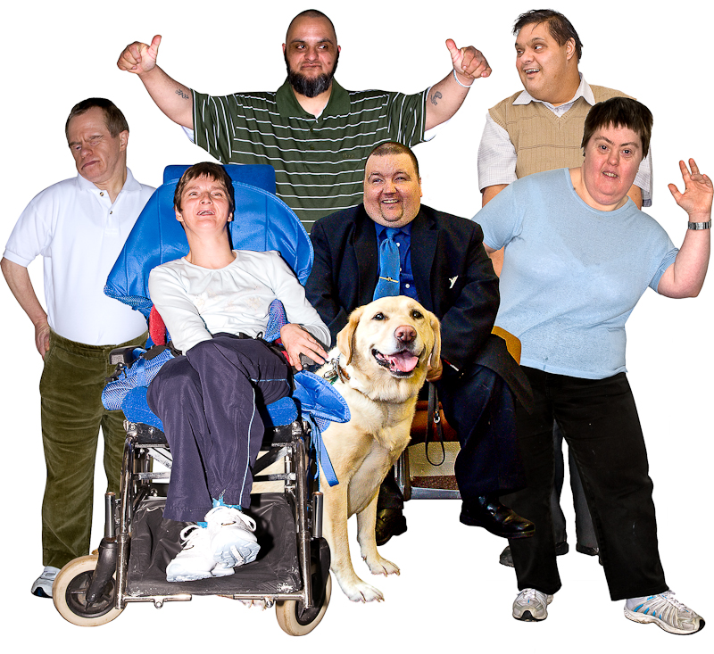

Easy read
Who we are
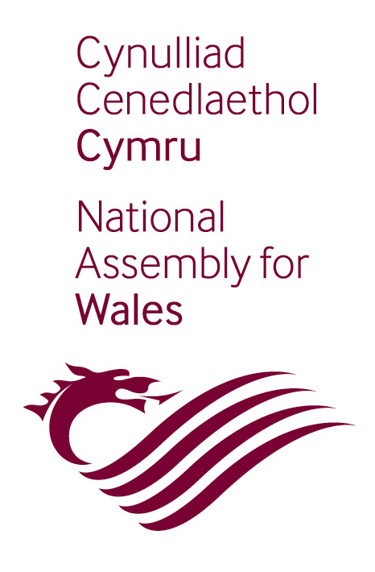

We are the Assembly Commission.

We are part of the National Assembly for Wales.

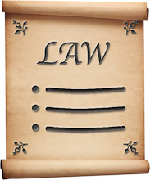
The National Assembly for Wales is in charge of things like

- making laws in Wales



- making sure the Welsh Government does a good job. The government is the group of people that run the country.

Our values

Our values are the things that are important to us.

Our values are

- making things fair for everyone



- stopping people being treated badly

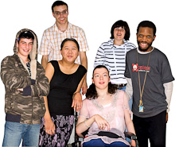

- working with groups of people from all different cultures and backgrounds.

The law

The law says we must do these 3 things.


1. Stop people being treated badly because of things like

- their disability

- their religion

- the country they are from.



2. Make sure there are more chances for everyone to live a good life.

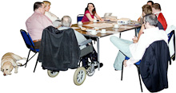
3. Get different groups of people to work well together.

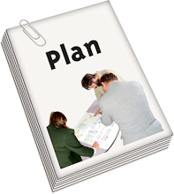

The law says we must make a plan to show how we are going to do these 3 things.

Making our plan


We spoke to lots of people to help us make our plan, like

- people who work for us



- other people who live in Wales.

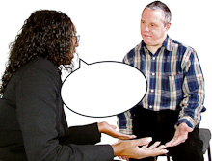

We asked them what we could do to make sure people are treated fairly.



We put a form on our website for people to fill in.

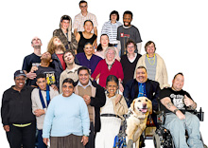

We made sure lots of people could have a say.

Our plan
We listened to what people told us and then made our plan.

The main things in our plan are

1. Make sure people know what the National Assembly does.

2. Help more people be part of our work.

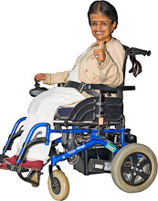

3. Make sure all people can get around our buildings and use our services.

4. Get people from all different cultures and backgrounds to work for us.



5. Support staff to treat everyone fairly.

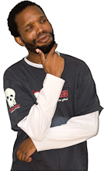
6. Make sure we think carefully about how to make things fair before we do anything.
More information

You can find out more about our plan by talking to our Equalities Team.

You can write a letter to
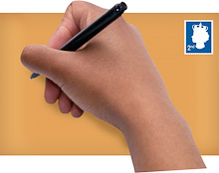
Equalities Team
National Assembly for Wales Commission
Cardiff
CF99 1NA



You can call 029 2089 8197


You can send an email to

equalities.team@wales.gov.uk
Easy words by Mencap. Pictures by Photosymbols.

