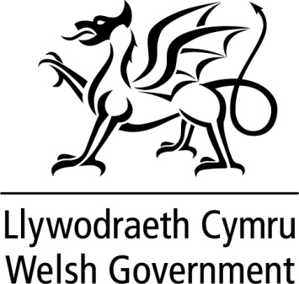

WRITTEN STATEMENT

BY

THE WELSH GOVERNMENT

TITLE Betsi Cadwaladr University Health Board: special measures update

DATE 22 October 2015

BY Vaughan Gething AM, Deputy Minister for Health

The Wales Audit Office and Healthcare Inspectorate Wales recently carried out a review of progress made over the four months since Betsi Cadwaladr University Health Board was placed in special measures on June 8. This high-level and targeted overview of progress was discussed yesterday at a tripartite meeting of senior Welsh Government officials, the Wales Audit Office and Healthcare Inspectorate Wales.
The tripartite meeting agreed that work taken forward by the health board as part of the 100-day plans had focused attention and positive action in a number of key areas. However, longer-term plans are needed to build on this initial phase of stabilisation in order to tackle more fundamental challenges, particularly to improve mental health services in North Wales.
I have therefore accepted the advice of the tripartite meeting that Betsi Cadwaladr University Health Board should remain in special measures for the next two years with progress and milestones reviewed every six months.
I will make a further statement about the next stage of special measures arrangements after recess.
A copy of the Wales Audit Office and Healthcare Inspectorate Wales special measures review letter to Betsi Cadwaladr University Health Board and its response is available at:
http://www.hiw.org.uk/news/39060

http://www.audit.wales/publication/betsi-cadwaladr-university-health-board-letter-interim-chief-executive

