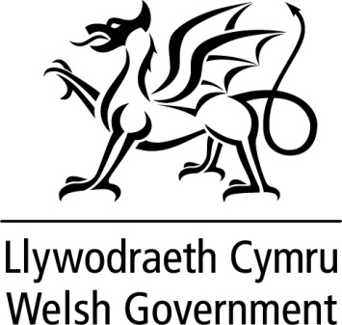

WRITTEN STATEMENT

BY

THE WELSH GOVERNMENT

TITLE | Consultation on the reform of non-domestic rates in Wales – summary of responses
DATE | 09 February 2023
BY | Rebecca Evans MS, Minister for Finance and Local Government

On 29 March 2022, I made a statement setting out the Welsh Government’s plans for the reform of non-domestic rates (NDR) during the current Senedd term. I later launched a consultation on a range of proposals to improve NDR in Wales. The Reforming Non-Domestic Rates in Wales consultation ran from 21 September to 14 December 2022.

The consultation sought views on a wide range of improvements to the NDR system in Wales. Our proposals include the following.

- More frequent revaluation cycles, a change which many stakeholders have been calling for to ensure that rates valuations more accurately reflect up-to-date market conditions, along with additional measures necessary to support this.
- Improving the flow of information between government and ratepayers, taking advantage of digital services.
- Providing the Welsh Government with more flexible legislation to amend reliefs and exemptions in future years.
- A review of reliefs and exemptions to ensure the arrangements align with our Programme for Government commitments and the available support is targeted in the most effective way.
- Providing greater scope to vary the multiplier to help align annual increases with our economic development priorities.
- Improving the administration of valuation functions and rating lists to streamline processes and reduce the burden on government and ratepayers.
- Further measures to ensure we can continue tackling avoidance.
- Consideration of an alternative approach, such as a local land value tax, to raising local taxes over the longer-term.
The consultation received 73 responses, with detailed and considered views put forward by a wide range of representative groups, local authorities, and individual organisations. Views were generally supportive of most of the Welsh Government’s proposals. I have today published a summary of responses.

Following the consultation, we will further develop our proposals for our planned Local Government Finance Bill. In particular, we remain committed to introducing three-yearly revaluations and the measures required to support them. We will also continue to develop the other proposals set out in the consultation.

More immediately, I will be bringing forward secondary legislation, to come into force from 1 April 2023, to clarify which matters should not result in a change of rateable value between revaluations. This legislation will reinstate the intended policy position for the scope of appeals citing a material change of circumstances and ensure the law is clear and fair.

I note the comments raised in relation to alternative approaches to local taxes. The initial views provided by ratepayers and stakeholders will help to inform ongoing work to develop future ideas for raising revenue for local services in a different way. Any substantial change to local taxation would require further development beyond the current Senedd term.

As proposals continue to be developed, we will work closely with the Valuation Office Agency, local government and other stakeholders. I thank all respondents for their valuable contributions as part of the consultation process – this will inform further improvements to the NDR system in Wales.

The summary of responses can be found at the following link:
Consultation on the reform of non-domestic rates in Wales – summary of responses

