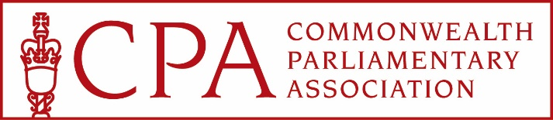

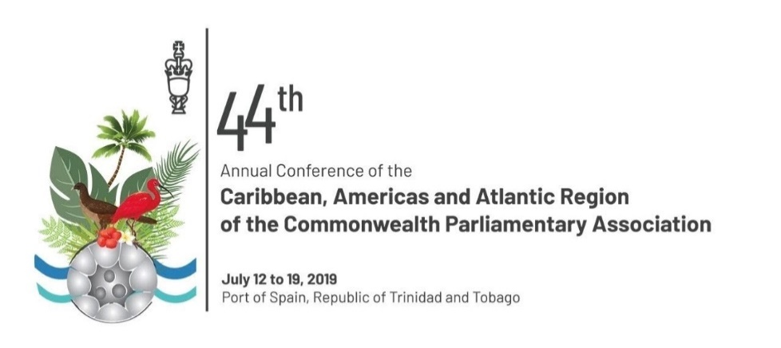

**CPA Caribbean, Americas and Atlantic Region: 44th Annual Conference**

**Trinidad July 2019**

Report from Rhun ap Iorwerth AM

Representative of the CPA British Islands and Mediterranean Region

*As a sub-state CPA member, I was eager for the Wales branch to seek to represent the British Islands and Mediterranean Region at the conference due to the chosen theme, ’***Globalisation and Nationalism: Quo Vadis – Impacts on Commonwealth Parliaments*’****. Although the Wales branch is not considered to be a ‘small’ CPA branch, Wales is a relatively small nation in UK and European terms, and is a young democracy, seeking to grow in stature and confidence as it finds its way in the world. It struck me that this would be a valuable opportunity to learn from other CPA members how they have learnt from the challenges of operating in a global context and what the influences have been on their development in a post-colonial context. I was very pleased that I was subsequently selected to attend as the Wales CPA Chairman.*

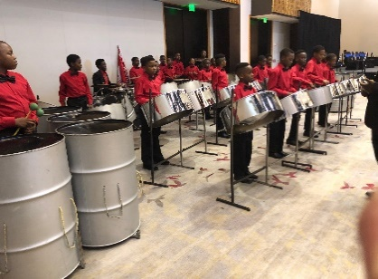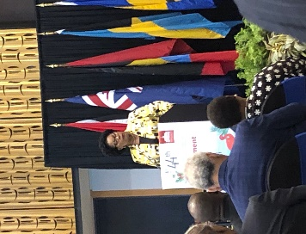 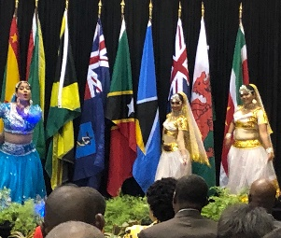 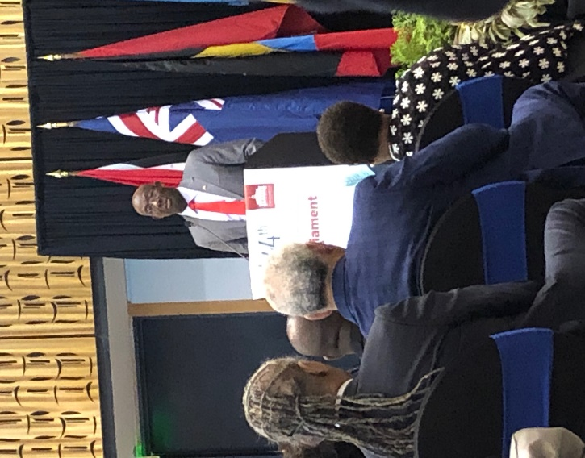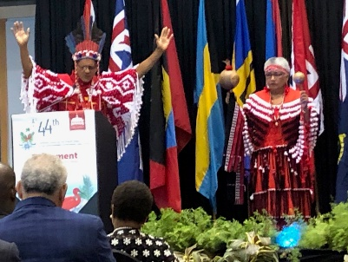

The conference was hosted in Port of Spain by the Trinidad and Tobago CPA branch, and the colourful pageant of the opening ceremony – during which we were addressed by Her Excellency Paula-Mae Weeks, President of the Republic of Trinidad and Tobago, and Dr Keith Rowley, the Prime Minister, as well as the CPA Secretary-General, Akbar Khan - set the tone for what would be a very good-spirited, thought-provoking and well-organised conference. Traditional and multi-cultural dancing and musicians welcomed delegates and whilst I was very disappointed that organisers made the mistake of playing the UK anthem instead of *Hen Wlad fy Nhadau* as each national flag was raised, I was proud to see the red dragon fly alongside the flags of our Caribbean, Americas and Atlantic friends.

*All discussions took place in full plenary session, with speakers either from among the conference delegates or from the Trinidad and Tobago Parliament or Government.*

**DAY 1** SESSION 1

The opening session was entitled ***Migrants and refugees is there a need for a collective regional response***. This was a fascinating discussion. We discuss the issues of migration and refugees through a European prism, and it was interesting to track a debate taking part from the perspective of another part of the globe.

Trinidad and Tobago is only a few miles off the coast of Venezuela, and recent economic difficulties there have led to concerns about an influx of economic migrants. Stuart Young, Minister of National Security in the Trinidad and Tobago Government stressed the need for regional cooperation, given the limited resources and relatively small sizes of Caribbean nations. The need for collective action was echoed by the Bahamas representative Donald Saunders.

Akbar Khan contributed to the discussion, emphasising in particular the role climate change is likely to play in driving refugee issues in future. He spoke of the importance of promoting understanding between nations of the issues behind the movement of people, wherever that may be in the world.

Other speakers in the ensuing debate touched on similar themes, as well as bringing in other elements including the specific issue of women in migration. I was constantly drawn to think about our context - in Wales, the UK and Europe - and the way the Brexit debate was influencing opinions in our communities and in our politics.

SESSION 2

**Human rights: are our Parliaments fully accessible to persons with disabilities**. This next topic didn’t fit obviously into the overall theme of the conference, but it sparked an important discussion nonetheless. It struck me that we in Wales are more developed than a number of nations that contributed to the debate, both in terms of access to our Parliaments and the wider issue of disability legislation. Some CPA branches described the inaccessibility of their institutions to people with disabilities, whilst other described plans to address these shortcomings. Some members described positive changes in attitudes towards disabilities, with Marlon Penn of the British Virgin Islands emphasising the importance of framing disability issues as a matter of ‘human rights’.

(This discussion was marred somewhat by procedural disagreements, on time allowed for speakers etc, which was disappointing.)

SESSION 3

Next, we turned to the topic of **Forging a Caribbean identity: how relevant are the Westminster traditions in modern Parliament.** Speakers from Antigua and Barbuda, and from Guyana gave descriptions of their parliaments and how they worked, and as the discussion opened out a number of topics were introduced: how to remunerate MPs adequately to ensure they can be fully committed to their Parliamentary work; how to rebalance the sizes of Government and opposition, Ministers and backbenchers; the need to have fit-for-purpose Standing Orders.

I’m not sure the session managed to answer fully the issue of whether Caribbean Parliaments were, or should be, forging their own *identity* as such, but once again this was, to me, an example of where working across the CPA brings real benefits to Parliamentarians, learning from others and sharing some of our own good practices.

As a reminder that there is no ‘perfect Parliament’, if this session was to be seen in any way as a means to ‘look up to’ Westminster, one speaker did give a very wry account of why, in the current context, the British Parliament perhaps shouldn’t be seen as a model to follow!

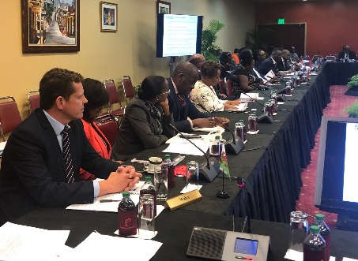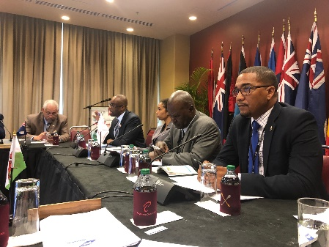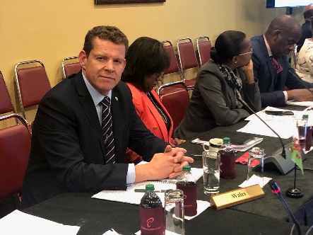

**DAY 2** SESSION 4

**The committee system and the part-time parliamentarian** was our topic to begin our discussions on day 2. Again, a very valuable opportunity to learn about the practices and procedures of other Parliaments. There was widespread agreement on the importance of working in committees in a cross-party manner, but we heard many concerns about capacity. Opening speakers from Trinidad and Tobago, and from Bermuda shared their experiences about the pressures of sitting on multiple committees, and it was emphasised how difficulties arise when a politician isn’t full-time. In smaller territories, it was described how it can be difficult to fill seats on committees, and how it can be hard to achieve a quorum. It was good to be able to contribute to the discussion, describing our committee structures and some of the challenges we face, even as full-time politicians in sitting on multiple committees.

SESSION 5

Next, we turned to a topic similar to ones we discussed at length during the recent BIMR CPA Conference in Guernsey: **Digital Disinformation: the challenges to Parliaments and democracy.**

What this very engaging session proved to me that these issues are ones which are global in nature. Opening contributors discussed the growth of ‘fake’ and ‘junk news’, trolling, the influence of algorithms, the importance of investing in good journalism, and how misinformation can distort political discourse.

I was able to contribute with reference to my own experience as an elected politician and a journalist, but I also introduced some of the themes we explored in Guernsey, especially the theory of taking a ‘public health approach’ to addressing the problem of disinformation.

SESSION 6

The final plenary session was entitled **Rethinking the Westminster model of governance: the need for a fundamental shift.** This was a fascinating discussion, with powerful opening remarks from contributors.

Dr Lovell Francis MP of Trinidad and Tobago gave a passionate speech, saying Caribbean states should be proud of how they have developed their own respected parliamentary structures and democracies in a very short period. He described the painful and corrupting colonial experience of wealth extraction, and argued that there was a real irony in expecting those countries that had emerged as independent states from those colonial shadows to then embrace the British parliamentary model.

In a fascinating discussion, the need for democracies to evolve, and to learn from each other during that process of evolution, was a clear theme, again showing real value in coming together as a CPA family in forums such as this.

**DAY 3**

The third day of conference was dominated by the Regional Commonwealth Youth Parliament, and I was honoured to be asked to be one of three judges, choosing the best overall speaker.

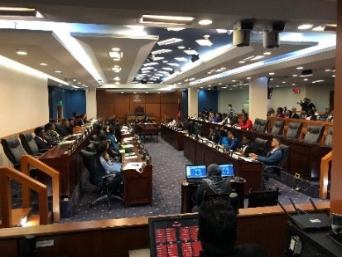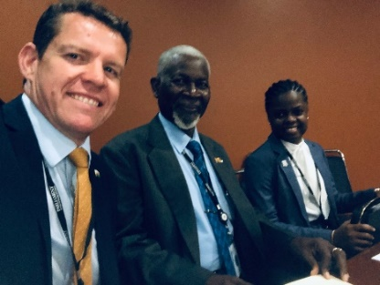

I had been looking forward to seeing how this Youth Parliament operated, and how similar or different it would be to our own new Welsh Youth Parliament. It was, indeed, very different, its format being very adversarial, with members divided into ‘Government’ and ‘Opposition’ groups.

Adjudicating was quite a challenge, marking 36 speakers from across the CAA region, in 10 different categories. However, it was a real pleasure to see so many talented young men and women engaging with this democratic exercise and speaking so eloquently.

**CLOSING EVENT**

All delegates convened at the President’s residence at the end of the final day, an opportunity to reflect on the Conference and to continue our discussions in a less formal environment.

It was here that I presented gifts from the CPA Wales Branch the two conference hosts, **Senator Hon. Christine Kangaloo, President of the Senate of Trinidad and Tobago and Hon. Bridgid Annisette-George, MP, Speaker of the House of Representatives of Trinidad and Tobago.**

**I expressed to them our gratitude for allowing us to be observers at, and to take part in their prestigious conference on behalf of the British Islands and Mediterranean Region. I’m confident that relationships were forged that can be built upon in future for our mutual benefit.**

