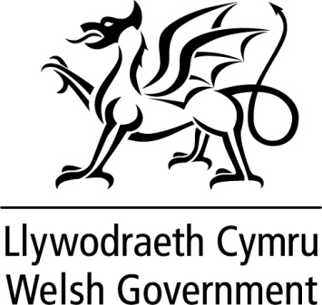

WRITTEN STATEMENT

BY

THE WELSH GOVERNMENT

TITLE | The UK Government’s Non-Domestic Rating Bill
DATE | 05 April 2023
BY | Rebecca Evans MS, Minister for Finance and Local Government

Non-domestic rates (NDR) is a local tax that raises more than £1.1bn every year to help fund vital local government services. The Welsh Government is pursuing a range of reforms during the current Senedd term, which will make essential and positive changes to NDR in Wales.
Several elements of the NDR system work on a similar basis across Wales and England, and many businesses operate on both sides of the border. Some of the Welsh Government’s policy and legislative aims align to those of the UK Government. Businesses and other ratepayers in Wales benefit from a consistent operational approach and a similar landscape of NDR reliefs, tailored to reflect our unique tax-base.
Some of the proposals in the Welsh Government’s recent consultation on Reforming Non-Domestic Rates in Wales, including plans for more frequent revaluations and the measures required to support them are aligned with the UK Government’s reform agenda. Our proposals will be pursued through Welsh Government legislation, where a difference in the timing and scope does not risk disadvantaging ratepayers in Wales. In addition, we are working with the UK Government on the Digitalising Business Rates Programme, which will provide the Welsh Government with a new opportunity to use linked data to support the development of future NDR policy tailored to Wales.
There is an opportunity to use the UK Government’s Non-Domestic Rating Bill to bring about certain reforms earlier than would otherwise be possible using our planned Local Government Finance (Wales) Bill and where new functions will be conferred on UK Government bodies (His Majesty’s Revenue and Customs (HMRC) and the Valuation Office Agency), to ensure ratepayers in Wales are not disadvantaged. Having considered the options and approach to delivering our wider NDR reform agenda, I have decided that it is optimal for certain provisions for Wales to be made within the UK Government’s Bill.
The provisions extended to Wales include powers to establish new relief schemes and make certain reliefs applicable to properties on the central rating list which, if not included in the UK Government’s Bill would risk putting ratepayers in Wales at a comparative disadvantage. We have also sought provisions to enable information sharing between UK Government bodies and ratepayers on the same basis across Wales and England. Requiring the Valuation Office Agency to share more information with ratepayers will improve transparency and understanding of the NDR system.
In addition, provisions to facilitate the exchange of information between HMRC, ratepayers and billing authorities have been extended to Wales to ensure that we are able to benefit from the realisation of shared aims for the Digitalising Business Rates Programme. It will be operated by HMRC across England and Wales, so we are able to benefit from enhanced information when making policy decisions, including HMRC tax data, that we would not otherwise be able to access.
To help ensure that any reform fully reflects the Welsh Government’s policy priorities for NDR, my officials have been working closely with UK Government officials, to make sure the provisions reflect the policy intent for Wales. I will be laying a Legislative Consent Memorandum to be debated in the Senedd, to ensure proper scrutiny of these measures, and the consent of the Senedd will be required in due course.
In the meantime, we will continue to develop proposals for bringing about the wider reforms set out in our consultation, on which I will be updating members in due course.
This statement is being issued during recess in order to keep members informed. Should members wish me to make a further statement or to answer questions on this when the Senedd returns I would be happy to do so.

