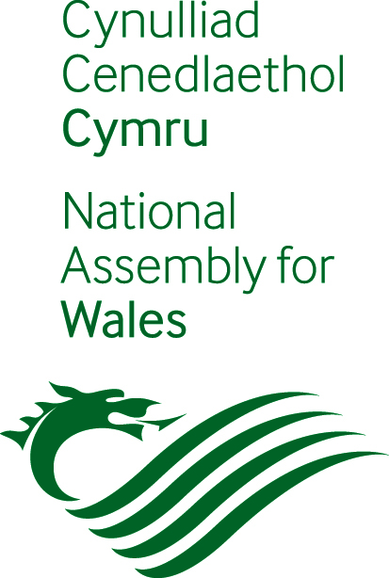

How can we make it easy for you to have a say in our work?
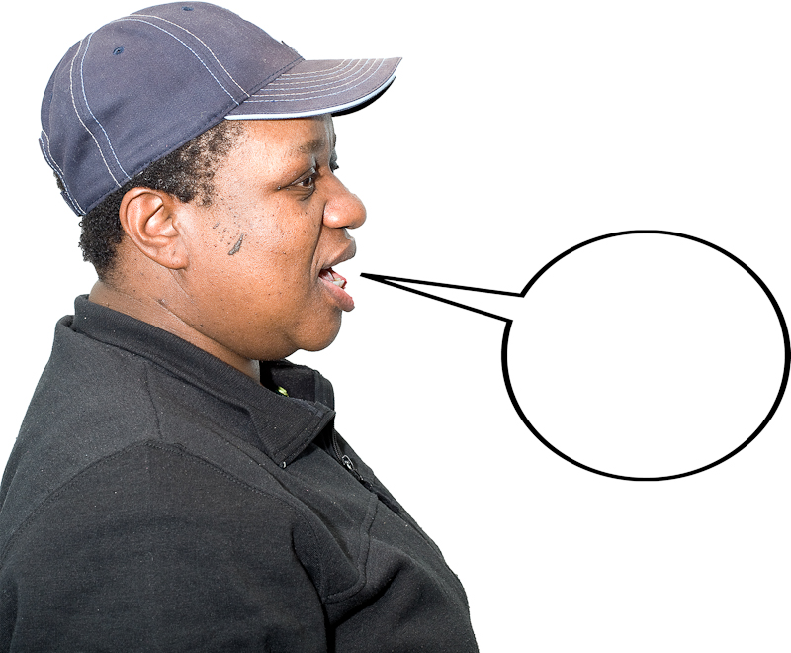

Please answer our questions.

Easy read
Who we are

We are the National Assembly for Wales.

We do things like
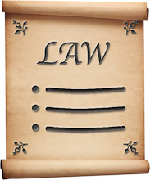
- make laws for Wales

- make sure the Welsh Government is doing a good job. The government is the group of people that run the country.

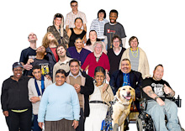

We speak up for people who live in Wales. We make sure the government listens to what they need.

What this booklet is about


We are going to make a new plan for the way we work.

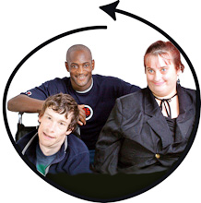

This plan will be about treating everyone fairly.

We want to make sure everyone has the chance to have a say in what we do.

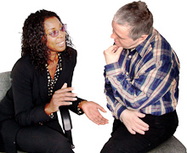

We want to know what we could do to make this easy for you.

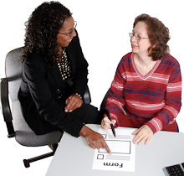

Please let us know by answering these questions. You can ask someone to help you if you want to.

Questions
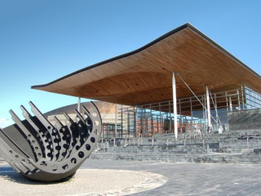
1. What can we do to make our buildings easy to get around?

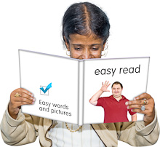
2. Would it help if we made more easy information about what we do?

Yes No

3. What easy information would be useful?
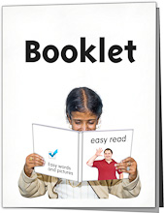

Information about what we do

Notes from our meetings

Reports about what we do each year

Information for people who visit our building

Information about how you can have your say

4. We want to work more with people with a learning disability.

Can you think of anywhere we can go to meet more people?

5. We want everyone to have the chance to
- visit us
- get good information from us
- come to meetings and have a say about what we do.
Please tell us how we can make it easy for you to do these things?


6. Is there anything else you would like to say about what we do?


Please send your form to

Ross Davies
Equality Manager
National Assembly for Wales
Cardiff Bay
Cardiff
CF99 1NA

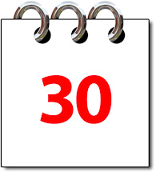
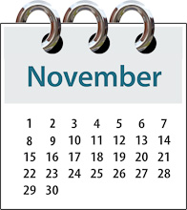
Please send us your form before

30 November 2011.

If you need help
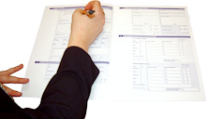
If you need some help filling in your form you can



- call 029 2089 8197

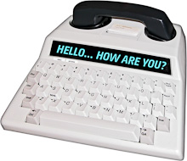

- textphone 029 2089 8601



- email equalitiesteam@wales.gov.uk

Easy words by Mencap. Pictures by Photosymbols

