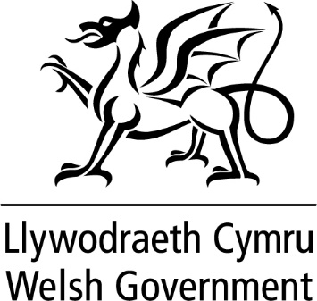

WRITTEN STATEMENT

BY

THE WELSH GOVERNMENT

TITLE | Implementation of the Local Government and Elections (Wales) Act 2021 (11 March 2021)
DATE | 11 March 2021
BY | Julie James MS, Minister for Housing and Local Government

On 3 March I announced I had made the first commencement Order in respect of the Local Government and Elections (Wales) Act (“the Act”) and confirmed my intention to make further commencement Orders before the end of this Senedd term

I can today inform Members that I have made the Local Government and Elections (Wales) Act 2021 (Commencement Order No. 2 and Saving Provisions) (Wales) Order 2021.

The second commencement Order will bring into force, on 1 April 2021, the majority of Chapter 1 of Part 6 of the Act in respect of the performance and governance of principal councils. Chapter 3 of that Part, which provides for co-ordination between regulators will also come into force on 1 April 2021.

This will ensure that the new performance and governance regime, other than the provisions relating to panel performance assessments, will apply to principal councils from, and in relation to, the 2021-22 financial year. This will give principal councils the entire financial year to conduct their first self-assessment and report early in the 2022-23 financial year.

Councils will continue to assess their performance in accordance with the Local Government (Wales) Measure 2009 (“the 2009 Measure”) in respect of the 2020-21 financial year, with reports to be published by the end of October 2021.

The provisions relating to panel performance assessments will commence on 5 May 2022 in line with the next ordinary election of councillors. This will enable a gradual and measured roll out of the new regime, allowing for at least one cycle of self-assessments to be conducted before requiring a panel assessment be completed.

In November 2020, I launched a consultation on draft statutory guidance to facilitate the implementation of the new regime, and to support principal councils in discharging their duties under Part 6 of the Act.

Prior to formal consultation, the draft statutory guidance was co-developed with local government and extensive engagement was undertaken with key stakeholders. I wanted to ensure that the guidance we produced was something valuable to local government, providing a meaningful opportunity to continually strengthen councils.

The consultation on the draft guidance concluded on 3 February 2021 and I am grateful to all those who have responded. The responses to the consultation collectively showed that there was broad support for the guidance as drafted, with the approach to co-development of the guidance being seen as constructive. There were some points raised which have been taken into account in the final guidance, to clarify or strengthen certain aspects. I intend to publish this guidance for principal councils next week, ensuring it is in place ahead of the commencement of the new duties on 1 April.

The second commencement Order also disapplies the 2009 Measure to principal councils and National Park authorities, and includes saving provisions to ensure that the exercise of certain functions, and other things done, under the 2009 Measure continue to have effect following its disapplication.

As a result of the new performance and governance regime in Part 6, and the subsequent disapplication of the 2009 Measure, a number of consequential amendments are required to other enactments. These are provided for in the Local Government and Elections (Wales) Act 2021 (Consequential Amendments) Regulations 2021, which I have also made today. These Regulations will come into force on 1 April 2021.

The second commencement Order also brings section 115 of the Act into force on 1 April 2021. This section provides for the re-naming of ‘Audit Committees’ to ‘Governance and Audit Committees’ and requires these committees to review and assess their council’s performance assessment, together with its ability to handle complaints effectively.

Chapter 2 of Part 6, which makes provisions in respect of the membership and proceedings of governance and audit committees, will come into force on 5 May 2022.

Those provisions in Part 7 of the 2021 Act, in respect of restructuring of principal areas, that are not yet in force will also be brought into force on 1 April 2021.

