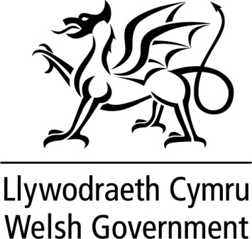

WRITTEN STATEMENT

BY

THE WELSH GOVERNMENT

Title: | Local Authority Services Performance Web Pages 2014-15
Date: | 16 September 2015
By: | Leighton Andrews  Minister for Public Services

Today I am announcing the launch of the new Local Authority Services Performance webpages which replace our annual publication on local authority performance in key service areas.

The webpages will bring together key performance indicators, to give the user an overview of the performance of Local Authorities. They will also include descriptive and contextual information alongside the performance data. The availability of these indicators online represents good digital progress in this area and widens access to a range of audiences.

Local Authority services performance data come from a number of sources which are published throughout the year. Initially, the website will contain the data relating to Local Authority services performance as measured by the National Strategic Indicators. More information will be added as it becomes available.

The abundance of performance data can be confusing. Whilst the webpages will provide considerable information to support robust scrutiny, they are not intended to be the only source. The pages include links to other sources of information which will help those who have an interest in, or duties which involve, analysing performance variation. They are also intended to help to facilitate debate.

Over time, the webpages will be developed to contain the latest performance data to support the accountability and scrutiny of public services by citizens and by Elected Members acting on their behalf.

The webpages can be accessed at the following link:

http://gov.wales/topics/improvingservices/local-authority-service-performance/?lang=en

