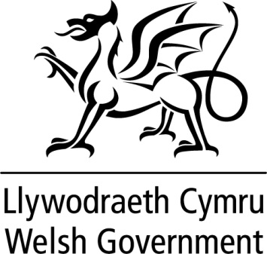

WRITTEN STATEMENT

BY

THE WELSH GOVERNMENT

TITLE | Circuit of Wales Report by Wales Audit Office
DATE | 27th April 2017
BY | Ken Skates AM, Cabinet Secretary for Economy and Infrastructure

The Auditor General for Wales has today published his report on the initial funding of the Circuit of Wales project.

https://www.wao.gov.uk/system/files/publications/circuit-of-wales-eng-2017_0.pdf

This report is critical of some aspects of the way in which Welsh Government managed the initial funding. Whilst the Welsh Government recognises some of the points made in the report we do not accept all of the findings of the report.

We have been surprised and disappointed by the decision of the Auditor General for Wales to publish this report within pre-election periods. There appears to have been a haste to publish the report which has meant we have not been given the normal period of sufficient time to consider and respond to the final draft prior to publication.

We have a number of key concerns regarding the content and the inferences of the report which have not been addressed prior to its publication. For example, the report makes repeated reference to our agreement to provide £16million Repayable Business Finance to Heads of the Valleys Development Company (HoVDC), but does not acknowledge that we subsequently took that offer off the table for this proposal – despite us pointing this out to the Wales Audit Office.

The report also questions risk and safeguarding measures that we put in place. As a Government, we are routinely asked to take on higher levels of risk to support companies and projects than might be acceptable to the private sector. The Circuit of Wales is a complex project that has always been acknowledged as a particularly high risk venture.

We are satisfied that we have assessed risk against value for money for the taxpayer and have sought to secure the maximum security available from the developer. The level of interest and fees charged by the Welsh Government in this case reflects this high risk.

It should be noted that the initial funding support was provided to HoVDC to help develop the business proposition for the Circuit of Wales, to progress planning permission and secure private finance.

The Auditor General has highlighted four key areas where he considers there were short comings in the way the project was processed by the Welsh Government. This has led him to make five recommendations and I would like to assure Members that the report will be considered in detail and a full response issued in due course.

I have made it clear to my Officials that it is important that as a Government, we learn from such past experience and always seek to improve the way we manage projects and public funds.

Indeed, we have already made a number of changes to our business support processes that take into account some of the WAO recommendations, including the PDG approval process and due diligence on related companies.

This statement is being issued during recess in order to keep members informed. Should members wish me to make a further statement or to answer questions on this when the Assembly returns I would be happy to do so.

