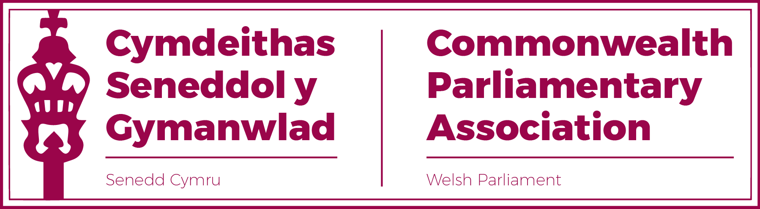

BRANCH EXECUTIVE MEETING
16 February 2022
MINUTES

Present
Rhun ap Iorwerth MS, Chair
David Rees MS (Vice-President)
Delyth Jewell MS
Alun Davies MS
Rhianon Passmore MS
Natasha Asghar MS
Sam Rowlands MS
Secretariat
Al Davies, Acting Branch Secretary
Enfys Roberts, International Relations Team

- APOLOGIES FOR ABSENCES

None

- MINUTES OF THE LAST MEETING - Paper CPA 6S 01-21

The Minutes were accepted as an accurate record.

- There were a number of Matters arising from the Minutes. The following
actions were noted, all of which had been completed.
- Selection of Branch Commonwealth Women Parliamentarians (CWP) Steering Committee Representatives.
Following several meetings, a proposed rotation had been agreed, which would see all three women members of our BEC sit on the CWP Steering Committee during this Sixth Senedd Term.
The Chair noted that, since this arrangement had been agreed, both Natasha Asghar MS and Rhianon Passmore MS had put themselves forward for the BIMR CWP Chair. Should either of them be successful then the rotation would need to be looked at once again as the CWP Chair would need a permanent place on the Steering Committee for her full term.
It was queried why our Branch appeared to be the only one with a more than one Steering Committee Representative and that other Branches were represented by just one Member.
Action: Branch Secretariat to contact the BIMR Secretariat to seek clarity on this.

- Selection of Branch Commonwealth Parliamentarians with Disabilities (CPwD) Champion.
Mark Isherwood MS had been the only applicant for this role and Branch Members were pleased to accept his nominations.

- Letter of thanks to former DPO Ann Jones OBE.
This letter of thanks had been sent to Ann Jones with Members having seen a copy of the letter.

- Selection of Branch Representative for BIMR “Climate Emergency” working Group.
Llyr Gruffydd MS had been pleased to accept the Branch’s offer to represent the Senedd on this new BIMR Working Group.

- REVIEW OF RECENT ACTIVITIES

Feedback and follow-up of recent Meetings, Visits,
Events and Conferences

- CPA UK Climate Webinar and Roundtable Series
15/28 October.
Members had unfortunately been unable to participate in this Roundtable.

- BIMR Working Group on “Climate Emergency”
Virtual
Dates in November 21- February 22

Llyr Gruffydd had attended this meeting, the Working Group’s first formal session, which had been hosted by Julie Elliott MP (UK) on the topic of “Equinor and the Norway story”.
Action: Secretariat to forward the note, drafted by Jon Davies, on this session.

- BIMR CWP Steering Committee Meetings
Virtual
18 November 2021 & 3 February 2022
Natasha Asghar MS and Rhianon Passmore MS fed back on these meetings which had focussed on Gender Sensitive Parliaments and Gender Audits.
The Senedd had since provided a document outlining its position.
- CPA UK Women's Roadshows :
22 November

Natasha Asghar MS had attended this Roadshow and spoke positively of the session which had focused on the important issue of training to tackle Harassment of Women Parliamentarians through Social Media.
Afternote: CPA UK has since released the recording of this session,
which is available here

- Regional Commonwealth Parliamentarians with Disabilities (CPwD) Meeting
Virtual
17 January

Mark Isherwood MS had attended this virtual meeting for which the Branch had provided a self-assessment of the Senedd as a disability inclusive parliament. Moving forward, the group looked to create a grid of priority areas for action by identifying key areas for improvement from each legislature.

- Visit by Australian High Commissioner to the UK
Senedd
15 February.
The Llywydd had been pleased of the opportunity to meet with the High Commissioner where they had the opportunity to discuss a range of issues of interest to the HC, including links between Wales and Australia, the Welsh Language and constitutional matters.

5. FORWARD PLANNING
Forthcoming Meetings, Visits, Events and Conferences
- The Issues of Human Trafficking through Sport
Virtual Workshop
22-24 February
Members were reminded of the opportunity to participate in this session, though it was noted that this was to take place during the following week’s recess.
- 70th Westminster Seminar
Hybrid
14-18 March

The Chair reported that the Branch was pleased that both Sam Rowlands MS and Natasha Asghar MS were able to attend this Seminar aimed at newly elected parliamentarians. The CPA organisers had also been keen to balance our representation with an offer for places to a Member from the Executive party but none of the three new Labour Members were able to attend on this occasion.
There had been no take-up of the virtual places offered to Senedd Groups.
- 51st BIMR Annual Conference (incl CWP Chair Election)
Isle of Man
23-26 March
The Branch discussed the forthcoming BIMR Conference and of the need to select our delegation.
The Branch Vice-President made the case that both Rhianon Passmore MS and Natasha Asghar MS should be given the opportunity to attend this conference, given that the election for the BIMR CWP Chair, for which they had both put themselves forward, would take place at the Conference AGM.
Details of the cap which applied to Branch Executive Members’ participation in BIMR Conferences was raised.
Action: Branch Secretariat to circulate Branch Rules which clarifies this issue.
Afternote: The final Senedd Branch delegation selected was as follows:
Rhun ap Iorwerth MS (Chair)
David Rees MS (Vice-President)
Rhianon Passmore MS
Natasha Asghar MS
with Alun Davies MS, Delyth Jewell MS, and Sam Rowlands MS also having been offered the opportunity to attend.
- CPA Mid-Year Executive Committee Meeting
(for information only)
Assam, India
9 April
The Chair noted the forthcoming governance meeting which would be reported back on by the Regional Secretary Jon Davies and our BIMR Representatives, in due course.

- Commonwealth Women’s Forum (as part of CHOGM 2022)
Kigali, Rwanda
w/c 20 June
The Chair noted the forthcoming CHOGM meeting which the Branch would monitor in case Members might be able to participate in the Women’s Forum, to which the Branch had sent representatives previously.
- 65th Commonwealth Parliamentary Conference (CPC)
Halifax, Nova Scotia (Hosted by Canadian Federal Parliament)
20-26 August
The dates of the CPC had now been confirmed and the Branch would expect a formal invitation before our next Branch Meeting.

6. NEW ITEMS / ANY OTHER BUSINESS

- Gender Sensitive Parliamentary Practices in BIMR Research Project
It was understood that several of our Branch Members were now in
contact with Dr Jessica Smith from the University of Southampton on
research she was undertaking on Gender Sensitive Parliaments.

- There was a short discussion on the Branch’s priorities.
Action: Branch Secretariat to highlight these, as detailed in Branch Rules.

- Election Observer Mission Training
The Deputy Presiding Officer questioned whether there was any update on when the next EOM training would be held.
Action: Branch Secretariat to follow this up with BIMR Secretariat.
Afternote: It was subsequently confirmed that the next BIMR EOM Training would take place on 14-15 July 2022

7. FUTURE MEETING DATE:
May/June 2022 (TBC)
END OF BUSINESS.

