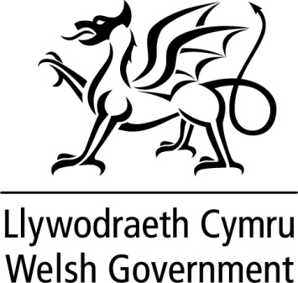

WRITTEN STATEMENT

BY

THE WELSH GOVERNMENT

TITLE | Minister for Education and Skills announces appointments to the Qualifications Wales Board
DATE | 28 January 2016
BY | Huw Lewis AM, Minister for Education and Skills

Qualifications Wales was established under the Qualifications Wales Act 2015 and the Board will exercise an important role in ensuring that Qualifications Wales has:

- effective leadership,
- a well defined strategic direction; and
- that it undertakes activities efficiently and effectively and in accordance with its’ aims, objectives and targets.

The Board is to consist of the Chair (Ann Evans), the chief executive of Qualifications Wales (Philip Blaker) and at least eight and no more than ten ordinary members as appointed by the Welsh Ministers.

In August 2015, I agreed to the appointment of five members to the Shadow Qualifications Wales Board and to their subsequent appointment to the Qualifications Wales Board following the establishment of Qualifications Wales on 21 September 2015. The members are:

Paul Croke
Angela Maguire-Lewis
Claire Morgan
Isabel Nisbet
Dr Caroline Burt

These appointments began on 6 August 2015 and will be for an initial period of three years.

I have agreed to the appointment of the following three members to the Board of Qualifications Wales:

- Ellen Donovan is an experienced Management Board Director, with over 25 years Business experience in the Private Sector. Her previous roles include Trading Director where she was responsible for the development of Brands, Products and Services within Debenhams PLC, and Operations Director where she led a workforce of over 5,000 staff.

- Robert Lloyd Griffiths is currently the Director of the Institute of Directors (IoD) for Wales, a post he has held since 2009 following earlier career roles in advertising, Public Relations, marketing and communications. He is a member of both The First Minister’s Council for Economic Renewal and The Secretary of State for Wales’ Business advisory Group and has also chaired/been a member of a number of Welsh Government review bodies and task and finish groups.

- Rheon Tomos is a CPFA qualified accountant and is currently a partner of TDE-Associates where he provides specialist support on Corporate Governance. He has been involved in the administration of public sector services over many years including periods with the Audit Commission and Deloitte & Touche.

These appointments began on 8 December 2015 and will be for an initial period of three years.

I was delighted to appoint the first five members to the new Qualifications Wales Board. They bring with them a wealth of experience and knowledge from a variety of education, qualification and regulation backgrounds. I am now pleased to announce the appointment of three new members to the Qualification Wales Board. These additional members will bring a different and valuable perspective to the Board and I am sure the Board will help steer this new organisation as it starts out and establishes itself as the new qualifications regulator for Wales.

Notes

These appointments were made in accordance with the Commissioner for Public Appointments Code of Practice.

All appointments are made on merit and political activity plays no part in the selection process. However, in accordance with the original Nolan recommendations, there is a requirement for appointees’ political activity (if any declared) to be made public. None of the appointees to the Board of Qualifications Wales declared any political activity.

