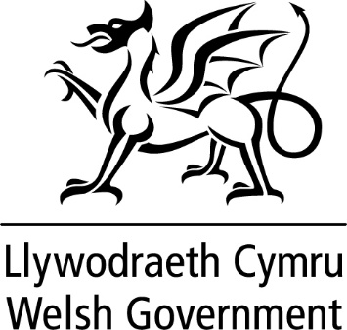

WRITTEN STATEMENT

BY

THE WELSH GOVERNMENT

TITLE | Ministerial Overseas Visit to the USA
DATE | 12 December 2022
BY | Vaughan Gething MS, Minister for Economy

I was in Washington DC between 20-22 November to lead a programme of events designed to raise the profile of Wales alongside Wales’ inaugural World Cup group game against the USA.

My first meeting was with La-Chun Lindsay, a Welsh Government Envoy, who has consistently promoted Wales as a great place to do business. She has also undertaken high profile events such as chairing a panel on gender equality in Wales at the United Nations. This was an excellent opportunity to catch up on the work that she has been doing on behalf of Wales and the Welsh Government and discuss future plans.

At a showcase event, ‘Soccer in the Circle’ held at the Dupont Circle, I welcomed around 2,000 fans and business stakeholders to watch the Wales v USA game live on big screens in an outside setting. The event featured a range of Visit Wales marketing materials and attracted US media coverage. It was a great opportunity to jointly celebrate Welsh and American culture – including the live production of a collaborative piece of art produced by a local American artist and a young Welsh artist sponsored by the Urdd - one of our ‘Team Wales 22’ partners. Welsh food and drink was available at the event, which was a great opportunity for participants to learn more about the bonds between our two nations.

The first day of my visit concluded with a reception hosted by the Welsh Government’s DC team and His Majesty’s Ambassador to the USA, Dame Karen Pierce, which was attended by senior leaders in business and education and other diplomats. This provided a vehicle for me to highlight opportunities in economic investment, education, sporting and diaspora links between the USA and Wales.

On the second day of my programme, I held a bilateral meeting with the Ambassador, to discuss how the Embassy team can promote Wales further.

The final event of my programme was a roundtable with senior business leaders from the British American Business Association (BABA). We discussed how they are addressing current political and economic challenges and promoting Wales’ strengths in sectors such as fintech, manufacturing and cyber security. This was also an opportunity for our US team to connect directly with DC-based leads of major investors in Wales such as GE and IQE.

Media coverage of Wales throughout my visit was wide and varied. I undertook both radio and television interviews and some major national and international networks covered the game, referencing the links between Wales and the USA. We were particularly pleased with coverage by the Washington Post Metro supplement which had the ‘Soccer in the Circle’ event on the front page of its Metro supplement, plus a double page inside spread, which included interviews with American alumni who had studied in Wales.

Our profile within the USA has undoubtedly been raised through the visit and profile from the World Cup. We will continue to work with partners to secure future trade, investment and education opportunities.

