Visiting the Pierhead

The Pierhead is a visitor, events and conference venue.

It is open from 10.30 to 16.30, Monday to Sunday. Please note that Sunday opening hours are subject to change.

If you are planning to visit you can call ahead to find out what is happening in the building and to confirm opening hours – our Information Line can be contacted at 0300 200 6565.

The Pierhead is a free attraction that is open all year round.

Access

Main entrance

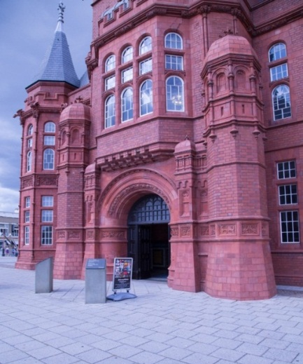
When the Pierhead is open, the large wooden doors will be open and a sign placed outside.

The area surrounding the entrance can be very busy and noisy.

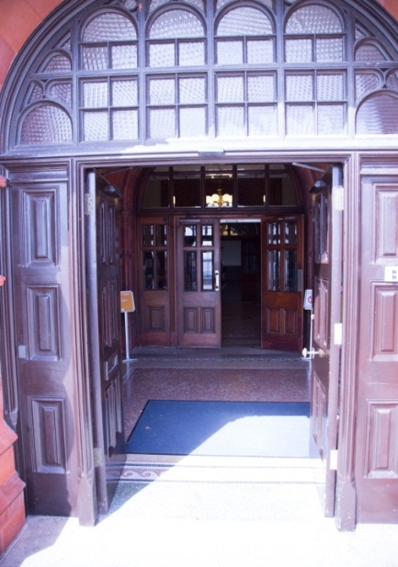
You access the Pierhead by stepping through a level access open doorway into a tiled foyer area. You are allowed to touch the tiles to feel the different textures and surfaces. On entering the foyer area you will notice the light levels change dramatically as you step out of the natural light into a darker space.

There is potential for close contact to other people in this area as they may be exiting as you enter.

Grand Entrance Hall

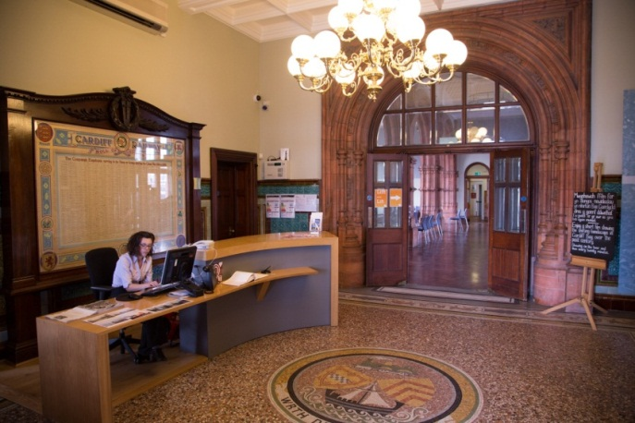
The Grand Entrance Hall is a large space. Like most tall stone spaces, it echoes. It can sometimes be more difficult to hear voices clearly because of the levels of background noise.

In the Grand Entrance Hall there is a reception desk where you can speak to a member of our staff for information. There is a loop system on the reception desk for deaf people who use a hearing aid.

Although there is not a security procedure, please note that there will be security staff on site. You can request the loan of a wheelchair from our reception staff.

There are three options from the Grand Entrance Hall entrance:

1. The Dock Master’s Room
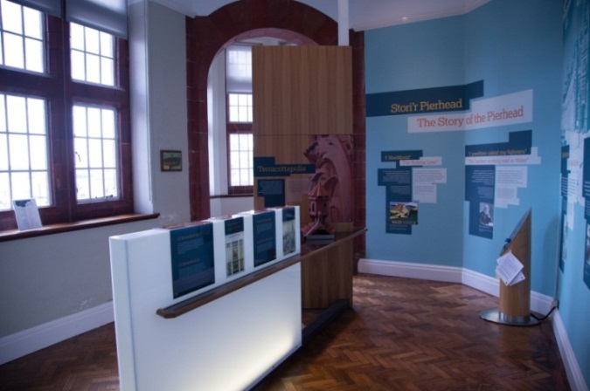
The Dock Master’s Room is situated to the left of the reception desk. When you walk through the doors you enter a naturally lit area full of interactive displays. You should feel free to touch and activate any of the displays.

There is a film in this room that can be watched at any time.

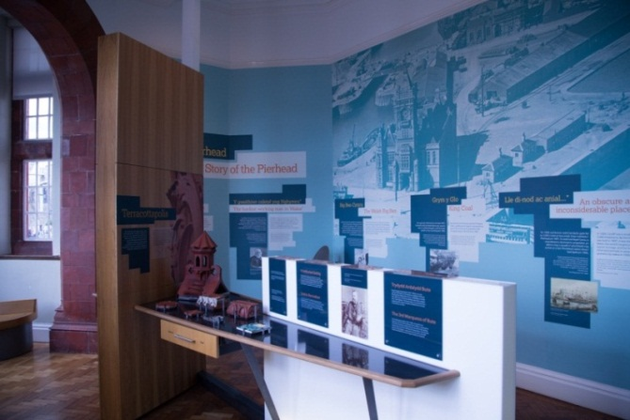
There is potential for close contact to other people as they exit and enter through the same doorway. Once in the room the space to move round the displays is quite narrow. The room can get quite busy and noisy.

2. The Main Hall

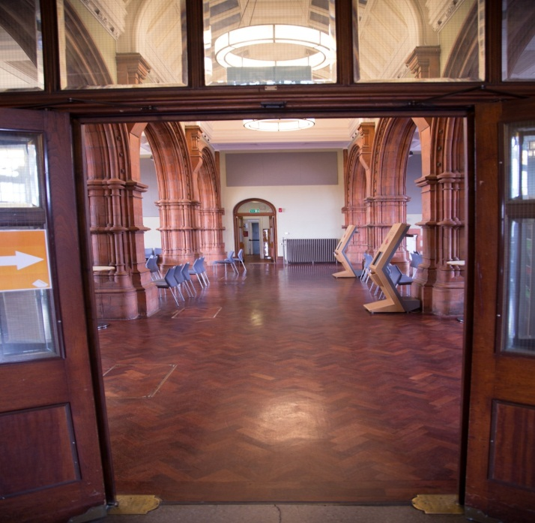
If you continue straight ahead through the doors you will enter a large area which can echo. You may especially notice the sound of people’s shoes as they walk across the floor.

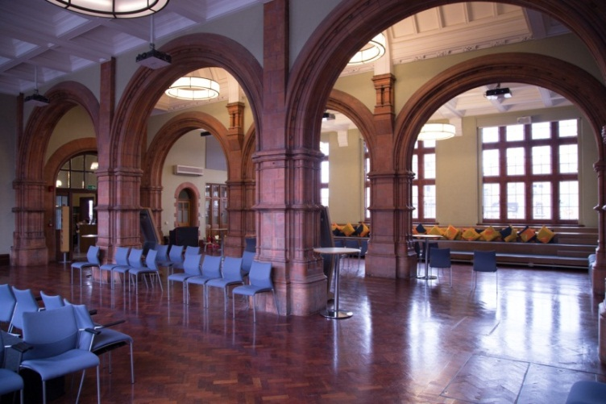
To the left of the entrance is a two level platform with large yellow and orange cushions. You are welcome to sit there. If you prefer there are also grey plastic chairs.

There are large windows either side of the space. On entering the main hall you can expect a dramatic change in light levels.

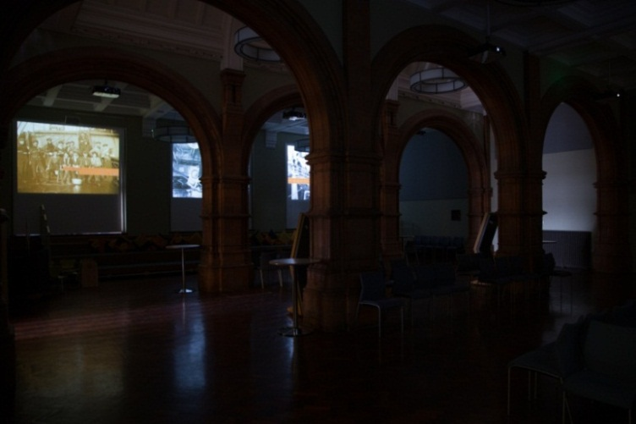
In the Main Hall a multi-screen projected film exhibition is run showing the different landscapes in Cardiff Bay over the past century. This happens automatically on the hour and then every twenty minutes. For example, the film will start at 12.00, 12.20 and 12.40.

When the film is being played the space is filled by a whirring sound as the blinds on the windows automatically lower and the Main Hall gets very dark. At the same time, a projector lowers and then starts projecting the film on to the blinds. An audio commentary accompanies the film. This is loud and can be heard throughout the space. If you are hypersensitive to light and sound you may wish to plan your visit so it does not coincide with the projected film exhibition.

There is also a children's table and chair laid out with activities for children. Visitors with children are welcome to spend as long on the activities as they want.

Toilets can be found through the doors on the other side of the Main Hall. There is a men’s toilet, women’s toilet and a wheelchair accessible toilet with left hand transfer. As you go through the door you should expect to experience a change in light. The air vents in the toilet areas can be heard whirring and the hand dryers are particularly noisy as the sound echoes in the space.

Events in the Main Hall

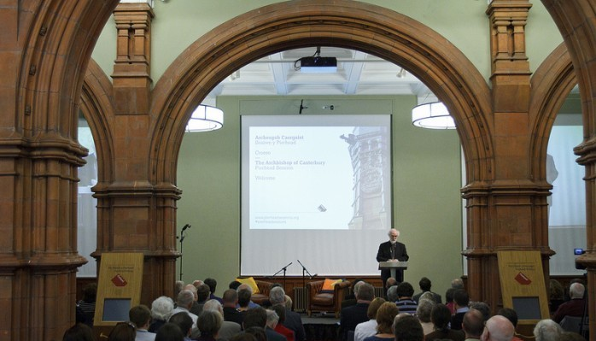
The Main Hall can become very busy. A range of different events can happen in this space including musical performances, conferences, exhibitions, and market stalls. As such, you may encounter a range of different sensory experiences.

When the Main Hall is being used for a private event it will be closed to the public.

You are encouraged to contact our information line in advance to see what is happening on the day of their visit or speak to our reception staff on arrival.

3. The Stone and Tile Staircase

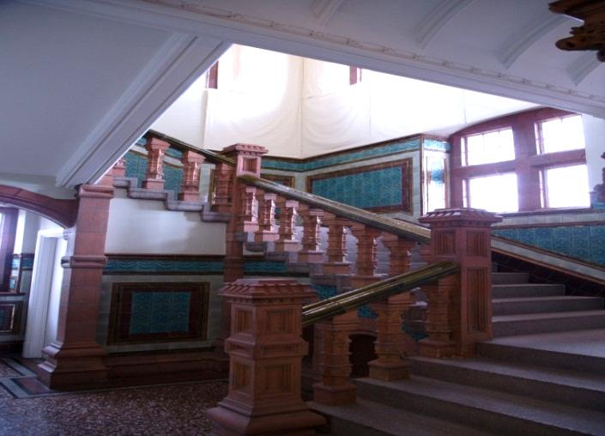
You can go up two flights of stairs to get to get to the second level.
Alternatively, lifts are available to each level. The lift can be accessed via the Main Hall.

At the top of the stairs you have a couple of options:

A. The Pierhead Suite

Through the doorway at the top of the stairs is a three-room tribute to the history of Wales and devolution titled ‘Making Wales’.

Artefacts room

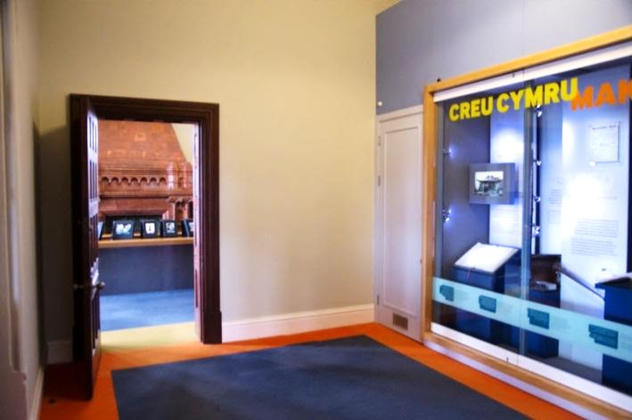
The first space is lit by artificial lighting and can be quite dim. Here, you can look at various artefacts that showcase milestones in Welsh history from 950 to 1997. The artefacts are kept behind glass. The audio sound from a video can be heard around the whole room. As this is a relatively small area, there is the potential for close contact to other people as people enter and exit the rooms.

Oral Histories room

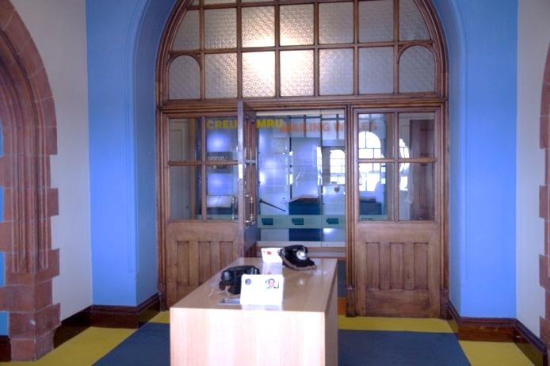
You can enter the Oral Histories room via a door to your left. You may need to push open a heavy wooden door, which might make a noise. You may experience a change in light levels as you enter the room. This is an interactive space. You are welcome to touch the displays and listen to personal audio accounts of life in Cardiff Bay. These accounts are also available on paper. There is a shelved display case of artefacts in the room. You should be careful not to hit your head on the glass when looking in to the display case.

Digital display room
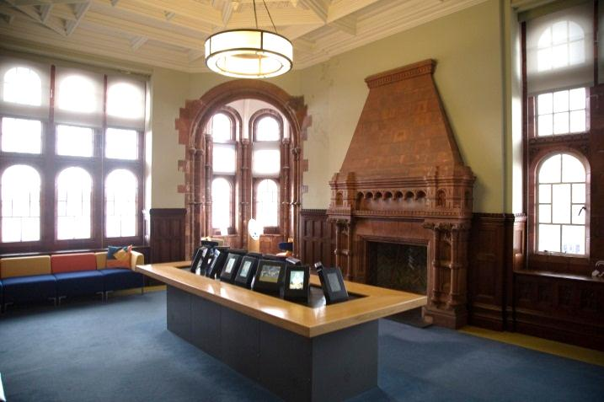
This space offers you a digital display that pays tribute to Welsh heroes. You can to touch the displays. An audio soundtrack sometimes accompanies the digital displays, so the room can be quite nosy. There is also seating available in this space.

B. The Futures Gallery

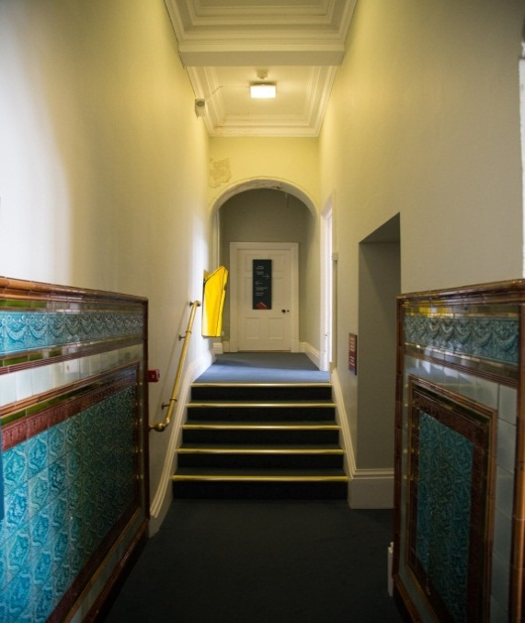
The Futures Gallery is situated at the top of the stairs on your right. There is also lift access to this level.

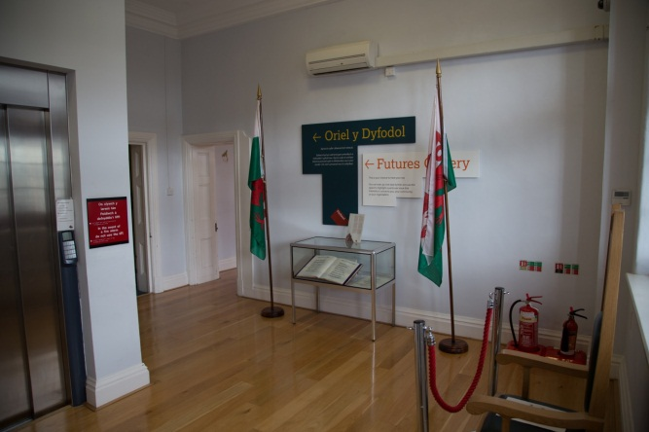
The space is lit by natural light so you may experience a change in light levels as you enter the room. You will see a big wooden chair in the room. Please note that you are not allowed to sit on this chair.

A glass display case is also in the room. Be careful not to bang your head on the glass when looking in to the display case.

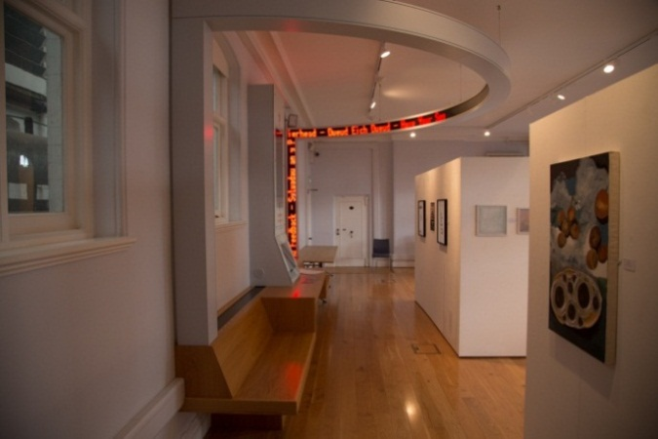
The room next door is the Futures Gallery, an area dedicated to the display and exhibition of art. Unless it says so, you are not allowed to touch any of the exhibits or displays.

You are invited to leave messages on an interactive feedback station. Your messages are then put on display by a digital tickertape for people to see. A message made up of red dots travels on a loop across the room via the tickertape.

C. Toilets

Toilets are available on the upper level, passed the Futures Gallery. Signs are in place. The corridor to the toilets can be dark. Male and female toilets area available on this level, but there is no disabled toilet on this level.

D. Seminar Rooms

Seminar rooms can be booked for meetings and events. Access to this area is restricted so you can only use these rooms if you are accompanied by a member of our staff. The restricted areas are clearly marked as “Pass holders only”. The seminar rooms can be quite bright as they have a lot of natural light.

Fire alarm

The fire alarm is tested every Monday at 9:30, before you are allowed into the building. If the fire alarm sounds at any other time a member of staff will tell you you what to do.

Quiet Room

There is not a dedicated quiet room in the Pierhead.

