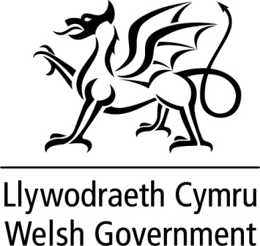

|  |
| --- |
| WRITTEN STATEMENTBYTHE WELSH GOVERNMENT |

|  |  |
| --- | --- |
| **TITLE** | **Revised Police Settlement 2016-17** |
| **DATE** | **4 February 2016** |
| **BY** | **Leighton Andrews AM, Minister for Public Services** |

Further to my announcement of the Provisional Police Settlement in December, I am today publishing updated proposals for the Welsh Government component of funding for Police and Crime Commissioners in Wales for 2016-17. This follows the completion of the consultation on the Provisional Police Settlement.

In order for Welsh Forces to have the equivalent information as their English counterparts, my statement follows today’s announcement made by the Home Secretary on the Home Office Final Police Grant allocations for English and Welsh policing bodies.

A common needs-based formula operated by the Home Office is used to distribute funding across English and Welsh police forces. As announced in the Provisional Police Settlement, the Home Office has overlaid its needs-based formula with a floor mechanism resulting in all police forces in England and Wales receiving the same percentage reduction of 0.6% for 2016-17 when compared on a like-for-like basis with 2015-16.

The total support for police forces in Wales will total £354.9 million. Within this, I propose to set the Welsh Government’s contribution to police funding for 2016-17 at £136.8 million. The allocations for individual forces are unchanged from the Provisional Settlement.

This information provides Police and Crime Commissioners with the information they need to set their budgets for 2016-17.

I will publish the Final Police Settlement in early March following the completion of the Assembly’s scrutiny of the Welsh Budget.

<http://gov.wales/topics/localgovernment/finandfunding/policesettlement/police-settlement-2016-17/?lang=en>

**Police revenue funding**

