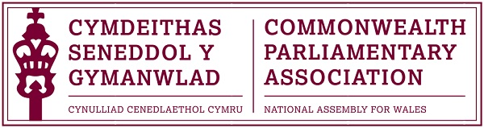

2015 Commonwealth Day Report
by
CPA Wales Branch Representatives,
James Jones and Esther Jones of Ysgol Dyffryn Aman.

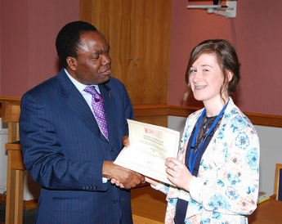

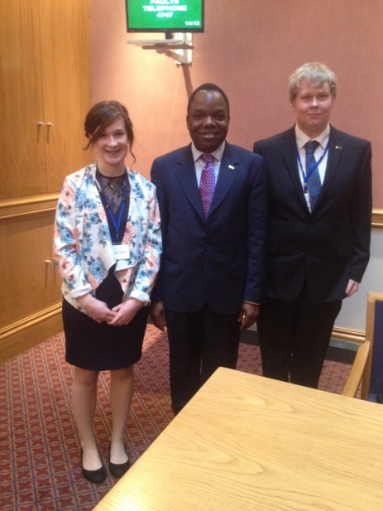
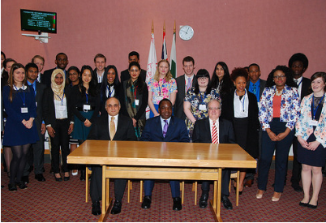

Photo :

As representatives of the National Assembly for Wales’ Branch of the Commonwealth Parliamentary Association. We, James Jones and Esther Jones were privileged to go to London on the 9th of March 2015 to attend the official Commonwealth Day celebrations.
Our experience centralised around this year’s theme of “A Young Commonwealth.” Our day began with a session hosted by His Excellency Norman Hamilton, the High Commissioner of Malta, and His Excellency Syned Ibre Abbas, the High Commissioner of Pakistan, on what the work of a high commissioner involves. The Republic of Malta and the Republic of Pakistan, are on the surface two very different countries. However, both His Excellency Norman Hamilton and His Excellency Syned Ibre Abbas, emphasised that consultations between the commonwealth countries are essential. Without the talking between nations, trust and understanding would soon deteriorate and the countries risk slipping backwards, rather than progressing forwards. The discussions also enable smaller countries like the Republic of Malta to have a voice at an international level. Inevitably resulting in a balanced and equal platform.
It is clear that each commonwealth nation has its own goals and targets but whilst working alongside other nations, they can achieve their respective goals more efficiently. It was made clear that young people play a vital role in ensuring that relationships between the commonwealth countries remain strong for the benefit of all. Our attendance at this event alone shows the significance of this. As representatives of our home jurisdictions, we were in the presence of representatives from other jurisdictions, each with their own cultural heritage. But if this event has taught us anything, it is that there is unity in diversity. We can ignore these cultural differences and come together for the sake of the commonwealth and in an attempt to improve the world in which we live.
The idea of unity in diversity became even more apparent during our tour of the Houses of Parliament. Among random facts on the architecture and reason for which the monarchy is forbidden from entering from entering the houses of parliament, we learned a very valuable lesson, the significance of democracy. During our tour of the House of Lords and House of Commons, the Parliament was often referred to as the fore father of all Parliamentary democracy. Roughly 60% of the Commonwealth population are under the age of thirty, and it is this substantial percentage that is a crucial instigator for the focus to be on the younger generation. The encouragement of unity and democracy can be developed through the youth, who through their energy and enthusiasm are capable of establishing a brighter future.
Following our tour of the houses of Parliament, we then attended an Observance at Westminster Abbey in the presence of Her Majesty The Queen on “A Young Commonwealth.” Also in attendance were His Royal Highness the Duke of Edinburgh, His Royal Highness the Prince of Wales, Her Royal Highness the Duchess of Cornwall, His Royal Highness the Duke of Cambridge and Her Royal Highness the Duchess of Cambridge.
Her Majesty the Queen mentioned that “the Commonwealth can only flourish if its ideas and ideals continue to be young and fresh and relevant to all generations”. Her Majesty the Queen emphasised the significance of the relationships between different nations. When we are willing to work with each other we can accomplish extraordinary things. The presence of various religious leaders emphasised this. The represented religions were very diverse, not only were there many religions represented but there were many denominations within each religion present. The idea was that despite our own personal beliefs, we are all still able to come together to celebrate the commonwealth. The commonwealth can only flourish if we embrace the fact that the world is a diverse place.

Following our attendance at Westminster Abbey, we were due to receive a session by Andrew Percy MP but unfortunately, due to a delayed train he was unable to attend which was blamed wholeheartedly on Boris Johnson. This session was swiftly replaced by a session hosted by the Commonwealth Parliamentary Association, hosted by the Acting Secretary-General of the CPA, on what the work of the Commonwealth Parliamentary Association actually involves. The main aim of the Commonwealth Parliamentary Association is to ensure the strengthening of Parliamentary Democracy in all member states. They desire to promote ‘good governance’ and to increase the knowledge and understanding of the Commonwealth values. The CPA never enforces a specific set of Parliamentary rules, but encourages a country to improve its own system. They wish for countries to build upon their own Parliamentary system, whilst following the general Commonwealth principles.
We were unable to meet The Queen as only limited jurisdictions had been permitted to do so, so our day ended with a powerful session delivered by human rights lawyer Ulele Burnham. She addressed the nature of the Commonwealth’s history. The Commonwealth exists due to the British Empire’s desire to expand. She addressed the significance of not forgetting the mass atrocities that colonization has caused. She claims in contemporary life, people are dismissive of other countries’ problems. She urged us not to turn our back on them. Often their problems stem from a period of colonisation. She instead urged us to use the commonwealth to our advantage. Today, the commonwealth is an opportunity to change the lives of people across the world. Ulele Burnham stated with great conviction that it should not just be at government level that democracy is promoted, but that another means is necessary in order for success to be achieved. An example of working below the government level could be youth organisations, such as ‘Young Leaders’ or ‘Youth Parliament’. These initiatives pave a foundation that can be built upon for the future, young minds desire the challenge to change things for the better.
The commonwealth brings together approximately 1.7 billion people, 25% of the world’s population-of many faiths, races, languages and traditions. During the day, we were able to see that if we are willing to work together, we, as young citizens, can accomplish extraordinary things. We, as the future generation, have been able to challenge and expand our minds concerning the Commonwealth values and the ideal of Parliamentary Democracy. We have been able to interact with other young individuals from various cultures, and to develop an understanding of their views. New friendships have been established and these will be treasured and incorporated within our future decisions, in order to further a unified and peaceful Commonwealth. We must continue to encourage the young to participate in Parliamentary Democracy and to build relations, this will manifest into strong leaders of the future.
We would like to thank the National Assembly for Wales’ CPA Branch for this once in a lifetime opportunity. The things that we have learnt and the experiences we had will stay with us forever and we will be forever grateful.

