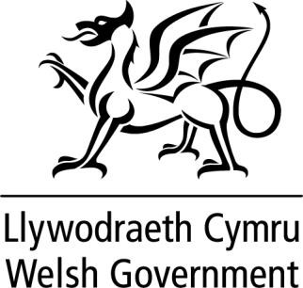

WRITTEN STATEMENT BY
THE WELSH GOVERNMENT

TITLE | Suspension of the new Technical Advice Note 15: development, flood risk and coastal erosion
DATE | 23 November 2021
BY | Julie James, Minister for Climate Change

A ‘soft launch’ of a new version of Technical Advice Note (TAN) 15, accompanied by a new Flood Map for Planning, took place on 28 September, ahead of their planned formal publication and coming into full effect on Wednesday 1 December 2021. Since the soft launch some Local Authorities have raised concerns about the proposed new policy advice and map.

The advice in the new TAN 15 is based on a Flood Map for Planning that includes projections showing future flood risk areas as a result of climate change. The inclusion of such projections has caused some significant increases in the extent of the highest risk flood zones including in some of our city and town centres

To allow local planning authorities to fully consider the impact of the climate change projections on their respective areas, I am suspending the coming into force of the new TAN 15 and Flood Map for Planning until 1st June 2023. I have written to local authorities setting out the work that must now be done to make communities that may be affected by climate change resilient.

The existing TAN 15, published in 2004, and the Development Advice Map will continue in the meantime as the framework for assessing flood risk in the planning system.

I have informed the Llywydd that the suspension of TAN 15 and Flood Map for Planning will require legislation in the form of the Development Procedure (Consultees) (Wales) (Miscellaneous Amendments) (Amendment) Order 2021.

1

