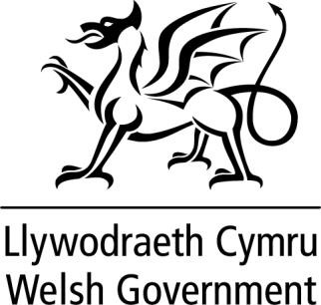

WRITTEN STATEMENT BY
THE WELSH GOVERNMENT

TITLE | Local Authority Electoral Boundary Review - Update
DATE | 29 September 2021
BY | Rebecca Evans MS, Minister for Finance and Local Government.

On 16 June I wrote to members to set out the current position in respect of the current programme of Electoral Arrangements Reviews. I also set out the process by which I intend to communicate my decisions about each area.

This included my commitment to provide regular updates to members through written statements. This is the ninth of these statements.

On 28 September I wrote to the Leader and Chief Executive of the County of Gwynedd to confirm my decision to accept the recommendations of the Local Democracy and Boundary Commission for Wales with modifications, in respect of the County of Gwynedd.

The Local Democracy and Boundary Commission for Wales Final Recommendations Report for the County of Gwynedd can be found here. The modifications made to these recommendations are set out in the annex to this statement.

I also wrote to the Leader and Chief Executive of the County of Monmouthshire to confirm my decision to accept the recommendations of the Local Democracy and Boundary Commission for Wales with modifications, in respect of the County of Monmouthshire.

The Local Democracy and Boundary Commission for Wales Final Recommendations Report for the County of Monmouthshire can be found here. The modifications made to these recommendations are set out in the annex to this statement.

Further information will be provided once I have made decisions about other areas.

Annex

Modifications made to the Commission’s Final recommendations for electoral arrangements in the following areas.

County of Gwynedd

- The Commission recommended the single name of Brithdir, Llanfachreth, Y Ganllwyd a Llanelltyd. The electoral ward will be given the English name of Brithdir and Llanfachreth/Ganllwyd/Llanelltyd and the Welsh name of Brithdir a Llanfachreth/Y Ganllwyd/ Llanelltud. This means the electoral ward names remain as at present.

- The Commission recommended the single ward name Cwm-y-Glo. The electoral ward will be given the English name of Cwm-y-Glo and the Welsh name of Cwm-y- glo. This means the electoral ward names remain as at present.

County of Monmouthshire

- The Commission has recommended the Welsh language name of Castell Caldicot and the English language name of Caldicot Castle. The electoral ward will be given English language name of Caldicot Castle and the Welsh Language name of Castell Cil-y-coed.

- The Commission has recommended the single name of Caldicot Cross. The electoral ward will be given the English name of Caldicot Cross and the Welsh language name of Croes Cil-y-coed.

- The Commission recommended the Welsh language name of Porth Sgiwed and the English language name of Portskewett. The electoral ward will be given the English language name of Portskewett and the Welsh language name of Porthsgiwed.

- The Commission recommended the single name of St Arvans. The electoral ward will be given the English name of St Arvans and the Welsh language name of Llanarfan.

- The Commission recommended the single electoral ward name of St Kingsmark. The electoral ward will be given the English language name of St Kingsmark and the Welsh language name of Llangynfarch.

