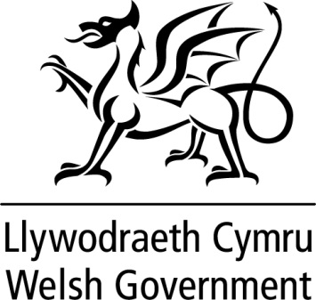

WRITTEN STATEMENT

BY

THE WELSH GOVERNMENT

TITLE | Statement on the Review of Higher Education Funding and Student Finance Arrangements in Wales
DATE | 18 December 2015
BY | Huw Lewis, Minister for Education and Skills

The Review of Higher Education Funding and Student Finance Arrangements in Wales, chaired by Professor Sir Ian Diamond, commenced in April 2014. Since then, the Panel has made good progress in reviewing a wide range of evidence and data relating to the HE sector and HE funding.

It was agreed that in autumn 2015 Sir Ian would produce a factual summary of the evidence he and the Review Panel had collected as part of their work. Sir Ian has now produced that report, which I am publishing today. The report summarises the evidence considered by the Review Panel from April 2014 to September 2015. It identifies the key themes arising from this evidence, but does not make any judgement about its validity or significance. Nor does it seek to represent the Review Panel's views or provide any recommendations. These will be presented in the final report, which will be issued by September 2016.

Alongside the interim report, I am publishing three additional documents from the Panel which provide further evidence in relation to the Review. They comprise a summary of responses to the Review Panel's Call for Evidence, which ran from November 2014 to February 2015; a report commissioned by the Panel on part-time higher education in Wales; a report on the focus groups that were used to gauge opinions from students and student representatives, employers and widening access professionals.

http://gov.wales/topics/educationandskills/highereducation/review-of-he-funding-and-student-finance-arrangements/?lang=en

This statement is being issued during recess in order to keep members informed. Should members wish me to make a further statement or to answer questions on this when the Assembly returns I would be happy to do so.

