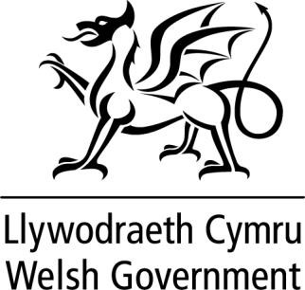

WRITTEN STATEMENT BY
THE WELSH GOVERNMENT

TITLE | Legal challenge to the UK Internal Market Act 2020
DATE | 19 January 2020
BY | Jeremy Miles MS, Counsel General and Minister for European Transition

I have committed in statements to the Senedd, at committee appearances and in correspondence, to keep Members of the Senedd updated as to the steps the Welsh Government is taking to protect the Senedd from the attack on its competence made by the UK Internal Market Act 2020.

So far, there has been an exchange of pre-action correspondence with the UK Government about the Act. Members will recall that a pre-action letter was sent to the UK Government on 16 December, just before the Act was passed and received Royal Assent. We received a response to that letter on 8 January. That response did not address any of our concerns about the effect of the Act on devolution.

Therefore, I have today issued formal proceedings in the Administrative Court seeking permission for a judicial review. We recognise the difficulties faced by the Senedd because of the uncertainty that this Act leaves in terms of the Senedd’s ability to legislate. I have therefore applied for the proceedings to be expedited although this is entirely a matter for the Court. I have proposed a timetable to the Court which would result in this case being heard in the final week of March 2021.

I attach the detailed Grounds of Claim. These grounds confirm the two planks of the challenge we seek to make; that the Act impermissibly, impliedly repeals parts of the Government of Wales Act 2006 in a way that diminishes the Senedd’s legislative
competence and that the Act confers power on the UK Government, by way of wide Henry VIII powers, which could be used by UK Ministers to substantively amend the Government of Wales Act in a way that cuts down the devolution settlement.

I will continue to keep Members closely updated on the progress of this action.

1

