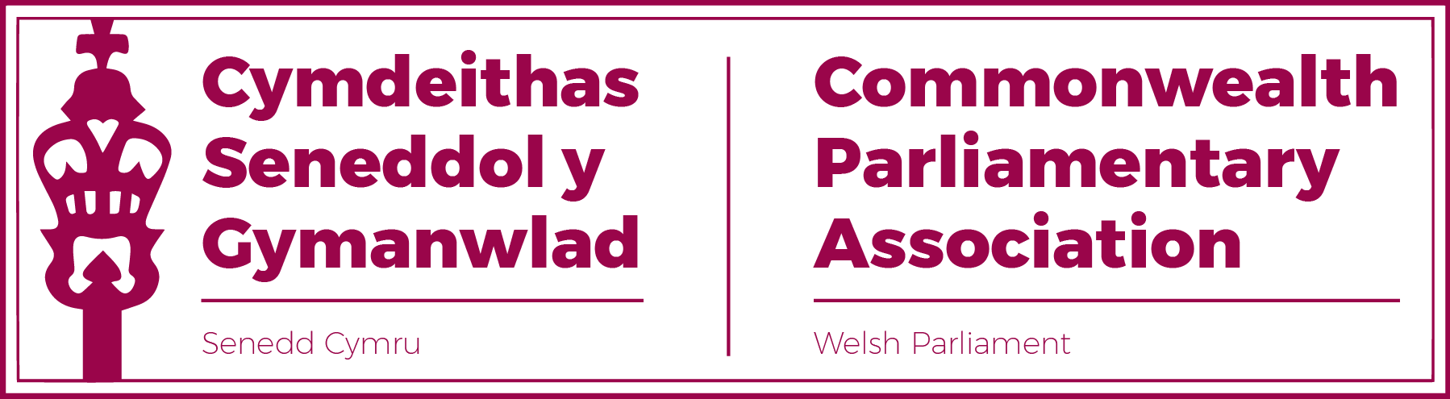

BRANCH EXECUTIVE MEETING

Date: Tuesday 8 November 2022
Time: 12:45-13:15
Format: Hybrid Meeting
i) Conference Room B, Ty Hywel
ii) Microsoft Teams meeting

Microsoft Teams meeting
Join on your computer, mobile app or room device
Click here to join the meeting
Meeting ID: 328 204 788 634
Passcode: bUZRCK
Download Teams | Join on the web

AGENDA

- APOLOGIES FOR ABSENCES

- MINUTES OF THE LAST MEETING - Paper CPA 6S-22-02 (DOC 1)
- MATTERS ARISING FROM MINUTES

- REVIEW OF RECENT ACTIVITIES

Feedback and follow-up of recent Meetings, Visits,
Events and Conferences

- Visit by Mr Adam Searle MLC, NSW Parliament
12 July

- BIMR Election Observer Mission Training Session
Virtual
14-15 July

- 65th CPC – (DOC 2)
Halifax, Nova Scotia,
20-26 August

- Visit by Prime Minister of St Vincent and Grenadines
28 September
- BIMR CWP Conference
Gibraltar
4-7 October

- BIMR CPwD Session – led by Mark Isherwood MS
Virtual
2 November.

5. FORWARD PLANNING

Forthcoming Meetings, Visits, Events and Conferences
2022

- BIMR CWP Steering Committee
Virtual
14 November

- 11th Commonwealth Youth Parliament
Trinidad and Tobago
20-24 November

2023

- Visit by St Helena PAC Committee
2 February

- CPA UK Trade Workshop for Overseas Territories, Crown Dependencies and Devolved Legislatures.
Westminster
7-9 February

- 71st Westminster Seminar
13-17 March

- BIMR Conference (hosted by CPA UK)
Westminster
May/June (Dates tbc)

- Commonwealth Parliamentary Conference (CPC)
Accra, Ghana
30 September – 5 October

- NEW ITEMS / ANY OTHER BUSINESS

7. FUTURE MEETING DATEs:

Branch AGM – 23 November 2022
Branch ExCo Meeting - February 2023 (TBC)

END OF BUSINESS

