**Visiting the Senedd**

The Senedd is the main public building of the National Assembly for Wales. It is a public building and a free visitor attraction.

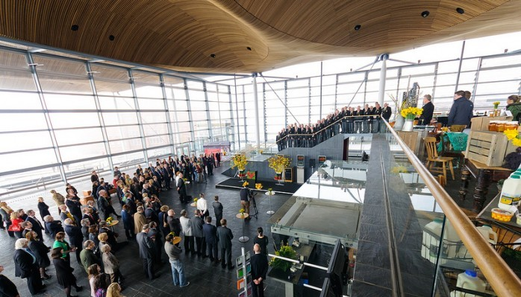

As a public building and event space the Senedd can be very busy. Many different events and activities can take place including musical performances, conferences, exhibitions, and market stalls. As such, you may experience a range of different sensory experiences and you are encouraged to contact our information line in advance to see what is happening on the day of your visit. Alternatively, you can ask reception staff for information on events happening upon arrival. Some of these events will have food and drink. Unless you are invited to do so, please do not to help yourself.

The Assembly can get especially busy when the Assembly Members are meeting. On business days, the Assembly Members meet every Tuesday and Wednesday afternoon at 13.30 in the Siambr. These meetings are called Plenary meetings. Committee meetings are held on a Tuesday and Wednesday mornings, throughout the day on Thursday and occasionally on Mondays and Fridays.

You are welcome to visit the Senedd on a quieter day (such as a Friday) before your visit to familiarise yourself with the building.

You can pre-book a tour of the Senedd or find out what is happening on the day of your visit by contact our Information and Booking line at 0845 010 5500 or 01492 523 200. Bookings for Group Visits must be made in advance. We welcome calls via the Text Relay Service. Alternatively you can:

* e-mail [assembly.bookings@wales.gov.uk](mailto:assembly.bookings@wales.gov.uk)
* write to: Assembly Booking Service,

National Assembly for Wales,

North Wales Visitor Centre,

Princes Park,

Princes Drive,

Colwyn Bay,

Conwy,

LL29 8PL

**Arrival**

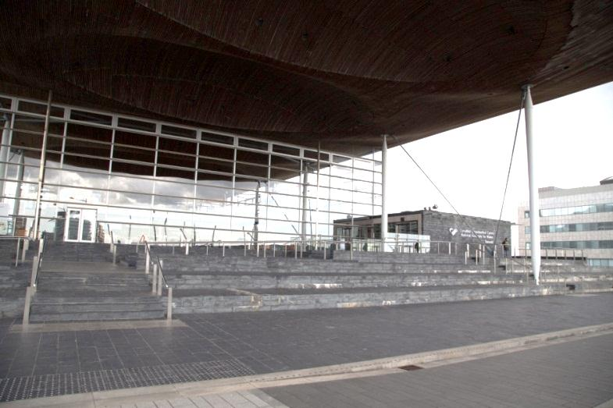You access the Senedd, by using the steps and ramps or by the lift located to the side of the Senedd opposite the Wales Millennium Centre.

When there is an event in the bay or if the weather is particularly nice you can expect to find that the entrance area surrounding the Senedd is very busy and noisy.

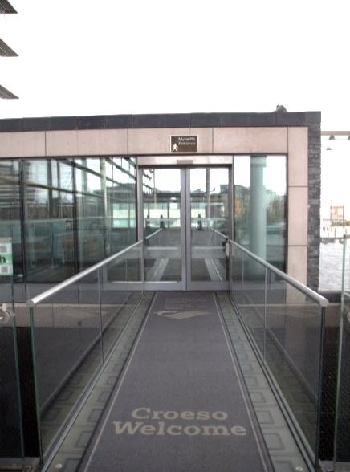

You enter the Senedd building by walking over a carpeted bridge and through an automated door. You may not be comfortable looking over the barrier to the area below.

There can be a slight delay before the doors open. This is also the exit, so people may be exiting through the door as you enter the Senedd.

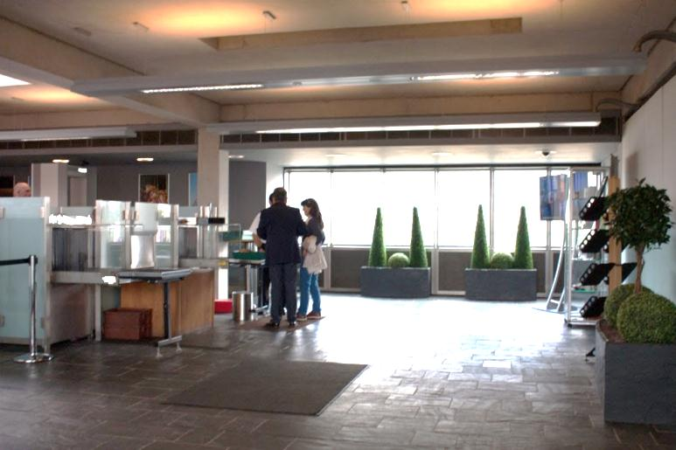You will enter an open area where security staff and security equipment are located (“the Security Area”). There may also be a police presence.

**Security Area**

This area can be noisy and busy. You might hear noise from:

* the machines,
* people in the area, or
* the TV suspended on the wall.

You must go through a security check. At busy times the security process may involve queuing, so you should allow enough time to go through the security checks.

If you, or someone in your party, is on the autism spectrum and finds queuing and being searched difficult, please speak to a member of the security staff who may be able to arrange that you go through the security search quickly. Most security staff will have received autism awareness training. Alternatively, you can contact the booking line in advance of your visit, on 0845 010 5500 or 01492 523 200, and arrange to speak to an autism champion.

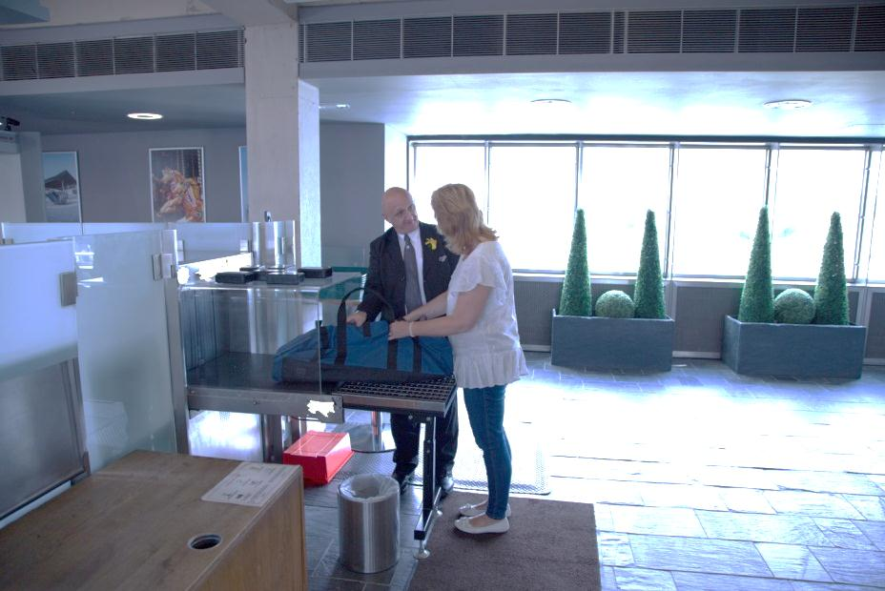You must follow the instructions of the security staff. You will be asked to put your bags through an x-ray machine and all metallic and electrical items – keys, coins, cameras, laptops, tablet devices, mobile phones etc. – must be removed from pockets and put into your bag or a tray provided. You must also remove your coat and you might be asked to remove your belt if you are wearing one. All of your items will go through the scanner and be returned to you.

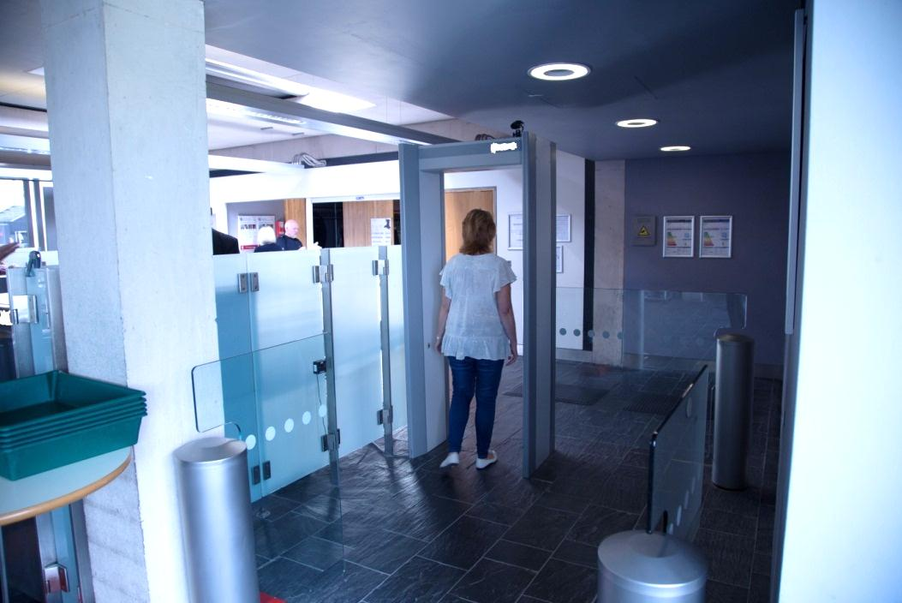

You will be asked to walk through a metal detecting arch, which makes a high-pitched beep noise if it detects something metal.

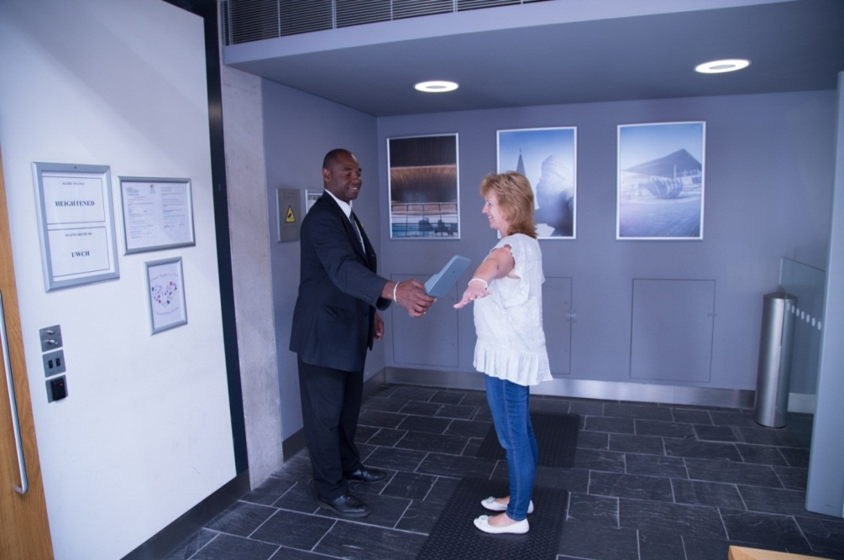

If that happens, staff will use a hand-held detector and wave it around your body to find out what set off the alarm. The detector should not touch your body. The detector will make a noise to indicate what set off the alarm. Often a watch or metal belt buckle will have caused the alarm to sound.

If you, or someone in your party, is on the autism spectrum and finds loud, high-pitched noise difficult, please speak to a member of our security staff who will be able to arrange for a light rather than sound to activate when something metal is detected. Alternatively, contact the booking line in advance of your visit, on 0845 010 5500 or 01492 523 200, and arrange to speak to an autism champion.

Any forbidden items will be taken by Security staff and, depending on the item, it will usually be returned at the end of your visit. Forbidden items include knives or other sharp or bladed objects, any rocket, firework or ammunition and any firearm or imitation firearm.

Behind the security area is a free cloakroom where you can leave any items to pick up when you leave. When you check in any items a uniformed member of staff behind the desk will give you a ticket. At the end of your visit, give the ticket back to the uniformed member of staff behind the desk and they will give you back your item.

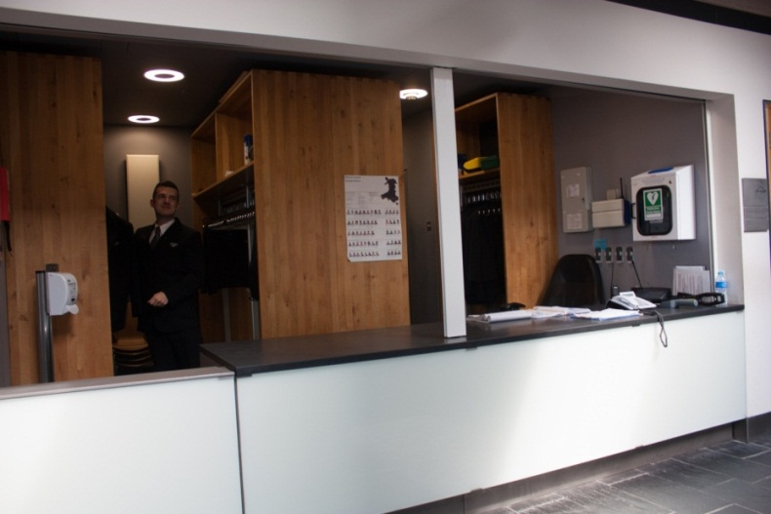

**The Neuadd**

The Neuadd is the main public area of the Senedd. There may be an event in this area.

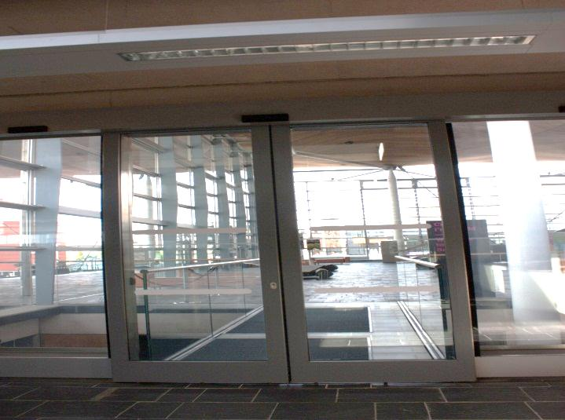You can access the Neuadd through the automated door. There can be a slight delay before the doors open. As you walk through the automated doors onto a carpeted bridge there can be a significant change in light levels.

As you cross the bridge from the security area into the Neuadd you can look down into an area that is restricted to staff. Lifts and stairs leading up from the restricted area to the Neuadd are locatedto your right as you walk over the bridge. You may see and hear people moving around in the area below. You may not be comfortable looking over the barrier to the area below.

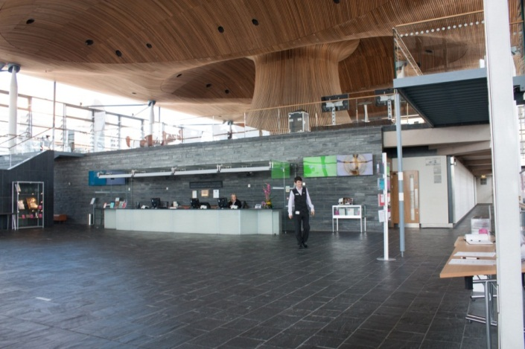Once you cross the bridge and enter the Neuadd you may see a uniformed member of staff standing in this space. The uniformed member of staff may say a greeting in English and Welsh. The people in uniform are there to help with any questions you may have.

Just after the bridge is a tactile map that shows the layout of the Senedd, highlighting where things can be found and the areas that are closed to members of the public. Near the map is a range of information leaflets and a feedback book. In this area you will also find the lift to access the upper level, the Oriel.

Directly ahead of you is a seating area and the slate stairs leading up to the Oriel, which is the area at the top of the stairs which surrounds the large wooden funnel at the centre of the building.

If you are sensitive to light you should be aware that the Senedd can be very bright due to natural or artificial light. There are automatic blinds in this area that control the light of the space. They may move suddenly, make a noise and change the level of lighting without warning.

The floor of the Neuadd is made of slate and can be uneven in places.

**Located on the Neuadd level are:**

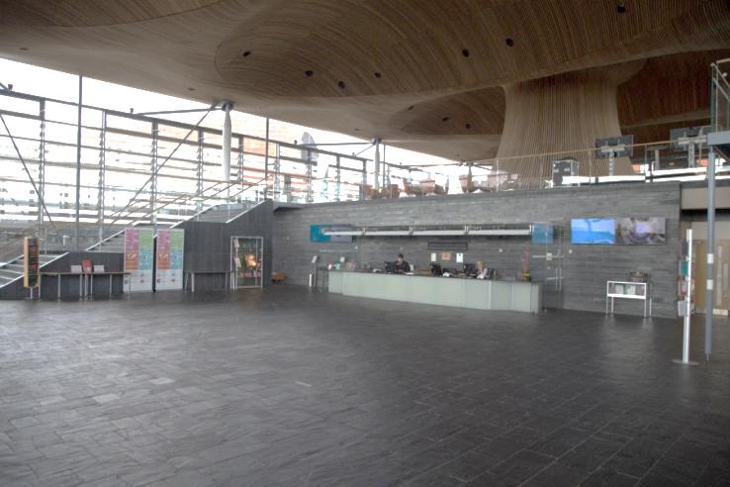**a) Reception**

The Reception desk is located to your right as you cross the bridge. There is a loop system on the desk for people who use a hearing aid. The reception staff will be happy to assist or answer any questions you may have during your visit. They have received autism awareness training. You should go to reception for tickets to access the viewing gallery to watch either Plenary or a Committee. Once reception has issued you with a ticket they will direct you to the public viewing galleries.

Should you need a quiet space, you can speak to a member of our reception staff to identify a suitable location to rest and de-stress.

**b) The Siambr public gallery**

The Siambr is the main debating chamber of the National Assembly for Wales. Once you have collected your ticket to the viewing gallery, the entrance to the Siambr public gallery is located to the right of the reception desk. It is signposted, but you can ask any uniformed member of staff for directions.

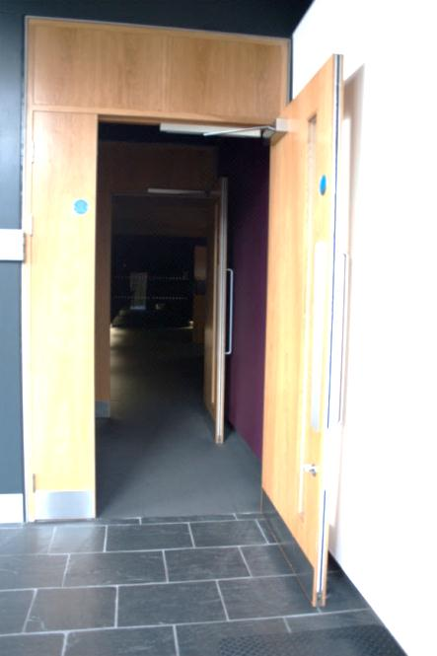

If it is an Assembly business day you will be asked to show your ticket as you make your way in. If you are visiting on a non-business day, you can still go in to the Siambr public gallery. The door to the Siambr public gallery may be closed or open. You should are welcome to enter in either case, unless told otherwise by a sign or by a member of staff. There is potential for close contact to other people, as they enter and exit as you try to enter. At busy times there may be a lot of people in the public gallery.

The Siambr public gallery is quite dark, and the light levels change dramatically as you walk through the door.

As you enter the Siambr public gallery the carpeted floor can make a noise.

On the wall to your left as you enter there are framed pictures of the past and present Presiding Officer. The frames are lit by two lamp lights. You are not allowed to touch the pictures.

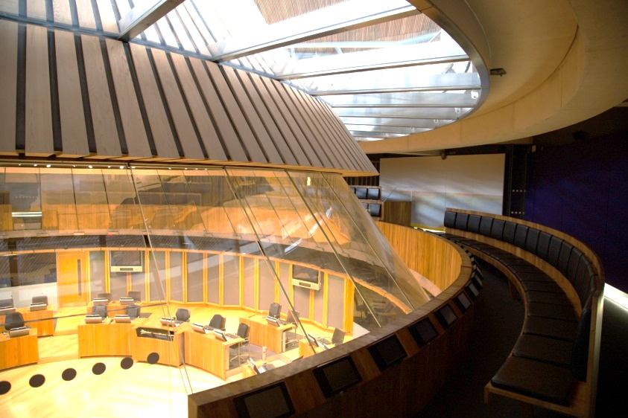

The seating is in the shape of a circle and goes all around the Siambr, so it does not matter which direction you take to access the seating. You are allowed to sit in any available seat. Wheelchair accessible places are available. There is a glass panel allowing you to look down into the Siambr. This may be uncomfortable for some visitors who are sensitive to heights or getting dizzy.

On entering the gallery you should be aware that if you walk to the right, the floor slopes down. There is also a glass panel that allows an uninterrupted view of the chamber. Visitors who may be sensitive to heights or get dizzy looking down should avoid this route.

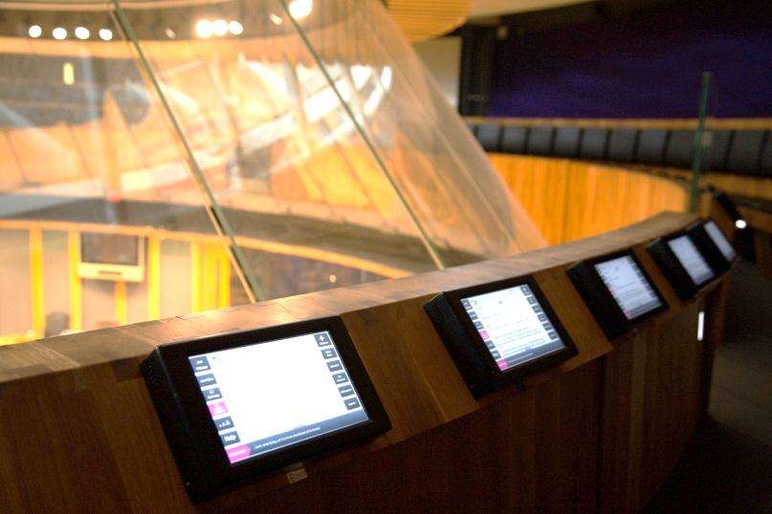Each person in the public gallery has access to a screen on which they can watch proceedings. You can use the headphones provided to listen to proceedings. An English translation of any Welsh language spoken is available. You are allowed to use the equipment while in the public gallery. You should not try to remove the equipment from the Gallery.

There is a loop system available.

**c) The Committee public galleries**

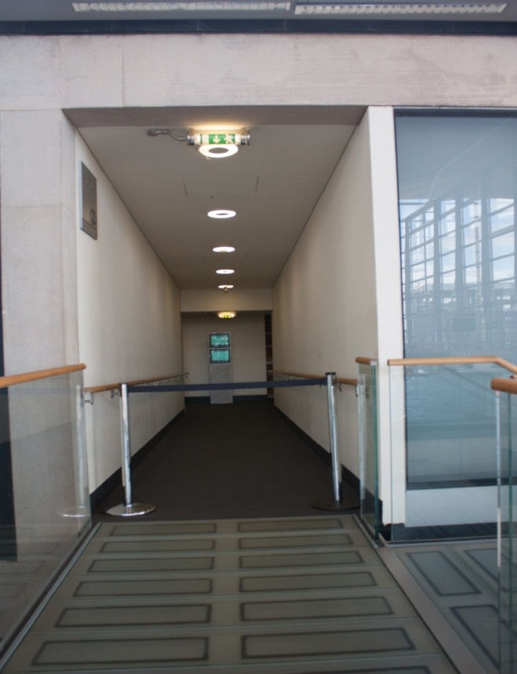There are three Committee rooms. When a Committee is in public session, you are welcome to view the committee from the public galleries.

To access a Committee public gallery you have to cross over a carpeted bridge into a corridor. If the committees are not in session a barrier will be placed across the bridge. You should not attempt to enter any area where they see this barrier.

On entering the corridor the light levels may change. At the end of the corridor is a screen which will displays the details of the committee. You will either turn right or left at the end of the corridor, depending on which committee you are going to see.

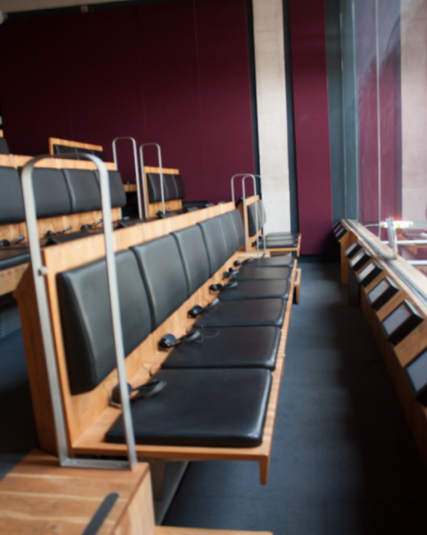A uniformed member of staff will open the door to the committee public gallery to allow you to enter. There may be a noise as the door is pulled open. This area can be busy. The light levels will change again as you enter the public gallery, as it may be quite dark near the back of the chamber public gallery.

The stairs in the gallery can be quite steep. You are allowed to sit in any available seating. Wheelchair accessible positions are available.

Each person in the Committee public gallery has access to a screen on which they can watch proceedings. You can use the headphones provided to listen to an English translation of Welsh language spoken. You are allowed to use the equipment while in the public gallery. You should not try to remove the equipment from the Gallery.

There is a loop system available in the Committee viewing galleries.

The doors lock automatically so you might need to push a button to exit the gallery. This button is located on the wall next to the door.

**Conduct in the public galleries**

Electronic devices such as mobile phones, laptops, and tablets must be switched to silent.

You may be asked to leave the gallery if you act in a disorderly or disruptive manner, or otherwise interfere with the Assembly’s business.

You must not:

* Be under the influence of alcohol or drugs;
* Cause offence to other visitors;
* Speak loudly or otherwise disrupt the meeting;
* Bring food or drink into the gallery.

**d) Public toilets**

We have a range of toilets available that can be found by walking down the corridors either side of reception.

* Both the Male and Female toilets include a wider cubicle designed for people with mobility issues
* Our Changing Places facility includes an adult changing bed, hoist and accessible toilet with right and left transfer space.
* We have two additional wheelchair accessible toilets, one with right transfer space and one with left transfer space.
* Our baby changing room also has an accessible toilet.
* Due to our sustainability policy, there are no paper towels in the toilets and the hand dryers are loud.

**e) Stairs that lead to the Oriel**.

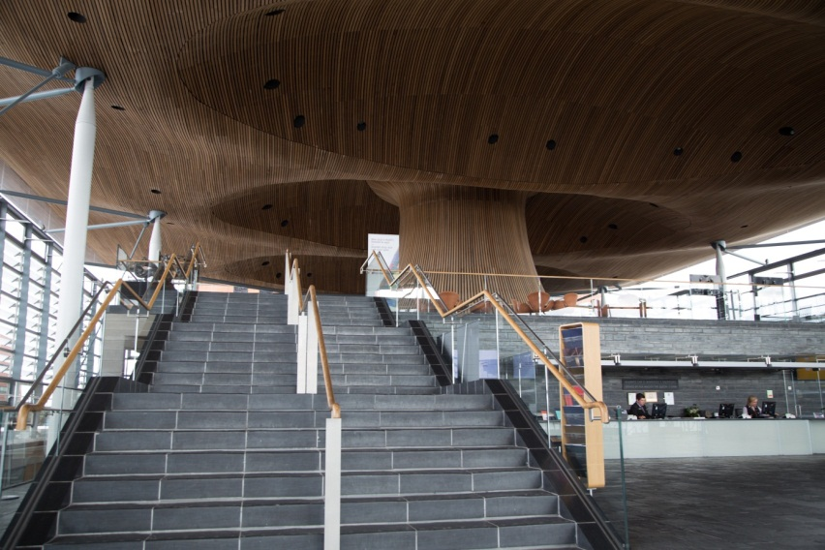

**The Oriel**

The area at the top of the stairs, which surrounds the large wooden funnel at the centre of the building, is called the Oriel.

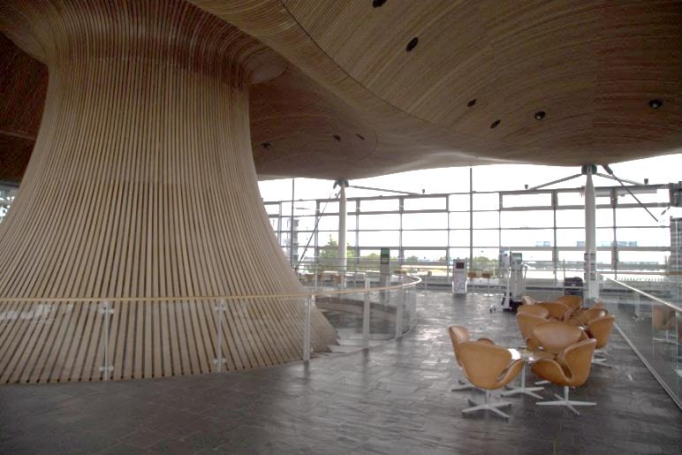

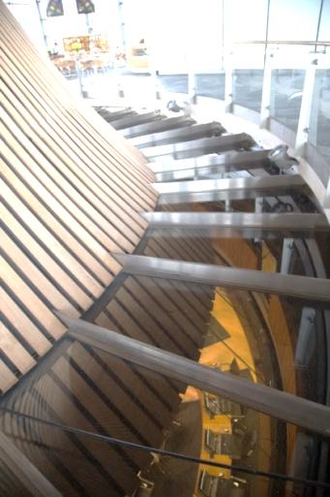

The funnel is surrounded by glass flooring, which enables look down into the Siambr two floors below. If you are sensitive to heights or get dizzy looking down you should avoid the barrier around the funnel.

**On the Oriel** **level are:-**

1. **Interactive display screens**, which are there for you to use.
2. **Seating -** There are a range of seating options available on this level.
3. **A platform and podium**

This is permanently set up for events. Please do not climb onto the platform.

The Oriel can be busy when there are events taking place the Oriel level.

**4. The Shop and café**

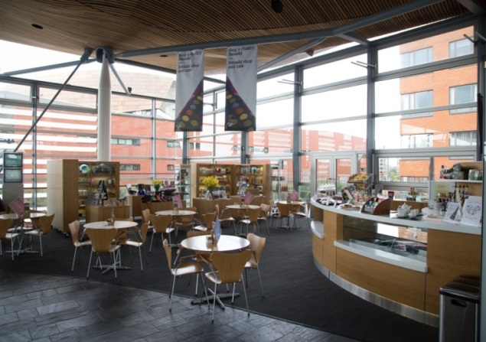

The café and shop are at the back of the Oriel. This area is quite small and can get very busy and noisy. The Shop may have many glass and china items at an easy grab level. The Café offers a selection of refreshments, including tea, coffee, juice and a choice of cakes and sandwiches.

1. **Gallery**

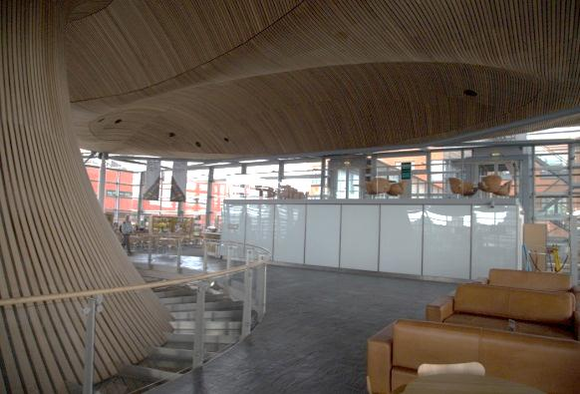Along the wall by the café is a small gallery where art may be displayed. Unless clearly stated, you are not allowed to touch any of the art.

**Sensory issues particular to the Senedd.**

Visitors on the autism spectrum may find the following sudden sounds to be stressful:



* The noise as the windows open and close automatically. This is done to maintain a constant temperature in the building.
* The sound of the food trolley as it is pushed across the slate floor can echo very loudly throughout the building. It sounds like a banging of crockery such as plates and cups.
* When the Assembly sits on a Tuesday and Wednesday you can expect to hear the noise of the Call to Plenary bell at 13.25 and 13.30 to call Members to the Siambr to vote. If you are hyper sensitive to sound you may wish to plan your visit to avoid the Call to Plenary bell.
* The fire alarm will sound in the Senedd on a Monday, Tuesday, Wednesday morning at 8.45. If you hear the fire alarm at any other time, a member of staff will tell you what to do and where to go.