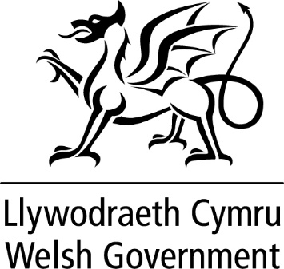

WRITTEN STATEMENT

BY

THE WELSH GOVERNMENT

TITLE | Bus Network Grant
DATE | 14 March 2024
BY | Lee Waters, Deputy Minister for Climate Change

Since the onset of the Covid-19 pandemic we have provided the bus industry with over £200m funding support to maintain bus services across Wales.
Since the pandemic less people are now using bus services. But for those who do rely on them, they are a lifeline. Bus services are vitally important in supporting our economy. They facilitate access to work opportunities, health care services and education and social activities too.
Buses are a greener mode of transport and are key to reducing people’s reliance on cars. We need to give people a genuine alternative to the car for everyday journeys by making public transport, an attractive option.
It is therefore vital that we continue to support the provision of bus services across Wales from the point when emergency funding comes to an end to bring stability to the bus industry going forward.
From 1 April this year we are introducing the Bus Network Grant (BNG). In addition to the £25m Bus Services Support Grant (BSSG), BNG will provide local authorities across Wales with £39m to secure bus services that they deem socially necessary that the commercial market will not provide when BTF comes to an end. The new scheme will include specific conditions that will encourage improved regional co-ordination of bus services; network ticketing and the need to ensure accurate and up to date information about the bus services provided.
BNG will bring about stability to the industry as well as increased public control of bus services. It will also act as a bridge from the emergency funding that has been provided to bus franchising.
BNG will be a twelve month scheme. From 1 April 2025 we aim to introduce one scheme that will replace BNG and BSSG.

