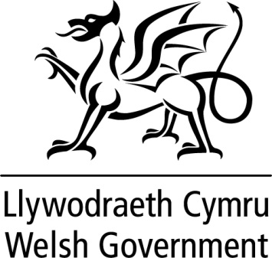

WRITTEN STATEMENT

BY

THE WELSH GOVERNMENT

TITLE | The Welsh Government Annual Report 2021 - 2022
DATE | 05 July 2022
BY | First Minister, Mark Drakeford

Today, we have published the first Annual Report of this Senedd term, setting out the progress we have made towards our well-being objectives as set out in the Programme for Government.
I will lead a debate on the Annual Report in the Senedd on the 12 July.
The Annual Report can be found via the following links: https://gov.wales/welsh-government-annual-report-2022

