**COMMONWEALTH PARLIAMENTARY ASSOCIATION**

# Falkland Islands Legislative Assembly

**British Islands and Mediterranean Region**

**Commonwealth Women Parliamentarians Conference**

**“Combatting Stereotypes in Small Communities”**

**16 - 21 February 2020**

**Report**

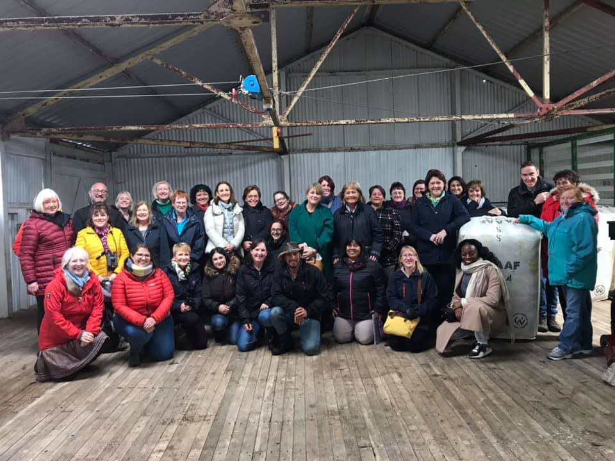

**Contents**

|  |  |
| --- | --- |
|  | **Page** |
| **Foreword** | **3** |
|  |  |
| **Delegates** | **4** |
|  |  |
| **Summary Report** | **5** |
|  |  |
| **Acknowledgements** | **7** |
|  |  |
| **Key Themes and Learning** | **8** |
|  |  |
| **Programme** | **10** |
|  |  |
| **Annex A – Statement by the BIMR CWP Steering Committee** | **12** |

**Foreword**

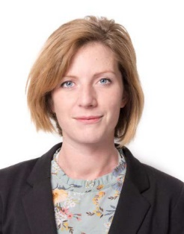

The Falkland Islands are proud to welcome the Commonwealth Women Parliamentarians, British Islands and Mediterranean Region Conference 2020. Promotion of human rights and equity needs a continuous call for action. Using this opportunity of gathering political leaders and influencers, we hope to truly harness the potential of the BIMR CWP and continue the drive for empowerment and equality.

The setting in one of the smallest branches of the region offers a valuable insight to members. Through the support, resilience and warmth of our community, Falkland Islanders have built a unique society. As contributors and participants in this inaugural event you will have an opportunity to share and build upon the work of the BIMR CWP, and we hope also to find ample opportunity to immerse yourselves in the culture of our spectacular South Atlantic Islands.

***The Hon. Leona Roberts MLA & The Hon. Teslyn Barkman MLA***

**Delegates**

Eleni Mavrou MP (Cyprus)

Dr Eleni Theocharous former MEP (Cyprus)

Hon Samantha Sacramento MP (Gibraltar)

Deputy Rhian Tooley (Guernsey)

Deputy Michelle Le Clerc (Guernsey)

Ms Christine Foster (Guernsey)

Connétable Sadie Rennard (Jersey)

Connétable Karen Shenton-Stone (Jersey)

Lisa Hart (Jersey)

Hon Claudette Buttigieg MP (Malta)

Hon Roderick Galdes MP (Malta)

Dr Stephanie Bonello (Malta)

Margaret Mitchell MSP (Scotland)

Hon Christine Scipio MLC (St Helena)

Rt Hon Maria Miller MP (UK)

Meg Hillier MP (UK)

Joyce Watson AM (Wales)

Rhianon Passmore AM (Wales)

CPA regional secretariat staff were Jon Davies (Regional Secretary), Helen Haywood and Seyi Afolabi

**Summary Report**

The British Islands and Mediterranean Region (BIMR) Commonwealth Women Parliamentarians (CWP) Conference was hosted by the CPA Falkland Islands from 16-21 February 2020.

Delegates attended from the parliaments of Cyprus, Gibraltar, Guernsey, Jersey, Malta, Scotland, St Helena, UK and Wales.

**Day 1**

Members of the Falkland Islands Legislative Assembly welcomed the visiting delegates at an informal reception and supper on the evening of Monday 17 February at the Falkland Islands Museum. The evening included a short briefing on the Falkland Islands and its economy from the Chief Executive, and delegates also had the opportunity to look around the Museum to learn more about the social, political, economic and natural history of the Islands.

**Day 2**

Members of the BIMR CWP Steering Committee met early on the Tuesday morning to review and plan the Commonwealth Women Parliamentarians’ regional activities. They met on several other occasions during the week to frame their feedback on the draft CWP international strategy. They also agreed a statement addressing the many cases of violence against women and girls across the region, the worrying trend of impunity, and failure to protect women because of criminal justice system failings. The statement is printed in full at Annex A.

Following the formal welcome and launch of the Conference by Deputy Speaker Claudette Prior MBE, the day was organised into a series of plenary sessions. As well as delegates from regional parliaments, the Conference was open to participants from the Falklands Islands Community.

The first plenary chaired by Hon Samantha Sacramento MP (Gibraltar) comprised speeches from Statute Law Commissioner Ros Cheek, Corporate Paralegal Krysteen Ormond and Public Accounts Committee Chair and farmer Nadia Knight. All three spoke on the subject of 'Combatting Stereotypes in Small Communities'. Their contributions were well received and diverse in style. All three speakers raised the positive impact that successful and supportive women can have in helping others overcome stereotypes, particularly in fields still dominated by men. The tendency to stereotype victims of sexual abuse was the issue that drew the lengthiest discussion from delegates.

The Falklands' first retained female firefighter and the conference's youngest speaker, Vicky Collier, picked up the theme in the following session, concentrating on the culture of victim-blaming, and the negative impact this has on those who suffer it. She outlined how reasons were often found to blame the young girls and to remove the responsibility from the perpetrator. A worldwide problem, the issue drew a number of questions and comments from the audience and delegates.

The other second plenary presentations were given by Director of Natural Resources Dr Andrea Clausen and Community School Principal Christina Watson, on Building Roles in Small Communities in a session chaired by MLA Leona Roberts. There was a shared sense of encouraging women to have greater confidence in their ability to affect change, and not to leave it to others – be “10% braver”.

On the subject of Creating Opportunities and Encouraging Women to Stand for Public Office, chaired by MLA Teslyn Barkman, speeches were given by Joyce Watson AM (from the Welsh Assembly), former Member of Legislative Assembly Phyllis Rendell MBE and Editor of Penguin News Lisa Watson. Joyce Watson stressed that good governance requires gender equality in decision-making. She also made the point that ‘women’s issues’ were in fact society’s issues because ingrained inequalities have cross-cutting detrimental effects.

The combatting stereotypes theme was chosen because women can face bias along intersectional identity dimensions including gender, race, disability, sexual orientation, gender identity and age, and efforts should be made to recognise, and work to overcome, conditioned stereotypes.

A theme that came out of the speeches was that Falkland Islands women were traditionally strong and enterprising and already breaking stereotypes. It was felt that because of the requirement for women to work, either on farms or in a town desperate for human resources, they did not face the same degree of barriers which might occur in other countries. However, the large gender pay gap, the many senior posts never held by women and the fact that the Legislature has never had more than three women at any one time (presently only two out of eight) was evidence of deep-rooted inequality. Approaches to bringing change to this situation were examined including nurturing self-confidence and positive action.

That evening HE the Governor Nigel Phillips CBE hosted a reception at Government House and afterwards delegates were joined for dinner by a large cross-section of members of the local community.

**Day 3**

The following day, Conference delegates went to Fitzroy Farm for a visit hosted by farmers Gilberto Castro and Suzi Clarke. The group was fascinated to watch a demonstration by female shearer Michelle Amor and rousie Mandy Ford before enjoying an Asado lunch with attendees from the farming community and women from the Department of Agriculture.

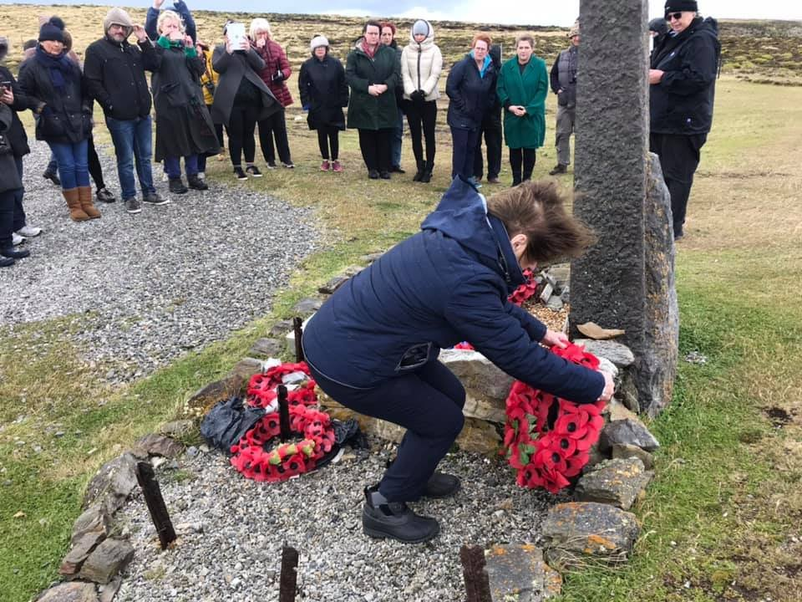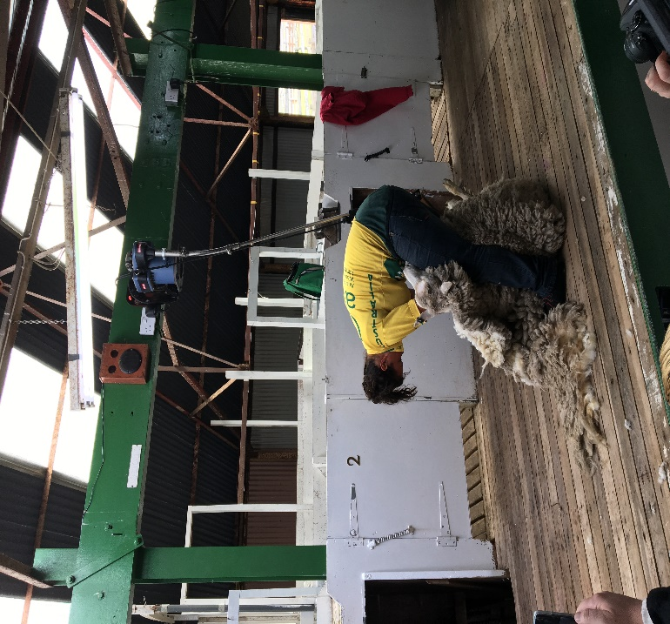

Delegates then attended a short, poignant service of Remembrance at the Welsh Guards Memorial conducted by Reverend Canon Kathy Biles. Wreaths were laid by delegates from the National Assembly of Wales and the States of Jersey.

Later that day delegates met members of the Falklands Women’s Group at an informal reception at the Chamber of Commerce.

**Day 4**

On Thursday 20 February the day began with discussions with members of the Falklands Chamber of Commerce. Delegates from diverse local contexts and backgrounds held a lively and broad-ranging discussion around empowering women through enterprise and small businesses.

Also that morning, a number of delegates including parliamentarians from the UK, Cyprus, Malta and St Helena visited the Falkland Islands Community School to run a CPA Roadshow. They began with introductions focusing on the pathways they had followed into political life and then broke into smaller groups for more interactive discussions with pupils. They responded to questions and encouraged discussions about standing for public office and taking on the role of a representative on behalf of others. It was an interactive and enjoyable event for both the parliamentarians and the young Falkland Islanders.

Back at the Conference, Hon. Samantha Sacramento MP (Gibraltar) led a session on Mentoring Women in Parliament. She was joined by fellow speakers Roberta Blackman-Woods and Patricia Ferguson, both former parliamentarians in the UK and Scotland respectively, and both former Chairs of the British Islands and Mediterranean Region Commonwealth Women Parliamentarians. The speakers explored opportunities for prospective, incumbent and former parliamentarians to get mentoring and support from a network of women with similar experiences, knowledge and expertise.

That afternoon delegates visited the stunning Bluff Cove to enjoy the magical experience of seeing some of the native penguins – the Falkland Islands’ other noteworthy residents.

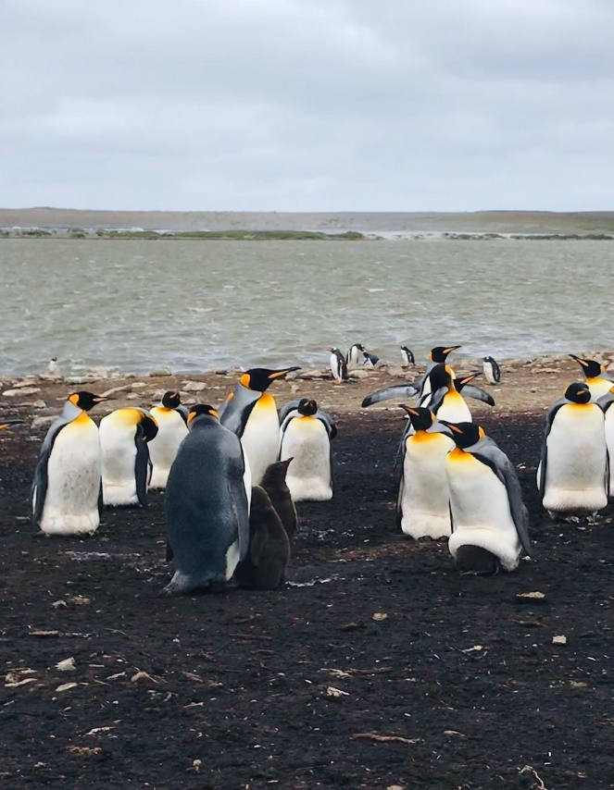 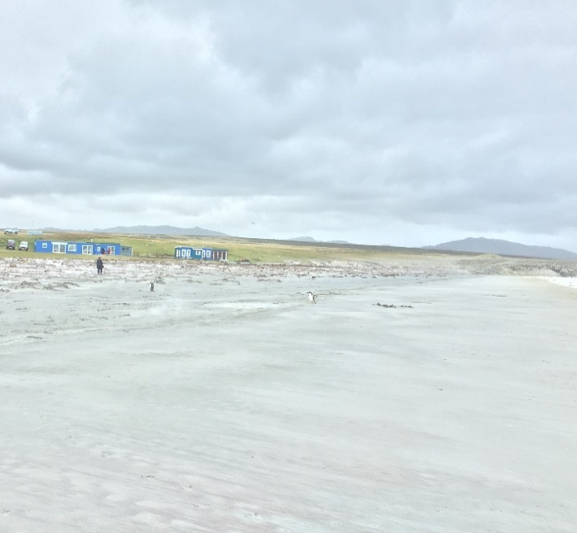

The Conference finished that evening with a gala dinner at the Defence Force Club hosted by members of the Falkland Islands Legislative Assembly. It was an enjoyable and well attended event. Teslyn Barkman MLA spoke on behalf of the Legislative Assembly, thanking the delegates and members of the community for their participation and taking a strong interest in the subjects discussed, and her colleagues in the Legislative Assembly for organising such an interesting and engaging Conference. Acting CWP Regional Representative Margaret Mitchell MSP responded by echoing thanks to the hosts, emphasising the positive experience of all attendees, and how much they had enjoyed such a rich learning experience.

**Acknowledgements**

Members of the British Islands and Mediterranean Region Commonwealth Women Parliamentarians would like to express their gratitude to the Falkland Islands Legislative Assembly for hosting the 2020 BIMR CWP Conference. Particular thanks go to Clerk Cherie Clifford and her colleagues for their vision, organisational skills and hard work in delivering a smooth-running and well-organised Conference. Also, special thanks go to Leona Roberts MLA and Teslyn Barkman MLA for leveraging the political will to host the Conference in the Falkland Islands, and for their contributions and hospitality throughout the event.

BIMR CWP recognises the breadth of participation from across the community including speakers in the plenary sessions, those who accompanied delegates on the field visits and who attended plenary sessions, people who hosted and catered to such a high standard and everyone who extended a warm welcome and interest in the work and objectives of the Commonwealth Women Parliamentarians.

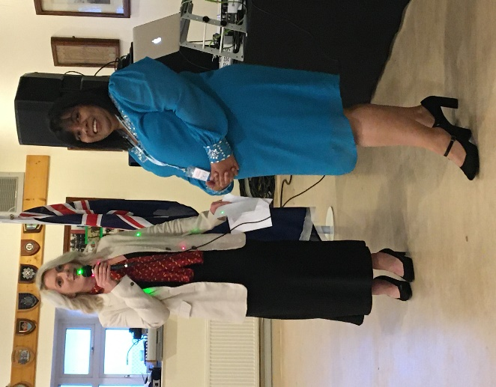

**Key Themes and Learning**

Delegates were not asked to complete pre and/or post assessment forms. For this purpose, key themes and learning were derived from prevalence in discussion, media and social media coverage and informal feedback.

**Combatting Stereotypes in Small Communities**

* The existence of stereotypes may be refuted because of examples of successful, resilient women and role models. However, the data tells a different story, i.e. the existence of gender-pay gaps, low representation of women in certain professions (including elected office) and senior posts never being held by a woman. Deep-rooted inequality must be exposed and called out.
* Imposter syndrome and self-doubt is commonly experienced by women. It can be a barrier to women’s career trajectories, however once recognised can be addressed and overcome. There is help and support available.

**Building Roles in Small Communities**

* Highlighting the achievements of women who have broken through barriers is important. Give them a platform to allow others to learn what they have done, and how they have done it.
* Start at a young age. Empower and equip young girls to achieve their goals. Expose and challenge gender stereotypes.
* Gender-stereotyping is acute in cases of gender-based violence and sexual abuse. Victims are frequently blamed for the way they act, dress, behave etc. This is particularly the case in small communities when victims and perpetrators can be identified. There needs to be a societal shift towards condemning all forms of violence against women and girls, not blaming the victim and/or mitigating the behaviour of abusers.

**Creating Opportunities for Women in the Future in Small Communities, Encouraging Women to Stand for Public Office**

* Positive action is not discrimination. It is designed to address and undo systematic and deep-rooted inequality.
* Do not accept the status quo at face value. If you think something is unfair, it probably is. Ask questions, and if you do not get a satisfactory answer, keep asking.
* Women’s participation in political life is of particular importance, to ensure representative voices, views and experiences in policymaking, legislation, scrutiny and representation.

**Mentoring of Women in Parliament**

* Mentoring is useful throughout political careers – from deciding to stand for election, being a candidate, when newly elected, pursuing career advancement, or taking on leadership roles and as a former parliamentarian.
* There are different types of mentorship; however it is important to design a framework which is fit for purpose and meets the needs of both mentees and mentors.

**Following the conference participants are asked to consider ways to apply their learning, such as:**

* **Ask a question in Parliament**
* **Propose an inquiry –** as part of a committee or parliamentary caucus on one of the issues raised
* **Share with your community –** arrange a school visit/visit to a community group
* **Get involved in mentoring –** either as a mentor or a mentee
* **Advocacy** – speak out on an issue, where possible collaborating with experts, campaigners and civil society organisations
* **Research** – become better informed about an issue

**Programme**

**Monday 17 February**

**Welcome Reception at the Falkland Islands Museum**

Welcome by Hon. Leona Roberts MLA

Briefing on the Falkland Islands and its economy by the Chief Executive

Tour of the Museum

**Tuesday 18 February**

**CWP Steering Committee Meeting**

**Welcome Session and Official Opening of the CWP Conference**

by the Deputy Speaker, Mrs Claudette Prior MBE

**Plenary 1: Combatting Stereotypes in Small Communities**

*Acknowledging that women can face bias along multiple identity dimensions, including gender, race, disability, sexual orientation, gender identity and age, we must focus our efforts on how to recognise and work to overcome conditioned stereotypes. Throughout this session we shall identify where bias has been experienced and methods to tackle and overcome these issues. Through our speakers’ personal contributions, we hope to identify what methods are most helpful to combatting stereotypes when living within a small community.*

Chair: Hon. Samantha Sacramento MP (Gibraltar)

Speaker 1: Ms Rosalind Cheek, Statute Law Commissioner

Speaker 2: Ms Krysteen Ormond, Corporate Paralegal, Premier Oil PLC

Speaker 3: Mrs Nadia Knight, Public Accounts Committee Chair and Farmer

**Plenary 2: Building Roles in Small Communities**

*Across the Commonwealth we have a goal to uphold the empowerment of women. This is a key opportunity to discuss successes and areas of work still needed towards empowerment and economic balance.*

*With the insight of our speakers we shall explore how to enhance opportunities for women to exercise power over their lives with sustainable and inclusive economic growth. There is a role for all levels of government to create enabling environments for economic participation of women and implementing and monitoring actual change*

*The Commonwealth Women’s Forum (CWF) calls on the Commonwealth to lead the world by creating and strengthening an enabling environment for women’s empowerment, for a sustainable, secure, prosperous, and fairer society – that is free from violence and coercion, focuses on actions to mainstream gender in all government programmes, policies and initiatives including gender budgeting.*

*Throughout the course of the BIMR Commonwealth Women Parliamentarians Conference, Falkland Islands we hope to gather leaders and spokespeople with experience in politics, industry and from the community to tackle internationally recognised issues.*

Chair: Hon. Leona Roberts MLA (Falkland Islands)

Speaker 1: Dr Andrea Clausen, Director of Natural Resources, Falkland Islands Government

Speaker 2: Ms Victoria Collier, Firefighter

Speaker 3: Ms Christina Watson, Principal, Falkland Islands Community School

**Plenary 3: Creating Opportunities for women in the future in Small Communities, Encouraging Women to stand for Public Office**

*It is recognised that women’s decision-making in the political, public and private sectors are essential to achieving gender equality. Challenges in small communities can be specifically discouraging to women taking on leadership and political roles. Whether through mentoring, or constitutionally enforced diversity representation, it is recognised that extra efforts to encourage women into public roles are needed, and many have been implemented across the Commonwealth.*

*Within the BIMR region, plans to address equitable representation in parliaments have been discussed before. Building on this work and through sharing what our contributory speakers in the session have experienced, we should work to keep these targets and plans relevant for future leaders to feel encouraged into the political arena.*

Chair: Hon Teslyn Barkman MLA (Falkland Islands)

Speaker 1: Joyce Watson AM (Wales)

Speaker 2: Mrs Phyllis Rendell MBE (former Falkland Islands MLA)

Speaker 3: Ms Lisa Watson (Editor, Penguin News)

**CWP Round up from plenaries**

**Reception at Government House hosted by His Excellency the Governor**

**Buffet Dinner with Islanders at the Malvina House Hotel**

**Wednesday 19 February**

**Visit to Fitzroy Farm**

Camp Life: “Farming and Diversification, our life, our culture, our history”

*Including Asado Lunch (Chilean BBQ) with attendees from the farming community*

**Service of Remembrance at the Welsh Guard Memorial**

conducted by Reverend Canon Kathy Biles

**Thursday 20 February**

**CPA Roadshow at Falkland Islands Community School**

Scene Setting | Discussion groups | Summary of discussions/Q&A

Hon. Dr Barry Elsby MLA (Falkland Islands), Rt Hon. Maria Miller MP (UK), Hon. Eleni Mavrou MP (Cyprus)

Hon. Roderick Galdes MP (Malta), Cllr Christine Scipio-O’Dean (St Helena), Jon Davies & Seyi Afolabi (CPA UK)

**Mentoring of Women in Parliament**

Speaker 1: Hon. Samantha Sacramento MP (Gibraltar)

Speaker 2: Mrs Roberta Blackman-Wood (former Member of the UK Parliament & BIMR CWP Chair)

Speaker 3: Mrs Patricia Ferguson (former Member of the Scottish Parliament & BIMR CWP Chair)

**Visit to Bluff Cove and the Penguin Colony**

facilitated by Bluff Cove owners Kevin and Hattie Kilmartin

**Gala Dinner at the Falkland Islands Defence Force Club**

Hosted by Legislative Assembly with invited Guests

**Annex A**

**Statement by the British Islands and Mediterranean Region Commonwealth Women Parliamentarians Steering Committee**

During the 7th British Islands and Mediterranean Region Commonwealth Women Parliamentarians Conference in the Falkland Islands (16-20 February 2020) the Steering Committee discussed the worrying prevalence of violence against women and girls in the region, and the failures of criminal justice systems to protect victims and bring perpetrators to justice.

The following statement was released on 25 February 2020:

**BIMR CWP: Recognises the rights of a woman to fair treatment in the criminal justice system, citing the treatment of an alleged gang rape victim in Cyprus and other cases across our region.  We wish to add our voice to those of international organisations in condemning the failure of systems to protect many women.**

**We are alarmed about the increasing cases of violence against women and femicides in the different jurisdictions we represent and commend the mobilisation of women and men in support of the rights of victims.**

**We confirm our commitment to work with other organisations to protect women in the criminal justice system through legislation, scrutiny and awareness-raising.**

* Margaret Mitchell MSP, Scotland – Acting CWP BIM Regional Representative
* Eleni Mavrou MP, Cyprus
* Hon. Teslyn Barkman MLA, Falkland Islands
* Hon. Samantha Sacramento MP, Gibraltar
* Deputy Rhian Tooley, Guernsey
* Hon. Claudette Buttigieg MP, Malta
* Hon. Christine Scipio-O’Dean MLC, St Helena
* Rt Hon. Maria Miller MP, UK
* Rhianon Passmore AM, Wales
* Joyce Watson AM, Wales