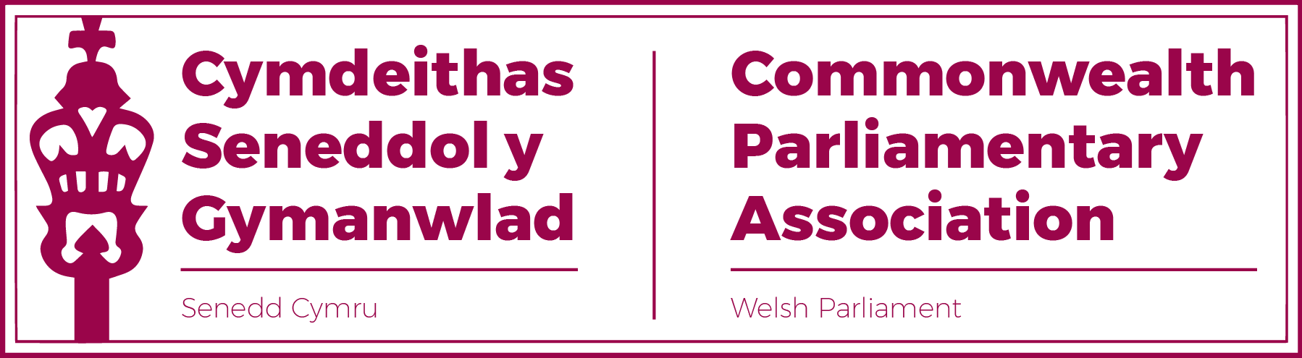
Report of the
COMMONWEALTH PARLIAMENTARY ASSOCIATION
65th Commonwealth Parliamentary Conference
20-26 August 2022
Halifax, Nova Scotia
Canada
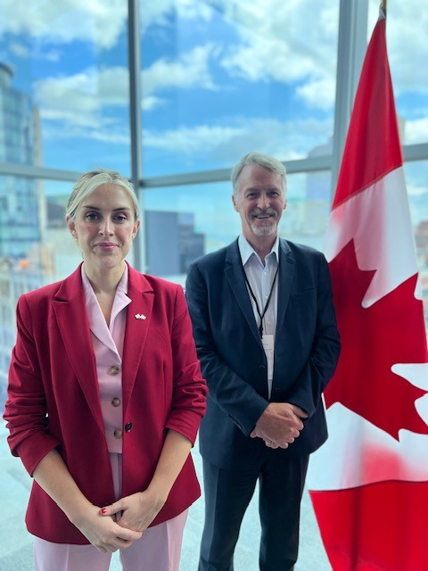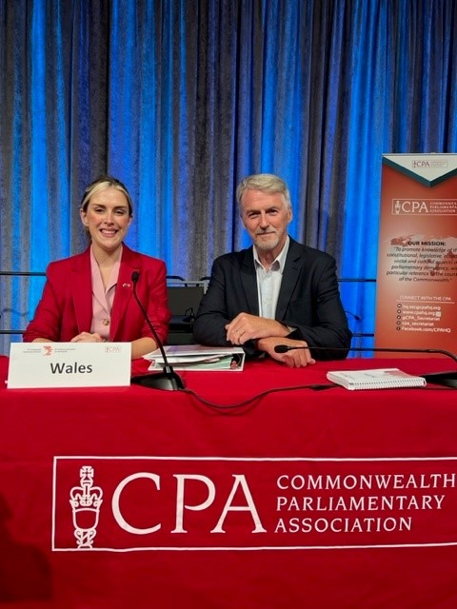
Delegation:
Sarah Murphy MS
Huw Irranca-Davies MS
Al Davies (Delegation Secretary)

Content:

- Background, Summary and Highlights p.3

- Report by Branch Sarah Murphy MS p.5

- Report by Huw Irranca-Davies MS p.11

- Concluding Statement p.14

- Acknowledgments p.15

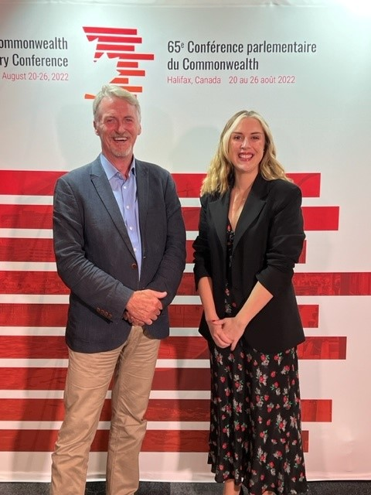

Background, Summary and Highlights.
The Commonwealth Parliamentary Conference (CPC) is the annual meeting of the Commonwealth Parliamentary Association (CPA). It is one of the largest Commonwealth meetings, bringing together some 500 Parliamentarians representing over 180 parliamentary Branches, from across the Association’s nine Regions.
The 65th CPC took place between 20-26 August 2022 in Halifax (NS), Canada. The Conference theme was “Inclusive, Accessible, Accountable and Strong Parliaments” .

Due to the Covid pandemic, this was the first time that an in-person CPC had taken place since the 2019 Conference, hosted by the Ugandan Parliament.

The CPA Wales (Senedd) Branch, as part of its fee structure, was invited to send one delegate with the option of being represented by additional conference “observer” participants.
As the 65th CPC incorporated the 7th Commonwealth Women Parliamentarians (CWP) meeting, it was decided that a woman Member of the Senedd should lead so as to ensure participation at this triennial conference, at which the CWP Chair is elected
(and at which only women delegates are eligible to vote.)

This was the first time in over a decade where the Senedd delegation was made up entirely of Members not on the Branch Executive Committee or previously active in the work of CPA. It was noted as encouraging to see the interest and participation by our wider Branch Membership.

The conference provided excellent networking opportunities as well as a platform to raise the profile of the Senedd and Wales.

The Senedd also took advantage of the opportunities beyond the immediate conference, including securing standalone meetings with Members of the Nova Scotia Legislature in order to learn more of their work.
Wales in Canada 2022
By good fortune, the rescheduled 65th CPC coincided with Wales in Canada 2022 – the Welsh Government’s programme which put Canada at the heart of its international focus to showcase Wales during this year. By further happy coincidence, Halifax’s Wanderers Stadium was the venue for the Rugby Union test match between the Welsh and Canadian Women’s National teams, in preparation for the 2022 Rugby World Cup hosted by New Zealand.

This wonderful occasion provided the opportunity for the delegation to meet with Andrew Wagstaff, Head of the Welsh Government in Canada team to learn more of the Wales in Canada programme; as well as to attend the rugby match in the company of the many Welsh ExPats who had now settled in Canada.

Short Welsh Government films highlighting both the first six months of its Wales in Canada 2022 programme as well as an overview of the Canada vs Wales rugby game in Halifax (in which Huw Irranca-Davies MS is interviewed) can be accessed below.

Wales in Canada - 6 months in | Wales
When Welsh Rugby came to Canada | Wales

Report by Sarah Murphy MS
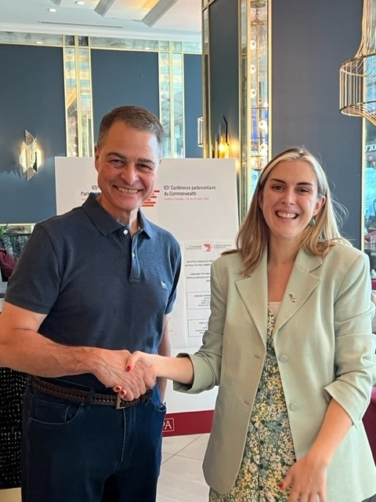
Photo: Sarah Murphy MS with Anthony Rota MP, Speaker of the Canadian Parliament’s House of Commons and President of the 65th Commonwealth Parliamentary Conference.

Note: As I said in my application, I shared my experience in real-time through my Instagram and Facebook stories. I asked for questions and lots of people messaged asking ‘What do people think of Wales?’ and more about the Canadian drug policies and views of other Commonwealth nations – www.instgram.com/sarah4bridgend in my stories.
It was a privilege to attend the 65th Commonwealth Parliamentary Conference in Halifax, Canada between 20th and 26th August of this year, organised by the Senedd Commission staff. Having not had one for two years due to the pandemic, there was a real buzz in the air and it was wonderful to see many people who have attended in the past getting to catch up with one another. It was enlightening and inspiring, and I was very proud to be there representing our Senedd, particularly as Wales is recognised in our own right as a Parliament and member of the British Islands and Mediterranean Region.
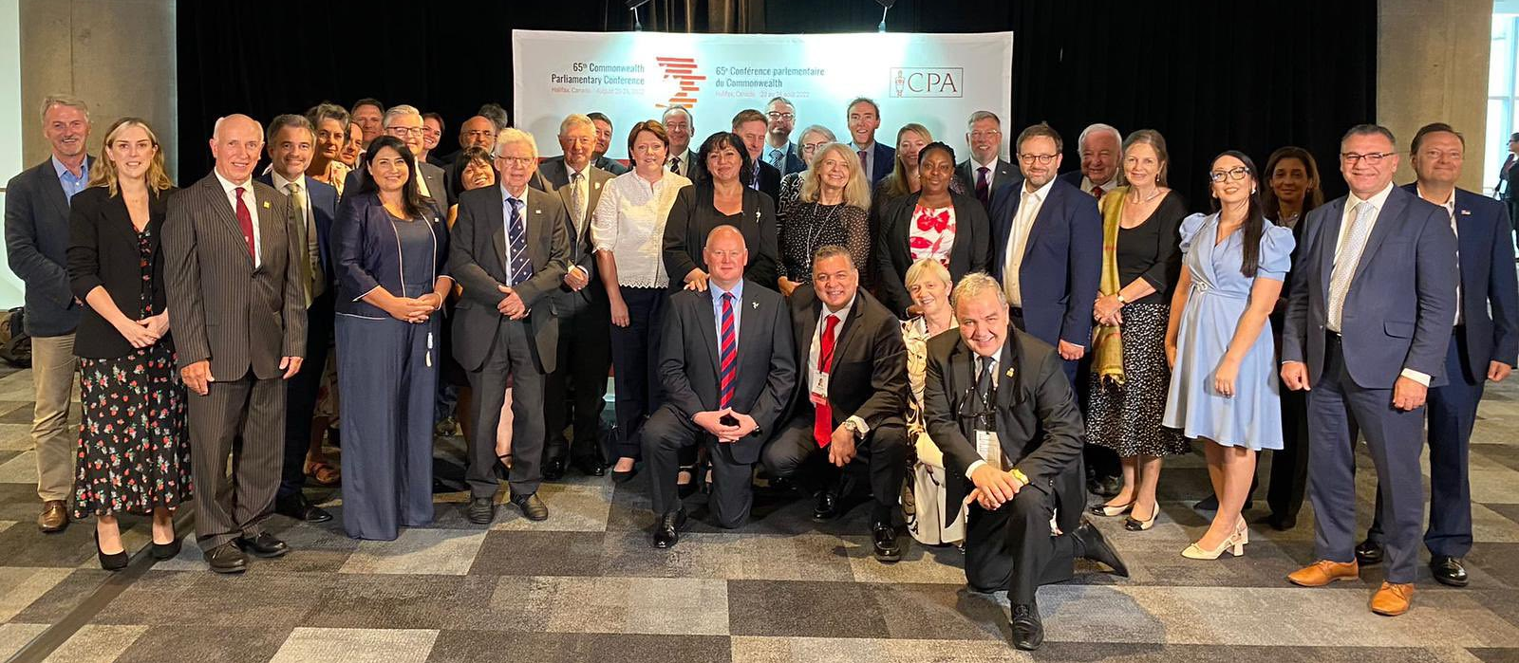
Photo: Members of our BIM Region present at the CPC.
7th Commonwealth Women Parliamentarians (CWP) Conference
“Commonwealth Women Parliamentarians aim to 'break the bias' to build gender equality and representation in Parliaments at 7th Commonwealth Women Parliamentarians (CWP) Conference.”
One of my main highlights included attending the Women Parliamentarians Conference where the theme was ‘BreaktheBias: Gender Equality Today for a Sustainable Tomorrow’ and we to discussed issues around gender equality, women's leadership and creating gender sensitive Parliaments in a series of workshops. My particular favourite was the ‘Financial Empowerment of Women and Gender-Sensitive Budgeting’ workshop where we heard from Ms. Anoush der Boghossian, Head of the WTO Trade and Gender Unit and the WTO Gender Policy Adviser, who taught us about the need for gender budgeting and assessments in trade agreements. Since returning I have raised this in our Senedd Economy, Trade and Rural Affairs Committee in relation to the Welsh Government Agriculture Bill as a gender impact assessment has not been carried out.

It was also agreed that the recommendation:
Commonwealth parliaments must ensure that all budgets incorporate a gender lens and all policies and agreements are gender sensitive
would be put to the General Assembly later that week which felt like a hugely significant and positive step that I know many in our Senedd CPA Branch Executive Committee, and previous members, have campaigned for. In the Senedd Equality and Social Justice Committee, we have decided to do this for our Welsh Government Financial Budget.
One of the more uplifting moments was during a break when we sang and danced along to Shania Twain, with one of the Canadian Parliamentarian stating loudly, “She was only having a dance” in a reference of solidarity to the Finnish Prime Minister, Sanna Marin who had been portrayed with extreme gender bias faced in the global media after videos were leaked showing her partying with friends.
Some criticisms that I heard were that the Women’s Conference was held at the same time as the 38th CPA Small Branches Conference, which meant that many women who were members of both had to split their time and could not fully participate in either. I understand that this has been an issue before, and I do believe that this should be changed in future.
In addition, unfortunately, our new Chairperson of the Commonwealth Women Parliamentarians network. Hon. Dr Zainab Gimba MP, Nigeria (who was elected and will hold the position for three years) was unable to attend due to issues with her visa and entry into the country.
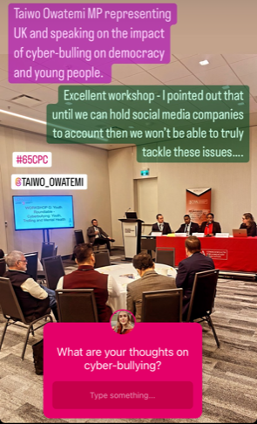
CPC Workshops
I really enjoyed attending the workshops because we got to hear from so many people from around the world. I attended the ‘A People’s Parliament: Accessibility through Innovation’ workshop where the main topic was the digital divide and ensuring every citizen has access to the internet as so many services, information and support are available online now. As well as hearing how other parliaments are designing apps and websites to show people what is happening in their parliaments, to educate, break down barriers and be more accessible. I asked a question about how we ensure any data collection on citizens through these apps is used safely and transparently – giving the negative example of citizen scoring in some countries – and there was a consensus that citizen data should not be used to categorise and profile.
I also attended the ‘Youth Roundtable - Cyberbullying: Youth, Trolling and Mental Health’ where Taiwo Owatemi MP represented the UK and spoke about the impact of cyber-bulling on young people and our democracy. I raised the issue that until we can hold social media companies to account then we will not be able to truly tackle these issues, which others agreed was a significant global issue.
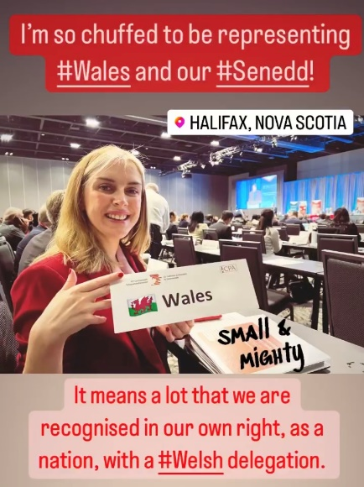
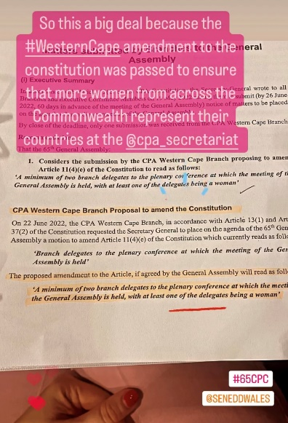
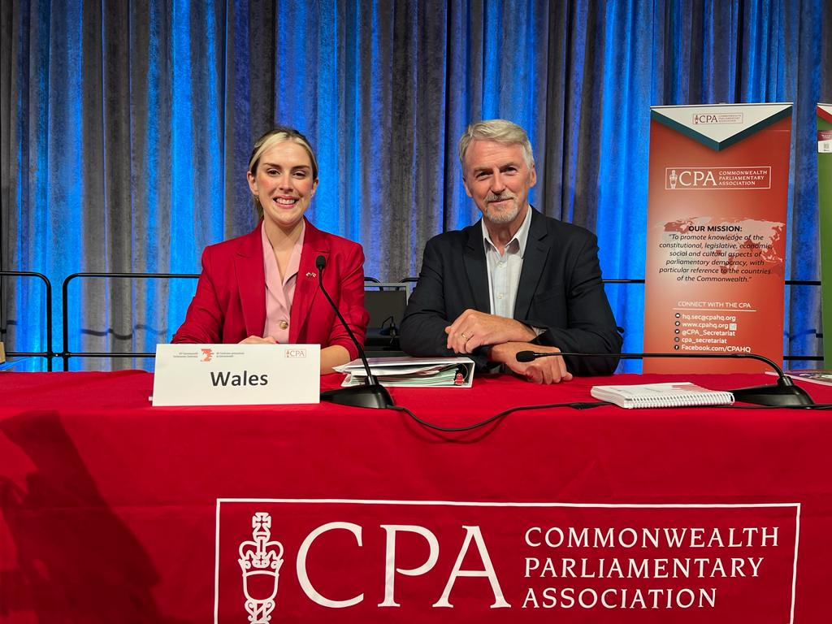
CPA 65th General Assembly

Again, I have to say that it felt special and significant to be able to be there at the Wales table, in our own right. The highlight of course was voting in favour of the CPA Western Cape Branch amendment to the Constitution that, ‘A minimum of two branch delegates to the plenary conference at which the meeting of the General Assembly is held, with at least one of the delegates being a woman’. I want to reiterate that I was aware that I was standing on the shoulders of giants in that moment, many women who have attended before me who have hoped and fought for this moment. It made me realise that we sometimes take for granted the gender equality that we have in our Senedd, and also that a small branch like Western Cape, like ourselves, can make a big difference by carrying through a motion in a room full of much larger delegations.
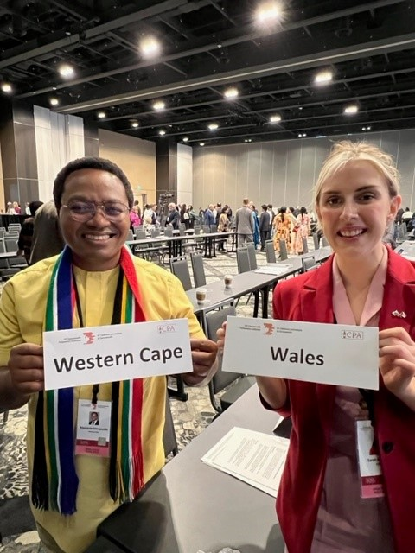
Photo: Catching up with an old friend – the alphabetical seating order of the CPC Plenary found us sat next to Masizole Mnqasela, Speaker of the Western Cape (South Africa) Provincial Parliament who had led a delegation to the Senedd in May 2022.
Al Davies will tell you that I was gutted when it ended. Sadly, for me, this was the one year where the Chair not only kept everything to time but also had us finishing early! However, Huw Irranca-Davies MS and I used the extra time wisely to hi-jack the top table and have a Wales delegation photo.
Canadian Politics and Culture - Mi'kmaq Nation
I am grateful that during the trip we had excellent opportunities to explore Halifax and Nova Scotia’s political and cultural history and policies. In particular, how the territory passed back and forth between France and England until 1713, and how this impacted the First Nations people of the Miꞌkmaq whose land was taken away from them. Significantly, in April 2022, legislation was introduced that recognises Mi’kmaw as Nova Scotia’s first language and will support efforts to preserve and promote it now and for future generations. It is seen as a critical step on the path toward reconciliation.

Wales vs Canada Women’s Rugby
Finally, thank you to the Senedd Commission for discovering that our Welsh Women’s rugby team were due to play Canada whilst we were there. The game was sponsored by Welsh Government which was cool to hear over the tannoy throughout the match, and Huw and I got to speak to Welsh people living and working in Halifax and fostering trade between our two nations. I flew out on the same flight as the women’s team and they were thrilled that we were going to be there supporting them. We won’t mention the score, and to be fair they were using the friendly as a way to get every player out on the pitch in preparation for the World Cup, which I can’t wait for!

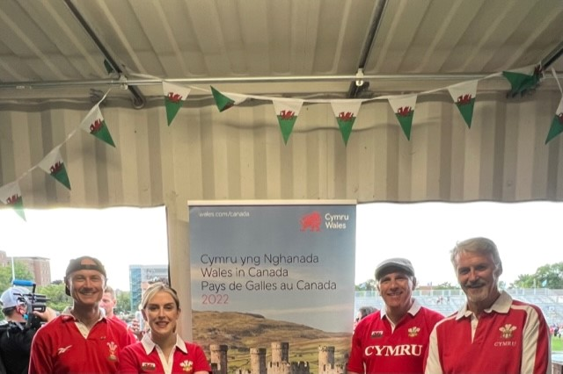
Photo: Senedd delegation with Andrew Wagstaff, Head of the Welsh Government’s Wales in Canada Team at the Wales vs Canada Women’s Rugby Test at Halifax’s Wanderers Ground stadium.

Report by Huw-Irranca Davies MS

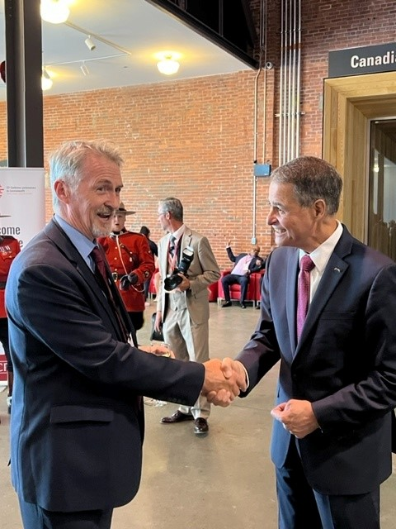
Photo: Huw Irranca-Davies MS with Speaker Rota.
It's the Planet (stupid)!
Sustainable Development, Climate Change, Future Generations – and new friends.
It was a privilege to represent Senedd Cymru along with Sarah Murphy MS (with the excellent support of Al Davies) at the CPA Conference in Halifax Nova Scotia. My primary focus at the conference was very much on sustainable development, climate change and the environment. I also spent time exploring the experiences with parliamentarians around the world of their parliaments and governance, and structures and styles of democratic governance and engagement including (no surprise in Canada) federal and confederal systems of government.
So first off: sustainable development, climate change, biodiversity and the environment were amongst the key issues for the conference and workshops. I actively engaged in lively discussions in workshops and around the conference, especially with delegates from smaller and island nations and developing nations, sharing good practice and challenges. Some of the key themes which emerged were:
- The importance of effective and routine parliamentary scrutiny of Sustainable Development Goals, progress towards climate change targets, and biodiversity restoration
- The limited capacity of parliaments – especially smaller parliaments - to effectively hold governments to account on SDGs and wider environmental matters
- The need to improve the wide variability in knowledge and understanding by parliamentarians of SDGs, sustainable development and environmental matters which leads to variable scrutiny – again particularly marked in smaller parliaments
- Frustration at developed nations’ repeated failure to make good on offers of financial support and expertise to smaller nations who are key to environmental solutions on biodiversity and climate change, and a demand for all parliamentarians – especially those from larger and developed nations - to rally behind this call
- The common lack of stretching short-term goals amongst most governments on climate change and sustainability to drive progress towards the longer-term goals, and the need for parliamentarians to challenge more effectively
- the problems parliamentarians have in facing longer-term environmental issues when faced by the short-term election cycles, as well as immediate challenges such as cost of living and energy costs, and fossil-fuel exploitation opportunities to drive short-term growth and jobs.
- Parliamentarians need to collaborate with external expert-led working groups and with non-governmental organisations (NGOs) to better inform and educating the public
- Parliamentarians should actively use their elevated public and elected position to promote change in government policy and legislation and in public discourse, and to shape budgetary decisions away from fossil fuels and to tackle climate change.

As a parliamentarian from Wales it was heartening to see the very wide interest in our Well-being of Future Generations legislation and framework, and how this could help provide that longer-term focus for parliamentarians and governments beyond short-term electoral cycles and priorities. My emails have since been working overtime in response to request for WB&FG links from all parts of the Commonwealth! We had a great deal of discussion with Nova Scotian and Canadian parliamentarians on this too, and they were very taken with the similarities with the “Seventh Generation Principle” of the First Nation indigenous people of Canada, based on the ancient Haudenosaunee (Iroquois) philosophy that the decisions we take today should consider the needs of seven generations into the future. They were intrigued on how a modern piece of legislation could put into effect this ancient and very sound principle.
We also organised a separate visit to the Nova Scotia legislature to discuss their experience of working in the Canadian federal system of government, and exploring the balance of powers between local, provincial and national – as well as the fascinating interplay with the rights of the First Nation indigenous peoples. Indigenous self-government is recognised by the Canadian Government as part of the evolving system of “cooperative federalism”. Every system of government and parliament evolves and adapts to its own political and social and cultural environment and history.
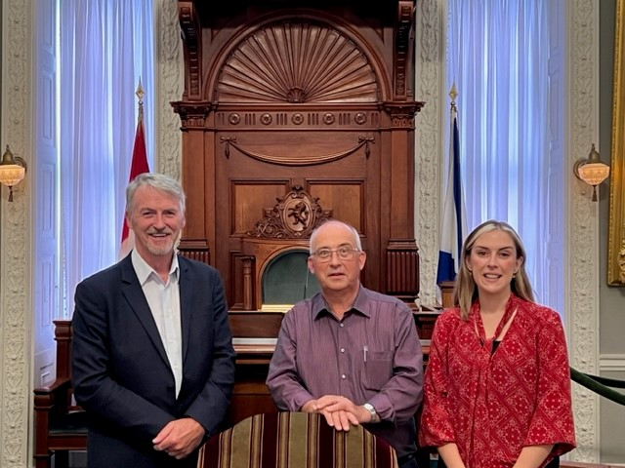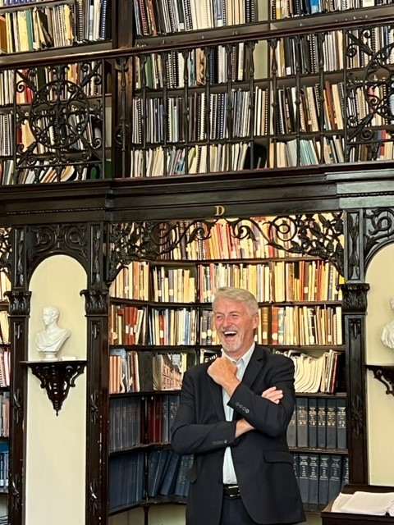
Photos: Sarah Murphy MS & Huw Irranca-Davies MS with Gary Burrill MLA in the NS legislature debating chamber.
Huw Irranca-Davies MS at the Legislature’s impressive library.
My final reflection – except for the incredible warmth and hospitality of our Nova Scotian hosts and the superb organisation by Al Davies – is that CPA is not simply about the formal meetings and the workshops and the business done. It is about the experiences shared, friendships made, and lessons learnt from being with other parliamentarians from around the Commonwealth. That is invaluable, and I would recommend the experience to all Members of the Senedd.

Conference Concluding Statement

The Conference Concluding Statement for the 65th Commonwealth Parliamentary Conference (CPC) is available at the following link.

This concluding statement contains:
- the main outcomes of the conference,
- a summary of the workshop discussions, and
- the recommendations that were either endorsed or noted by the Members in attendance.

For access to further news and resources from the 65th CPC – please visit the CPA website hub and CPA social media channels using the hashtag #65CPC.

Images from the events of the 65th CPC are also available at the CPA's Flickr page.

A full round-up of all of the conference news, images and detailed workshop reports from the 65th Commonwealth Parliamentary Conference (CPC) appears in The Parliamentarian: Conference Issue ( October 2022).

Acknowledgments

The CPA Senedd-Wales Branch would like to put on record its sincere gratitude to:
The CPA Canada Branch
Jon Davies and the BIMR Secretariat
The CPA HQ Secretariat
Andrew Wagstaff and Lowri Llywelyn, Welsh Government in Canada Team.

