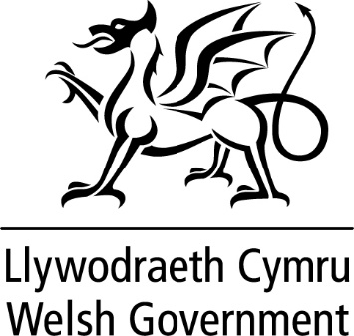

WRITTEN STATEMENT

BY

THE WELSH GOVERNMENT

TITLE | Ministerial Overseas Visit to Qatar
DATE | 28 November 2022
BY | First Minister, Mark Drakeford MS

I visited Qatar between 19-22 November to support the Wales men’s football team at its inaugural World Cup game against the USA. I also took part in a wider programme of activity designed to promote Wales on the world stage and draw attention to our values.

My first engagement was at the Welsh bucket hat installation, a focal point for Wales’ presence in Doha. I met the FAW Ambassadors, Ian Rush and Jess Fishlock, and one of our Lleisiau Cymru Ambassadors, Colin Jackson, and we collectively undertook a variety of global media engagements. Media interest in Wales continued throughout the time I spent in Qatar, presenting numerous chances to set out the reasons behind my decision to travel to this World Cup – to represent Wales and its values on the world stage. I then met with the Qatar Minister of Culture to discuss collaboration opportunities between the Museum of Islamic Art and Amgueddfa Cymru as well as highlighting the Welsh cultural programme that is taking place in Qatar around the World Cup. I also accompanied a delegation from Amgueddfa Cymru to the Museum of Islamic Art, to endorse their plans for a female curator exchange programme.

Following the meeting with the Minister for Culture, I met with the Deputy Prime Minister and the UN Secretary General to discuss mutual interest around sustainable development and our future generations. I was also able to travel to Wales’ training camp and meet with the Wales football team to pass on the nation’s best wishes for the game the following day and attend the opening ceremony and first game of the tournament, celebrating all 32 teams in the competition with Wales there for the first time in 64 years.

On the second full day of the programme, I met the Qatar Businessmen’s Association to discuss trade and investment opportunities, particularly around Wales’ expertise in cyber security, fintech, renewable energy and advanced manufacturing. This was followed by a meeting with the Chief Executive of Qatar Airways, the latest in a series of discussions about the resumption of the airline's Doha - Cardiff service and how the route would benefit Welsh exporters.

HM Ambassador to Qatar hosted a Wales-themed reception at the British Embassy in Doha which I attended, along with the UK Foreign Secretary. With around 200 guests, the reception provided a platform to promote Wales and its values to a high-profile audience including senior Qatari business leaders, representatives from the academic and cultural sectors, alumni of Welsh Universities and key Welsh and British business leaders. It was also an opportunity to meet the US delegation and senior US representatives, including the US Ambassador to Qatar, to discuss Wales’ relationship with the USA. The reception showcased the best of Welsh food and drink and featured performances from Welsh artists and musicians.

Later that day, I met with the Qatari Ambassador to the UK to follow up on our meeting in July and our discussion on values.

The final part of my programme was Wales’ match against the USA where I met briefly with the United States Secretary of State, Anthony Blinken. I was able to share in the reaction of the hundreds of Welsh supporters at the game, at the first goal scored for Wales at a World Cup final for over half a century, as the team secured a draw in its opening game of the tournament.

