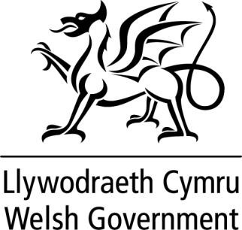

WRITTEN STATEMENT BY
THE WELSH GOVERNMENT

TITLE | UK Government Bill of Rights
DATE | 22 June 2022
BY | Mick Antoniw, Counsel General & Minister for the Constitution and Jane Hutt MS, Minister for Social Justice

The UK Government has today introduced a Bill of Rights in the House of Commons.

The Welsh Government did not have advanced sight of the contents of the Bill, except for five clauses, which were provided at the end of last week. There has been very little engagement with the Welsh Government since the UK Government closed its consultation at the end of March.

We set out our substantial concerns about this Bill in our formal response to the consultation. As we said then, the Welsh Government is opposed to any proposal to replace the Human Rights Act. It is our view that this action would be part of a concerted effort to dilute the rights of the people of Wales and the UK.

We understand there was a very large response to this consultation, and we know that many others have expressed their concerns that the UK Government’s proposals represent a serious regression on human rights in the UK, at a time when it has never been more important to uphold international law. The consultation report has only just been published so we have not yet had time to consider it.

Although the Deputy Prime Minister has said that the UK will remain a signatory to the European Convention on Human Rights, it seems clear that the intention is to undermine the Convention by increasing the rights of UK Ministers and reducing the power of UK courts, as well as the European Court of Human Rights, to enforce the rule of law and hold Ministers to account.

We will of course study the Bill very carefully and have previously told the Deputy Prime Minister that we are willing to continue dialogue as it progresses through Parliament.
Nevertheless, the process followed by the UK Government has been totally unsatisfactory, not least in relation to engagement with the Devolved Governments.

1

