Visiting Tŷ Hywel

Tŷ Hywel is the office building where Assembly Members and staff of the National Assembly for Wales are based. You can only come to this building if you have been invited to a meeting or event.

Arrival
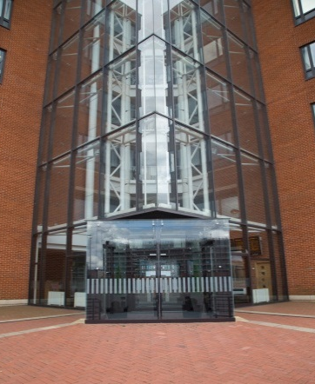
The entrance is on the corner of Pierhead Street and Bute Place. The building is clearly marked ‘Tŷ Hywel’ on both sides. There are flags outside the building that on a windy day can make a loud noise.

There are steps and ramps that lead to the entrance. You enter the building through one of two large automated doors – it does not matter which door you use. There can be a slight delay before the doors open. You may come across people entering through the door on the opposite side of the entrance. This is also the main exit, so people may be exiting through the door as you enter.

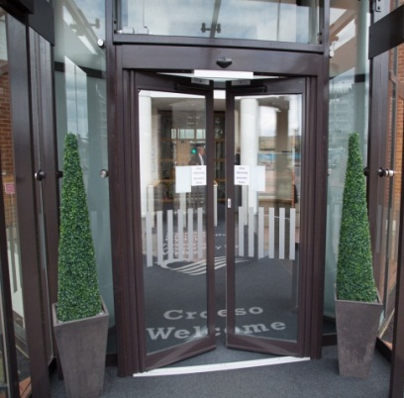
You will walk through a small porch into a large naturally lit foyer area. The foyer area can be a busy and noisy place. Uniformed members of staff are there to help with any questions you may have. There may also be a police officer present.

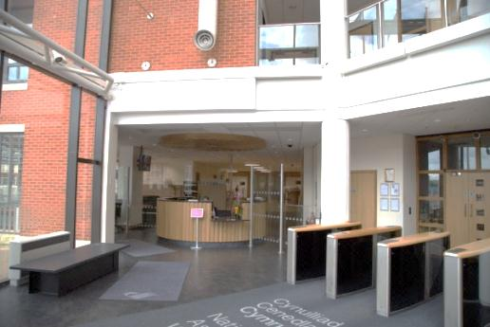
You should report to reception, which is located to your left as you enter the building and clearly marked with a sign. The reception area can be busy so there may be a queue. Please let a member of our staff know if you or a member of your party might suffer discomfort or stress by having to queue.
Reception staff have received autism awareness training. They will ask for your name and the name of the person you are there to see or the event you are attending. You can expect a slight wait while reception staff ring the person you are here to meet to tell them of your arrival.

Reception staff will issue you with a visitor pass that should be worn around your neck and must be clearly visible at all times. Reception will direct you to the security area.

Should you require the need of a quiet space, you can speak to a member of our reception staff to identify a suitable location to rest and de-stress.

There is a loop system available on the reception.

Security

You must go through a security check. The security area is a noisy space that can get busy and often involves queuing. You should allow enough time to go through the security checks.

If you, or someone in your party, is on the autism spectrum and finds queuing difficult, please ask to speak to security staff who may be able to arrange that you go through the security search quickly. Alternatively, contact the booking line in advance of your visit, on 0300 200 6565 and arrange to speak to an autism champion.
Most security staff will have received autism awareness training.

You must follow the instructions of the security staff. You will be asked to put your bags through an x-ray machine and all metallic and electrical items – keys, coins, cameras, laptops, tablet devices, mobile phones etc. – must be removed from pockets and put into your bag or a tray provided. You will also be asked to remove your coat and you might be asked to remove your belt if you are wearing one. Your items will be returned to you on the other side of the machine.

You will be asked to walk through a metal detecting arch which makes a beep if it detects something metal. If that happens, staff will use a hand-held detector and move it around your body to find out what set off the alarm. The detector should not touch your body. The detector will make a noise to show what set off the alarm. Often a watch or metal belt buckle will have caused the alarm to sound.

If you, or someone in your party, is on the autism spectrum and finds loud, high-pitched noise uncomfortable, please speak to security staff who will be able to arrange for a light rather than sound to activate when something metal is detected.

Any forbidden items will be taken by Security staff and, depending on the item, it will usually be returned at the end of your visit. Forbidden items include knives or other sharp or bladed objects, any rocket, firework or ammunition and any firearm or imitation firearm.

You will be directed to the waiting area behind the reception desk.

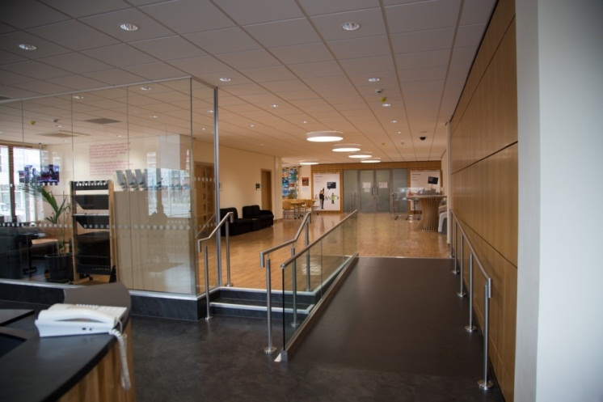
The Milling Area
The Milling Area is a large area used by members of the public, to wait before they are taken to other parts of the building. Areas, which are only used by staff, are marked with the words “Pass holders only” and can only be accessed by a member of staff swiping a card. Please do not attempt to enter these areas unless you are with a member of staff.

On bright days there can be a change in light as you enter the Milling Area as the light levels change from natural to mostly artificial light.

On entering the Milling Area there are a number of options:

1. The Waiting Area
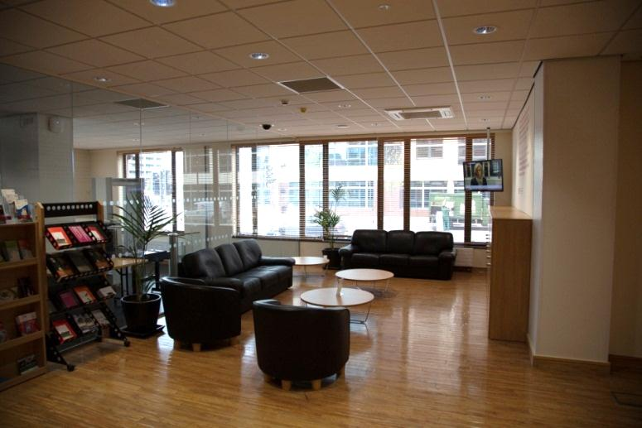
The Waiting Area is located behind reception. Seating and a range of information about the National Assembly for Wales is available in this area. You should expect background noise from the TV located in the area. A member of staff will come to collect you from this area.

2 The Meeting Rooms

There are two meeting rooms to the left of the Milling Area. You may see people entering and exiting these rooms.

3 Toilets
Toilets are located on the right-hand side of the Milling area, including an accessible toilet. A larger accessible toilet is available upon request. Please let a uniformed member of staff aware that you would prefer to use this.

4 The Activity Area

Tables and chairs are positioned at the far end of the Milling Area outside Siambr Hywel, the Assembly’s dedicated youth debating chamber.

You should be aware that school groups meet in this area before entering the Siambr Hywel and to have lunch. The Milling Area can get very busy and noisy during these times. During term time the Assembly offers three education visits a day on Tuesdays, Wednesdays and Thursdays during these time slots: 10.00 – 12.00, 11.00 – 13.00, 13.00 – 14.30, (13.00 – 15.00 on Thursdays). You may wish to avoid the area during these times.

To find out more information and booking call 0300 200 6565 or email contact@assembly.wales. More information about education visits to the Assembly, including how to book one, is available from our Information line on 0300 200 6565.

5 Siambr Hywel

Siambr Hywel is an event space that is mostly used by our education service to provide free tailored education programmes for schools and colleges.

This room is only open to people who have been invited to attend an event

You access Siambr Hywel through either the large doors or via a corridor, both of which are located at the far end of the Milling area. A member of staff will tell you which way to go. There may be a sudden change in light as you enter the room.

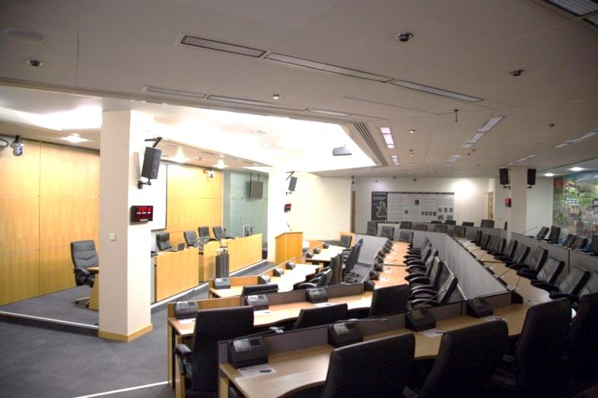
Siambr Hywel is a large space with rows of seats, each with their own screen and buttons which visitors are allowed to use during a simulated debate.
There is a loop system in the room.

Other Events or Meetings in Tŷ Hywel

If you are attending an event in Tŷ Hywel you will be taken out of the Milling Area past reception and back into the foyer area. You will either be taken to an event space on the ground floor or on the first floor.

1. On the ground floor

You will be taken passed some automated doors on your left and the turnstiles on your right. This is a busy area. You will move through automated doors into a corridor. You should expect a slight delay as the doors open. You can also expect to hear a noise as the door opens. As you enter the corridor there can be a change in light.

Various rooms lead off the corridor. Not all of these rooms are available to the public. Please do not attempt to enter any restricted areas unless with by a member of staff. Meeting and event rooms are located along the right side of the corridor. This is a central corridor and can get very busy.

2. On the first floor

You will need to be taken by a member of staff to access the first floor. You access the first floor by entering through automated doors directly opposite the turnstiles. A uniformed member of staff may hold open the door and issue a greeting in English or Welsh. On passing through the door you might experience a change in light levels. You will enter an area that has access to toilets, the lifts and the stairs. This is a central area and can be very busy. You will go up to the first floor via the lift or stairs.

Once on the first floor you will exit the lift or stairs and enter an area that provides access to toilets, the lifts and the stairs. This area can be very busy. You will then be taken through a door that leads onto a balcony area. If you are sensitive to heights, you may not be comfortable looking over the balcony. To access the event spaces on the first floor you will be taken through automated doors and enter a busy corridor that has access to the staff canteen, as well as the meeting rooms. The corridor gets very busy and noisy. You can also expect to experience the smell of cooked food.

You may also be invited to a meeting elsewhere in the building. You will need to be taken by a member of staff to access the venue of the meeting.

To find out more information about the specific event / meeting space you will be visiting contact our information line on 0300 200 6565 and arrange to speak to an autism champion.

Sensory issues particular to Tŷ Hywel

Visitors on the autism spectrum may find the following sudden sounds to be stressful:

- The fire alarm is tested in Tŷ Hywel every Monday at 9.00. If the alarm sounds at any other time a member of staff will instruct you what to do. If you are hyper-sensitive to sound, you may wish to plan your visit to avoid the fire alarm test.
- When the Assembly sits on a Tuesday and Wednesday you can expect to hear the noise of the Call to Plenary bell at 13.20 and 13.25 to call Members to the Siambr to vote. If you are hyper sensitive to sound you may wish to plan your visit to avoid the Call to Plenary bell.

