Fully-Proportional Representation and Election Processes
The case for fully-proportional representation in the UK House of Commons (and indeed, in every Representative Assembly) is now surely undeniable.
Many presuming to an opinion on this issue focus on electoral/appointment processes. However, an electoral/appointment process can only ever be a ‘means’ to an ‘end’. The merits of a given electoral/appointment process can be assessed only in the context of the electoral/appointment requirements:
  - If the requirement is to appoint a large number of ‘Party-placeholder’ Representatives
from a smaller number of ‘knowable’ Party-Options
(e.g. such as for a Representative Assembly such as the Welsh Senedd):
    - Full-Proportionality (by Party, at Full-Constituency Level) is paramount.
    - Preferential Voting is an irrelevant concept.
    - Transferability of Votes is an irrelevant concept.
    - List-Full is the only process fully-aligned to the requirement.
  - If the requirement is to appoint a small number of ‘knowable’ Personal-Representatives
(or indeed a single ‘knowable’ Personal-Representative)
from a larger number of ‘knowable’ Personal-Options
(e.g. such as for a Political Chief Executive such as the First Minister of Wales):
    - Proportionality is an irrelevant concept.
    - Preferential Voting is paramount.
    - Transferability of Votes is paramount.
    - STV-n (i.e. ‘AV or ‘STV’) is the only process fully-aligned to the requirement.
Thus:
  - If the requirement is to appoint a large number of ‘Party-placeholder Representatives
to the Welsh Senedd,
List-Full is the only process fully-aligned to the requirement.
  - If the requirement is to appoint a single ‘knowable’ Personal-Representative
to be First Minister of Wales,
STV-1 (i.e. ‘AV’) is the only process fully-aligned to the requirement.
This could be done either directly (i.e. as for a US President or a UK Mayor),
or indirectly from within the Welsh Senedd (i.e. as in current practice in the Welsh Senedd). The First Minister of Wales would then appoint the rest of the Welsh Executive,
subject to moderation by the (fully-proportional) Welsh Senedd.
However, most discussions about electoral/appointment processes conflate these two radically-distinct types of requirement and process. In particular, many advocates of STV (such as the Electoral Reform Society) propose STV even for large Representative Assemblies (such as for the Welsh Senedd). The rest of this paper reviews the evidence assembled by the Electoral Reform Society to back their case for STV, and claims that that evidence itself actually illustrates the fact that, whilst less dis-proportional than FPTP, STV is nowhere near proportional, and indeed that STV is not fit for the purpose of appointing ‘Party-placeholder Representatives to the Welsh Senedd.

The table overleaf presents estimates as to how a number of election processes would have ‘performed’ in the 2015 UK election with the actual ‘first preference’ votes in that election.
With respect to the ‘Seats’ columns:
1. The first column Full-PR illustrates a ‘fully-proportional’ allocation of seats (to two decimal places!) as a ‘frame of reference’ for the evaluation of the ‘proportionality’ of ‘practical’ electoral processes (and indeed, of ‘democracy’ itself). Note the Gallagher Index (of proportionality) equal to zero (i.e. 0.00).
2. The second column List-Full would use the ‘Largest-Remainder Method’ to round-up or round down the Full-PR allocation of seats by less than one seat up or down for each Party. List-Full would therefore be as near to fully-proportional as was practically-possible. List-Full and AMS-Full are identical at full-constituency level, and provide a ‘frame of reference’ for ‘best practical proportionality’ of electoral processes (and indeed, of ‘democracy’ itself). Note the Gallagher Index close to zero (i.e. 0.35).
3. In a switch from the best option to the worst, and then work backwards, the sixth column illustrates the fact that FPTP was very disproportional (with a Gallagher Index equal to 15.04):
a. The Conservative Party received an absolute majority of seats with only 36.93% of the votes (to become the unchallengeable ‘Constitutional Government’).
b. The Labour Party received a substantial un-democratic boost (to become the unchallengeable ‘Constitutional Opposition’).
c. The Scottish National Party received a substantial un-democratic boost (to become the unchallengeable ‘non-Constitutional’ ‘monopoly-representative’ of Scottish opinion).
d. Voters for other Parties were disenfranchised and marginalised.
4. The fifth column illustrates the fact that STV-1 would have been just as bad as FPTP (with a Gallagher Index equal to 15.28).
5. The fourth column illustrates the fact that STV-4, although substantially better than FPTP and STV-1, would have been nowhere-near fully-proportional (with a Gallagher Index equal to 7.44):
a. The Conservative Party would still have received a substantial un-democratic boost.
b. The Labour Party would still have received a substantial un-democratic boost.
c. The Liberal Democratic Party would have received only 26 seats, when they ought to have received 51 seats.
d. The Green Party would have received only 3 seats, when they ought to have received 25 seats.
e. Voters for other Parties would still have been disenfranchised and marginalised.
6. The third column illustrates the fact that List PR (i.e. List, with ‘rounding’ by one of the D'Hondt/Jefferson method or the Webster/Sainte-Laguë’ method), although substantially better than FPTP, STV-1 and STV-4, would have been spuriously-complex, counter-intuitive, and not fully-proportional (with a Gallagher Index equal to 1.46). One has to ask why it should be favoured over the much simpler, intuitive, and fully-proportional ‘Largest-Remainder Method’ of the second column.

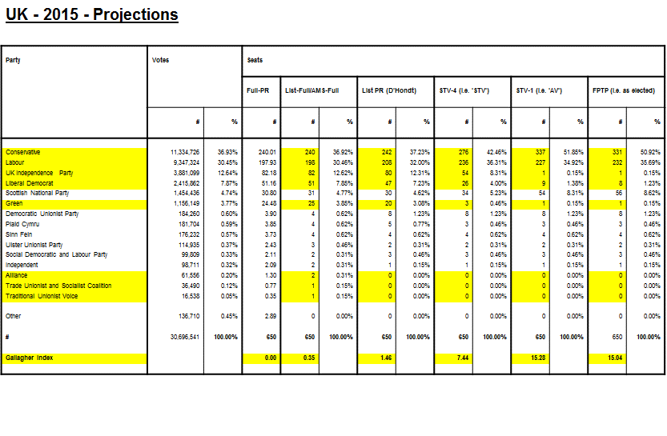
The source of the data was the Electoral Reform Society; 2015-05-29; ‘The 2015 General Election – A Voting System in Crisis’; Page 27. Note that projections for List PR (D’Hondt), STV-4 (i.e. ‘STV’), and STV-1 (i.e. ‘AV’) were not available for Northern Ireland:
http://www.electoral reform.org.uk/sites/default/files/files/publication/2015%20General%20Election%20Report%20web.pdf

Note that this exposition does not reflect the intuitive belief that, with full-PR:
  - The largest Parties could/should/would probably split:
    - The current Labour ‘covert coalition’ Party could/should/would split into (at least) an ‘Old Labour’ Party and a ‘New Labour’ Party.
    - The current Conservative ‘covert coalition’ Party could/should/would split into (at least) a ‘Europhile Conservative’ Party and a ‘Europhobe Conservative’ Party.
    - The current Scottish National ‘covert coalition’ Party could/should/would split into (at least) a ‘Scottish Devolution’ Party and a ‘Scottish Independence’ Party.
  - Support for ‘smaller’ Parties would be boosted because electors would know that votes for such Parties would not be wasted.

The table below illustrates the effect of the switch from FPTP to STV-4 for local elections in Scotland from 2007.
Note:
  - The dramatic reduction in elector choice (i.e. Candidates per Seat) with STV-4.
  - The weak Gallagher Index (of proportionality) with STV-4 equal to 9.70
(when compared to List-Full which could have delivered a Gallagher Index close to zero).

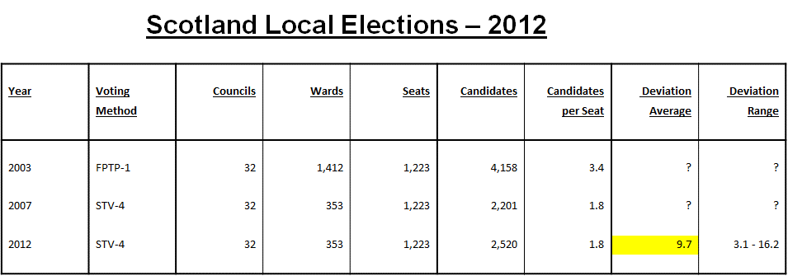

The source of the data was the Electoral Reform Society;2013-02-26; ‘2012 Scottish Local Government Elections – 2012-05-03’; Pages 5, 7 & 21:
http://www.electoral-reform.org.uk/sites/default/files/2012-Scottish-Local-Government-Elections.pdf
Note also that this exposition does not reflect the intuitive belief that, with full-PR:
  - The largest Parties could/should/would probably split:
    - The current Labour ‘covert coalition’ Party could/should/would split into (at least) an ‘Old Labour’ Party and a ‘New Labour’ Party.
    - The current Conservative ‘covert coalition’ Party could/should/would split into (at least) a ‘Europhile Conservative’ Party and a ‘Europhobe Conservative’ Party.
    - The current Scottish National ‘covert coalition’ Party could/should/would split into (at least) a ‘Scottish Devolution’ Party and a ‘Scottish Independence’ Party.
  - Support for ‘smaller’ Parties would be boosted because electors would know that votes for such Parties would not be wasted.
The tables below present estimates as to how a number of election processes would have ‘performed’ in the 2016 Welsh election with the actual ‘first preference’ votes in that election.
The source of the data was the Electoral Reform Society; 2016-12-02; ‘Reshaping the Senedd – How to elect a more-effective assembly’; Page 19:
http://www.electoral-reform.org.uk/sites/default/files/files/publication/Reshaping-the-Senedd.pdf
The first table below illustrates the potential impact of a simple switch from the current AMS-Partial process to a List-Full process (both with 60 seats):
  - Note the potential improvement in Gallagher Index (of proportionality) from 13.06 to 1.45.
  - Note that Labour gained just under 50% of the seats with the current AMS-Partial process (and has been able to dominate the Political Executive and the Senedd), but would have gained just under 33% of the seats with List-Full (and would have had to take sharing of power much more seriously).

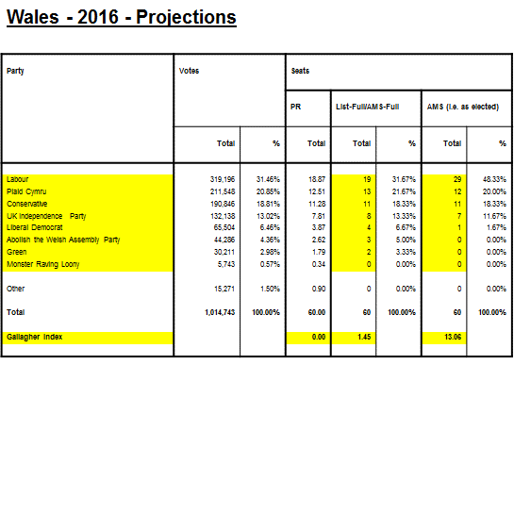
The second table below illustrates the potential impact of a simple switch from the ERS’s mooted STV-3 process to a List-Full process (both with 87 seats):
  - Note the potential improvement in Gallagher Index (of proportionality) from 13.56 to 1.40.
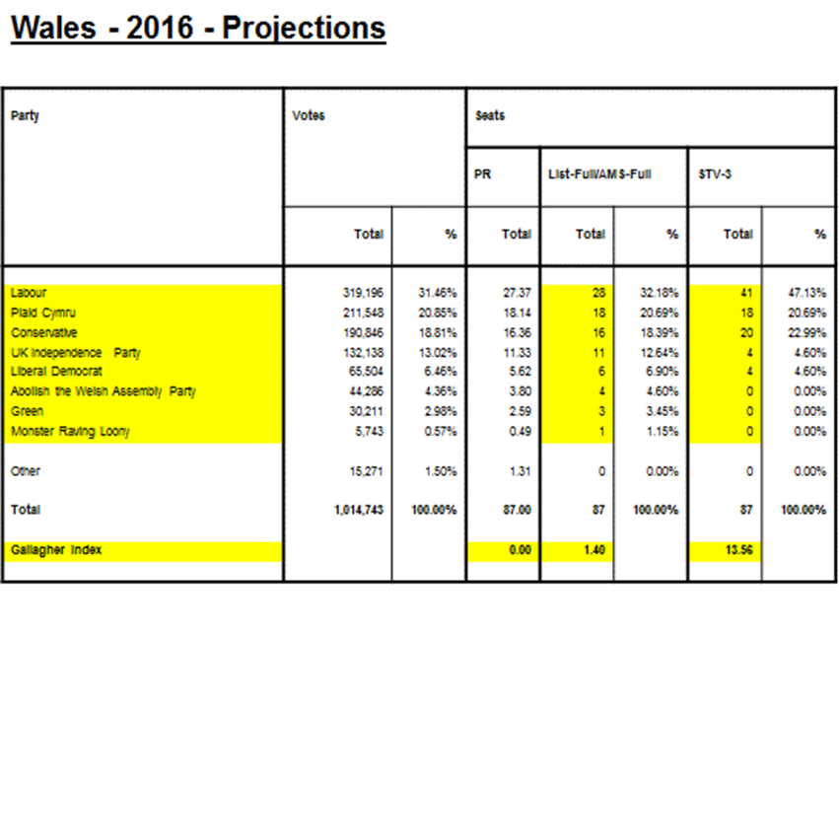
  - Note that Labour would have gained just under 50% of the seats with the ERS’s mooted STV-3 process (and would have been able to dominate the Political Executive and the Senedd), but would have gained just under 33% of the seats with List-Full (and would have had to take sharing of power much more seriously).
Note also that this exposition does not reflect the intuitive belief that, with full-PR:
1. The largest Parties could/should/would probably split:
    - The current Labour ‘covert coalition’ Party could/should/would split into (at least) an ‘Old Labour’ Party and a ‘New Labour’ Party.
    - The current Conservative ‘covert coalition’ Party could/should/would split into (at least) a ‘Europhile Conservative’ Party and a ‘Europhobe Conservative’ Party.
  - Support for ‘smaller’ Parties would be boosted because electors would know that votes for such Parties would not be wasted.

