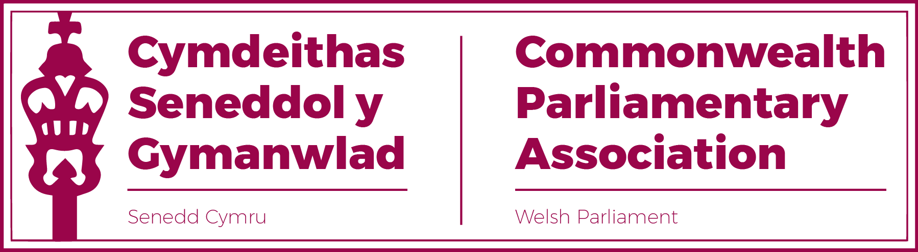

COMMONWEALTH PARLIAMENTARY ASSOCIATION
WELSH PARLIAMENT BRANCH EXECUTIVE

REPORT TO THE SENEDD BRANCH FOR THE PERIOD
26 March 2021-20 November 2022

Background
The Welsh Parliament unanimously agreed a motion signed by the four party leaders to apply for admission to membership of the Commonwealth Parliamentary Association (CPA) on 7 July 1999. Wales was formally welcomed into the CPA at the General Assembly meeting in Trinidad on 19 September 1999.
Branch Structure
All Members of the Senedd are by default Members of the
CPA Wales Branch

Office Holders:
President: Elin Jones MS
Vice President: David Rees MS
Chair: Rhun ap Iorwerth MS
Secretary: Manon Antoniazzi,
Chief Executive and Clerk of the Senedd
Acting Secretary:
Al Davies, Senior International Relations & Protocol Manager

Branch Executive Committee
Rhianon Passmore MS
Alun Davies MS
Natasha Asghar MS
Sam Rowlands MS
Delyth Jewell MS

CHAIR'S FOREWORD

This past year has been a productive time for the Senedd’s Branch of the CPA.

Our newly enhanced Branch Executive Committee, now with six Members and gender balanced for the first time, has worked effectively and offered a refreshing new dynamic and outlook to our work.

However, as often stressed, all Members of the Senedd are Members of our CPA Branch. It has therefore been particularly pleasing for me to see the number of new Members of the Senedd, as well as those who have not previously engaged with the CPA, take an interest and participate in the opportunities presented by our Membership of this network.

Whilst we are only too aware that COVID hasn’t gone away, the success of the vaccination programme worldwide has allowed the resumption of in-person meetings and a near to normal return of CPA programmes. This has included over this past year our participation in physical conferences at both regional level in Northern Ireland, the Isle of Man and Gibraltar, as well as Internationally in Canada and the Caribbean. We have also been pleased to welcome delegations representing a number of Commonwealth parliaments, including Australia, Pakistan and South Africa.

Meanwhile, we have been able to make continued use of virtual platforms, adopted during the pandemic, to strengthen our participation across the CPA.
This has included our participation in Steering Committee Meetings as well as webinar sessions to take forward the agenda for the Region’s Climate Emergency working group as well as to share best practice in the Commonwealth Parliamentarians with Disabilities network, in which Mark Isherwood MS is our Senedd Champion.

2023 promises to be an equally exciting year for our Branch with planned conferences in Westminster and Ghana as well as our hosting a diverse range of Commonwealth Parliaments; from one of the very smallest legislatures in St Helena to the largest in Canada. I look forward to your continued interest and engagement in these and many other CPA opportunities.

Rhun ap Iorwerth MS.
CPA Senedd Branch Chair.

SELECTED ACTIVITIES UNDERTAKEN DURING THE PERIOD OF THE REPORT:

1. Participation in CPA Conferences and Seminars

50th BIMR Annual Conference
Belfast, NI
September 2021
The Annual Regional Conference – the Branch’s first face to face CPA activity since the pandemic – was hosted by the Northern Ireland Assembly in Belfast.

The conference theme was “Post Pandemic Parliaments” and the Senedd was represented by Branch Chair, Rhun ap Iorwerth MS, Branch Vice-President David Rees MS, Rhianon Passmore MS and Sam Rowlands MS. Report

70th Westminster Seminar
March 2022
This CPA UK hosted Seminar, for new or recently elected Members, was attended by Sam Rowlands MS and Natasha Asghar MS.
Report (Senedd)
Report (CPA)

51st BIMR Annual Conference
Isle of Man
March 2022
The Regional conference on the theme of “Impactful Scrutiny” was attended by the Chair as well as Natasha Asghar MS. Rhianon Passmore MS attended the AGM and CWP Steering Committee virtually and was elected as Regional CWP Vice-Chair. Report

65th Commonwealth Parliamentary Conference
Halifax, (NS), Canada, August 2022
Sarah Murphy MS and Huw Irranca-Davies MS represented the Senedd at this international CPA conference, attended by over 500 Commonwealth Parliamentarians. Report

2. Commonwealth Women Parliamentarians (CWP)
Rhianon Passmore MS, Delyth Jewell MS and Natasha Asghar MS have participated in the BIMR’s CWP Steering Committee meetings.
CPA UK Women's Roadshows
November 2021

Natasha Asghar MS attended this Roadshow which focused on the important issue of training to tackle Harassment of Women Parliamentarians through Social Media. The recording of this session is available here
9th BIMR CWP Conference
Gibraltar, October 2022
The Senedd was represented by Rhianon Passmore MS, Buffy Williams MS and Heledd Fychan MS at this CWP Conference hosted by the Gibraltar Branch, the theme of which was “Attracting and Retaining Effective Women Parliamentarians”. Report

3. Commonwealth Parliamentarians with Disabilities (CPwD)

Following the strong foundation set by the work of former Vice-President Ann Jones MS, the Branch was pleased that Mark Isherwood MS has taken on the role of the Senedd’s CPwD Champion.
Our engagement with the Parliamentarians with Disabilities network has included:
- playing a leading role in virtual regional meetings where we provided
a self-assessment of the Senedd as a disability inclusive parliament, as well as participation in a virtual presentation led by the Scottish Parliament which focussed on their “Access to Elected Office Fund”

On 2 November 2022 Mark Isherwood MS led a successful session on “Listening to people with disabilities, and their lived experience of the barriers to access and inclusion”

4. Engaging with Young People in Wales
11th Commonwealth Youth Parliament (CYP)
Trinidad and Tobago
November 2022

The Branch collaborated with our Welsh Youth Parliament team in order to facilitate our representation at this conference. Former WYP Members Betsan Angell Roberts and Gwion Rhisiart have been selected and, at the time of the publication of this report, are in Port of Spain,Trinidad representing the Senedd at the Commonwealth Youth Parliament.

5. Notable visits and other activities.

Western Cape Provincial Parliament – May 2022
This visit led by Speaker Masizole Mnqasela was hosted by the Llywydd and followed her visit to the WCPP in 2019.

The visit programme included a series of meetings and presentations allowing discussions on a range of issues, including:
- Parliamentary Capacity and Reform;
- The work of Senedd Committees (with a focus on our Finance and Petitions Committees);
- The Welsh Youth Parliament;
- Support for Members of the Senedd.
Election Observer Mission (EOM) Training
During this reporting period Delyth Jewell MS and Alun Davies MS have undertaken EOM training, organised by the BIMR Secretariat.

BIMR Working Group on “Climate Emergency”
Llyr Gruffydd MS has represented the Branch on this working group which has held several sessions; including a webinar hosted by Westminster on the topic of “Equinor and the Norway story”.

6. Commonwealth Visitors to the Senedd.

The Branch has assisted in the development of programmes for visitors to the Senedd including Speakers, High Commissioners, delegations and officials from Commonwealth countries and parliaments, including Australia (federal and provincial), Pakistan, New Zealand and the Western Cape (South Arica).

7. Branch Sponsorship Scheme (on-going).
Members are reminded of this scheme and encouraged to look for opportunities to apply for support for study visits to other Commonwealth Parliaments. Members interested in this opportunity should, in the first instance, email the Acting Branch Secretary Al Davies (al.davies@senedd.wales) with a brief outline and business case of their proposed study visit.

8. Forward Look

2023
- 71st Westminster Seminar (March)
- BIMR Conference, UK (April)
- Commonwealth Parliamentary Conference, Ghana. (September)

November 2022

