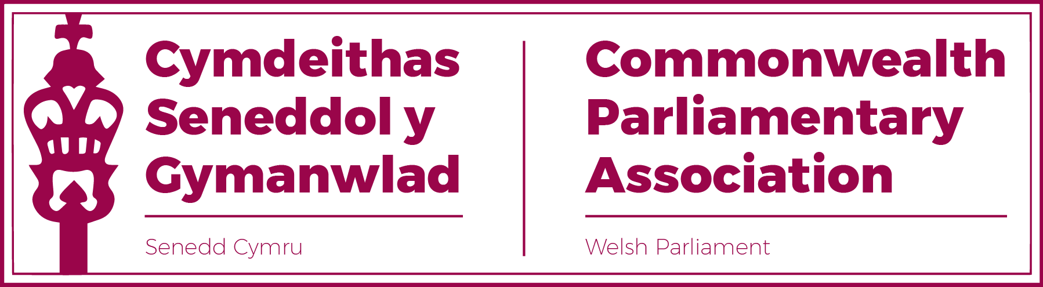

BRANCH EXECUTIVE MEETING
8 November 2022

Draft MINUTES

Present
Rhun ap Iorwerth MS, Chair
David Rees MS (Vice-President)
Delyth Jewell MS
Alun Davies MS
Rhianon Passmore MS
Natasha Asghar MS
Sam Rowlands MS
Secretariat
Al Davies, Acting Branch Secretary
Enfys Roberts, International Relations Team

- APOLOGIES FOR ABSENCES

None.

- MINUTES OF THE LAST MEETING - Paper CPA 6S-22-02 (DOC 1)
The Minutes were accepted as an accurate record.

- MATTERS ARISING FROM MINUTES
There were no matters arising

- REVIEW OF RECENT ACTIVITIES

Feedback and follow-up of recent Meetings, Visits,
Events and Conferences

- Visit by Mr Adam Searle MLC, NSW Parliament
12 July
Mr Searle’s programme had included meetings with both Llyr Gruffudd MS and John Griffiths MS in their capacity as Senedd Committee Chairs as well as a presentation on the Senedd.

- BIMR Election Observer Mission Training Session
Virtual
14-15 July
Both Alun Davies and Delyth Jewell participated in this training session and fed back on their experiences.

The Branch Secretariat would keep an eye out for further EOM training sessions provided by the BIMR, for those who had not yet had the opportunity.
- 65th CPC – (DOC 2)
Halifax, Nova Scotia,
20-26 August

As Members were aware, Sarah Murphy MS, Laura Anne Jones MS and Huw Irranca-Davies MS were selected to represent the Branch at this conference. Laura Anne Jones MS unfortunately had to withdraw from the conference at short notice.
Sarah Murphy MS and Huw Irranca-Davies MS participated fully in the conference and had fed back on what a positive and worthwhile experience they found the CPC (the first in-person international CPA conference since 2019) to be.
The formal CPC report had been distributed and would now be posted on the Branch webpages.

- Visit by Prime Minister of St Vincent and Grenadines
28 September.
The Senedd had been pleased to welcome Ralph Gonsalves, Prime Minister of St Vincent and Grenadines following his visit to Lampeter to receive an Honorary Degree.
Following a presentation on the Senedd, Mr Gonsalves met with Welsh Government Ministers Vaughan Gething MS and Julie James MS.

- BIMR CWP Conference
Gibraltar
4-7 October
The Regional Commonwealth Women Parliamentarians Conference took place in Gibraltar on the theme of “Attracting and Retaining Effective Women Parliamentarians in the BIM Region”.
The Senedd was represented by Rhianon Passmore MS, Buffy Williams MS and Heledd Fychan MS.

The conference touched upon numerous topics of interest, including the need for online safety and supporting parliamentarians.
Heledd Fychan MS contributed to a session where she spoke of the significance of the proposed Senedd Reforms and Rhianon Passmore had undertaken Chairing duties as the Regional CWP Vice-Chair, in the absence of Dame Maria Miller.
- BIMR CPwD Session – led by Mark Isherwood MS
Virtual
2 November.

As the Senedd’s representative on the Commonwealth Parliamentarians with Disabilities (CPwD) network, Mark Isherwood MS lead this virtual session, facilitated by the BIMR Secretariat.
The session: “Listening to people with disabilities, and their lived experience of the barriers to access and inclusion” included
- an introduction by Mark Isherwood MS, giving a parliamentarian’s
perspective,
- a presentation by the Senedd’s Diversity and Inclusion Team
- a contribution by Welsh Youth Parliament Member, Georgia
Miggins who gave an insight into her personal experience as a
WYP young person living with autism.

Very positive feedback had been received by our BIMR Secretary Jon Davies as well as from other Parliamentarians with Disabilities participants from legislatures including the UK, Scottish and Jersey Parliaments.

5. FORWARD PLANNING

Forthcoming Meetings, Visits, Events and Conferences
2022

- BIMR CWP Steering Committee
Virtual
14 November
The Branch’s CWP representatives had been invited to this virtual Steering Committee meeting. The meeting was expected to focus on outcomes of the recent Gibraltar conference as well as the region’s CWP programme and priorities for 2023.

- 11th Commonwealth Youth Parliament
Trinidad and Tobago
20-24 November
The Chair noted how pleased he was to report that our Branch had secured two places at the Commonwealth Youth Parliament which would take place in a fortnight in Trinidad.
The conference would, on this occasion, clash with the first residential meeting of the recently elected Welsh Youth Parliament and the Senedd would therefore be represented in Trinidad by former WYPs Betsan Angell Roberts and Gwion Rhisiart. The Chair extended the best wishes of the Branch and looked forward to learning of their experiences in due course.

2023

- Visit by St Helena PAC Committee
2 February
Confirmation had been received of the rescheduled date for this visit, at which the Senedd’s PAC Committee would lead.

- CPA UK Trade Workshop for Overseas Territories, Crown Dependencies and Devolved Legislatures.
Westminster
7-9 February
This Workshop, also rearranged, was discussed and it was noted that as there had been no firm expressions of interest received from Senedd Members of the Economy and Trade Committee , this opportunity would now be advertised more widely.

Afternote: Alun Davies MS was subsequently selected to represent the Senedd at this workshop.

- 71st Westminster Seminar
13-17 March
CPA UK had confirmed the dates for their flagship seminar programme aimed at new or recently elected Members which Natasha Asghar MS and Sam Rowlands MS had most recently attended.
The Chair requested that this opportunity be opened to Members.
Afternote: Expressions of interest were received by Peredur Owen Griffiths MS and Carolyn Thomas MS and nominations submitted on their behalf.

- BIMR Conference (hosted by CPA UK)
Westminster
25-28 April
CPA UK had confirmed that they would host the 2023 full Regional Conference in Westminster. The Senedd had been allocated places for four Members and priority for these, in the first instance, would be given to Members of the Executive Committee.

- Commonwealth Parliamentary Conference (CPC)
Accra, Ghana
30 September – 5 October
The Chair noted that Ghana had (at the Halifax CPC) been confirmed as hosts of the 2023 CPC.
It was queried how many places the Senedd Branch would be given. The Acting Branch Secretary confirmed that this would be One, with the option of supplementing this with an Observer Member. It was noted stated that, flowing an approved motion (by the Western Cape Provincial Parliament) at the recent CPC in Halifax, “sub-national” Branches (such as the Senedd) had the option to pay to have Two Delegates at future CPCs.
Action: The Branch Secretariat was asked to prepare a paper on this for discussion at the next Branch Executive Committee.
- NEW ITEMS / ANY OTHER BUSINESS
None

7. FUTURE MEETING DATEs:

- Branch AGM – 23 November 2022
- Branch ExCo Meeting - February 2023 (TBC)

END OF BUSINESS

