This note explains how to use the ‘Read Aloud’ option in Microsoft Word. It also explains how to change page background colours, text sizes and text colours.

Read Aloud
Click on ‘Review’
Click on ‘Read Aloud’.
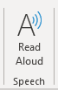
This will read text out loud and highlight each word as it is read.
You can pause, go back, and go forward by clicking on the icons in the top tight hand corner.
You can choose the reading voice and reading speed by clicking on the settings icon.

Change the page colour
Click on ‘Design’:
Click on the ‘Page color’ button. You can use one of the colours in the list.
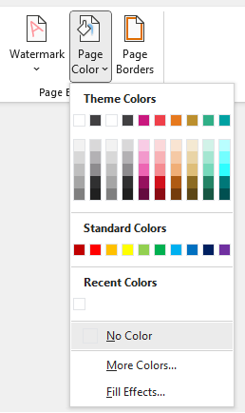
If you have a specific colour you like to use, click on ‘More Colors…’ to see a bigger set of colours

You can pick one of the colours from the basic set.
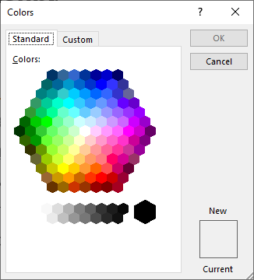

Click on ‘Custom’ to make your own colour. If you know the HEX code for the colour you like to use, you can add this here.
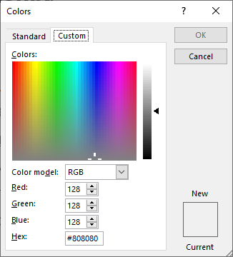

Change the text size
Click on ‘Home’
Click on ‘Select’.
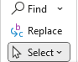
This will show you a list with four options, click on ‘Select all’. This will highlight all the text in the document.
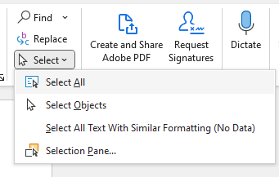
You can make the text size bigger using the button with a capital A and an up pointing arrow.
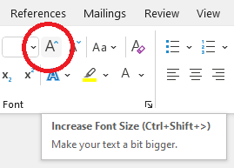

Change the text colour
Click on ‘Home’
Click on ‘Select’.
This will show you a list with four options, click on ‘Select all’. This will highlight all the text in the document.
You can change the text colour by clicking on the A with a colour line under it.
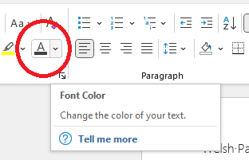
You can use one of the colours in the list.
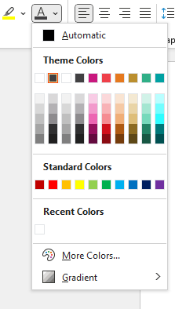
If you have a specific colour you like to use, click on ‘More Colors…’ to see a bigger set of colours
You can pick one of the colours from the basic set.
Click on ‘Custom’ to make your own colour. If you know the HEX code for the colour you like to use, you can add this here.

