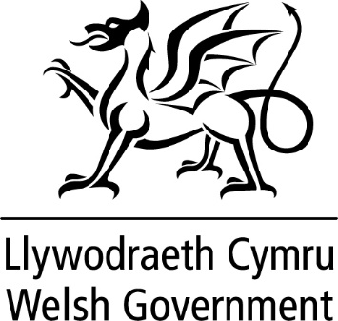

WRITTEN STATEMENT

BY

THE WELSH GOVERNMENT

TITLE | Publication of ‘Second homes – Developing new policies in Wales’ report
DATE | 02 March 2021
FROM | Eluned Morgan MS, Minister for Mental Health, Wellbeing and Welsh Language & Julie James MS, Minister for Housing and Local Government

We welcome the ‘Second Homes – Developing new policies in Wales’ report by Dr Simon Brooks. He is an interdisciplinary scholar with experience in many areas including history, multiculturalism, political theory, public policy and language planning. He is also a member of our Welsh Language Partnership Council.

The Coleg Cymraeg Cenedlaethol awarded a grant to Hywel Teifi Academy to scrutinise public policy on second homes in Wales and Cornwall. With the interest in this policy area, the Minister for Mental Health, Wellbeing and Welsh Language asked if the research could make policy recommendations.

The report builds on previous papers within this policy area dating back to the 1970s. It also encompasses the findings of the report recently published by Gwynedd and Anglesey Joint Planning Committee, in relation to holiday homes, again strengthening the evidence base on this issue.

The report sets out the policy context of the second homes debate, highlighting that second homes and associated issues are not a pan-Wales phenomenon. Rather, it suggests, regional or local interventions are required. As the Minister for Housing and Local Government noted in the Written Statement of 29 January, the issues are complex and there is no single answer. The report reflects that view.

As the report notes, we are currently in unprecedented times with the devastating effects of COVID-19 and the uncertainties of the full impact of leaving the European Union on our economy, as well as the many challenges our communities are facing.
This is a well-balanced report, providing an in-depth analysis of the multi-faceted challenges, including those related to planning, tourism, taxation and the sustainability of our communities. It also recognises there are roles for both the Welsh Government and local authorities in developing effective solutions.

The Welsh Government is keen to find balanced and practicable whole-system solutions to ensure that our young people are able to continue to live in their local communities, as well as ensuring communities’ long-term sustainability and vitality.

Since the pandemic, we’ve seen growing concerns about the effects that large numbers of second homes can have on some of our communities and, in particular, on the long-term sustainability of our Welsh-speaking heartlands. We are concerned for the future of these communities and welcome the linguistic considerations in the report.

We wish to thank Dr Brooks for his detailed work on this report, and also the Coleg Cymraeg Cenedlaethol and Academi Hywel Teifi, Swansea University for commissioning and funding this piece of work.

A webinar will be held to discuss the report and we look forward to the discussion on its findings.

