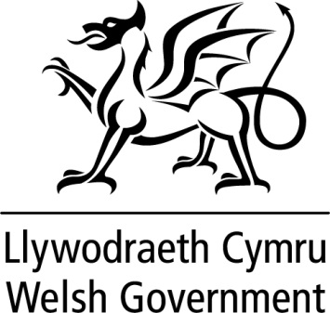

WRITTEN STATEMENT

BY

THE WELSH GOVERNMENT

TITLE | The Welsh Government Annual Report 2022 - 2023
DATE | 04 July 2023
BY | Mark Drakeford MS, First Minister

Today, we have published the second Annual Report of this Senedd term, setting out the progress we have made towards the well-being objectives in our Programme for Government.

I will lead a debate on the Annual Report in the Senedd on the 11 July.

The Annual Report can be found via the following link:
Welsh Government Annual Report 2023 | GOV.WALES

