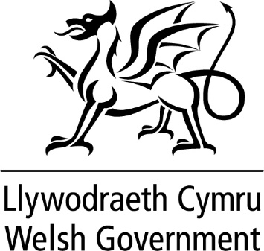

WRITTEN STATEMENT

BY

THE WELSH GOVERNMENT

TITLE | Ministerial Overseas Visit to Qatar
DATE | 05 December 2022
BY | Minister for Economy, Vaughan Gething MS

I visited Qatar between 28-30 November to support the Wales men’s football team at its World Cup group game against England. I also took part in a wider programme of activity to promote Wales’ values and trade and investment opportunities with global partners in line with the Welsh Government’s International Strategy.

During my visit I met the FAW and had the opportunity to wish the team well and convey our collective pride in their historic achievements as a group.

As part of my programme, I saw the work of Welsh artists and cultural organisations on show across Qatar. I visited Welsh installations and exhibitions on display in the Katara Cultural Village, the bucket hat installation on the Corniche and a Welsh element to the UK government’s ‘Garden of GREAT’. While visiting the bucket hat installation, I had the opportunity to meet Welsh fans who had travelled from Wales and elsewhere to support the team and to learn about their experiences of visiting Qatar during the World Cup. I also engaged and met with the Welsh Government's Lleisiau Cymru ambassadors prior to and during my time in Qatar.

I undertook extensive media engagement during the visit with both print and broadcast outlets from Qatar together with national and international media organisations. The interviews provided an excellent platform to promote Wales and our values on a global stage as well as emphasising our commitment to the rights of LGBTQ+ communities and workers’ rights everywhere. I was also able to publicly challenge the decisions taken by FIFA which were designed to prevent expressions of solidarity on the pitch.

On 30th November, I participated in a roundtable discussion on values, hosted by HM Ambassador to Qatar. This brought together Ministers and Ambassadors from the UK, Europe, North America and Australia and focussed on the incidents that had taken place in Qatar, such as the confiscation of items of clothing displaying rainbow colours, and how, collectively, our nations can engage constructively on our approach to human rights, LGBTQ+ rights, labour rights, women’s rights and political and religious freedom.

Following engagement with the International TUC prior to the tournament, I also met the International Labour Organisation to receive a briefing on their work regarding the progress and challenges related to labour law reforms in Qatar.

I met with the Qatar Businesswomen’s Association (QBWA) to discuss Welsh opportunities within UK investment plans. The meeting also allowed me to discuss the role played by women in Qatari economy.

Over the course of the two days, I met with the Qatar government’s Minister for Finance, as well as the Qatar Investment Authority. These meetings provided an opportunity to discuss the Strategic Investment Partnership (SIP) that is in place between Qatar and the UK. In my discussions, we focussed on how SIP plans for the UK could support capital investment projects in Wales specifically.

South Hook LNG in Pembrokeshire is the only Qatari-headquartered company operating in Wales. Exxon Mobil and Qatar Energy, which own South Hook, recently announced that they would be increasing capacity at the Pembrokeshire site and investment would have a significant positive impact on the surrounding area and local supply chain. I visited Exxon to learn more about the investment and how Pembrokeshire would benefit.

Along with the Secretary of State for Wales and the UK Sports Minister, I also attended a dinner hosted by HM Ambassador to Qatar. The dinner was an opportunity for prominent investors from the Middle East to hear about investment opportunities in the UK and Wales. I met Qatar’s Ambassador to the UK at this dinner and took the opportunity to once more raise the significance of our values as nation and how we wish to engage on these matters following the World Cup.

