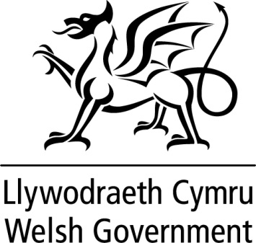

WRITTEN STATEMENT

BY

THE WELSH GOVERNMENT

TITLE | Green Paper: Our Health, Our Health Service – consultation summary report
DATE | 22 February 2016
BY | Mark Drakeford AM, Minister for Health and Social Services

Between 6 July and 20 November, the Welsh Government published the Green Paper Our Health, Our Health Service, for consultation. It covered a wide range of topics relating to the health service in Wales and asked for views about what legislative measures could be introduced to improve the quality of health services and the accountability, governance and functions of NHS organisations.

A summary of the responses received during the consultation is being published today.

A total of 170 written responses were received to the consultation, together with comments from more than 40 stakeholder meetings, including two large public events.

The responses and comments varied widely from detailed views about health board membership and leadership, to comments about achieving collaboration and partnership working and from thoughts about effective regulation and inspection to capturing the patient voice.

The summary document identifies the key themes to emerge and those areas where there is support for further work and those where legislation is not felt to be the driver for change.

Some of the key areas identified are:

- An appetite for the further development of joint working and collaboration between NHS organisations and their partners in the best interests of citizens, building on the goals set out in the Well-being of Future Generation (Wales) Act 2015 and the enablers within the Social Services and Well-being (Wales) Act 2014;

- The need for a shared vision for health and social care and the importance of culture, values and attitudes in improving quality and accountability;

- Support for further work to look at the remit and functions of Healthcare Inspectorate Wales and Care and Social Services Inspectorate Wales;

- The potential for a statutory duty of candour to promote a culture of openness;

- Consideration of whether the current mechanisms for capturing the views of citizens are effective, inclusive and representative enough and whether there is duplication;

- More consistent arrangements for the way some services are governed, particularly those hosted by other organisations

The detailed responses provide a rich source of information for the next Welsh Government.

The Green Paper consultation summary report is available at:
http://gov.wales/consultations/healthsocialcare/service/?status=closed&lang=en

