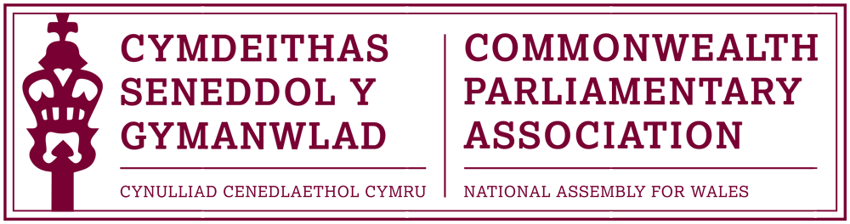

BRANCH EXECUTIVE MEETING

Meeting Date: Monday 23 March 2015

MINUTES

Present:
Joyce Watson AM, Chair
Simon Thomas AM

Al Davies, Acting Branch Secretary

- APOLOGIES FOR ABSENCE

Apologies had been received for
Mohammad Asghar AM and William Powell AM

- MINUTES OF THE LAST MEETING – Paper CPA 01-15M

Attendees present concurred with the minutes of the previous meeting

- MATTERS ARISING FROM MINUTES

There were no matters arising

- REVIEW OF RECENT ACTIVITIES

Feedback and follow-up of recent Meetings, Visits, Events and Conferences

- Visit by Parliament of Fiji
2-3 February 2015

The Chair confirmed that a successful two day visit to the Assembly had taken place and thanks received from the parliamentary delegation from Fiji for the dinner hosted by the CPA Branch and to Members who had participated in the visit programme.

- BIMR CWP Conference Gibraltar
4-6 February 2015

The Chair gave a brief verbal account of the recent Regional Commonwealth Women Parliamentarians (CWP) conference in Gibraltar which she had attended, accompanied by Branch Members Ann Jones AM and Jenny Rathbone AM. She stated that the conference had been of a very high standard and included excellent speakers. The programme had highlighted many important issues within the context of the conference theme of Ending Violence against Women, and provided interesting perspectives of the challenges of tackling this within small countries and territories
The Chair also noted the Branch’s thanks to the CPA Gibraltar Branch and staff for the very warm and professional welcome received.
An official report would be drafted shortly and presented to the Branch.

- Commonwealth Day 2015
a) Westminster – Monday 9 March

The Branch had been represented at the official Commonwealth Day Programme in Westminster by Esther Jones and James Jones of Ysgol Dyffryn Aman. Very positive feedback had been received from Esther and James of their experience and thanks from them and the school to the Branch for the opportunity. An official report was being finalised and would be presented to in time for the next Branch meeting.
- Senedd Reception – Tuesday 10 March

The Chair confirmed that a Commonwealth Day / International Reception had been held in the Senedd, hosted by the Branch President in partnership with the British Council Wales. The reception had included contributions by James and Esther from Ysgol Dyffryn Aman who had given excellent addresses of their experience in Westminster the previous day.

Unfortunately, there had been a disappointing turnout for the event, because of the very late running of Plenary which had prevented Members’ attendance.
Members present discussed this and agreed that, as this was always a risk in holding evening receptions on plenary days, that future Branch Commonwealth Day receptions would be held during lunchtimes where practical.

5. FORWARD PLANNING

Forthcoming Meetings, Visits, Events and Conferences

- 45th BIMR Regional Conference
Cyprus, 24-27 May 2015

The Chair stated that, given the unusual situation whereby the other Executive Committee Members had either applied to attend the BIMR conference or were absent, she had sought advice from the Presiding Officers in their capacity as Branch Presidents, on the merits of the business cases submitted. Having considered this, it was decided that the Branch delegation to attend the forthcoming Regional Conference in Cyprus would be:

- David Melding AM – Branch Vice-President
- Joyce Watson AM – Branch Chair / CWP Steering Committee Representative
- Simon Thomas AM – Delegate
- Ann Jones AM- Delegate

With
Jeff Cuthbert AM – 1st Reserve
William Powell AM - 2nd Reserve

Members present decided that the Branch would not seek any additional places on this occasion.

The Chair noted the updated conference programme which has been issued and sent to Members for reference. The programme indicated that the plenary themes would focus on Parliaments and (Youth) Unemployment and Parliaments and Accountability

- 12th CPA Canadian Parliamentary Seminar
Ottawa
24-30 May 2015

The Branch has been successful in gaining one place to attend the forthcoming Canadian Parliamentary Seminar to take place in Ottawa in May. A Branch notification inviting applications would be sent out to Members later that week.

- 61st Commonwealth Parliamentary Conference
Islamabad, Pakistan
30 September – 8 October 2015

Confirmation had been received of the official dates of this year’s Commonwealth Parliamentary Conference (CPC) to be held in Islamabad, Pakistan.
The Chair suggested that the Branch would wait until after this year’s Regional conference before making its final decision on whether we would participate in this year’s CPC in Pakistan.

  - FUTURE MEETING DATES:

TBC

  - NEW ITEMS / ANY OTHER BUSINESS
None

END OF BUSINESS

March 2015

