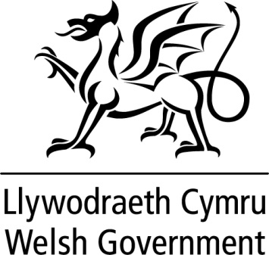

WRITTEN STATEMENT

BY

THE WELSH GOVERNMENT

TITLE | Mobile Animal Exhibits including Wild Animals in Travelling Circuses
DATE | 15 July 2016
BY | Lesley Griffiths, Cabinet Secretary for Environment and Rural Affairs

The Review of the science on ‘The Welfare of Wild Animals in Travelling Circuses’ has been published today. This Review was carried out by Professor Steven Harris, the 2nd Lord Dulverton Memorial Professor of Environmental Sciences at Bristol University. It is comprehensive in its approach and is to be welcomed.
The Review collated 764 scientific items from across the world. In the main, they have been peer reviewed from 2007 onwards, which is when the last UK Government Report was published.
One of the outcomes of the Review was that the use of wild animals in travelling circuses is not restricted to the ‘traditional sense’ of a ‘big top’ circus; it has therefore also considered all of the relevant scientific evidence in relation to Mobile Animal Exhibits (MAEs). There are a far greater number of these types of businesses, with animals required to undertake various activities at themed events, schools, corporate functions, weddings and parties.
This subject is complex. The Review suggests “there is a lack of clarity” regarding definitions e.g. “domesticated animal”, “wild species”, “travelling circus”, “mobile zoo” and “performance”, which leads to inconsistencies as to which pieces of legislation apply to which species and in which circumstances.
I have, therefore, asked officials to provide me with detailed options on the next steps regarding the use of wild animals in circuses, as well as further considerations on the use of all animals in MAEs
These options will also be examined by the Wales Animal Health and Welfare Framework Group. This connects with the responsible ownership of all animals and the standards expected to ensure an animal’s welfare is not compromised. Working together to produce sustainable outcomes is also a requirement of the Wellbeing of Future Generations (Wales) Act 2015.
The Review can be found at www.wales.gov.uk/animalwelfare.
I will keep Members updated.

Notes
The Welfare of Wild Animals in Travelling Circuses’ review was carried out by Professor Steven Harris, the 2nd Lord Dulverton Memorial Professor of Environmental Sciences at Bristol University. The review commended in November 2015 and the final document was received shortly before the recent National Assembly elections.

