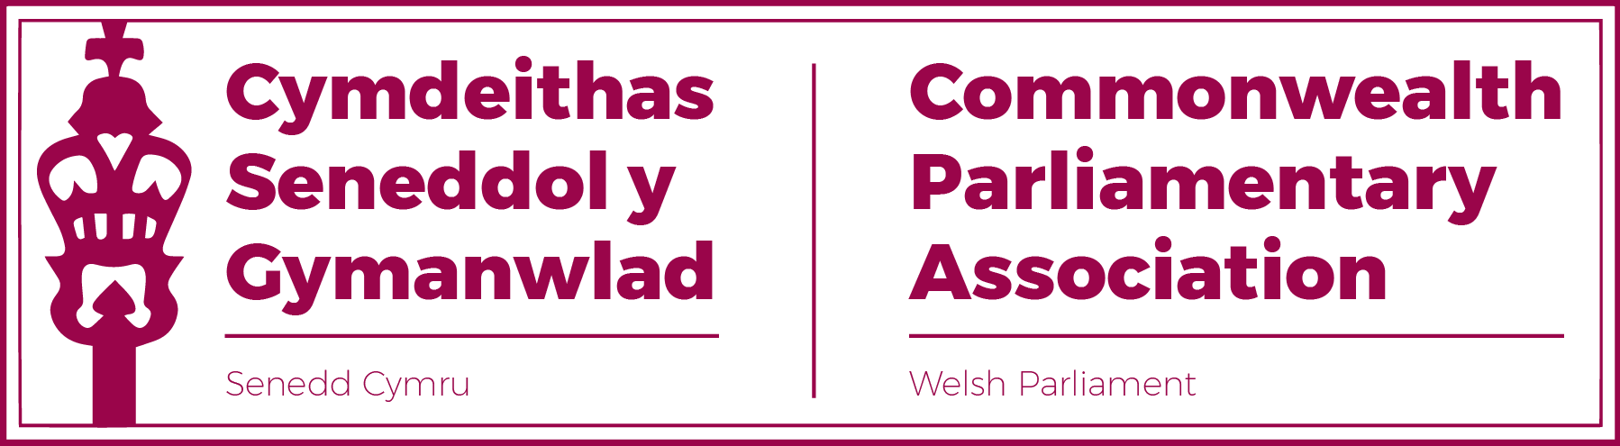

COMMONWEALTH PARLIAMENTARY ASSOCIATION
SENEDD BRANCH

ANNUAL GENERAL MEETING

Thursday 16 September 2021
12:30-13:00

AGENDA

1. Minutes of Last Meeting (16.09.21)

2. Matters Arising

3. Any Urgent Business

4. Report by the CPA Senedd Branch Chair

