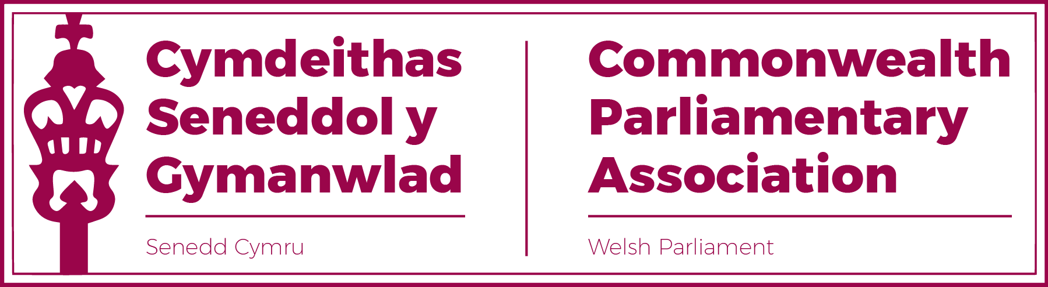

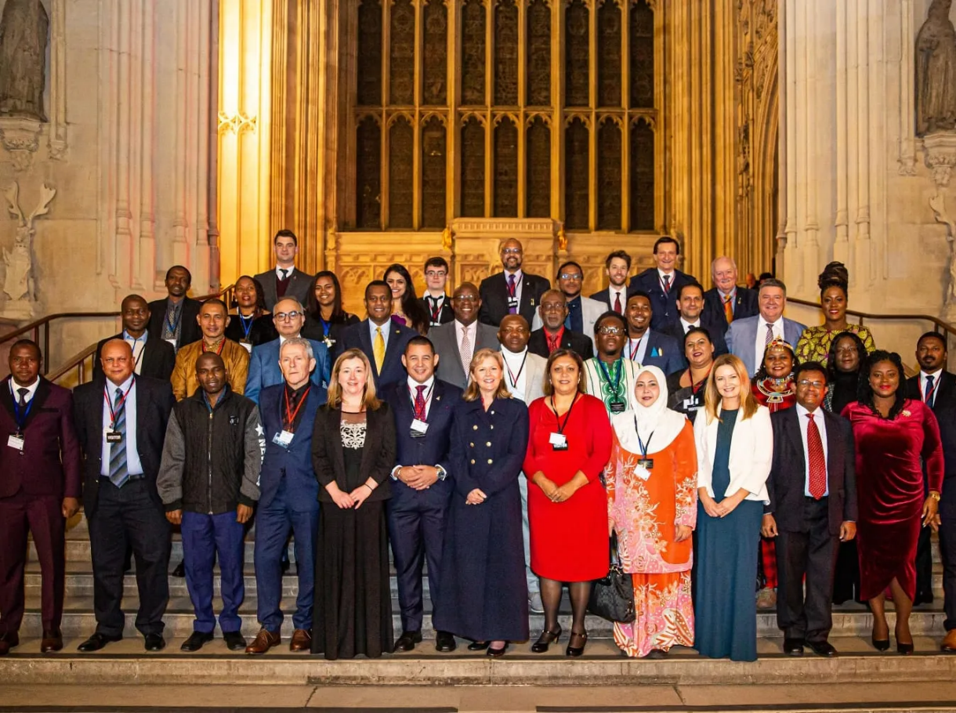

Official Photograph of the 70th Westminster Seminar

- Sam Rowlands MS
Introduction
I attended the 70th Westminster Seminar in the UK Parliament 14th – 18th March 2022 which was aimed at continuing to follow the CPA’s recent theme of Evolving Parliaments. Specifically, as the programme booklet outlined, the topics explored over the 5 days included ‘Hybrid Parliaments’ and ‘Navigating the Digital Space’ as well as more conventional sessions such as ‘Holding the Prime Minister to Account’ and ‘Conducting an Inquiry’.
Celebration
Day one of the seminar was also the day of commonwealth day celebrations; included within this was a flag raising ceremony on the Palace of Westminster estate as well as a commonwealth parliaments exhibition in Portcullis house. The day’s celebration concluded with a Commonwealth Service at Westminster Abbey which was a great sight of cultures and countries coming together to celebrate what we have in common and to understand how we can continue working together in a changing world.
Effective Parliaments
Day two explored the theme of ‘Effective Parliaments’ and covered:
- The Role of the Speaker
- Our Parliamentary Systems
- The Evolution of Parliamentary Scrutiny Tools
- Effective Committees - Insights from UK Public Accounts Committee
- Effective Parliaments and the Responsibilities of Members
- Parliamentary Privilege, Standards, and Ethics
With so much covered, there were a couple of highlights which came from the session attended by The Rt. Hon. Sir Lindsay Hoyle MP who shared his experience of being the Speaker of the House of Commons and how he sees his role of ensuring fairness in debate whilst keeping the sessions moving along at an appropriate pace. I was also struck by the comments of Lord Mann, a vastly experienced parliamentarian, who shared his thoughts on questioning techniques and making sure they are a mixture of genuine fact finding and not just looking to embarrass the government of the day.

Adapting Parliaments
Day three explored the theme of ‘Adapting Parliaments’ and covered:
- Hybrid Parliaments: How Covid-19 changes Process and Procedure
- Holding the Executive to Account
- Representation and Diversity in our Parliaments
- Navigating the Digital Space
- Engaging with the Public

I had the privilege of being a panel member for the session on Hybrid Parliaments which I found very interesting as there was such a broad range of views on how to use and support democracy through hybrid solutions. It was also helpful to hear how parliaments across the world adapted to new ways of working as quickly as possible and where powers were delegated to ensure government was still able to function appropriately through the pandemic.

The session on engaging with the public highlighted the diversity within the CPA of parliaments. With many of the commonwealth countries being of such a geography that engagement with constituents takes place much more at a local and face to face level and reminded me that there is very rarely a substitute for this.

This day also included an observation of PMQs which was undertaken by the Deputy Prime Minister, as well as a reception at the Speaker’s House in the Palace of Westminster.

Scrutiny in Practise
Day four explored the theme of ‘Scrutiny in Practise’ and covered:

- Conducting an Inquiry - Committees of the UK Parliament
- Observing a Committee Hearing
- Committee Hearing Workshop
- Committee Recommendations and Report Writing

The highlight of this day was being able to take part in a mock committee meeting with delegates and committee clerks, the topic of the inquiry being ‘Committee Hearing on the issues of Human Trafficking through Sport’. The committee heard evidence by two expert witnesses and we were able to scrutinise and challenge the information shred whilst being guided by a facilitator as to how to more effectively work together as a committee etc.
The day ended with 70th Anniversary Gala Reception and Dinner in the Palace of Westminster.
Parliaments and People
Day five was an opportunity for CPA members to join UK Members of Parliament in their constituency and to better understand the role of MPs outside of a Parliamentary Building. I didn’t take part in these visits as I had to travel to North Wales for an engagement back in my region.
Conclusions
I found this week of seminars extremely insightful and thought provoking. Most of my thinking was engaged whilst spending time with CPA delegates from Australia and Canada, with whom we share a close cultural connection. The discussions with these delegates mainly focused around the use of the federal system and how the state parliaments relate to the federal parliament and how this has developed over time – certainly plenty of food for thought!
I would highly recommend any members to attend this seminar in the future if they are able as it broadens your thinking in a context which is still relevant to who we serve in Wales.

- Natasha Asghar MS

Being on the CPA is a huge honour for me.

The trips and experiences available to members of this group were something I'd only heard of, but I was delighted to attend the conference in London.

On the first day the 6am start did not fill my heart with joy, however the flag hoisting ceremony in the House of Commons Garden was an experience I will never forget.

This was followed by a tour and history of the Houses of Parliament and later we were whisked away to Westminster Abbey to attend the Anniversary of the Commonwealth which was attended by The Prince of Wales, the Duchess of Cornwall , the Duke and Duchess of Cambridge, the Prime Minister and many more.

It was amazing to be part of such a historical event.

The following four days were filled with various seminars where delegates from Canada, Pakistan, Ghana, St Helena, Jersey and many others shared the workings, best practices and conditions of their legislative bodies.

It was clear from the outset that every single country present wanted to see diversity and change within their own legislative bodies and I was keen to learn about their plans to achieve this.

For me it was fascinating to learn how members such as St Helena which only has a small non-political government were responsible for everything. Their struggles in relation to technology, export and even their healthcare provisions were an eye opening experience. We learnt various scrutiny techniques, which will certainly come in useful when I attend committees in the Senedd.

However, above all, meeting such a wonderful group of delegates from across the world was a once in a lifetime experience, which I, alongside my colleague Sam Rowlands, (and CPA buddy on this trip) shall cherish forever.

