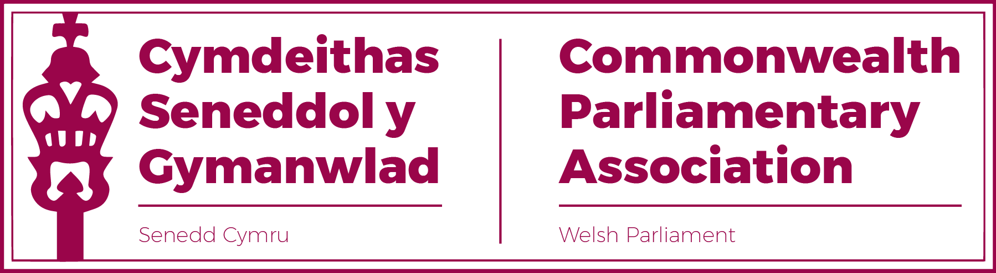

BRANCH EXECUTIVE MEETING
19 October 2021
MINUTES

Present
Rhun ap Iorwerth MS, Chair
David Rees MS (Vice-President)
Delyth Jewell MS
Alun Davies MS
Natasha Asghar MS
Sam Rowlands MS
Secretariat
Al Davies, Acting Branch Secretary
Enfys Roberts, International Relations Team

- APOLOGIES FOR ABSENCES

Apologies were accepted by Rhianon Passmore MS

- CHAIR’S WELCOME AND INTRODUCTION TO THE WORK OF THE
SENEDD BRANCH OF THE CPA.

The Chair opened by welcoming Members to the first Branch Executive Meeting of the Sixth Senedd and, under our new Branch constitution, with an enhanced and gender balanced membership.

The Branch Secretariat were introduced to Members, their roles explained and it was noted that Members had been sent a comprehensive briefing with a background to the CPA and the work of our Branch within the BIMR and the wider Association. The Secretariat were happy to help with any queries Members would have in going forward.

The Chair reiterated his intention of widening opportunities for all eligible Senedd Members throughout this term, whilst the new Branch Executive Committee could also look forward during this Sixth Senedd to participate in CPA Opportunities at Branch, Regional and International levels.

- MINUTES OF THE LAST MEETING - Paper CPA 02-21M (DOC 1)
The Minutes were agreed.
- MATTERS ARISING FROM MINUTES
None.

- REVIEW OF RECENT ACTIVITIES

Feedback and follow-up of recent Meetings, Visits,
Events and Conferences

- BIMR Covid-19 Working Group on “Agile Parliaments”
Hosted by CPA Wales – Chaired by Rhianon Passmore MS
26 March.
This had been the last of the BIMR’s presentations from the Working Group on Covid -19 and was presented by the Branch’s Rhianon Passmore MS. A summary of this session was included in the Region’s final report on this workstream.

- BIMR Commonwealth Parliamentarians with Disabilities Meeting
8 September
The Chair provided a brief context to the CPwD and its work for the benefit of new Members.
This informal meeting on 8 September had been an opportunity for the Region’s new CPwD Paul Maynard MP (from the UK Parliament) to introduce himself and to note his wish that this work remained practical and focused on making a specific difference.
- 50th BIMR Annual Conference
Belfast, NI
20-22 September
The Senedd had been represented at this Regional CPA Annual Conference – the Branch’s first face to face CPA activity since the pandemic - in Belfast last month.

The Senedd delegation had been led by the Chair, accompanied by Branch Vice-President David Rees MS, Rhianon Passmore MS and Sam Rowlands MS. The Conference theme was “Post Pandemic Parliaments”.
Our delegation had played a full part in the conference which was of interest and well organised. Members present at the conference were invited by the Chair to feed back on their experiences.
An official conference report would be produced in due course and circulated.

- BIMR Election Observer Training
13-14 October.
There had been interest from several Members to attend this training session but it had unfortunately clashed with the Official Opening of the Sixth Senedd.

Members were told that there would be other opportunities to participate in this training and the BIMR expected to offer a further programme in 2022.

- Llywydd virtual meeting with Speakers of the Western Cape (South Africa) Provincial Parliament
13 October
Following the Branch President (Llywydd) and Chair’s visit to the Western Cape Provincial Parliament (WCPP) in 2019, the Llywydd had accepted an invitation to meet virtually with both the Speaker and Deputy Speaker of the WCPP.
The discussion included the possibility of closer cooperation between our two parliaments on a range of issues, such as the work of youth parliaments and citizen engagement. There was also the hope that the Senedd could host a formal visit by the WCPP Speakers in 2022.
Members of our Branch would be kept updated with an opportunity to participate in future engagement.

- CPA UK Climate Webinar and Roundtable Series
15/28 October
The CPA UK Branch was leading work on this series, in the run up to the COP26 in Glasgow. Our Branch had been offered some places for the webinars and these had been made available in the first place to the Senedd’s Climate Change, Environment and Infrastructure Committee.
Action: Branch Secretariat to forward details to Members interested in participating in the 28 October webinar.

- FORWARD PLANNING

Forthcoming Meetings, Visits, Events and Conferences

- BIMR CWP Standing Committee Meeting
Virtual
November 2021 (Date tbc)
The BIMR was expecting confirmation from our Regional Women Parliamentarians Chair for the date of the next meeting of the Steering Committee in November.

- CPA UK Women's Roadshows :
- Tuesday 9 November (15:00-18:00)
- Tuesday 22 November (08:00-11:00)

CPA UK would be hosting a second series of Women’s Roadshows for women parliamentarians who had experienced or who were concerned about online abuse and its impact on democracy.
The Senedd Branch had been invited to nominate up to five women parliamentarians to attend one of the sessions which would take the form of a three hour workshop.
Action: Secretariat to forward details so that places offered to the Branch Executive’s three women Members as well as Jane Dodds MS (WLD) in the first instance, with Members encouraged to share the opportunity with other women within their party groups.
2022
The Chair noted, for reference, the likely dates and locations of next year’s Regional and International CPA Conferences will be held.

- 51st BIMR Annual Conference
Isle of Man
May 2022 (TBC)

- 65th Commonwealth Parliamentary Conference (CPC)
Halifax, Nova Scotia,
Canada
August 2022

7. NEW ITEMS / ANY OTHER BUSINESS

Selection of Branch Commonwealth Women Parliamentarians (CWP) Steering Committee Representatives.
The Chair noted the need for the Branch to select our Members to represent our Branch on the Region’s Women Steering Committee for this Sixth Senedd. The New Branch Rules state that:
“Two women Members of the Branch Executive Committee, from different political parties, will represent the Branch as its Regional CWP Steering Committee Members.

These positions may be rotated, as necessary, within the Senedd term to accommodate interest from other women Members on the Executive Committee. “
It was ascertained that all three women members of the Branch Executive Committee were interested in serving on the Steering Committee.
A possible suggestion of how these places could be shared between Members over the duration of the Sixth Senedd term was discussed. It was agreed that sharing the allocated places would be ideal, but that this would need to be discussed with Rhianon Passmore MS, and her agreement sought, given it was not possible for her to be present at the meeting.
Action: Secretariat to facilitate discussions between Branch Executive Women Members to decide upon an agreeable rotation for the sharing of these job roles.

Selection of Branch Commonwealth Parliamentarians with Disabilities (CPwD) Champion.

Following the former Branch DPO and Vice-President Ann Jones standing down at the last election, the Senedd had now been asked to select a new Branch Champion for our CPwD Network.
The Chair relayed to Members the advice from the Region’s Secretary, Jon Davies of the criteria for our new Champion which included the need for our parliamentarian to have a “track record of championing disability rights”

Actions:
- The Chair to write to Ann Jones to thank her for her
contribution to this role on behalf of our Branch as well as
the Region’s Chair.
- The Secretariat to circulate a notice to all Members of the
Senedd to advertise this role and to invite expressions of
interest from those interested in the opportunity.

- Selection of Branch Representative for BIMR “Climate Emergency” working Group.

The Chair noted that he was keen for a suitable Members to represent the Branch in the Region’s new strategic working group on the “Climate Emergency”.
Members agreed that this opportunity should, in the first instance, be offered to Llyr Gruffydd MS, Chair of the Climate Change, Environment and Infrastructure Committee; before being opened to all Members if necessary.
Action: The Chair to write to Llyr Gruffydd.

8. FUTURE MEETING DATE:
January 2022 (TBC)

END OF BUSINESS

