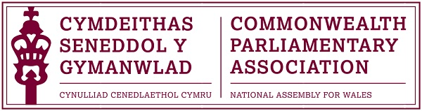

2017 Commonwealth Day Report
by
CPA Wales Branch Representative
Matthew Walker.

In March of this year myself (Matthew Walker) and Samantha Ellis were given the opportunity to attend the Commonwealth Day celebrations in London. This is an annual event bringing together the 52 countries of the Commonwealth around one central theme, this year being "a peace building Commonwealth." The day is used to promote the links between our countries and our shared ideals, proving that we have more in common with one another than we have differences.

The Commonwealth Parliamentary Association put together a programme of discussion around the theme of "a peace building Commonwealth" which myself, Samantha and other youth representatives from other commonwealth states took part in. The main aim of these discussions were to address the questions of the role of young people in a peace building Commonwealth.

The day started with an address by the chairperson of the CPA and a guest speaker, Mpaka Mwine, youth MP in Uganda. It was fascinating to hear her speak on how the Ugandan Parliament has incorporated youth into its procedures. Youth MPs in the main parliament are an interesting step forward in participation of young people and her accounts on how involving young people in government decisions go a long way to promote a peace building Commonwealth were incite full.

What followed were round table discussions with Commonwealth youth parliamentarians and other attendees around the central theme of the event. We shared experiences and best practise of young people involved in building peace. There were thoughts on youth parliaments, grass roots education and a focus on religious and cultural inclusive education. Being from a country such as Wales, which could be seen as somewhat of a stable country in terms of peace, whilst I felt we didn't have much to add, listening to the experience of other young people from around the world, some of which are from more unstable nations, was fascinating and I take away many a story from the people I met. The ideas and advice shared can help us all not only keep peace within our nation but promote the peace process in others.

We then proceeded to feedback the discussions from our individual groups to the wider room, again with more added to the discussion around war and the protection of young people in those environments as well as the part developing countries have to play in the peace process.

We then proceeded to Westminster Abbey for the main event of the day, the Commonwealth Day Service in the presence of members of the Royal Family and the Head of the Commonwealth, Her Majesty the Queen. The Commonwealth Day service in the Abbey is the biggest cross cultural, multi-faith service of its kind in the world, and it was a pleasure to be a part of. If ever there is an advert for a peace building Commonwealth, this service was it. Members of every faith and denomination imaginable, coming together and sharing a stage in celebration of our shared principles and values. We truly do have more in common than we do differences.

All in all the experience I had at the Commonwealth Day events were eye opening. They helped me better understand the concept of a peace building Commonwealth and the role that young people can play in it. We can be agents of change and build a better world for tomorrow."

