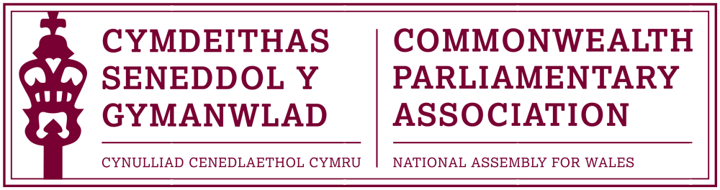
Report of the
COMMONWEALTH PARLIAMENTARY ASSOCIATION
64th Commonwealth Parliamentary Conference
22-29 September 2019
Kampala,Uganda
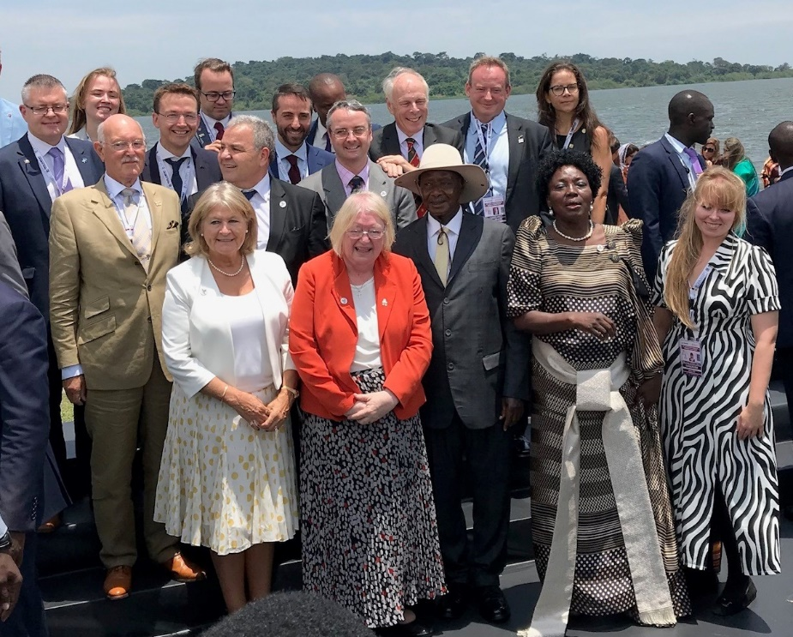

Photo: CPA Wales delegation and BIMR delegates pictured with
Ugandan President Yoweri Kaguta Museveni and Speaker Rebecca Kadaga

Delegation:
Ann Jones MS (Delegate), Branch Vice-President
Delyth Jewell MS (Observer)

Content:

- Background, Summary and Highlights p.3

- Report by Branch Vice-President, Ann Jones MS p.5

- The Visit to Mbale - Report by Delyth Jewell MS p.8

- Conference Programme and Concluding Statement p.11

- Acknowledgments p.15

Background, Summary and Highlights.
The Commonwealth Parliamentary Conference (CPC) is the annual meeting of the Commonwealth Parliamentary Association (CPA). It is one of the largest Commonwealth meetings, bringing together some 500 Parliamentarians representing over 180 parliamentary Branches, from across the Association’s nine Regions.
The 64th CPC took place between 22-29 September 2019 in Kampala, Uganda. The Conference theme was “Adaption, Engagement and Evolution of Parliaments in a Rapidly Changing Commonwealth”

The CPA Wales Branch, as part of its fee structure, was invited to send one delegate with the option of being represented by additional conference “observer” participants.
As the 64th CPC incorporated the 6th Commonwealth Women Parliamentarians (CWP) meeting, it was decided that a woman Member of the Senedd should lead so as to ensure participation at this triennial conference, at which the CWP Chair is elected
(and at which only women delegates are eligible to vote.)

Deputy Presiding Officer Ann Jones MS, in her capacity as the Branch Vice-President, was selected to lead the delegation to this CPC. Delyth Jewell MS was selected as the delegation Observer, from a number of applications received, by Members of the Branch Executive Committee. The visit was supported by Al Davies, CPA Wales Branch Acting Secretary.

The conference provided excellent opportunities to raise the profile of the Senedd and of Wales and for the delegation to play an active role within the conference proceedings; in particular:
- as part of the Commonwealth Women Parliamentarians sessions, at which Ann Jones
MS gave a keynote address;
- the Workshop on Parliamentarians with Disabilities which was Chaired by Ann Jones
MS and at which Delyth Jewell MS acted as a session rapporteur.

The conference also provided excellent networking opportunities with parliamentarians and officials from within our own British Islands and Mediterranean Region (BIMR) as well as from other CPA Regions.
The delegation was pleased of an informal meeting with Deputy Speaker Beverley Ann Schäfer, of the Western Cape Parliament, to discuss a range of issues including further engagement between our Parliaments (the Llywydd and CPA Wales Chair, Rhun ap Iorwerth MS, undertook a visit programme to the Western Cape Parliament as part of their visit to Botswana and South Africa in February 2019).
The CPA Wales Branch has long been interested in the work of the Welsh Government’s Wales for Africa Programme as well as the long established links between Wales and Uganda.
The location of this year’s CPC in Uganda provided an opportunity for the Branch and the Senedd to learn more of the Wales for Africa Programme’s work in the Mbale region (in the East of Uganda) in a programme facilitated by the Welsh Government for Delyth Jewell MS.

Report by Branch Vice-President, Deputy Presiding Officer Ann Jones MS
Having had the honour to represent the Welsh Parliament along with Delyth Jewell MS and accompanied by Al Davies, these are my thoughts on the Conferences.
The Commonwealth Women Parliamentarians Conference (CWP) took place over two days and took the working title CWP at 30 years: Achievements and unfinished business – Looking forward to the next 30 years.

Photo: Ann Jones MS Chairing CPC Workshop in Kampala

The Conference was given over to sessions around this theme and allowed for a lot of reflection over the last 30 years and then solutions and recommendations for the future.
I was asked to speak and participate in the session Empowering Women as Effective Legislators in the 21st Century and in doing so was able to inform delegates present that the Senedd had been the 1st Legislature to return a true 50:50 ratio and had also produce a cabinet of more women than men. Women politicians in Wales have held powerful positions such as Minister for Finance; Minister for Economy & Transport; Minister for Local Government and Public Services and virtually every portfolio within Welsh Government within the 20 years.

I drew attention to my own experience of taking through Legislation as a back bencher and now as DPO how I am developing Women in Political and Public Life.
The session was well attended and we heard also from other Parliaments of how they are progressing.

The 2nd session was around Combatting Bullying and Harassment Within Parliaments. It is disappointing to hear of the struggles which many women are still facing and to see that social media is playing a huge role in the bullying and harassment of parliamentarians; not just women, however the effect of women who on a daily basis in some regions are facing what thankfully we have managed to address I believe through our Dignity and Respect agenda. Many of the women delegates referred to incidents that quite frankly we would not tolerate in Wales are often going unchallenged.

The 3rd Session was themed as Promoting Women to Leadership Positions and Senior Portfolios and it was pleasing to hear many delegates refer to the contribution I had made previously and the fact that many would be citing our positive experience here in Wales.
The 4th Session focussed on The Importance of Mentoring for New Parliamentarians and, again presented an opportunity to highlight the work of our Assembly Commission around preparing information for would be candidates and also how political parties look to assist those seeking election.

Election of the CWP Chair
The ballot for the CWP Chair always attracts much interest and this time was no exception. There were two candidates standing: Shandana Gulzar Khan, of the National Assembly of Pakistan and Tara Rivers JP, MLA of the Legislative Assembly of the Cayman Islands. Both candidates spoke well and after voting Shandana Gullzar Khan was declared successful and will serve as the CWP Chairperson for the next 3 years.
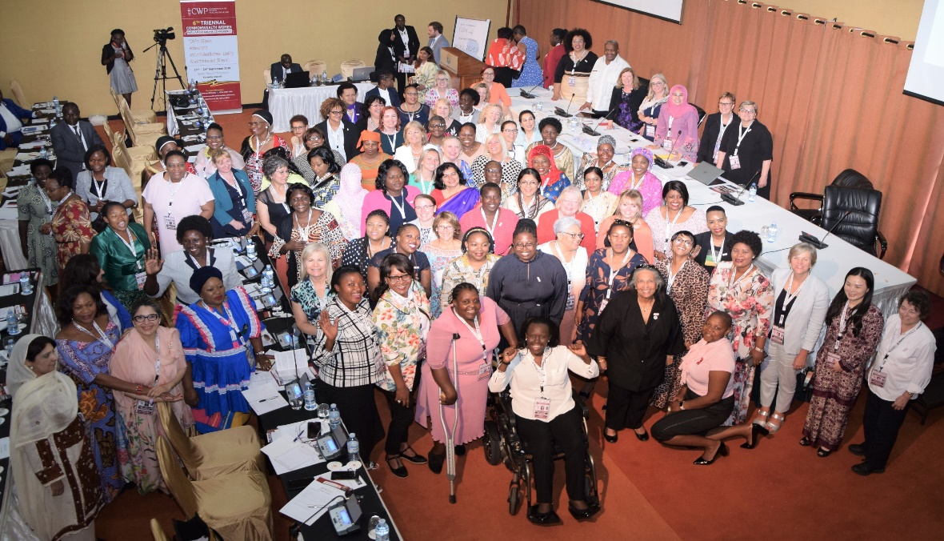
One point I feel which should be raised is that the timing of the CWP coincides with the CPA Small Branches conference. This scheduling is not, in my opinion, fair and many women delegates were having to make a choice as to which conference they would attend.

After the official opening of the CPC there were several workshops and I was pleased to have been asked to Chair the session on The Role of Parliaments in Facilitating Persons with Disabilities as Electors, Candidates and Legislators. It was pleasing to be involved following my attendance at the inaugural CPA Conference for Parliamentarians with Disabilities, hosted by the Nova Scotia Branch in 2017. One of the recommendations from that gathering was to ensure that this subject remained high on the CPA agenda.

It was of great interest to learn more of the challenges which many parliamentarians with disabilities were facing and also of the difficulties which some older parliaments had in adapting to be suitable for all Members as well as visitors. I was pleased of the opportunity to showcase the Senedd as a truly accessible parliament, open to all.
The session was well attended and the panel assembled had a wealth of experience which led to a lively Q & A and round table discussions.

Assembly Tweet following Ann Jones MS’ Chairing of the conference workshop
https://twitter.com/AssemblyWales/status/1177593898492936193

Mbale Visit
Report by Delyth Jewell MS

Between 24th and 25th September of this year, I had the privilege of visiting communities in Mbale, Uganda as part of a visit organised by the Commission staff and coordinated by Wales for Africa. It was a thoroughly enriching experience.

On 24th September, we set off early from the hotel in Kampala for a five-and-a-half-hour car journey to Mbale. During the course of the journey, we passed tea and sugar plantations, forests, towns and villages, and crossed the Nile at its source.
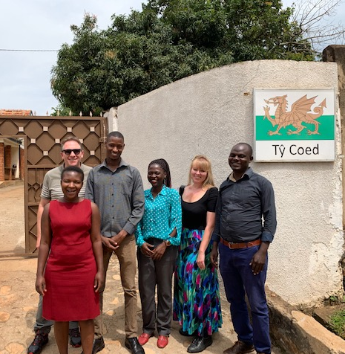
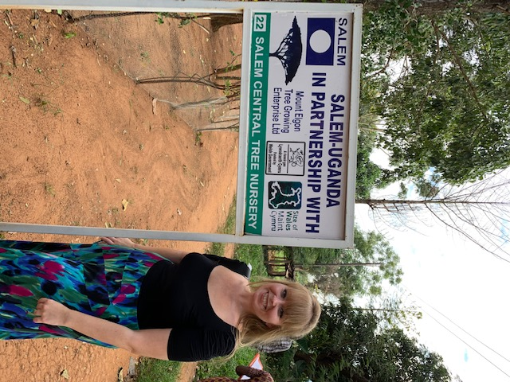

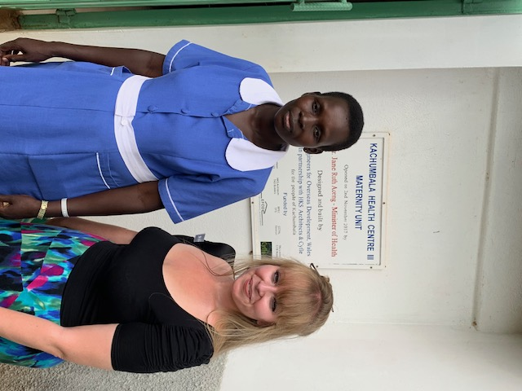
Once in Mbale, we met Directors of the Tree Planting Programme, PONT, and Size of Wales for a briefing, before visiting the Kachumbala Maternity Centre (which was built by Carmarthenshire-based Engineers for Overseas Development.

We were given a tour of the facilities and were able to speak to a midwife about the daily challenges she faces in the role. They were evidently very grateful for the centre, though they still have difficulties in always getting access to the drugs they need.

We then called at Salem, which is a single development housing a health centre, a school and a midwife college. It is a tree planting partner for the programme, and as well as being given a tour of the site, I was allowed the honour of planting a mango tree in the grounds. After our tour, the Directors of the programme invited us to have tea, cake and samosas with them and to discuss the importance of combating climate change. We talked about their plans for the future, and the central importance of the relationship between Wales and Uganda. It was an eye-opening and enjoyable conversation.

In the evening, Wales for Africa had arranged an informal meal with some of the partners in our hotel, where we had the opportunity to socialise and share stories about our different countries. We were joined by Sophie Weeks and Marga Quince, who were both taking part in the International Learning Opportunities programme.

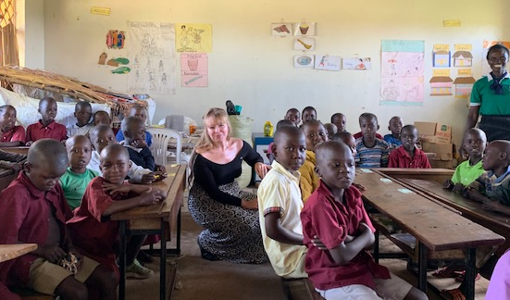
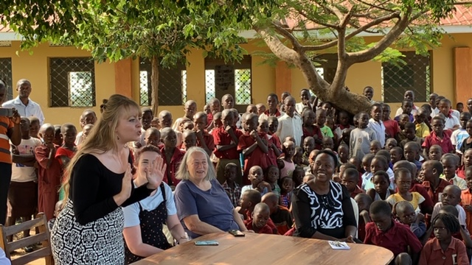

On the 25th of September, we visited two schools. We took part in an assembly in the first school where children sang and danced for us, and I was delighted to be able to teach them to say “Bore da”.

After the visit, we joined members of the Sunu Women’s Group and were shown their bee keeping project, before taking part in a gathering where the women performed a play for us. This was in many ways the highlight of a thoroughly inspiring trip. The women there were incredibly warm and welcoming and were keen to hear stories about Wales, as well as to show their projects to us. They made me feel like another world is possible. While we were with the women, we were visited by a Motorcycle Ambulance, and I understand that the bikes were bought with a DfiD grant, whilst the volunteers are trained by PONT.

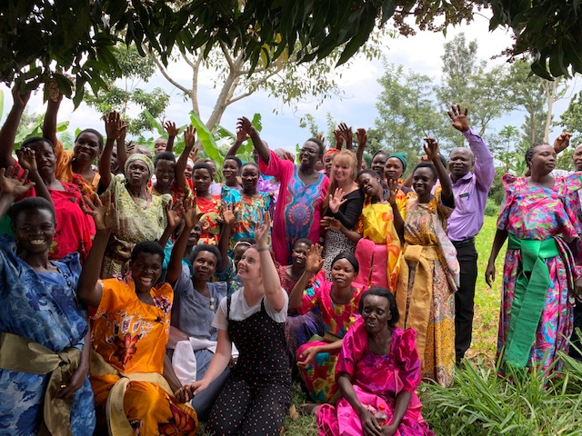
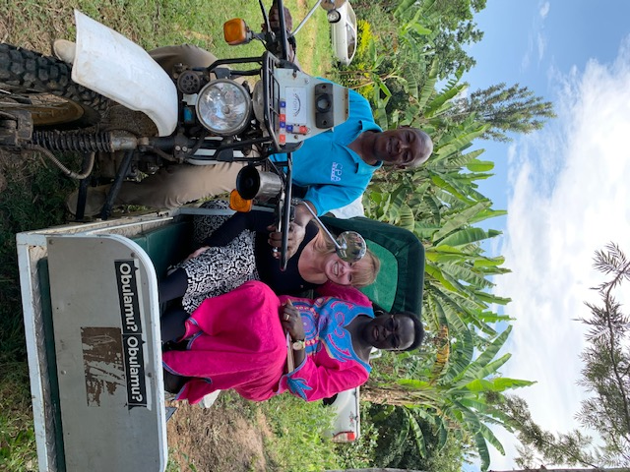

I found the entire two-day trip enlightening, enriching and really, truly enjoyable. It was a tremendous privilege for me to take part in the visit and to see first-hand the fantastic work that Wales for Africa, PONT and Size of Wales are undertaking in the area.

I hope that I will have an opportunity in the future to visit the projects again, in particular the Sunu Women’s Group, who left a strong impression on me. I am very grateful to have had this wonderful experience.

64th Commonwealth Parliamentary Conference, 2019, Uganda: Outline Programme

Main Conference Theme: ‘Adaption, engagement, and evolution of Parliaments in a rapidly changing Commonwealth'

(DAY 1) SUNDAY 22 September 2019
Arrival of the CWP Steering Committee, Co-ordinating Committee Members, Executive Committee Members, Small Branches Conference Delegates, CWP Conference Delegates and Regional Advisors and/or Secretaries.
(DAY 2) MONDAY 23 September 2019 Arrival of CPA Executive Committee Members.
08:00 – 10:00: Meeting of the CPA Regional Secretaries

09:00 – 13:00: Meeting of the Commonwealth Women Parliamentarians (CWP) Steering Committee |  | 09:00 – 13:00: Meeting of the CPA Small Branches Steering Committee
14:00 – 17:30: 6th triennial Commonwealth Women Parliamentarians (CWP) Conference – CWP Conference theme: CWP at 30 years: Achievements and Unfinished Business – Looking forward to the next 30 years.  o CWP Conference Session 1: The Importance of Mentoring for new Parliamentarians.  o CWP Conference Session 2: Promoting Women to Leadership Positions and Senior Portfolios.  To view workshop data papers please click here. | 14:00 – 17:30: 37th CPA Small Branches Conference - Conference Theme: Adaption, engagement, and evolution of Parliaments in a rapidly changing Commonwealth.  o CPA Small Branches Workshop 1: Talk-show panel: How do Commonwealth countries (CPA Small Branches in particular), that all ostensibly base their Parliamentary procedures and practices on the Westminster model, implement culturally appropriate measures including institutional design?  o CPA Small Branches Workshop 2: TED-style Talk - Innovation in Parliament: The possible effects of the United Kingdom’s ‘Brexit’ on CPA Small Branches  To view workshop data papers please click here. |  | 14:00 – 17:30: Governance Review Working Group
16:00 – 18:30: CPA Co-ordinating Committee Meeting followed by the Audit Subcommittee meeting and the CPA Headquarters Premises Working Group Meeting.

(DAY 3) TUESDAY 24 September 2019
Arrival of all Delegates, Observers, Accompanying Persons and Society of Clerks-at-the-Table and other participants.
09:00 – 17:30: Meeting of the main CPA Executive Committee (including Finance Subcommittee and Planning & Review Subcommittee) | 09:00 – 17:30: 6th triennial Commonwealth Women Parliamentarians (CWP) Conference (continued) including Commonwealth Women Parliamentarians (CWP) Business Meeting and CWP Chairperson Election.  o CWP Conference Session 3: Empowering Women as Effective Legislators in the 21st century.  o CWP Conference Session 4: Combatting Bullying and Harassment within Parliaments.  To view workshop data papers please click here. | 09:00 – 17:30: 37th CPA Small Branches Conference (continued) including CPA Small Branches Business Meeting and CPA Small Branches Chairperson Election.  o CPA Small Branches Workshop 3: Mentoring Session: What professional development and training is required to develop focused and talented Parliamentarians?  o CPA Small Branches Workshop 4: Workshop Session: Climate change and the possible effects on CPA Small Branch economies and development  To view workshop data papers please click here.
19:30: Dinner for CPA Executive Committee Members, CPA Small Branches Steering Committee and conference delegates, CWP Steering Committee and conference delegates and CPA Regional Secretaries.
(DAY 4) WEDNESDAY 25 September 2019
• 09:00 – 17:30: Meeting of the main CPA Executive Committee (continued)
• Optional Tour Day for all other delegates.
(DAY 5) THURSDAY 26 September 2019
Official Opening of the 64th Commonwealth Parliamentary Conference
10:00 – 12:30: Official Opening of the 64th Commonwealth Parliamentary Conference
14:00 – 15:00: Briefing for delegates, observers and secretaries followed by briefing for workshop moderators, discussion leaders, rapporteurs and session secretaries. Also briefing on election of the Treasurer and briefing for spouses/partners accredited to the conference.
15:30 – 18:00: 64th CPC Workshop A: Talk-show panel - Climate Change: Achievements, Challenges and Efficacy of Parliamentary Interventions (Host Branch Topic) | 15:30 – 18:00: 64th CPC Workshop B: TED-style Talk – Innovation in Parliament: the impact of science and technology on how Parliament works today.  To view workshop data papers please click here. | 15:30 – 18:00: Meeting of Society of Clerks at-the-Table (SOCATT)
18:30 – 19:30: CPA Secretary-General’s reception for Clerks, Secretaries to Delegations and their spouses/partners and accompanying Officials (invitation only).

20:00 – 22:00: Dinner hosted by the Speaker of the Parliament of Uganda for all delegates.

(DAY 6) FRIDAY 27 September 2019
09:30 – 13:00: 64th CPC Workshop C: Mentoring Session – The role of Parliament in facilitating persons with disabilities as electors, candidates and legislators. | 09:30 – 13:00: 64th CPC Workshop D: Youth Roundtable – Strategies to deal with Youth Unemployment (Youth Related Topic).  To view workshop data papers please click here. |  | 09:30 – 13:00: 64th CPC Workshop E: Talk-show panel - Combatting rapid urbanisation and rural decline – A challenge for the Commonwealth. |  | 09:30 – 13:00: Meeting of Society of Clerks at-the-Table SOCATT (continued)
14:30 – 17:00: 64th CPC Workshop F: TED-style Talk – Innovation in Parliament – The possible effects of United Kingdom Brexit on Small Branches (Small Branches Topic). | 14:30 – 17:00: 64th CPC Workshop G: Mentoring Session – Fostering a Culture of Respect, Fairness and Dignity: Sexual Harassment has no place in legislatures (Gender Topic).  To view workshop data papers please click here. |  | 14:30 – 17:00: 64th CPC Workshop H: Workshop – The Role of Parliament in the doctrine of Separation of Powers; Enhancing Transparency and Accountability. |  | 14:30 – 17:00: Meeting of Society of Clerks at-the-Table SOCATT (continued)
18:00 – 20:00: CPA Commonwealth Parliamentary Lecture: Topic: Maintaining Stability, Evolution, Dynamics and Challenges of Terrorism in Eastern Africa. All delegates to attend. |  | 18:00 – 20:00: Dinner hosted by the Uganda Head of State for Speakers, Heads of Delegations and Members of the Executive Committee. |  | 18:00 – 21:00: SOCATT Dinner hosted by Secretary CPA Uganda Branch (invitation only).

(DAY 7) SATURDAY 28 September 2019
09:30 – 12:30: 64th CPC Workshop I: Workshop - Post Legislative Scrutiny (PLS) - a dimension of the oversight function of Parliament. How is this represented within different political systems?  To view workshop data papers please click here. | 09:30 – 12:30: 64th CPC Workshop J: Talk-show panel: How the Updated CPA Benchmarks for Democratic Legislatures has been used to strengthen the capacity of CPA Legislatures.
14:00 – 16:30: 64th CPA General Assembly. All delegates.

17:00 – 18:00: Meeting of the new CPA Executive Committee and Election of the CPA Vice-Chairperson.

18:30: Cultural Gala. All delegates.

Conference Concluding Statement
The Conference Concluding Statement for the 64th Commonwealth Parliamentary Conference (CPC) contains: .

• the main outcomes of the conference,
• a summary of the workshop discussions, and
• the recommendations that were either endorsed or noted by the Members in attendance.

And can be downloaded by Clicking here
Images from the events of the 64th CPC are available at: www.cpahq.org/cpahq/flickr

Acknowledgments

The CPA Wales Branch would like to put on record its sincere gratitude to:
The CPA Uganda Branch
The CPA HQ Secretariat
Jon Townley, Head of Wales for Africa Programme
The Community in Mbale, Uganda.

