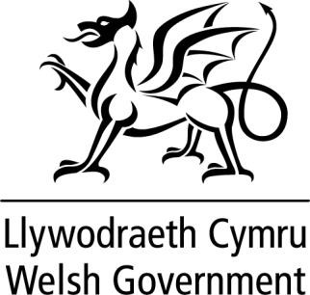

WRITTEN STATEMENT BY
THE WELSH GOVERNMENT

TITLE | Local Authority Electoral Boundary Review - Update
DATE | 23 September 2021
BY | Rebecca Evans MS, Minister for Finance and Local Government.

On 16 June I wrote to members to set out the current position in respect of the current programme of Electoral Arrangements Reviews. I also set out the process by which I intend to communicate my decisions about each area.

This included my commitment to provide regular updates to members through written statements. This is the eighth of these statements.

On 22 September I wrote to the Leader and Chief Executive of the County of Blaenau Gwent to confirm my decision to accept the recommendations of the Local Democracy and Boundary Commission for Wales with a modification, in respect of the County of Blaenau Gwent.

The Local Democracy and Boundary Commission for Wales Final Recommendations Report for the County of Blaenau Gwent can be found here. The modification made to these recommendations is set out in the annex to this statement.

I also wrote to the Leader and Chief Executive of the County Borough of Conwy to confirm my decision to accept the recommendations of the Local Democracy and Boundary Commission for Wales with modifications, in respect of the County Borough of Conwy.

The Local Democracy and Boundary Commission for Wales Final Recommendations Report for the County Borough of Conwy can be found here. The modifications made to these recommendations are set out in the annex to this statement.

I also wrote to the Leader and Chief Executive of the City and County Borough of Newport to confirm my decision to accept the recommendations of the Local Democracy and

Boundary Commission for Wales with a modification, in respect of the City and County Borough of Newport.

The Local Democracy and Boundary Commission for Wales Final Recommendations Report for the City and County Borough of Newport can be found here. The modification made to these recommendations is set out in the annex to this statement.

Further information will be provided once I have made decisions about other areas.

Annex

Modifications made to the Commission’s Final recommendations for electoral arrangements in the following areas.

County of Blaenau Gwent

- The Commission recommended the single name of Beaufort. The electoral ward will be given the Welsh language name of Cendl.

County Borough of Conwy

- The Commission proposed retaining the single name of Betws yn Rhos. The electoral ward will be given the single ward name of Betws-yn-Rhos
- The Commission proposed a single name of Craig-y-Don. The electoral ward will be given the single ward name of Craig-y-don.
- The Commission proposed single name of Pensarn Pentre Mawr. The electoral ward will be given the single electoral ward name of Pen-sarn Pentre Mawr
- The Commission recommended the Welsh language name of Betws-y-Coed a Threfriw and the English language name of Betws-y-Coed and Trefriw. The electoral ward will be given the Welsh language ward name of Betws-y-coed a Threfriw and the English name of Betws-y-Coed and Trefriw

City and County Borough of Newport

- The Commission proposed retaining the Welsh language electoral name of Y Gaer and the English name of Gaer. The electoral ward will be given the single name of Gaer.

