Annual Equality Report
April 2014 – March 2015

Contents
Foreword 1
Glossary of terms 2
Encouraging and Widening Public Engagement 5
Presiding Officer’s Women in Public Life Campaign 5
Education and Youth Engagement 6
Promoting Equality 10
Welcoming People 12
Accessible estate 14
British Sign Language interpretation of First Minister’s Questions 14
Going forward 14
Supporting our Workforce:
The Assembly Commission as an employer of choice 17
Arrangements to support Commission staff 17
We have a number of policies and initiatives in place to support our staff and to help us promote equality, foster good relations and remove discrimination. These include: 17
Benchmarking 18
Assembly Apprenticeship Scheme 19
Apprenticeship Awards Cymru 2014 19
Staff networks 20
BME Action Plan 21
Learning and Development 22
Going forward 22
Supporting Assembly Members, their Staff and Assembly Business 25
Online Equality Training 25
Equality Information, Advice and Guidance 25
Access Fund 25
Committees 26
Going forward 28
Embedding Equality into our work 30
Monitoring and Reporting 30
Building Equality Considerations into Our Work 30
Procurement 31
Internal Audit of Equality 31
Going forward 31
Annex A: Progress on Achieving Equality Objectives 32
Annex B: Monitoring workforce and Recruitment Data 54
Annex C: Equal Pay Audit 2015 72

Foreword
The Assembly Commission is committed to the principles of equality, diversity and inclusion. We know that everything that we do is in the interest of all of the people of Wales that we are here to represent.
Our most important resource is our workforce and we would like to thank our staff for their all of their hard work engaging with people across Wales, for promoting equality and for supporting the operation of the Assembly as an accessible parliament and inclusive employer. They continue to provide outstanding service for members of the public, Assembly Members and colleagues.
This report is a celebration of all of that hard work and is designed to give a snap shot of what we do. Whilst it is not possible to highlight everything in this report, it will give readers an insight into the National Assembly for Wales’ work on equality.
This year, we are particularly proud of our increased commitment to engage more young people in our work and we are especially excited by the further development of the Women in Public Life campaign.
We have gained further external recognition for our work to be inclusive and accessible and we are delighted to be acknowledged as an organisation with equality of opportunity at its heart.
This is the third annual report relating to our Equality Plan 2012-2016 and it highlights the work we have undertaken to engage with the people of Wales, to support the diverse needs of our staff, to support Assembly Members and Assembly Business, and to embed equality in our organisation.
Included in this document is an update on our Equality Plan Action Plan as well as reports on workforce equality data, recruitment equality data and an equal pay audit.
We welcome any feedback that you may have on the report, on our approach to equality or the accessibility of the Assembly.

Dame Rosemary Butler AM  Presiding Officer and Chair of the Assembly Commission | Sandy Mewies AM  Assembly Commissioner with responsibility for Equality | Claire Clancy  Chief Executive and Clerk to the National Assembly for Wales

Glossary of terms
Assembly Business – the work undertaken by Assembly Members in the National Assembly for Wales, including plenary debates, committees and constituency work.
Assembly Commissioners – the four Assembly Members who, alongside the Presiding Officers, are responsible for the work of the staff in the Assembly Commission.
Assembly Committees - a group of Assembly Members who meet to scrutinise the policies of the Welsh Government, holding Ministers to account, and examining proposed laws.
Assembly Estate – the buildings that make up the National Assembly for Wales. The Senedd, Tŷ Hywel and the Pierhead are based in Cardiff Bay, and the Public Information Office is based in Colwyn Bay. The Senedd is the main building where the political work of the Assembly takes place. Tŷ Hywel is the administrative office supporting the running of the Assembly. The Pierhead is a public exhibition and events space.
Assembly Members – elected politicians that make up the National Assembly for Wales. The 60 Members represent the different areas of Wales.
Cardiff Travel To Work Area - identified by the Office of National Statistics as Cardiff and the surrounding area where people who work in Cardiff may live. In addition to Cardiff, it covers parts of the following areas; Newport, Caerphilly, Merthyr Tydfil, Rhondda Cynon Taf and Vale of Glamorgan.
Constituencies – the areas of Wales represented by 40 Assembly Members. The remaining 20 Assembly represent the different regions of Wales – North Wales, Mid and West Wales, South Wales West, South Wales Central and South Wales East.
Consultation – the work that we do to find out what people in Wales think about the issues that the Assembly Members are considering.
Equality Impact Assessments (EQIAs) - a process designed to ensure that a policy, project or scheme does not discriminate against any disadvantaged or vulnerable people.
First Minister’s Questions (FMQs) – The First Minister is the leader of the Welsh Government. First Minister's Questions is the name given to the weekly questioning of the First Minister during a dedicated plenary session.
Management Board – the group of senior staff who take forward the management, operational and policy matters on behalf of the Assembly Commission. The Management Board comprises the Chief Executive, Directors and each Head of Service.
National Assembly for Wales (Assembly) – made up of 60 Assembly Members from across Wales. They are elected by the people of Wales to represent them and their communities, make laws for Wales and to ensure the Welsh Government is doing its job properly.
National Assembly for Wales Commission (Assembly Commission) – the body which provides property, staff and services to support the Assembly Members. The Commission is chaired by the Presiding Officer and four other Members nominated by the main political parties. The Commission has responsibilities as an employer and as an organisation that supports Assembly Members and interacts with the public. The services the Commission offer to the public include welcoming visitors to the Assembly estate, providing information to people and visiting schools and community groups across Wales.
Plenary – a meeting of all 60 Assembly Members to discuss Assembly Business.
Presiding Officers – the Assembly Members nominated by the main political parties to chair plenary debates and to represent the National Assembly for Wales. The Presiding Officer is Dame Rosemary Butler AM, and the Deputy Presiding Officer is David Melding AM.
Welsh Government – is responsible for developing and implementing policies. The National Assembly for Wales scrutinises the work of the Welsh Government and makes sure it’s doing its job properly.

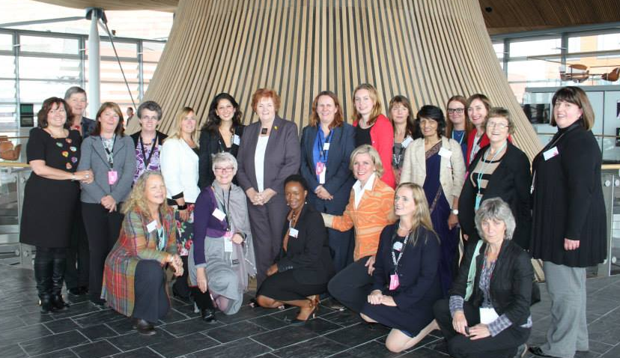
The Presiding Officer joins participants in the Development Scheme for an event in the Senedd.

#PaintItPurple
As part of celebrations to mark International Women’s Day 2015, the Presiding Officer attended 13 events across Wales and spoke to over 1000 women of all ages and from all walks of life. In addition, the Senedd, Assembly website and social media platforms all turned purple in support of the international campaign to promote women's equality -#PaintItPurple.

Encouraging and Widening Public Engagement
A key priority for the Presiding Officer and Assembly Commission is to enable more people to connect with the Assembly and to engage with our work. Over the last year we have interacted with a diverse range of people across Wales and welcomed thousands of people from across the world.
We continue to engage with a broad range of groups and individuals through:
- the Presiding Officer’s Women in Public Life scheme;
- the development of our education and youth engagement work;
- community events such as Black History Month, Cardiff Mela, and Swansea Pride;
- reaching out to a broad range of people to participate in Assembly Business;
- increasing our use of social media to reach people across Wales and across the world; and
- welcoming people to our estate for tours, events and to watch Assembly Business.

Presiding Officer’s Women in Public Life Campaign
The Women in Public Life campaign seeks to identify practical solutions for enhancing women’s representations in various areas of public life, including public appointments, other decision-making roles and positions of influence. Now in its fourth year the campaign has further developed some of the existing projects and launched new initiatives:
- The Women in Public Life Portal is an online space that includes details of public appointments in Wales, profiles of inspirational women, informative blog entries and details of upcoming events of interest. It has significantly increased its social media presence, becoming one of the leading voices in the debate on gender equality in Wales. The portal is run in partnership with Women Making a Difference, a third sector organisation which encourages and supports women to become active citizens. The portal can be seen at: www.womenmakingadifference.org.uk/wipl
- The Women in Public Life Development Scheme aims to providing women from across Wales with intensive personal development and skills training, one to one mentoring support and role shadowing opportunities at a senior level. The scheme is being delivered on behalf of the Assembly by Chwarae Teg and Cardiff Business School.
- The Women in Democracy caucus was formed in January 2014 with the aim to seek, particularly from other parliaments around the world, and impart best practice on how to increase women’s parliamentary representation. It was chaired by the Presiding Officer and made up of one member from each political party represented at the Assembly. Following several internal meetings and contributions from field experts, the caucus launched its report and recommendations in March 2015.

Pembrokeshire Lesbian, Gay Bisexual and Transgender (LGBT) Group
We met with a LGBT youth group based in Pembrokeshire to develop better contacts and give the young people an opportunity to take part in the Vote @ 16? consultation.

Inspirational Traveller Dimension – Flintshire
We have been working with a group of traveller young people. The young people took part in a workshop on ‘What is the National Assembly for Wales?’. The young people also spent time looking at what issues they face as travellers in their local community. As an outcome for this, they have invited their Assembly Members to meet with them to discuss their concerns.
- The Presiding Officer is now widely recognised as a leading voice in the debate on gender equality in Wales and has been invited to speak on the theme of equal representation both nationally and internationally. She has addressed many audiences including the Northern Ireland Assembly, the Canadian Parliament, Race Council Cymru and a group of women visiting the Assembly as part of the Active Citizen programme led by the British Council.

Education and Youth Engagement
Our Education Service welcomes children and young people to our education suite and visits schools and colleges across Wales. From April 2014 to March 2015, it has engaged with over 16,000 children and young people, and 242 schools / colleges.
The team's role is to provide opportunities for young people to learn about the work of the Assembly and to take part in discussions on issues that affects them. Their work has primarily focused on the formal education sector, but in October 2014 a new Youth Engagement Officer post was created to deliver activities within the informal education sector and engage with hard to reach young people in particular.
The Education Service uses an interactive approach to introduce children and young people to the Assembly. Their sessions look at what the Assembly is, explain the role of an Assembly Member, and describe how children and young people can become involved in the work of the Assembly.

Government and Politics Conference
A hundred sixth-form A Level Politics students from across Wales gained first-hand experience of life in the Assembly at the annual conference organised by the Assembly’s Education team in partnership with the WJEC. The 2 day conference took place in the Assembly’s dedicated education suite and debating chamber.

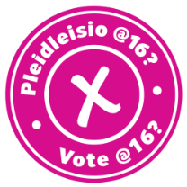
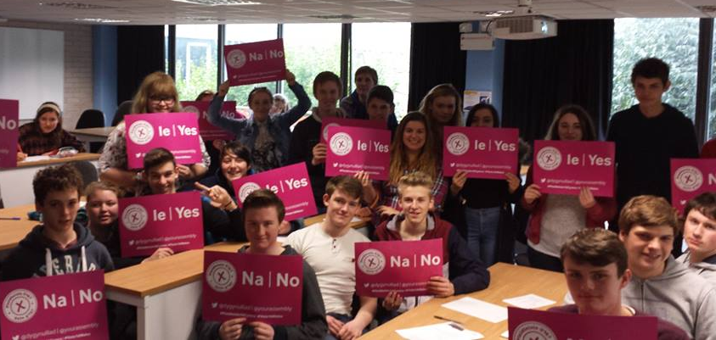
Student engagement
As part of an education visit, students from Ysgol Dyffryn Taf have their say on the Presiding Officer’s Vote @ 16? consultation. This is our national conversation that asks young people across Wales for their views about lowering the voting age.

To complement our dedicated Education Service we have developed a youth engagement programme to engage with children and young people outside of a classroom setting - youth organisations, youth fora, voluntary groups etc. A qualified youth worker was employed to take forward this work.
At the launch event for this new programme of work, the Presiding Officer, leaders of the four political parties represented in the Assembly and a representative group of children and young people signed a Children and Young People Engagement Charter which forms the Assembly’s contract with the young people of Wales. It sets out what young people can expect from the Assembly, and what the Assembly can expect from them. It states that the Assembly will:
- Communicate in a way that is clear and easily understood;
- Ensure that young people can contribute in an accessible, inclusive and safe environment;
- Listen to the needs and expectations of young people so that they may be understood and considered;
- Value the opinions of young people;
- Regularly promote and celebrate the involvement of young people; and
- Provide feedback on the contribution of young people and updates on the development of our work.
Our Youth Engagement Officer works closely with external groups to develop interactive sessions to help raise awareness about the Assembly and how to participate in its work. We are also developing new ways of promoting information about how young people are involved in Assembly Business and the impact of their contributions. During the past year, our youth engagement approach has enabled young people to contribute to Assembly committee inquiries into Supply Teaching, Assisting Young People into Work, the Child and Adolescent Mental Health Service, Recycling, and Psychoactive Substances (Legal Highs).

Children and Young People Engagement Charter
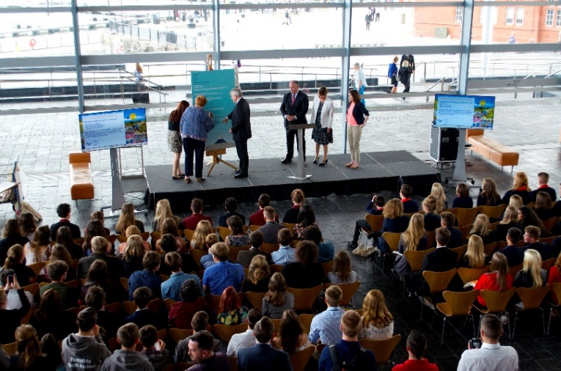
The Presiding Officer signs the Children and Young People Engagement Charter at the launch of the Assembly’s Youth Engagement programme.

Ethnic Youth Support Team (EYST) – Swansea
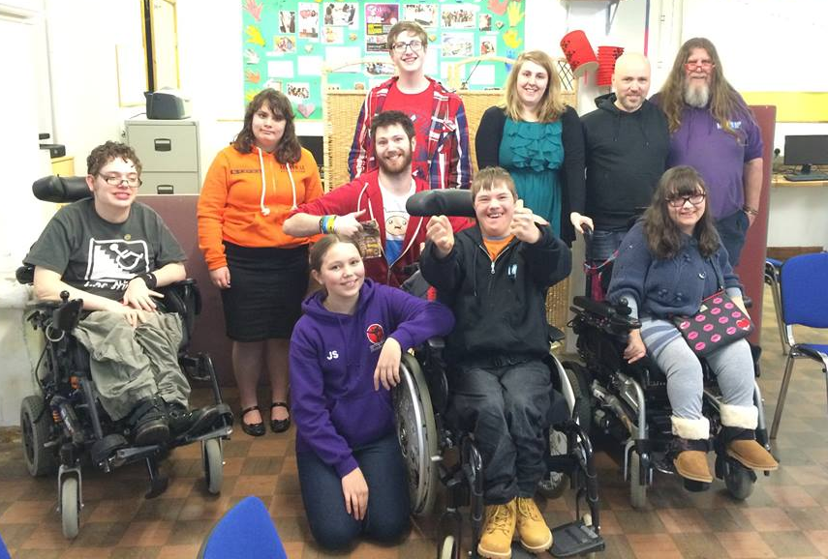
We have worked with two groups based at EYST. The first group was the ‘Mixed Up Group’ which gives young people with varying disabilities the opportunity to take part in social and educational activities on a Saturday. The second group was for girls from Black Minority Ethnic backgrounds. Both groups took part in a workshop on ‘What is the National Assembly for Wales?’ and contributed to the Vote @ 16? consultation.

Wipe Out transphobia
The Chair of our LGBT Staff network joined campaigners at Swansea Pride to promote the Wipe Out Transphobia campaign..

Promoting Equality
We have undertaken a variety of outreach and engagement activities that enable the Assembly to promote equality to the people of Wales and beyond.
We continue to increase our use of social media to promote the work of the Assembly, encourage participation in consultations, advertise jobs, promote the Women in Public Life and Youth Engagement schemes, promote our apprenticeship scheme, and to show our commitment to equality. Through social media, we have been able to reach people that might not otherwise have had an opportunity to influence the work of the Assembly.
We have used social media to promote a diverse range of equality and diversity occasions, including Stonewall’s #NoBystanders anti-bullying campaign during Anti-bullying week; LGBT History Month; Black History Month; a campaign to end sexual violence during conflict; Disability Access Day; World Autism Awareness Day; external recognition that we have received; International Women’s Day; Diwali; Bi Visibility Day; a campaign to end violence against women; Cardiff Pride; youth engagement; the Presiding Officer’s Women in Public Life scheme; and Cardiff Mela.

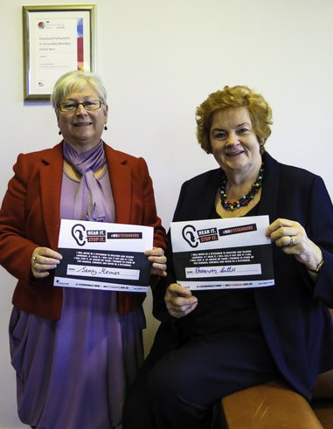
No Bystanders anti-bullying campaign
Sandy Mewies AM, Assembly Commissioner with responsibility for equality and the Presiding Officer, Dame Rosemary Butler AM, sign Stonewall’s No Bystanders anti-bullying pledge. The pledge was also signed by the Assembly’s Management Board, contractors working on site and staff throughout the Assembly.

Senedd lit up in support of the Time To Act campaign
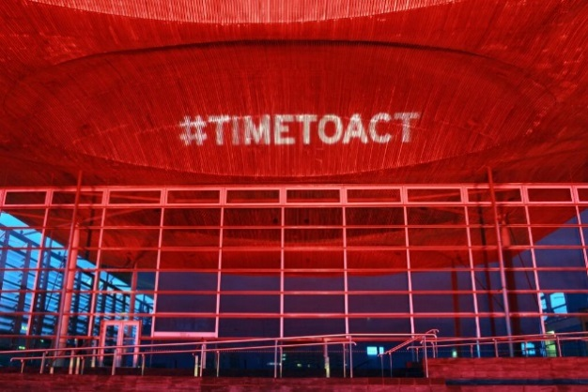
In June 2014, the Assembly participated in a campaign to end sexual violence during conflict by lighting up the Senedd with the #TimeToAct hashtag.

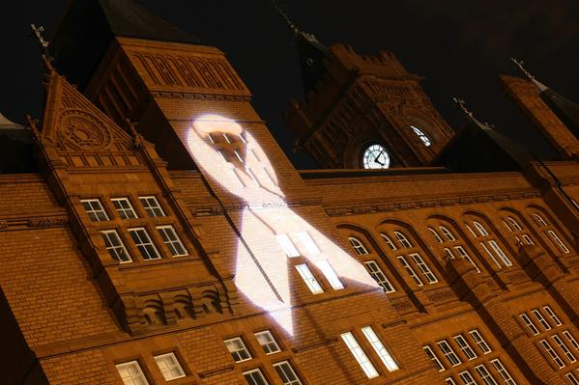
Assembly supports campaign to end violence against women
In November 2014, a white ribbon was projected onto the Pierhead as part of the UN’s International Day for the Elimination of Violence against Women.
Engagement with local community group
Hilaac Cymru are a Somali young women’s group that are based in Butetown, Cardiff. Their aim is to mix Somali and Welsh culture and meet every week. They came for a tour to learn about how they can get involved in politics.

Welcoming People
The Assembly estate continues to be a popular visitor attraction for people from Wales and across the world, with both the Pierhead and Senedd welcoming thousands of people every month. People may come to attend an event, to watch Assembly Business, to visit the shop or look at an exhibition.
We promote the Assembly as a visitor attraction through connections with the local Cardiff Bay Waterfront Partners Group, through social media, through our outreach work and through Euan’s Guide, a listings and review website that helps disabled people and their families know which venues are accessible.
We continue to welcome a diverse range of groups to the Assembly for visits, events and exhibitions. From April 2014 - March 2015 we welcomed over 184,000 people to our estate.
In the past year we have welcomed:
- Exhibitions covering a range of equality and diversity issues, including LGBT History Month; Jewish life; young people with additional needs; and mothers of Africa.
- Visitors from across the world, including India, Nigeria, France, Germany, South Africa, Russia, Saudi Arabia, Japan, Argentina, China, Germany, USA, Australia and Latvia.
- A range of visitors that reflects the diversity of Wales including tours for people with learning disabilities, people with sensory impairments, people with dementia, visitors from the Muslim Council of Wales, young people from pupil referral units, youth councils, people with autism, Women Making a Difference, and homeless people.
- People to a variety of community events, including events for mental health, youth debates, Dementia Awareness, Older People’s Commissioner, Disability Wales, Gypsy Roma Travellers, Muslim Association, Equality and Human Rights Commission, Armenian Genocide Memorial, Autism, Chinese New Year and the Hijinx Arts festival.
We always make reasonable adjustments upon request for visitors. This year, adjustments have included use of loop systems, accessible parking space, loan of a wheelchair, specialist seating, information in Easy Read and information in community languages.

Accessible estate
We continually review the accessibility of our estate, undertaking monthly maintenance audits and act upon feedback and adopt best practice. Further investment has been made to improve the physical accessibility of our estate. During this reporting period, the Assembly Commission has:
- Made changes to the lifts in Tŷ Hywel including lowering the buttons in the lift carts, improving the lighting and installing new buttons and displays in the lift lobbies;
- Installed automatic door push buttons to the main lobby doors in Tŷ Hywel;
- Installed flashing beacon fire alarms throughout Tŷ Hywel; and
- Considered access requirements whenever refurbishment work has been carried out, by ensuring that Light Reflectance Values provide a large enough differential between colours, installing new LED lighting to improve visibility and mounting large signage in the stairwells.

British Sign Language interpretation of First Minister’s Questions
Following a joint pilot with S4C to provide British Sign Language (BSL) interpretation for First Minister’s Questions (FMQs), we sought feedback on the service from users and the interpreters. Acting on their comments, and making use of new broadcasting technology that we installed, we changed the way we provide the service to S4C. This has helped the interpreters, and in turn has improved the accuracy of the service, which was reinstated during the autumn term in 2014.
The new Senedd.tv service, launched in September 2014, offers a better quality stream of proceedings on a wide range of devices. This has enabled us to post a recording of the interpretation of First Minister’s Questions for the first time. Archived videos of all BSL interpreted meetings can also be found on the site. We have also continued to provide subtitled versions of First Minister’s Questions on our dedicated YouTube channel.

Going forward
- We will continue to reach out to the people of Wales in innovative ways to raise the profile of the Assembly and to encourage participation in our work.
- We will continue to develop the Presiding Officer’s Youth Engagement and Women in Public Life initiatives.
- We will continue to celebrate and promote equality and diversity.
- We will continue to ensure that visitors to our estate have the welcome that they deserve by providing the facilities and staff training necessary to make their visit comfortable and accessible.
National Autistic Society Access Award
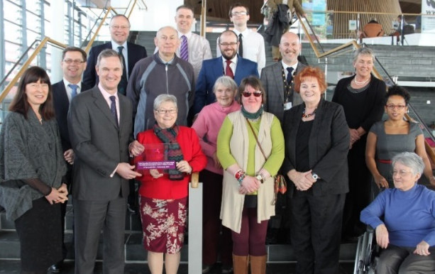
The Assembly Commission has received the National Autistic Society Access Award, which demonstrates our commitments to being an accessible venue for visitors on the autism spectrum. We worked with a local focus group to develop a suite of different information for visitors with autism and develop a dedicated section of our website. Assembly Members, Commission staff, representatives from the National Autism Society and members of our focus group came together to celebrate the Award that is currently on display in the Senedd.

Shared Parental Leave Event
We worked with the Working Families organisation to host an event to discuss the new Shared Parental Leave legislation. A number of public, private and third sector organisations from across Wales attended the event. The Presiding Officer sponsored the event and Claire Clancy, Chief Executive and Clerk to the Assembly opened the event. The event concluded with a panel discussion which included speakers from ACAS, Working Families, Admiral and our HR department.
Supporting our staff
The ability to type quickly is an essential part of my work, so when I sustained injuries that meant I could no longer type for extended periods, the Assembly ensured that I received Dragon voice recognition software, along with the appropriate training to adapt it to my work requirements. The Dragon software is invaluable.
Member of staff with a reasonable adjustment in place.
Since becoming a parent, several adjustments have been made to my work pattern in order to achieve a work-life balance that is appropriate for me, including a working week of 32 hours over four days, no late-night working, and term-time working. This work pattern means that I am available every evening and during all school holidays. All of these adjustments have proven to be extremely valuable.
Member of staff who has a flexible working pattern.

Work Life Balance Week
Our Engagement and Wellbeing team showcased how we can support staff to maintain a healthy work life balance. A series of tips and guidance were produced, and daily drop-in sessions were held where our staff networks and HR offered guidance, advice and information about the support and options available. We also endorsed the Employee Assistance Programme which also provides on line information, guidance, wellbeing tools and access to free 24 hour counselling.

Shared Parental Leave Event
We worked with the Working Families organisation to host an event to discuss the new Shared Parental Leave legislation. A number of public, private and third sector organisations from across Wales attended the event. The Presiding Officer sponsored the event and Claire Clancy, Chief Executive and Clerk to the Assembly opened the event. The event concluded with a panel discussion which included speakers from ACAS, Working Families, Admiral and our HR department.

Supporting our Workforce: The Assembly Commission as an employer of choice
We strive to be an inclusive employer that supports the diverse needs of our workforce. We have a number of teams, policies and procedures in place to ensure that staff are supported, can be themselves and fulfil their potential.
Our workforce and recruitment equality data and equal pay audit report are attached as Annexes B and C respectively.

Arrangements to support Commission staff
We have a number of policies and initiatives in place to support our staff and to help us promote equality, foster good relations and remove discrimination. These include:
- dedicated teams and staff networks that provide a range of advice and support;
- using our staff networks to impact assess our policies to ensure they are fair and inclusive;
- an Employee Assistance Programme that offers a counselling and advice service to staff;
- a variety of flexible working arrangements which to allow staff to find a working pattern that suits their needs;
- annual Display Screen Equipment (DSE) assessments and reasonable adjustments;
- an annual Equality and Diversity week to raise awareness of different equality issues and promote the support available to staff. In June 2014 guest speakers included the Welsh Refugee Council, who discussed the realities of being a refugee in Wales, and the South Wales Police who discussed building trust and working with different communities; and
- regular awareness-raising initiatives on equality–related themes to inform staff and Assembly Members, including factsheets, training, and a monthly Equality Bulletin that lists relevant news, publications and consultations.

Benchmarking
The Assembly has received the following benchmarks and accreditations:
- Ranked 4 in the UK in Stonewall’s Top Employers for LGB people and named Top Public Sector Employer in Wales for the second year running. In addition, our network group was highly commended;
- Listed as a Working Families Top 30 Employer during 2014;
- Listed in The Times Top 50 Employer for Women in 2014;
- Retained our commitment to the Positive About Disabled People and Age Champion campaigns;
- Retained Action on Hearing Loss Louder than Words charter mark;
- Achieved the National Autism Society Access Award; and
We retained our Investors in People Gold Standard.
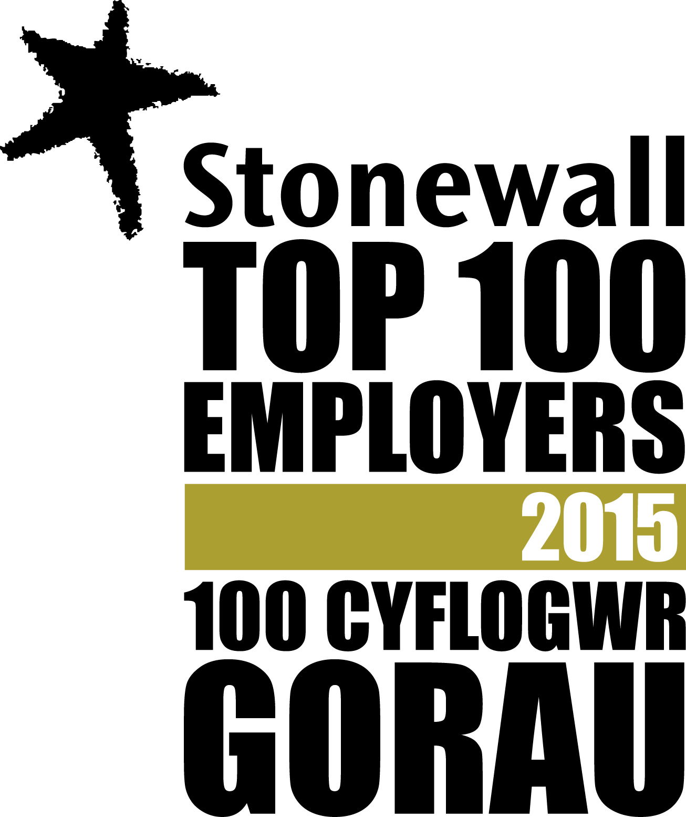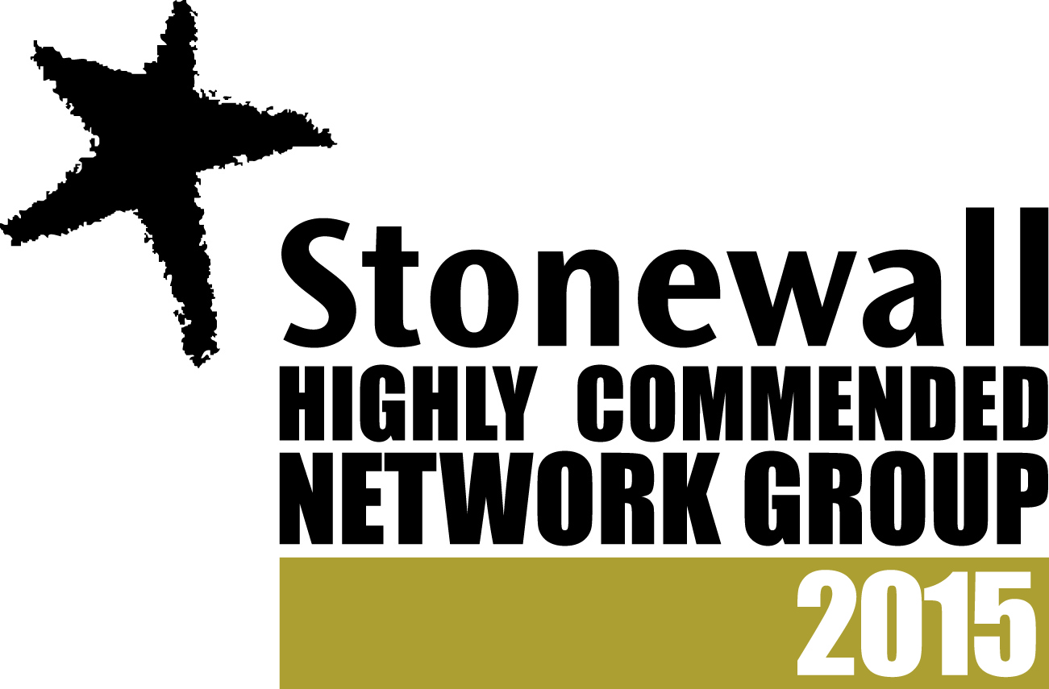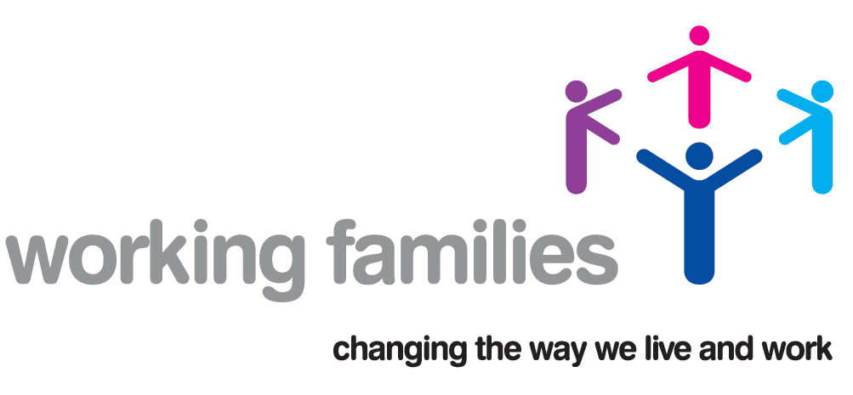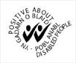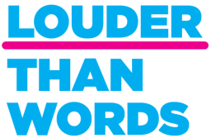

Assembly Apprenticeship Scheme
The Apprenticeship Scheme is intended to encourage young people to consider the Assembly as an employer of choice. We used social media and an outreach programme to ensure a diverse recruitment process by specifically targeting local schools, Welsh language candidates and other young people from groups under-represented in apprenticeships such as BME young people and young disabled people.
We invited a number of organisations from across Wales to an open day to inform them about the Apprenticeship Scheme. The representatives were then able to cascade information throughout their organisations and inform candidates about the recruitment process.
Starting as an apprentice at the National Assembly for Wales was the best career decision I have ever made.
Melissa Nichols, 23, of Cardiff, who worked in Commission and Members’ Support Service.
During the past two years we have recruited ten apprentices through our two Apprenticeship Scheme: four in the first tranche, and six in the second, including a new opportunity created in our Colwyn Bay office.
The Apprentices are paid a Living Wage, and are encouraged to learn from colleagues and take advantage of the learning and development opportunities available.
All four apprentices recruited from the original scheme have passed their NVQ Level 2 in Business Administration and have found full-time posts within the Assembly. These apprentices who graduated from the scheme continue to promote apprenticeships through youth engagement and social media events, and are now mentoring the new intake of recruits within the organisation.
Lori Nicholas was nominated as an ‘Apprenticeship Ambassador’ from the Assembly and visited her old school, Blackwood Comprehensive School, to talk to students about her experience as an apprentice, to share information about our application process, encourage students to consider apprenticeships, and promote the values of our scheme.

Apprenticeship Awards Cymru 2014
The Assembly was shortlisted as finalists in this year’s prestigious Apprenticeship Awards Cymru. The awards recognise employers who commit to developing their workforce through apprenticeships and other work-based learning programmes.
Following the success of our current scheme the Commission are also developing an apprenticeship programme for Assembly Members which is due to launch in time for the Fifth Assembly.
The Apprenticeship Scheme has provided me with an invaluable opportunity to gain skills in a key public sector organisation. Throughout the duration of the scheme, I have matured and gained belief in myself and my work.
Morgan Reeves, 19, of Maesteg, who has spent his apprenticeship in Facilities Management.

Staff networks
We have a number of staff networks that offer support to staff, promote equality and help us consider equality in our work.

Foodbank collections

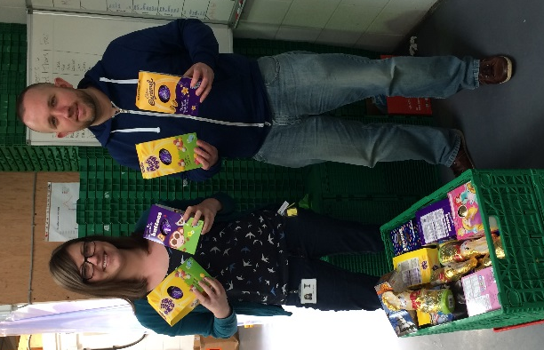
Our staff networks worked together to collect donations for Cardiff’s Foodbank to help support some of society’s most vulnerable people. Collections have also taken place at our Colwyn Bay office for their local Foodbank.

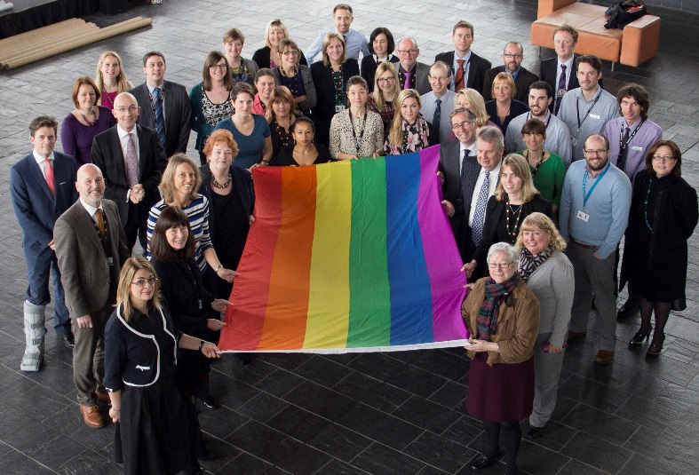
Promoting LGBT History Month
For LGBT History Month, OUT-NAW, our LGBT staff network organised a photoshoot of members and allies to mark the raising of the rainbow flag over our estate. We also promoted LGBT History Month through a series of internal awareness raising articles and social media updates.
Developing an accessible parking policy
When developing our accessible parking policy, members of our disability and chronic pain staff networks came together to discuss the additional support that they need when parking on site. Their contribution formed part of an Equality Impact Assessment of the policy and resulted in a more flexible approach to supporting staff with fluctuating medical conditions.

‘Train the trainer’ application writing course
Eleven organisations participated in a half day course aimed at removing barriers for potential applicants, and making the recruitment process more accessible and easier to understand to a wider group of people. Training packs were specifically developed to assist the attendees in their work with clients, helping to create sustainability of our engagement process.

Black History Month 2014
To celebrate Black History Month 2014 our BME staff network and the Welsh Government's Minority Ethnic Staff Network held a joint event to celebrate the contribution of BME staff. At the event, attendees had the opportunity to discuss how the Government and Assembly can recognise, nurture and develop BME talent. The event was hosted at Butetown Youth Pavilion and also offered an opportunity for staff from the two organisations to engage with young people from the local community.

BME Action Plan
Following the analysis of monitoring data and staff feedback, an improvement action plan was implemented in June 2014 to support staff from Black and Minority Ethnic (BME) backgrounds and increase the representation of BME people in our workforce. A Coordinator was employed to take forward our action plan.
The action plan has focused on overcoming some of the barriers to BME recruitment and on developing alternative recruitment methods. The Coordinator has concentrated on outreach, attending recruitment and community events, as well as providing targeted coaching and support to potential BME job applicants. Many of the barriers that the Coordinator encountered were related to misconceptions about working at the Assembly.
During this reporting period, the project has directly engaged with over 30 external organisations that work with BME groups and individuals to introduce the Assembly as a potential employer of choice and to provide information on our recruitment process. Vacancies have also been advertised through social media to help reach a more diverse range of applicants.
We continue to work with over 70 groups and individuals who act as recruitment partners, sharing information on job opportunities with their service users and contacts.
To help increase engagement with BME people and improve the visibility of the Assembly as an employer of choice, the Assembly BME staff network participated in a number of external events including the Cardiff Mela and two events to mark Black History Month.
Internally, our Coordinator has worked with members of our BME staff network to identify opportunities to support their retention and development within the Assembly. The Coordinator has provided support and training to enable development, and has provided a platform for staff to raise concerns.
During this reporting period, 7.1% of total applications for jobs advertised externally were from people who identified as BME. The 2011 Census states that 6.8% of people who are economically active and employed in the Cardiff Travel To Work Area (TTWA) identify as BME. As such, the number of applicants is slightly higher than the BME population in the Cardiff TTWA. The Cardiff TTWA is identified by the Office of National Statistics as Cardiff and the surrounding area where people who work in Cardiff may live. In addition to Cardiff, it covers parts of the following areas; Newport, Caerphilly, Merthyr Tydfil, Rhondda Cynon Taf and Vale of Glamorgan.

Learning and Development
We have continued to provide staff with opportunities to learn more about equality, diversity and inclusion. In addition to continuing induction training and online training for all staff, we have delivered training on Disability Confidence, Autism Champions, Supporting LGB staff, and Dementia Friends. We have also developed awareness factsheets on a range of topics including Cultural Diversity, Supporting an LGB person when they are coming out, supporting disabled staff, and supporting Muslim staff during Ramadan.

Going forward
- We will continue to participate in benchmarking exercises to ensure that we remain an equality of opportunity organisation.
- We will continue to implement our BME Action Plan and consider how this work is mainstreamed in our procedures and practices.
- We will look for opportunities to promote the Assembly as an employer of choice for diverse applicants.
- We will issue guidance for staff networks that outlines the Assembly’s continued commitment to them.
- We will introduce refresher BSL training and Deaf awareness training for interested staff.
- We will launch our Mental Health Workplace Policy for staff.
- We will encourage staff to update their personal equality data on our HR / Payroll system and we will be exploring ways in which we can reduce the number of ‘No replies’ on the equality monitoring section of our recruitment application forms.

Stonewall Work Experience placement
As part of Stonewall Cymru’s Work Placement Scheme, we welcomed Christian Webb to the Assembly to find out more about the work that we do. The scheme seeks to give young people the experience of working in LGBT friendly workplaces. Christian said:
“I had a fantastic week at the National Assembly. The atmosphere and ethos of the institution is a credit to each member of staff. I don’t think Stonewall Cymru could have found a better example of a workplace where people can be who they are, celebrate difference, and achieve brilliant results: the impression emanates from the moment you walk into Tŷ Hywel, where you see the Stonewall Cymru Diversity Champions certificate proudly hung on the wall.”

Supporting Assembly Members, their Staff and Assembly Business
The Assembly Commission provides a range of support for Assembly Members to assist them in building equality considerations into their work within the Assembly, when employing staff and when engaging with the public.

Online Equality Training
We have launched our online equality training for Members and their staff. This was promoted widely though a variety of media. The training includes information on each of the protected characteristics and includes sections on supporting staff, recruitment and providing services to members of the public. The launch of this training was supplemented by the re-launch of our Equality Factsheets.

Equality Information, Advice and Guidance
Our teams across the Assembly provide specialist advice and guidance to all Assembly Members, by:
- Providing employment, management and recruitment advice to Members;
- Providing equality-related training to Members and their staff on a range of topics such as Suicide Intervention, McKenzie friend (legal assistance), Welfare Rights, Welfare Appeals, Investing in Children, Personal Independence Payments and Fuel Debt. Members and their staff are invited to other training such as Disability Confidence and Supporting LGB Staff, and awareness events such as Refugee Week, Equality and Diversity Week, and Community Outreach and Cohesion;
- Ensuring that our staff networks are open to Members and their staff either as allies or members; and
- Making Health and Safety assessments and Personal Emergency Evacuation Plans available to Members and their staff.

Access Fund
The Access Fund was established to ensure that Members have the necessary support to engage with constituents with diverse needs, and provide additional support to disabled Members and disabled support staff. The Fund has been used to provide communication support for people who are deaf or have a hearing loss, make physical adjustments to Members’ offices, provide specialist equipment, and produce translations of correspondence in minority languages.

Committees
During the past year, work has been carried out on our document templates and drafting practices to ensure that, in addition to being able to provide alternative versions of material upon request, our documents have an underlying accessible structure, and can be downloaded in a choice of formats at initial publication. We continue to respond swiftly to specific requests for non-standard formats of documents for the public (including large print, Braille and word only electronic formats). Work continues to ensure that our published information is as technically accessible as possible.
Committee clerking teams have also been exploring the publication of simpler worded alongside more technical reports and we expect to produce more of these next year. Whilst understanding a need for technical accuracy in the wording of Scrutiny and Legislation related documents, these new styles of publication assist in making our work more accessible to a range of non-technical audiences without losing the impact of the technical aspects of our work scrutinising the Welsh Government.
We have published guidance for witnesses about giving evidence to Committee, building on our work with Chwarae Teg to offer witness training. Selected trainees will have the opportunity to give evidence to a mock-Committee about why it is important for Assembly Committees to hear from under-represented groups.
Committees continue to engage with a wide range of diverse groups as part of their policy and legislative scrutiny work. For example, the Communities, Equality and Local Government Committee undertook a number of visits as part of its inquiry into poverty and inequality. Venues included a food bank, a centre for women offenders, the RNIB and Chwarae Teg, where Members were able to meet service users and discuss the issues affecting them.

Committee Engagement
The Assembly’s Outreach Team engaging with service users and frontline staff as part of the Health and Social Care Committee inquiry into alcohol and substance misuse.
Our Outreach team interviewed young people from all parts of Wales to ask them about their experiences of trying to find work. This contributed to a video shown to the Enterprise and Business Committee for their inquiry into Assisting Young People into Work. The video included a diverse range of young people, including people who are disabled, identified as transgender, from BME backgrounds, and from disadvantaged areas.
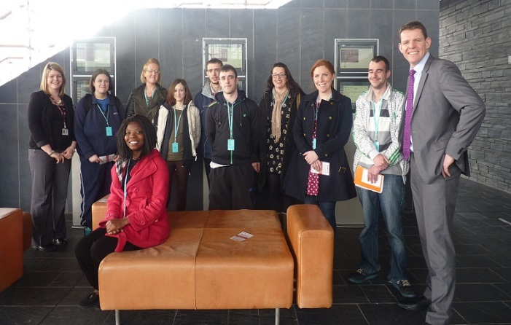
Outreach activity leading to the submission of a petition
Digartref Mon are a group who have taken part in committee engagement work through our Outreach team, and later took part in a workshop explaining what the Assembly does and how it works. As part of this session, the petitions process was covered, which lead them to work on submitting their own petition aimed at making political education compulsory in Wales.

Committee Engagement
Members of the Communities, Equality and Local Government Committee holding a discussion event with service users for the inquiry on the Renting Homes (Wales) Bill. Attendees included people of varying ages and abilities.

Going forward
- We will ensure that Assembly Members have the necessary support, information and advice in place to build equality considerations into their roles as employers, elected representatives and service providers.
- We will continue to promote equality-related training to Members and their staff, including Disability Confidence, Dementia Friends, and Supporting LGBT staff.
- We will continue to promote staff networks to members and their staff and ensure that they are invited to network events.

The Remuneration Board’s EQIA of the Members’ Determination
To support the review of the Members’ Determination, the Remuneration Board committed to undertaking a thorough Equality Impact Assessment. They consulted with former, current and prospective Assembly Members, commissioned research into what different people identified as potential barriers to standing for election, and engaged with Diverse Cymru’s Equality Assessment Working Group. The Board’s commitment to this EQIA was rewarded by being shortlisted for a Diverse Cymru “Excellence in Equality - Public Sector” Award.

Embedding Equality into our work

Monitoring and Reporting
Progress on achieving the objectives set out in the Equality Action Plan is monitored on an on-going basis. Our Annual Equality Reports are scrutinised by the Commission’s Management Board and the Assembly Commission to ensure compliance with our legal and corporate responsibilities and to monitor progress on our Action Plan.
We have undertaken an analysis of workforce and recruitment equality data and carried out an equal pay audit. These reports are available at Annexes B and C.
Going forward, the key actions resulting from the analysis are: building on our BME Action Plan, enhancing our recruitment webpages, reducing the number of ‘No replies’ on our equality monitoring form and reviewing how our HR/IT payroll system can be best utilised to gather and review data.
Findings from the equal pay audit revealed a limited number of pay differentials for which we were able to provide justifiable explanations. Overall, the analysis indicated that there were no equal pay risks identified.

Building Equality Considerations into Our Work
During the last year, we have introduced a more formalised system of Equality Impact Assessments (EQIAs) to ensure that we have a consistent approach across the organisation.
Over the last year, equality has been considered as part of a range of projects and policies including:
- The Youth Engagement project;
- The accessibility of our corporate brand;
- Our outreach and engagement work;
- Our Information Governance Framework;
- Staff policies;
- Building work and refurbishments; and
- The Remuneration Board’s Review of Members’ Pay and Allowances.

Procurement
We take every opportunity to champion equality throughout our procurement process and on-going contract management.
Equality is included as part of our sustainability risk assessments at the very start of a procurement process and as part of the pre-qualification process. Suppliers who fail to demonstrate their commitment to equality are not invited to tender.
Through our work on social responsibility, we look at the supply chain for our goods and we ensure that the living wage is paid to contractors working in our buildings.
To further raise awareness of equality we include a specific question on Corporate Social Responsibility in our contract review meetings with our suppliers and our terms and conditions of contract include a clause on “Equality Considerations” ensuring that equality is a contractual obligation.

Internal Audit of Equality
The Assembly Commission’s Internal Auditor carried out a review to assess the adequacy and effectiveness of our arrangements for equality. The objective was to assess the Assembly’s arrangements in managing the risk that equality and diversity is not celebrated, promoted and encouraged. This could result in poor compliance with legislation, poor publicity and a missed the opportunity to enrich the lives of staff and other stakeholders.
Based on the results of this work, the Assembly Commission is graded as Satisfactory.
The report found that the Assembly places a strong importance on equality and diversity and has a number of awards, and recognition from equality related bodies. The audit identified a number of areas in which the Assembly is displaying good practice and highlighted some areas for improvement.

Going forward
- We will ensure that staff have the confidence to implement our new approach to EQIAs.
- We will publish all completed EQIA on our website.
- We will ensure that contract managers have the support necessary to build equality into their review meetings.
- We will implement the recommendations of the Internal Audit report.

Annex A: Progress on Achieving Equality Objectives

Priority Objective One: Encouraging and Widening Public Engagement
Actions for 2014-2015
Actions | Lead Responsibility | Update - March 2015
Review written outputs to ensure people understand the role of the Assembly and Assembly Members | Head of Communications | This work is underway. Our Publications team has been making increased use of visual formats such as videos and infographics to share information. The team is also beginning a project to review and refresh the Assembly’s written messaging, in line with the Communication team’s Public Engagement strategy for the Fourth Assembly that was approved by the Commission in February 2015.
Consider how we provide hard copy information in a range of community locations | Head of Communications | The Communications team is currently creating a set of key narratives to explain each aspect of the Assembly’s work in a way that is clear, consistent and accessible. This will give staff and Members the tools they need to communicate effectively with their audiences and will give the Publications team content for a new suite of publications that can be distributed in community locations. We recently trialled distributing publications in all council buildings with public access in Wrexham as part of the #SeneddWrexham series of events in March 2015.  Our Outreach team are in the process of visiting Member’s constituency / regional offices to promote their work and to leave information for service users. They also leave information in the offices of the community groups that they engage with.
Review our publications brand /style guide to identify and prioritise actions to address any barriers to access | Head of Communications | The Publications Team has worked closely with the Equality Team to carry out an Equality Impact Assessment in relation to the Assembly brand. This assessment identified a number of actions that could make the brand and our information more accessible. The team is currently working through these actions.
Develop a new introductory publication in a range of accessible formats and languages | Head of Communications | This forms part of the Publications Team’s plans for developing new content for external audiences. The team’s intention is to produce a suite of information, based on the outputs of the work on the Assembly’s messaging and narratives.
Provide plain language training to staff | Head of HR training, Head of Communications | The Communications Team’s review of our written communications will ensure that we are communicating with our audiences in plain language and in a way that is clear, confident and accessible. The outputs of this work will be plain language narratives that will equip staff with the tools they need to communicate accessibly in writing. In addition, we have a Writing Style guide to ensure readability and consistency.  A number of different writing skills courses are available as part of the internal Learning and Development course offering. We have run an introductory Effective Writing course for staff and a more in-depth Writing Skills course. We are also in the process of developing Plain language Training which will be rolled out by HR.
Review and update database of equality groups for consultations | Head of Policy and Legislation Committee Service, Head of Chamber and Committee Service and Head of Research Service | Our Committee, Research and Outreach teams continue to build relationships with a range of equality groups. They are constantly reviewing and developing their contact lists in order to engage more grass roots and community groups in Assembly Business.

Priority Objective One: Encouraging and Widening Public Engagement
On-going Commitments
Actions | Lead Responsibility | Update - March 2015
Focus on engaging grass roots and diverse groups in our engagement and consultation strategies  Develop outreach work to increase committee engagement | Head of Communications, Head of Policy and Legislation Committee Service, Head of Chamber and Committee Service and Head of Strategic Transformation | Over the past 12 months our Outreach team has concentrated on engaging directly with those affected by the issues considered by Committees. Activities include:  - Establishing a reference group of service users and frontline staff for the Health and Social Care Committees inquiry into Alcohol and Substance Misuse.  - Interviewing a diverse range of young people from across Wales to ask them about their experiences of trying to find work. This contributed to a video shown to the Enterprise and Business Committee for their inquiry into Assisting Young People into Work.  - Arranging visits for Members of the Communities, Equality and Local Government Committee to hold focus groups with a variety of groups including BAWSO, RNIB, Ebbw Vale Food Bank, the Changing Lives Project, Remploy and Oasis.  As part of our annual events programme, we attend a number of community events that are specifically targeted at underrepresented groups, specifically LGBT and BME communities. We constantly look for other events targeted grass roots and diverse groups that could complement our existing events programme.
Develop our use of social media to reach diverse groups | Head of Communications | We continue to increase our use of social media to reach people that might not otherwise have had an opportunity to influence the work of the Assembly. We monitor the reach of our messages to ensure the effectiveness of our communications, using appropriate language to connect with key and diverse demographics.  Each survey we create is promoted to a variety of groups to encourage a broad range of responses.  Each Assembly Member and committee is provided with social media handles for various inquiries and work streams to enable them to promote Assembly Business.
Promote Outreach work through social media, local media and local contacts | Head of Communications | Media relations are an integral part of the communication planning for outreach initiatives. The Assembly’s Outreach blog is updated regularly and the Outreach team uses its Twitter feed, @SeneddOutreach, to engage with audiences online.  We encouraging a diverse range of people to take part in engagement activity online. We engage with community groups to help us promote the opportunity to have their say, and encourage their members / service users to take part and influence the work of the Assembly. Recent examples include the promotion of surveys relating to inquiries into supply teaching and alcohol and substance misuse which were promoted on social media.  In addition, the Outreach and Education Outreach teams now work with the Media Officer to issue media releases following events and visits with community groups. For example, we recently gained coverage in the Wrexham Leader newspaper following outreach activity with Age Connects in north Wales.
Work more closely with Members and the Presiding Officer to promote public engagement | Head of Communications | Out review of our written materials will lead to publications that will be made available in AM constituency offices, allowing Members to explain their role and encourage engagement with the Assembly.  Assembly Members regularly attend events, web-chats and other engagement activity which puts them in front of relevant stakeholders / service users / members of the public. Assembly Members are given the opportunity to shape Outreach work for committee inquiries.  We encourage Members to join us at events, including the annual Summer Events. The Presiding Officers were involved in the delivery of #SeneddWrexham in March 2015. The purpose of this pilot initiative was to take the Assembly on the road, relocating some of the Assembly’s activities to Wrexham. The event consisted of a “pop up Assembly” in several location across Wrexham, delivering numerous Outreach and Engagement workshops to organisations based in Wrexham, delivering Youth Engagement workshops with youth groups and delivering educational sessions to schools in the local area. In addition to the pop-up Assembly and the various sessions/workshops we also delivered a series of events that raised awareness of the Presiding Officer’s Vote@16? consultation, Women in Public Life, and Democratic Deficit initiatives.  Sandy Mewies AM the Assembly Commissioner with responsibility for equality and the Presiding Officer have also promoted equality at a range of events including Stonewall’s Workplace Conference, Race Council Cymru Conference, Women in Public Life scheme, and a variety of events such as Discover Islam, Commonwealth Day, Wales’ Paracycling Team and Dementia Friends.
Develop and promote a cross-Wales programme of events related to promoting equality | Head of Communications | We meet with a range of diverse groups and ensure that equality events are always considered as part of the summer events programme. We attend Pride Cymru in Cardiff, Swansea Pride and Cardiff Multicultural Mela to reach audiences that may not otherwise have engaged with the Assembly. Each year we review the range of events that we attend across Wales to ensure that all events are considered as part of the summer event programme.
Undertake monthly maintenance checks of accessible services | Head of Estates and Facilities | Monthly maintenance checks are still on-going and any actions taken forward as necessary.
Use a checklist to ensure accessibility of venues booked across Wales | Head of Policy and Legislation Committee Service, Head of Chamber and Committee Service, Head of Communications | Accessibility remains a priority when booking external venues and a checklist is used to ensure all considerations are taken into account before booking a venue. Outreach and Events Teams consult with the Equality Team for advice when necessary and use a local access group to provide additional advice when necessary.
Promote relevant debates to representative groups | Head of Communications | Relevant debates, such as evidence sessions at committee, or debates in the Chamber relating to Committee work is publicised with groups who have taken part in engagement work on that specific inquiry.
Promote petitions to diverse groups through outreach and communications | Head of Communications | The petitions process is promoted during presentations and workshops with community groups. For example, Digartref Mon are a group who have taken part in committee engagement work through the Outreach team, and later took part in a workshop explaining what the Assembly does and how it works. As part of this session, the petitions process was covered, which lead them to work on submitting their own petition aimed at making political education compulsory in Wales.
Review processes to identify and remove barriers to engagement and involvement | Head of Assembly Committees, Head of Chamber and Legislation Service, Head of Communications | The Publications Team continues to offer information in accessible formats and the Web Editor has been working to implement the recommendations of the Shaw Trust’s recent report on the accessibility of the Assembly website. This has included providing training and guidance to web publishers to ensure that we are adhering to best practice guidelines for structuring web content and working with the Broadcasting team to increase the accessibility of our video content.  Our increasing use of social media, and our youth engagement consultation are examples of our efforts to identify and remove barriers and increase awareness and understanding.  When organising events at venues across Wales the Events Team always consult with an access group to ensure that reasonable adjustments are made to allow everyone to be able to participate in the events we host.  Our BME Action Plan Coordinator has been working with representative groups to identify and remove any barriers to engagement and recruitment.
Audit the use of the Assembly estate as an event venue by diverse groups | Head of Front of House | We collect monthly data on the range of events and exhibitions held on site. We analyse the data to identify any gaps.
Ensure access issues are considered for events through equality impact assessments | Head of Front of House Events, Head of Corporate Events | Access issues are considered as part of every site visit prior to an event.  When delivering Assembly led events access issues are routinely considered. Where appropriate we will ask an external access group to come and assess potential event venues, we will take and act upon their advice when finalising the event venue.  We are constantly looking to improve our services and actively seek feedback to ensure that we are meeting the needs of our diverse customers.
Promote the availability of tours and visits to diverse groups | Head of Front of House | The availability of tours and visits is promoted to all groups by the Outreach team, the website and by the booking team. We regularly promote tours and visits via social media to reach communities across Wales. We offer adjustments on a case by case basis.  We promote the Senedd and Pierhead as accessible visitor attractions on the Euan’s Guide website. The site also enables us to capture feedback on visits. The link to Euan’s Guide is at the bottom of the feedback email we send to each group after their visit. We also promoted tours and visits on Disability Access Day.  We market our tours to many diverse groups including HiLaac Cymru, Diverse Cymru as well as European students from local universities.
Facilitate tours in British Sign Language (BSL) upon request | Head of Front of House | We have not had any requests for tours in BSL during this reporting period. All requests for reasonable adjustments are met.
Review information and signage directing people to the Assembly | Head of Estates and Facilities | We are having on-going conversations with Cardiff Council and the Cardiff Harbour Authority about the provision of additional signage for the Assembly around Cardiff Bay.
Front of House staff undergo training on welcoming diverse visitors. | Equality Manager, Head of HR training, Head of Front of House | All new staff undertake equality training related to an inclusive workplace and providing accessible services. We have delivered Disability Confidence training to all Front of House and Security staff. We have a procedure in place to welcome BSL-users to our estate.  We have trained Autism Champions across the organisation, including our Front of House and Security teams, to ensure that they can confidently welcome and support people with autism.

Priority Objective One: Encouraging and Widening Public Engagement
Completed and Closed Priority Actions
- Undertake an access audit of our website and prioritise actions
- Produce a toolkit of ways of conducting inclusive consultations
- Review current event guidance to include information on accessibility to third parties holding events here by sharing our accessible publications guidance
- Provide visitor information prior to security check in the Senedd
- Undertake an access audit of the Assembly Estate and prioritise actions
- Assess the feasibility of undertaking a further Step Up Cymru mentoring scheme
- Create signage outside the Senedd to welcome visitors and to promote services and facilities

Priority Objective Two: Assembly Commission as an Equality of Opportunity Employer
Actions for 2014-2015
Actions | Lead responsibility | Update - March 2015
Reinstate disability data for next reporting period. | Head of HR | Action complete. Data included in the monitoring report.
Produce data to demonstrate gender split by service area for next reporting period. | Head of HR | Action complete. Data included in the monitoring report.
Consider how new HR / Payroll system could be used to capture equal pay data on internal promotions and how many new starters start on minimum pay point. | Head of HR and Equality Team | The adopted Recruitment policy arrangements do not enable reporting in this way, as the Assembly is committed to offering a range of temporary paid developmental opportunities. Three different data sets are available and should be reported separately as Temporary Working Allowances; Internal promotions to a higher grade on a permanent basis; and New starters starting pay.
Increase the completion rate of equalities data form within the recruitment application process in order to develop greater insight into recruitment activity. | Head of HR | Candidates applying for positions within the organisation are required as part of the application process to submit a completed equality monitoring form. Applications will not be considered without submission of this form. We have updated our website to stress the importance of submitting a completed from and will monitor any changes in declaration rates. The importance of the forms has been shared with partner organisations. The data included is then used by the Assembly’s recruitment team to provide statistics for equal opportunities monitoring to assess how well our policies are put into practice. This information is stored on a database and not used for any other purposes. In addition to this, the completed equality monitoring form is stored in the HR/IT Payroll system.
Explore how new HR / IT Payroll system could be used to report separately on internal and external recruitment, alongside other useful data sets. | Head of HR | The recruitment module within our Resourcelink system is in three progressive module sections (Recruitment Team tool; Candidate interactive tool; Recruiting Manager tool). The module section ‘candidate interactive tool’ is currently planned for implementation towards the latter end of 2016. Full year data will be available for the financial year 17/18.
Re-brand our recruitment webpages and publicise the support available to staff (e.g. staff networks, workplace policies) to encourage applications. | Head of HR with support from Equality Team | On-going. We have started the process of updating our website by emphasising the need for monitoring forms as part of our recruitment process, gathering testimonials and drafting web copy. Updates to be completed during summer 2015.
Liaise with representative bodies to promote jobs | Head of HR | Through the work of the BME project, we are now working with over 30 partner organisations. All jobs are communicated to partners in order to encourage greater representative applications. Active work is underway to work with representative bodies to identify current ‘blocks’ within the system, including ‘potential’ candidate perception of the organisation, application form complexities and the Assembly’s adopted recruitment methodology. The formal project is due for completion in July 2015, and will be continued as an HR and Equality team partnership project.
Encourage more staff, including new starters, to self-identify on enhanced HR / Payroll system. | Head of HR  Internal Communications | Should employees need to amend their personal details, they are now able to do this themselves on the self-service HR / IT Payroll system. To encourage more staff to complete and update their data on the system the HR team are looking at ways in which alerts can be sent out to employees with missing information (every 6 months or so). We periodically send out reminders to staff to remind them why we need the data, who has access to it and how we will use it.
Implement BME Action Plan via the BME Action Plan Co-ordinator. | Head of HR with support from Equality Team | The BME Action Plan has achieved increased external engagement through outreach sessions with a diverse range of local community organisations. The Coordinator has engaged with organisations and networks for BME people, participated in Job Fairs and Recruitment events and provided targeted coaching and support to potential BME job applicants.  Internal support for BME members of staff is on-going and the BME staff network has increased support with a network of supporters and allies available to provide support to interested members. We have worked with members of our BME staff network to identify barriers to advancement and staff are better informed of both internal and external development opportunities through monthly updates and supported to take up any initiatives. Work is on-going to progress uptake of opportunities through the organisation via the Learning and Development team.
Continue to support staff networks and invite them to encourage applications for employment utilising their contacts. | Equality Team and Head of HR | Staff Networks have adopted improved working methods through sharing information on internal and external projects and working together to support each other. The BME staff network has seen an increased presence across the organisation with the appointment of a BME Champion from the Management Board. Information on existing opportunities is routinely sent to members as well as communicated through a monthly e-bulletin.
Continue to promote equality and recruitment training, including unconscious bias training. | Head of HR | On-going action. A revised commitment as a result of the October 2014 Recruitment Audit will be to provide Recruiting Manager training refreshers every three years.
Continue to participate in benchmarking exercises i.e. Stonewall WEI, Working Families, Action on Hearing Loss Charter Mark and Times Top 50 Employers for Women. | Equality Team and HR | The Assembly has been received recognition from the following benchmarks and accreditations:  - Ranked 4 in the UK in Stonewall’s Stop Employers for LGB people and named Top Public Sector Employer in Wales for the second year running;  - Listed as a Working Families Top 30 Employer achieved during 2014;  - Retained Action on Hearing Loss Charter Mark;  - Achieved the National Autism Society Access Award;  - We were listed in The Times Top 50 employers for Women in their 2014 list;  - We retained our Investors in People Gold Standard.
Develop mental health and wellbeing policy | Head of HR Operations, Head of Health and Safety | The Health and Well-being Strategy was launched, and many of its key points are being implemented including holding well-being events, such as Engagement and Wellbeing day, Mental Health Awareness Week, National Deaf Awareness Week, and the development of a stress management / mental health policy.
Equality Impact Assess recruitment practices | Head of HR Training, Head of HR Recruitment | The Assembly’s recruitment procedure and associated policies are currently being revised following the launch of a revised ‘Recruitment Principles’ document. Equality Impact Assessments and liaison with TUS and Staff networks are a key element of the revision process.
Develop guidance outlining the support available for staff networks | Head of HR Operations,  Equality Manager | Following the growth of our staff networks, draft guidance is being re-worked in consultation with staff networks and Trade Unions. Further individual working groups and support networks including pain support and mental health working groups have also been formed.

Priority Objective Two: Assembly Commission as an Equality of Opportunity Employer
On-going Commitments
Actions | Lead Responsibility | Update – March 2015
Run annual Equality and Diversity Week to raise staff awareness of equality issues | Equality Manager | For Equality and Diversity week 2014 we raised awareness of different equality issues and promoted the support available to staff. Guest speakers included the Welsh Refugee Council, who discussed the realities of being a refugee in Wales, and the South Wales Police who discussed building trust and working with different communities.
Promote support mechanisms to staff – networks, Equality Team, employee helpline, HR, Unions | Equality Manager, | We promote support mechanisms in a number of ways, including to all new starters as part of our induction process. We regularly promote our staff networks though internal articles. Our employee helpline is promoted to staff via our intranet site and across the organisation through a poster campaign. All of our HR policies are reviewed and promoted to staff and our Unions have a dedicated noticeboard to promote their services to staff.
Undertake Display Screen Equipment Assessments for all Assembly staff | Head of HR Health and Safety | All new members of staff have a DSE assessment within their first three months. A new course has been designed and is ready to roll out for new and existing assessors, so that the target of three months is sustained. A successful trial of ‘stand up-sit down’ desk have been undertaken across the Assembly. Working with the occupational health advisor these desks are being rolled out to staff who are known to have back pain, and would benefit from the option of standing whilst working.
Promote equality-related policies to staff | Head of HR Operations, | Equality-related documents are promoted to staff on the Intranet Newspage. New and updated policies are promoted via drop-in and awareness sessions which are advertised on the Newspage to encourage attendance. All policies are also promoted to members of our staff networks and Unions.
Undertake a rolling programme of Equality Impact Assessments of staff policies  Involve staff networks in the Equality Impact Assessments of corporate, where appropriate | Head of HR Operations, Equality Manager | We have a rolling programme of staff policy reviews and proposed policies that are impact assessed with the assistance of our staff networks, Equality Team and Unions.
Ensure all recruitment panels undergo equality awareness training | Head of HR Training, Head of HR Recruitment | Panel members undergo recruitment training including a section on equality, access, and reasonable adjustments. Our mandatory online training also covers recruitment best practice and dealing with unconscious bias. Following the recruitment Audit in October 2014, a revised commitment will be for all Recruiting Managers to undergo refresher training every three years.
Undertake annual equal pay reviews | Head of HR Operations | We undertake Annual Equal Pay Reviews. Our latest review is attached as Annex C.
Undertake regular staff surveys | Survey lead, Head of HR Operations, Equality Manager | We aim to engage continuously through on-going conversation with staff to enable us to have more meaningful discussions with different staff groups for a greater understanding.  The last staff survey was conducted in July 2013 with the results and agreed actions being published internally shortly thereafter. This was followed up with an all-staff meeting where the key themes arising from the survey were discussed to gain a better understanding of staff perspectives and to provide an initial management response.  These key themes centred on recruitment, performance management, accommodation and career progression and were similar to those of the previous year’s survey. Because of this, we decided to take time to look more closely at these areas to see if and how they could be improved. We have needed to allow a reasonable period of time to do this work effectively and to conclude and agree the outcomes. We felt that on balance it would; therefore, be better to delay the staff survey to take account of any changes made. We have also been considering our overall approach to the staff survey, and to staff engagement more generally, with the aim of making it less of a ‘once-per-year’ exercise and also to enable benchmarking of our performance. The conclusion of all of this work is the launch of the next survey in May 2015.
Offer one work placement a year to people from under-represented groups | Head of HR Recruitment | We encourage a number of representative placements through positive action. This has resulted in an increased representation within our apprentice cohort, and a positive partnership with Stonewall Cymru which secured a short work placement for one of their supporters.
Develop communications to address barriers to applications from diverse people | Head of HR Recruitment | We continue to develop tailored literature for community events and for community groups to develop a better understanding of the Assembly application process. We have outreach sessions to engage with communities at the grassroots level and also work with partners to help deliver our message.  We have increased engagement with the Assembly external outreach teams so that information on recruitment can be shared with diverse communities.  We have piloted a ‘train the trainer’ programme and an accompanying pack outlining our recruitment process to assist our ‘job ambassadors’ in targeting diverse people to apply to our organisation. We have also developed a Q&A sheet on our equality monitoring to accompany the application pack, helping to explain our equal opportunities drive within the organisation.  We are currently working at improving communications on our recruitment website so that it better reflects our diverse employees and helps us attract diverse people.

Priority Objective Two: Assembly Commission as an Equality of Opportunity Employer
Completed and Closed Priority Actions
- Develop and implement training strategy for all staff
- Develop glossary of equality language and promote to staff
- Build equality considerations into Management Development Programme
- Establish BME staff network
- Establish staff maternity network
- Recruit a BME Action Plan Co-ordinator

Priority Objective Three: Supporting Assembly Members and their Staff
Actions for 2014-2015
Actions | Lead Responsibility | Update – March 2015
Develop training and awareness raising strategy for Members and their staff on equality issues | Head of Commission and Members’ Support Team,  Equality Manager | We have updated and shared our equality factsheets and rolled out our online equality training for Members and their staff.  We have provided other equality-related training to Members and their staff such as Suicide Intervention, McKenzie friend (legal assistance), Welfare Rights, Welfare Appeals, Investing in Children, Personal Independence Payments and Fuel Debt. We are working with the Alzheimer’s Society to roll out Dementia Friends training to Members and their staff.  Members and their staff are invited to other training such as disability confidence and supporting LGB staff.

On-going commitments
Actions | Lead Responsibility | Update – March 2015
Annually review, update and promote equality guidance for Assembly members | Equality Manager, Head of Commission and Members’ Support Team | Our Equality Act 2010 guidance was reviewed and reissued to coincide with the launch of Assembly Members’ online equality training in February 2015.
Develop training and awareness raising strategy for Members and their staff on equality issues | Head of Commission and Members’ Support Team,  Equality Manager | This year, we launched our online equality training for Members and their staff. This was supplemented by the re-launch of our equality factsheets for Members. In addition, our Members’ Professional Development team have provided a range of equality-related training.  We continue to promote equality articles to AMs and their staff, and invite them to awareness events.
Promote staff networks to Members and their staff through internal communications | Network Chairs, Equality Manager | Our networks are promoted to Members and their staff through our internal website, leaflets and posters. They are invited to join the network as a members or to support them as an ally.
Ensure that equality is considered in all areas of research work | Head of Research Service | The Research Service has significantly progressed in mainstreaming equality into its work. Equality angles are routinely build into committee inquiry terms of reference – examples include the Communities Equality and Local Government Committee’s inquiry into human trafficking, the Enterprise and Business Committee’s inquiry into older people and employment, and the Children and Young People Committee’s inquiry into educational outcomes for children from low income households. Poverty has also been a key theme in committee inquiries and in their proactive outputs, following the policy trend in Wales of considering socio-economic background alongside protected characteristics.  They have published numerous articles featuring equality issues, including a series of blog posts on the Violence Against Women Bill, a British Bill of Rights, older people, autism, care homes, independent living, looked after children, academic achievement and free school meal entitlement, and children’s rights.  They have also provided expert advice on equality issues to other parts of the Assembly, including:  - the Presiding Officer’s Women in Public Life campaign;  - the Communications, Outreach Team and Press Team;  - the International Relations Team;  - the Equality Team and HR; and  - the Remuneration Board during its determination of the Members’ pay and pension schemes.
Promote the work of Outreach and Events Teams to Members to include them in our work to promote equality | Head of Communications | Members take part in Outreach and Events work for Committee scrutiny, taking part in site visits and events, which include equality groups. Examples include participating in roundtable discussions with service users for the Communities Equality and Local Government Committee inquiry on the Renting Homes (Wales) Bill which included a variety of tenants of different ages and abilities.

Priority Objective Three: Supporting Assembly Members and their Staff
Completed and Closed Priority Actions
- Provide Members with a checklist for hiring / using accessible venues
- Develop a glossary of equality language
- Introduce and promote Access Fund to support disabled Members and to support Members to effectively communicate with diverse constituents

Priority Objective Four: Embedding Equality into Organisational Management
Actions for 2014-2015
Actions | Lead Responsibility | Update – March 2015
Introduce new system of undertaking Equality Impact Assessments (EQIAs) of our decisions, policies and practices. | Equality Manager, Policy leads | Following a trial period over the summer of 2014, our new formalised approach to EQIAs received approval from Management Board. The approach has been cascaded to managers and policy leads across the organisation and training is scheduled to support identified EQIA leads in each service area.
Build Equality Impact Assessing into strategic developments and Project Initiation Documents. | Equality Manager, Policy leads | Our Projects, Business Analysis and Strategic Transformation teams are all building EQIAs into their work processes.

On-going commitments
Actions | Lead Responsibility | Update – March 2015
Ensure Equality is built into the entire procurement process | Head of Procurement | Equality forms part of the sustainability risk assessment at the very start of a procurement process. Equality is also part of the Pre-Qualification Questionnaire. Suppliers who fall short of our expectations on equality are not invited to tender. Our work on social responsibility has seen us look at the supply chain for our goods and we ensure that the living wage is paid to our contractor’s staff working in our buildings.
Ensure equality is considered in all areas of legal advice and drafting. | Director of Legal Services | Our Legal Services Directorate provide advice and guidance to Assembly Members, Committees and Assembly Commission staff. Over the last year, they have provided equality-related advice on a range of areas including procurement and contracts and the development and implementation of our HR policies.
Monitor equality –related issues and complaints | Equality Manager | Colleagues from across the Assembly share feedback with the Equality Team. The Front of House Team prepare monthly complaints and feedback updates for the Equality Team to take any action as necessary.
Promote the equality agenda by working with the Presiding Officer, Assembly Commissioners and Chief Executive via internal communications and sponsoring and speaking at events | Equality Manager | The Equality Team works closely with the Presiding Officer, Assembly Commissioners, Chief Executive and colleagues across the organisation to promote the equality agenda. In the last year they that have sponsored and / or spoken at a range of events related to equality, including Dementia awareness, Stonewall Cymru’s Workplace Conference, Discover Islam exhibition launch, and the Race Council Cymru conference.  We ensure that all events hosted by third party organisations that relate to our equalities agenda are brought to the attention of our Commissioners and Presiding Officer.
Share our corporate values with suppliers and the public | Head of Procurement, Head of Communications | Our corporate values are built into our procurement processes and form part of contract discussions with suppliers. Our expectation is that suppliers who do business with us share our values. Our values can be found on our internet site for prospective suppliers.

Priority Objective Four: Embedding Equality into Organisational Management
Completed Priority Objective Four Actions
- Produce Annual Equality Reports which identify performance on achieving objectives

Annex B: Monitoring workforce and Recruitment Data
Our workforce exists to support the efficient running of the National Assembly for Wales by providing services to Assembly Members, their staff and the public. Each year, we collect, analyse and publish equality data on our workforce and recruitment campaigns.
From this information, we are able to identify the equality profile of our workforce, the people we attract to apply for jobs and to whom we offer employment. We use the analyses of these monitoring exercises to help us ensure the diverse needs of staff and members of the public are met through improving policies, services and working practices. An equal pay audit report is also available.
All data presented is as at 31 March 2015. As 98% of our workforce is based in Cardiff Bay, we are using the Cardiff Travel To Work Area (TTWA) to compare the characteristics of our workforce to the wider Cardiff population.

Workforce Data
Our workforce data is collated via our HR / Payroll system. We collect the information to enable us to create monitoring reports. We have merged certain categories within the tables in the report to ensure that individuals’ privacy is protected. Raw data is only seen by a small number of key staff in the HR/Payroll Team and is held securely on a confidential basis in line with data protection requirements.
One of our identified on-going actions is to further increase the number of staff who self-identify their equality characteristics and update them on the HR / Payroll system.
Our staff structure is organised as:
Grade | Number as at 31 March 2015
Senior Staff, including Chief Executive and Directors | 5
Executive Band 1 | 13
Executive Band 2 | 43
Management Band 1 | 54
Management Band 2 | 117
Management Band 3 | 60
Team Support | 132
Apprentices | 6
Total | 430

Recruitment Data
The Assembly Commission’s recruitment policy commits to advertising all posts above Team Support internally in the first instance, where possible. If no suitable appointees are found, the job then goes to external recruitment. Occasionally and only with a supporting business case will we go direct to external recruitment. The number of recruitment schemes was lower than the previous year, and therefore explains the lower number of applicants.
The recruitment data presented below is related to external recruitment schemes and includes schemes which were advertised in 2013-14 reporting period but were not completed until after 1 April 2014.
Some of our temporary vacancies did not require applicants to complete an application form but to submit a CV instead. Although our equal opportunities monitoring form was available on the website for applicants to complete, very few submitted these details when applying by CV.
We will explore how our HR / Payroll system could be utilised to report on both external and internal recruitment data and look at how we could encourage the submission of equal opportunities monitoring forms at application stage.
To ensure equality during recruitment schemes we have:
- Gender balanced panels;
- Recruitment training for panel members; and
- Mandatory equality training including recruitment and unconscious bias.

Age
Table 1: Age Profile of Workforce. Disclosure rate: 100%
 | 2014-2015 |  | 2013-2014
Age range | number | % of total workforce | % of total workforce
Under 21 | 7 | 1.6 | 2.0
21-25 | 30 | 7.0 | 7.6
26-30 | 62 | 14.4 | 16.2
31-35 | 94 | 21.9 | 20.6
36-40 | 70 | 16.3 | 15.2
41-45 | 45 | 10.5 | 9.1
46-50 | 37 | 8.6 | 9.1
51-55 | 41 | 9.5 | 10.6
56-60 | 29 | 6.7 | 6.6
61-65 | 11 | 2.6 | 2.5
65+ | 4 | 0.9 | 0.5
Total | 430 | 100.0 | 100.0

According to data from the 2011 Census, 14.3% of people in the Cardiff Travel to Work Area (TTWA) who are economically active and employed are aged under 24.This compares to 8.6% of our workforce who are aged under 25.
The 2011 Census states that 23.9% of people who are economically active and employed in the Cardiff TTWA are aged 50 to 64. This compares to our workforce where 18.8% are aged between 51 and 65.

Table 2: External Recruitment (including internal applicants) by Age
Age range | Applications received |  | Successful at sift |  | Offer of employment |  | Overall success rate 2014-15 | Overall success rate 2013-14
 | number | % of total application | number | % of applications successful at sift | number | % of those successful at sift offered employment | % | %
<20 | 6 | 1.0 | 0 | 0.0 | 0 | 0.0 | 0.0 | 9.6
20-29 | 242 | 38.4 | 56 | 23.1 | 14 | 25.0 | 5.8 | 4.1
30-39 | 171 | 27.1 | 47 | 27.5 | 13 | 27.7 | 7.6 | 8.3
40-49 | 102 | 16.2 | 29 | 28.4 | 4 | 13.8 | 3.9 | 0.8
50-59 | 44 | 7.0 | 7 | 15.9 | 0 | 0.0 | 0.0 | 2.6
60< | 1 | 0.2 | 1 | 100.0 | 0 | 0.0 | 0.0 | 0.0
No reply | 64 | 10.2 | 25 | 39.1 | 5 | 20.0 | 7.8 | 11.7
Total | 630 | 100.0 | 165 | 26.2 | 36 | 21.8 | 5.7 | 5.6

The number of people under the age of twenty applying for jobs at the Assembly and resulting drop in success rate is due to the fact that we did not recruit for our apprenticeship scheme during this reporting period as we continue to support the current intake. We anticipate that the number of applicants and success rate of applicants under 20 will improve when we start our next apprentice scheme.
There was a decrease in the percentage of ‘No replies’ from 13.8% in 2013-2014 to 10.2% during this reporting period.
Although there was an increase in the success rate of people aged 40-49, we did not recruit any people aged over 50, who made up 7.2% of total applications.

Disability
Table 3: Disability Profile of Workforce. Disclosure rate: 100% (includes no replies)
Grade | Total staff | Disabled staff |  | Non-disabled staff
 | number | number | % of staff at that grade | number | % of staff at that grade
Apprentices | 6 | 0 | 0.0 | 6 | 100.0
TS | 132 | 4 | 3.0 | 128 | 97.0
M3 | 60 | 3 | 5.0 | 57 | 95.0
M2 | 117 | 8 | 6.8 | 109 | 93.2
M1 | 54 | 0 | 0.0 | 54 | 100.0
E2 | 43 | 4 | 9.3 | 39 | 90.7
E1 | 13 | 1 | 7.7 | 12 | 92.3
Senior | 5 | 0 | 0.0 | 5 | 100.0
Total | 430 | 20 | 4.7 | 410 | 95.3

Due to the nature of our HR monitoring system, the default setting for all staff is ‘Non-disabled’. As such the ‘Non-disabled’ figure includes staff who have not replied to the question or updated their status. The actual figure for disabled staff may therefore be higher than reported.
Although we were unable to provide data for 2013-14, the percentage of staff who declared a disability in 2012-13 was 10.4% of our total workforce. This has dropped to 4.7%. We believe that the drop in the number of staff, from 39 to 20, who have declared a disability is partly because of the change to our new HR system.
The 2011 Census states that 8.3% of people who are economically active and employed in the Cardiff TTWA have a long-term health problem or disability that limits their day to day activities.

Table 4: External Recruitment (including internal applicants) by Disability
 | Applications received |  | Successful at sift |  | Offer of employment |  | Overall success rate  2014-15 | Overall success rate 2013-14
 | number | % of total application | number | % of applications successful at sift | number | % of those successful at sift offered employment | % | %
Disabled | 25 | 4.0 | 4 | 16.0 | 0 | 0.0 | 0.0 | 6.9
Non-disabled | 536 | 85.1 | 133 | 24.8 | 31 | 23.3 | 5.8 | 4.3
Prefer not to say | 7 | 1.1 | 3 | 42.9 | 0 | 0.0 | 0.0 | 0.0
No reply | 62 | 9.8 | 25 | 40.3 | 5 | 20.0 | 8.1 | 12.3
Total | 630 | 100.0 | 165 | 26.2 | 36 | 21.8 | 5.7 | 5.6

Although the numbers remain relatively small, the overall percentage of people who declared a disability has increased from 3.3% of all applicants in 2013-14 to 4% in 2014-15. The success rate at sift from last year has remained roughly the same, decreasing only slightly from 17.2% to 16%.
The percentage of people who did not reply has fallen from 15.9% to 9.8%.
No disabled people were offered employment during this reporting period.

Gender Reassignment
No member of staff has self-identified as transgender.
Table 5: External Recruitment (including internal applicants) by Gender Reassignment
 | Applications received |  | Successful at sift |  | Offer of employment |  | Overall success rate  2014-15 | Overall success rate 2013-14
 | number | % of total application | number | % of applications successful at sift | number | % of those successful at sift offered employment | % | %
Identify as transgender | 2 | 0.3 | 1 | 50.0 | 0 | 0.0 | 0.0 | 0.0
Not identified as transgender | 525 | 83.3 | 132 | 25.1 | 30 | 22.7 | 5.7 | 4.5
Prefer not to say | 3 | 0.5 | 1 | 33.3 | 0 | 0.0 | 0.0 | -
No reply | 100 | 15.9 | 32 | 32.0 | 6 | 18.8 | 6.0 | 9.8
Total | 630 | 100.0 | 165 | 26.2 | 36 | 21.8 | 5.7 | 5.6

The percentage of total applicants who identified as transgender has remained constant, rising slightly from 0.2% in 2013-14 to 0.3% in 2014-15.
The percentage of ‘No replies’ has dropped from 22.3% to 15.9%.
We did not offer employment to anyone who identified as transgender.
While there are no comparative statistics for the Cardiff TTWA, Stonewall estimate that approximately 1% of the population identify as transgender. Because of the small numbers involved, it is difficult to draw conclusions on transgender applicants.
We actively promote the Assembly as an LGBT-inclusive employer by attending Pride events, promoting our support for International Day Against Homophobia and Transphobia, and celebrating LGBT History Month. We have a close working relationship with Stonewall Cymru who now also represent transgender people and anticipate working with them to further promote transgender equality.

Race / Ethnicity
Table 6: Race Profile of Workforce. Disclosure rate 96.5%
Grade | Total staff | BME staff |  | Non-BME Staff |  | Not disclosed |  | Comparison of BME staff by grade
 | number | number | % of staff at that grade | number | % of staff at that grade | Number | % of staff at that grade | 2014-15 / 2013-14
Apprentices  TS* | 138 | 15 | 10.9 | 118 | 85.5 | 5
 |  |  |  |  |  |  | 3.6 | 10.9 / 11.3
M3 | 60 | 5 | 8.3 | 55 | 91.7 | 0 | 0.0 | 8.3 / 7.4
M2 | 117 | 2 | 1.7 | 110 | 94.0 | 5 | 4.3 | 1.7 / 1.0
M1 | 54 | 0 | 0.0 | 54 | 100.0 | 0 | 0.0 | 0.0 / 0.0
E2*  E1  Senior | 61 | 2 | 3.3 | 54 | 88.5 | 5
 |  |  |  |  |  |  | 8.2 | 3.3 / 3.3
Total | 430 | 24 | 5.6 | 391 | 90.9 | 15 | 3.5 | 5.6 / 5.7

*merged for privacy
While the number of BME staff has increased slightly from 23 to 24, the percentage of the total workforce has decreased from 5.7% in 2013-14 to 5.6%.
The increase in the percentage of BME staff at M3 grade is not because there are more BME staff at that grade as the number has remained the same (5), but is due to the decrease in the number of non-BME staff at that grade, falling from 63 to 55.
62.5% of our BME staff workforce are employed at the lowest grades.
We have developed a BME Action Plan and employed a Coordinator to work with our staff network to support the development of our BME staff.

Table 7: External Recruitment (including internal applicants) by Race
 | Applications received |  | Successful at sift |  | Offer of employment |  | Overall success rate  2014-15 | Overall success rate  2013-14
 | number | % of total application | number | % of applications successful at sift | number | % of those successful at sift offered employment | % | %
BME | 47 | 7.5 | 9 | 19.1 | 1 | 11.1 | 2.1 | 2.9
Non BME | 521 | 82.7 | 131 | 25.1 | 31 | 23.7 | 6.0 | 4.5
Prefer not to say | 0 | 0.0 | 0 | 0.0 | 0 | 0.0 | 0.0 | 0.0
No reply | 62 | 9.8 | 25 | 40.3 | 4 | 16.0 | 6.5 | 12.6
Total | 630 | 100.0 | 165 | 26.2 | 36 | 21.8 | 5.7 | 5.6

The percentage of total applicants who identified as BME has remained similar to 2013-14, dropping slightly from 8.1% to 7.5%. The 2011 Census states that 6.8% of people who are economically active and employed in the Cardiff TTWA identify as BME. As such, the number of applicants is slightly higher than the BME population in the Cardiff TTWA.
The percentage of ‘No replies’ has decreased from 15.5% to 9.8%. We will be working to reduce this further.
We have developed a BME Action Plan and employed a Coordinator to identify and address any potential barriers to the recruitment of people who identify as BME.

Religion / belief
Table 8: Religion / Belief Profile of Workforce. Disclosure rate – 77.7%
Grade | Total staff | None |  | Christian* |  | Other** |  | Not Disclosed
 | number | number | % of staff at that grade | number | % of staff at that grade | number | % of staff at that grade | number | % of staff at that grade
Apprentices  TS*** | 138 | 60 | 43.5 | 39 | 28.3 | 11 | 8.0 | 28 | 20.3
M3 | 60 | 24 | 40.0 | 16 | 26.7 | 6 | 10.0 | 14 | 23.3
M2 | 117 | 31 | 26.5 | 47 | 40.2 | 10 | 8.5 | 29 | 24.8
M1 | 54 | 20 | 37.0 | 18 | 33.3 | 8 | 14.8 | 8 | 14.8
E2  E1  Senior*** | 61 | 12 | 19.7 | 21 | 34.4 | 11 | 18.0 | 17 | 27.9
Total | 430 | 147 | 34.2 | 141 | 32.8 | 46 | 10.7 | 96 | 22.3
*Christian, Roman Catholic, Church in Wales, Church of England
**Agnostic, Atheist, Hindu, Humanist, Muslim, Rastafarian, Sikh, Other
***Merged for privacy
As the disclosure rate is lower that we would wish it to be, we will encourage staff to update their personal record.
It is difficult to draw conclusions from the data other than it demonstrates diversity in religious belief and non-belief in the workforce. We ensure that staff have the support that they need and promote awareness of different religions.

Table 9: External Recruitment (including internal applicants) by Religion/Belief
 | Applications received |  | Successful at sift |  | Offer of employment |  | Overall success rate 2014-15 | Overall success rate 2013-14
 | number | % of total application | number | % of applications successful at sift | number | % of those successful at sift offered employment | % | %
None | 311 | 49.4 | 82 | 26.4 | 21 | 25.6 | 6.8 | 2.7
Christian * | 208 | 33.0 | 46 | 22.1 | 10 | 21.7 | 4.8 | 7.1
Other ** | 27 | 4.3 | 6 | 22.2 | 0 | 0.0 | 0.0 | 2.4
Prefer not to say | 15 | 2.4 | 5 | 33.3 | 0 | 0.0 | 0.0 | 0.0
No reply | 69 | 11.0 | 26 | 37.7 | 5 | 19.2 | 7.2 | 12.1
Total | 630 | 100.0 | 165 | 26.2 | 36 | 21.8 | 5.7 | 5.6
*Christian, Roman Catholic, Church in Wales, Church of England
**Agnostic, Atheist, Hindu, Humanist, Muslim, Rastafarian, Sikh, Other
37.3% of applicants declared a religion or belief.
49.4% of applicants declared no religion or belief.
The percentage of applicants who declared a minority religion decreased slightly from 4.7% of total applicants in 2013-14 to 4.3% in 2014-15.
The percentage of ‘No replies’ decreased from 16.1% of total applicants in 2013-14 to 11% in 2014-15.
We have no information for 13.4% of applicants, down from 19% in 2013-14.
Our BME Action Plan and outreach programme will continue to engage with minority communities in the Cardiff TTWA.

Sex
Table 10: Sex Profile of Workforce Disclosure rate; 100%
 | Total staff | Women |  | Men |  | % split comparison
Grade | number | number | % | number | % | Women/men  2014-15 | Women/men  2013-14
Apprentices | 6 | 4 | 67 | 2 | 33 | 67 / 33 | 67 / 33
TS | 132 | 51 | 39 | 81 | 61 | 39 / 61 | 37 / 63
M3 | 60 | 34 | 57 | 26 | 43 | 57 / 43 | 52 / 48
M2 | 117 | 75 | 64 | 42 | 36 | 64 / 36 | 73 / 27
M1 | 54 | 30 | 56 | 24 | 44 | 56 / 44 | 54 / 46
E2 | 43 | 22 | 51 | 21 | 49 | 51 / 49 | 48 / 52
E1 | 13 | 8 | 62 | 5 | 38 | 62 / 38 | 58 / 42
Senior | 5 | 2 | 40 | 3 | 60 | 40 / 60 | 50 / 50
Total | 430 | 226 | 53 | 204 | 47 | 53 / 47 | 52 / 48

We have more women than men working in the Assembly overall, and more women than men at each of our Management and Executive Bands. 55.5% of our top two tiers are women.
The differential at TS grade can be explained by the high number of male security guards at that level. We have actively targeted women to apply for roles in the security team and have successfully recruited more women to that team.
The differential at M2 grade can be explained by the high number of women translators at that level. The increase in the level of men at that grade is a result of the bringing our ICT service in-house.

Table 11: Sex and Working Pattern Profile of Workforce
In the table below, the percentage refers to the proportion of specified sex at each grade by working pattern. For example, 72.5% of women who are at Team Support grade work full time.
 | Total staff | Women |  |  |  |  | Men
 |  | Full-time |  | Part-time |  |  | Full-time |  | Part-time
Grade | number | Number | % | Number | % |  | Number | % | Number | %
Apprentices | 6 | 4 | 100.0% | 0 | 0.0% |  | 2 | 100.0% | 0 | 0.0%
Team | 132 | 37 | 72.5% | 14 | 27.5% |  | 72 | 88.9% | 9 | 11.1%
M3 | 60 | 29 | 82.9% | 6 | 17.1% |  | 22 | 84.6% | 4 | 15.4%
M2 | 117 | 53 | 70.7% | 22 | 29.3% |  | 41 | 97.6% | 1 | 2.4%
M1 | 54 | 20 | 66.7% | 10 | 33.3% |  | 22 | 91.7% | 2 | 8.3%
E2 | 43 | 15 | 71.4% | 6 | 28.6% |  | 21 | 100.0% | 0 | 0.0%
E1 | 13 | 6 | 75.0% | 2 | 25.0% |  | 5 | 100.0% | 0 | 0.0%
Senior | 5 | 2 | 100.0% | 0 | 0.0% |  | 3 | 100.0% | 0 | 0.0%
Total | 430 | 166 | 73.5% | 60 | 26.5% |  | 188 | 92.2% | 16 | 7.8%

Data from the 2011 Census shows that 37.3% of women in the Cardiff TTWA work part time. 26.5% of women in our workforce work part time.
Data from the 2011 Census shows that 9.9% of men in the Cardiff TTWA work part time. 7.8% of men in our workforce work part time.
The data shows that men are much less likely than women to have a formal part time working arrangement.
We have a number of flexible working options that are available to staff as either a formal or informal arrangement. Informal flexible working options include annualised flexi leave and working from home. Many members of staff, including many senior men, take advantage of these arrangements. The figures above refer to formal arrangements only.
We have won plaudits from Working Families and the Times Top Employers for Women for the breadth of flexible options that we have available.

Table 12: External Recruitment (including internal applicants) by Sex
 | Applications received |  | Successful at sift |  | Offer of employment |  | Overall success rate 2014-15 | Overall success rate 2013-14
 | number | % of total application | number | % of applications successful at sift | number | % of those successful at sift offered employment | % | %
Women | 251 | 39.8 | 69 | 27.5 | 20 | 29.0 | 8.0 | 6.5
Men | 321 | 51.0 | 73 | 22.7 | 12 | 16.4 | 3.7 | 5.0
No reply | 58 | 9.2 | 23 | 39.7 | 4 | 17.4 | 6.9 | 7.7
Total | 630 | 100.0 | 165 | 26.2 | 36 | 21.8 | 5.7 | 5.6

This is the only area where the percentage of ‘No replies’ increased – going from 1.5% of total applicants in 2013-14 to 9.2% during this reporting period.
Overall, the percentage of women applicants has remained roughly the same, dropping only slightly from 40.9% of total applicants in 2013-14 to 39.8% during this reporting period. The percentage of men applying for jobs has dropped from 57.6% of total applicants in 2013-14 to 51% during this reporting period.
The statistics show that women are slightly more likely to be successful at sift, but are significantly more likely to be offered employment. The overall success rate for women is double that for men.
The increased success rate for women can partly be explained by the targeted work that went into recruiting more women to our security team.

Sexual Orientation
Table 13: Sexual Orientation Profile of Workforce Disclosure rate: 80%
Grade | Total staff | Heterosexual |  | LGB* |  | No Reply
 | number | number | % | number | % | number | %
Apprentice  TS** | 138 | 106 | 76.8 | 3 | 2.2 | 29 | 21.0
M3 | 60 | 47 | 78.3 | 2 | 3.3 | 11 | 18.3
M2 | 117 | 90 | 76.9 | 5 | 4.3 | 22 | 18.8
M1 | 54 | 42 | 77.8 | 2 | 3.7 | 10 | 18.5
E2  E1  Senior** | 61 | 45 | 73.8 | 2 | 3.3 | 14 | 23.0
Total | 430 | 330 | 76.7 | 14 | 3.3 | 86 | 20.0
*Lesbian, Gay and Bisexual. No other minority sexual orientations were recorded by staff.
**Merged for privacy
The statistics show that we have LGB staff throughout the structure of the Assembly.
As the disclosure rate is lower that we would wish it to be, we will encourage staff to update their personal record.
The number of LGB staff has increased slightly from 13 to 14, representing a percentage increase from 3.2% to 3.3% of our total workforce.
Stonewall estimate that 5-7% of the population identify as LGB. There is not comparative data for the Cardiff TTWA for people who are economically active and employed. Assuming that some of the 5-7% estimate will be people who are not economically active and employed as they are too young or too old, our workforce percentage of 3.3% LGB people could be considered representative.

Table 14: External Recruitment (including internal applicants) by Sexual Orientation
 | Applications received |  | Successful at sift |  | Offer of employment |  | Overall success rate 2014-15 | Overall success rate 2013-14
 | number | % of total application | number | % of applications successful at sift | number | % of those successful at sift offered employment | % | %
Heterosexual | 524 | 83.2 | 132 | 25.2 | 28 | 21.2 | 5.3 | 4.6
LGB & Other | 28 | 4.4 | 5 | 17.9 | 2 | 40.0 | 7.1 | 0.0
Prefer not to say | 18 | 2.9 | 3 | 16.7 | 1 | 33.3 | 5.6 | 0.0
No reply | 60 | 9.5 | 25 | 41.7 | 5 | 20.0 | 8.3 | 12.5
Total | 630 | 100.0 | 165 | 26.2 | 36 | 21.8 | 5.7 | 5.6

The total percentage of applicants who identified as LGB has risen from 3.6% in 2013-14 to 4.4% during this reporting period. We believe that the 4.4% is considered in line with the Stonewall’s estimates of the Welsh population.
The ‘No replies’ decreased from 16.6% to 9.5%.
We have a very strong working relationship with Stonewall. We have been ranked in their Workplace Equality Index as the fourth best LGB-friendly employer and named the top Public Sector Employer in Wales for the last two years. We continue to promote the Assembly as a potential employer of choice to LGB people at Cardiff Pride, Swansea Pride, and through the promotion of LGB equality.

Actions going forward
- We will reduce the number of ‘No replies’ by continuing to encourage job applicants to complete the equality monitoring data.
- Our recruitment data shows that while a diverse range of people are applying for jobs, they are not necessarily getting offered employment. This suggests that there may be an internal blockage that needs to be addressed. We will work towards making our recruitment panels more diverse and ensure that all panel members have received unconscious bias training.
- We will continue to review how we sell ourselves as an employer of choice. We will review and update our recruitment website to include testimonials from a diverse range of staff.
- We will further interrogate the age profile of our workforce to look at the correlation with grade.
- We will look at where and how we advertise to promote ourselves as an employer of choice
- We will add caring responsibilities to our monitoring data to gain a better understanding of the needs of applicants and staff.
- We will introduce the Mx prefix to indicate our encouragement of applications from transgender applicants.
- We will continue to implement and mainstream our BME Action Plan through our recruitment and development work.
- We will continue to look at external benchmarking to ensure that we receive recognition as an employer of choice.
- We will continue to encourage staff to complete their personal data so that we have a more complete picture of our workforce.
- We will continue to promote flexible working options to all staff.

Grievance / Dismissal Related to Protected Characteristics
In the reporting period, we have had no grievance or dismissals primarily relating to protected characteristics. However, one grievance did, on investigation, reveal an issue that related to religious belief. However, the conclusion of the investigating officer was that the grievance should not be upheld.

Complaints About Discrimination / Prohibited Conduct
In the reporting period, we have not received any complaints related to discrimination.

Maternity Leave and Returners
Fifteen women returned from maternity leave during the reporting period, three of whom changed their work pattern.

Co-Parental/Paternity Leave
Three partners took paternity leave, none of whom took Additional Paternity Leave or reduced their hours on return.

Annex C: Equal Pay Audit 2015

Introduction
An equal pay audit involves comparing the pay of protected groups who are doing equal work in an organisation, investigating the causes of any pay gaps by gender, ethnicity, disability or working pattern and planning to close any gaps that cannot be justified on grounds other than one of those characteristics. An equal pay audit provides a risk assessment tool for pay structures. It can help organisations examine whether their pay practices are free from unfairness and discrimination and that they are compliant with the pay provisions in the Equality Act 2010.
Essential features of a pay audit include:
- Comparing the pay of women and men; BME and white staff; disabled and non-disabled staff who are doing equal work;
- Explaining any equal pay gaps; and
- Closing those pay gaps that cannot satisfactorily be explained on grounds other then one of the protected grounds.
Each year, the Assembly Commission conducts an equal pay audit to accompany the Annual Equality Report and corresponding workforce and recruitment equality data. This process involves:
- Deciding the scope of the audit and identifying the data required;
- Identifying where employees in protected groups are doing equal work;
- Collecting and comparing pay data to identify any significant equal pay gaps;
- Establishing the causes of any significant pay gaps and deciding whether these are free from discrimination; and
- Developing if required, an equal pay action plan and continuing to audit and monitor pay.
This report reviews available pay data, identifies and explains any differentials and any improvement actions required.

Context
The data used in this report is as of 31 March 2015. The employee headcount as of this date was 430 members of staff which includes permanent and temporary staff. Secondments and staff currently on career breaks are not included.
We have pay grades with relatively short pay scales which helps to minimise the likelihood of pay discrimination occurring. This information is available on the Assembly’s website at:
http://www.assembly.wales/en/gethome/working/recruitment/Pages/pay-scales.aspx
All pay information is per annum.
Table 1: Pay Scale by Grade (effective as of 01/10/14)
Grade | Minimum | Maximum
Apprentice | £15,104 | £15,104
Team Support | £17,410 | £21,633
Management 3 | £20,585 | £27,258
Management 2 | £26,321 | £35,735
Management 1 | £34,821 | £45,206
Executive 2 | £45,062 | £58,553
Executive 1 | £55,816 | £71,898
Senior Staff (S3) | £76,161 | £96,573
Senior Staff (S2) | £95,407 | £120,978
Senior Staff (S1) | £122,401 | £148,894

- Apprentices are paid a set amount, £15,104 per annum, for the duration of their fixed term contract. This is the Living Wage.
- Our organisation has minimal use of allowances, which helps to minimise potential for pay differentials.
- Usual practice is for new starters to begin on minimum pay point.
- Trade Union Side colleagues are involved in pay reviews and negotiations which take place every one to three years depending on economic conditions at the time.
- Our Job Evaluation System is the Cabinet Office’s JEGS system.

Analysis by Sex
Our organisation’s gender profile split is 47.4% men, 52.6% women. This result does not indicate a risk associated with the gender profile of the organisation.
Table 2: All Staff (includes Apprentices)
Total Median Salary includes allowances
 | Basic FTE median salary |  | % Difference |  | Total FTE median salary |  | % Difference
 | Male | Female |  |  | Male | Female
Median | £27,258 | £32, 567 | 19.5% |  | £27,258 | £34,134 | 25.2%
Count | 204 | 226 |  |  | 204 | 226
Source: HR/Payroll IT System
Analysis:
- The pay lead that women have over men has reduced from last year’s figure of 31.5% to 19.5% on median for basic salary and but increased from 22.8% to 25.2% on median for total salary. The difference is almost entirely accounted for by our gender split amongst staff with a high concentration of men in the TS grade (largely security) and a high concentration of women in the M2 (HEO) grade (largely translators) who receive a skills based allowance.
Table 3: Breakdown of Grade by Sex
Grade | Male | Female
Apprentice | 2 | 4
TS | 81 | 51
M3 | 26 | 34
M2 | 42 | 75
M1 | 24 | 30
E2 | 21 | 22
E1 | 5 | 8
CEO and Directors | 3 | 2
Source: HR/Payroll IT System

Table 4: Salaries of Men and Women by Grade
 | Basic FTE median salary |  | % Difference |  | Total FTE median salary |  | % Difference
Grade | Male | Female |  |  | Male | Female
Apprentice | £15,104 | £15,104 | 0.0% |  | £15,104 | £15,104 | 0.0%
TS | £21,633 | £21,633 | 0.0% |  | £21,633 | £21,633 | 0.0%
M3 | £27,258 | £26,011 | -4.8% |  | £27,258 | £27,249 | 0.0%
M2 | £32,567 | £35,735 | 9.7% |  | £33,350 | £35,735 | 7.2%
M1 | £43,291 | £45,206 | 4.4% |  | £43,291 | £45,206 | 4.4%
E2 | £58,553 | £58,553 | 0.0% |  | £58,553 | £58,553 | 0.0%
E1 | £71,898 | £71,898 | 0.0% |  | £71,898 | £71,898 | 0.0%
CEO and Directors | £96,573 | £122,734 | 27.1% |  | £106,230 | £122,734 | 15.5%
Source: HR/Payroll IT System
Analysis:
- We have attempted to recruit more women into the Security area over the last few years and the increase in women security guards has been gradual.
- M1 payband total salary differential of 7.2%: there is a higher number of women in Translation and Reporting Service who are also in receipt of market retention allowances for specialist roles. However, where possible, specialist role allowances are being tapered off. There is also an element of comparative length of service contributing to this pay lead.
- CEO and Directors differential of 27.1% basic and 15.5% total salary due to the small cohort involved and to protect privacy of individuals it is not possible to analyse this data further.

Table 5: Comparison between Full-time and Part-time Employees
Basic FTE Salary
 | Male |  | Female |  | % Difference
 | Full-time (FT) | Part-time (PT) | Full-time  (FT) | Part-time  (PT) | Male PT vs Male FT | Female PT vs Female FT | Female PT vs Male FT
Median | £27,258 | £21,633 | £31,031 | £35,735 | -20.6% | 15.2% | 31.1%
Count | 188 | 16 | 166 | 60

Total FTE Salary
 | Male |  | Female |  | % Difference
 | Full-time (FT) | Part-time (PT) | Full-time  (FT) | Part-time  (PT) | Male PT vs Male FT | Female PT vs Female FT | Female PT vs Male FT
Median | £27,258 | £21,633 | £31,031 | £35,735 | -20.6% | 15.2% | 31.1%
Count | 188 | 16 | 166 | 60
Source: HR/Payroll IT System
Analysis:
- Part-time women earn more than full-time men – this again is due to the prevalence of men in the Security Team on TS pay band and the prevalence of women translators in the higher pay bands.
- Last year Female PT versus Male FT difference in total median pay was also 31.1%.

Age Analysis
Table 6: Analysis by Age Group
Age group | Median Basic FTE Salary | Median Total FTE Salary | Count
Under 21 | £15,104 | £15,104 | 7
21-25 | £19,766 | £20,240 | 30
26-30 | £25,543 | £26,321 | 62
31-35 | £32,567 | £34,157 | 94
36-40 | £35,735 | £35,735 | 70
41-45 | £35,735 | £38,838 | 45
46-50 | £35,735 | £37,347 | 37
51-55 | £35,735 | £35,735 | 41
56-60 | £27,258 | £27,258 | 29
61-65 | £21,633 | £21,633 | 11
65+ | £21,633 | £21,633 | 4
Source: HR/Payroll IT System
Analysis:
- A number of staff over 51 have left over the last four years due to retirement/early severance exercises.
- The highest earners of total median salary are in 41-45 age bracket.
- Median salaries decrease for staff over 56 due to the predominance of older staff in the Security Team and Post Room at TS grade.

Disability Analysis
Table 7: Analysis by Disability Status
 | Median Basic FTE Salary | Median Total FTE Salary | Count
Disabled Staff | £35,735 | £35,735 | 20
Non-Disabled Staff | £29,475 | £31,031 | 369
No Reply | £21,633 | £26,973 | 41
Analysis:
- Staff who have declared themselves as disabled earn more than staff who have reported that they are not disabled or who have not replied. Based on the data presented, there does not appear to be an equal pay risk for disabled staff.

Sexual Orientation Analysis
Table 8: Analysis by Sexual Orientation
 | Median Basic FTE Salary | Median Total FTE Salary | Count
Lesbian, Gay and Bisexual Staff | £33,694 | £35,245 | 14
Heterosexual Staff | £27,897 | £29,983 | 330
No Reply/Prefer Not to Say | £32,567 | £32,567 | 86
Source: HR/Payroll IT System
Analysis:
- Staff who have declared themselves as LGB earn more than staff who have reported that they are heterosexual or who have not replied. Based on the data presented, there does not appear to be an equal pay risk for LGB staff.

Race Analysis
Table 9: Staff Pay by Race/Ethnicity
 | Median Basic FTE Salary | Median Total FTE Salary | Count
Asian Bangladeshi | £21,633 | £21,633 | 3
Asian Indian (including Asian-British Indian) | £21,633 | £21,633 | 6
Black African (including Mixed Black African and White) | £21,633 | £21,633 | 6
Black Caribbean (including Mixed Black, Caribbean and White) | £21,630 | £21,630 | 3
White | £31,031 | £31,031 | 391
Other Ethnic Origin | £29,205 | £29,205 | 6
No reply | £32,567 | £32,567 | 15

Analysis:
- Workforce monitoring data indicates that 58% of staff who identify as BME are concentrated at the TS pay band. To help address this issue, we have developed an improvement action plan to support existing BME staff and increase BME representation in the workforce. A new fixed-term Co-ordinator role has been created to implement this work.

Nationality Analysis
Table 10: Staff Pay by Nationality
 | Median Basic FTE Salary | Median Total FTE Salary | Count
British or Mixed British | £27,258 | £27,897 | 187
English | £35,735 | £35,735 | 9
Irish or Scottish | £31,031 | £31,031 | 3
Welsh | £31,031 | £31,031 | 213
Other Nationality | £26,321 | £26,973 | 9
No Reply | £35,735 | £37,347 | 9

Analysis:
- Based on the data presented, there does not appear to be an equal pay risk based on nationality.

Religion or Belief Analysis
Table 11: Staff Pay by Religion or Belief
 | Median Basic FTE Salary | Median Total FTE Salary | Count
Agnostic | £35,735 | £38,838 | 9
Atheist | £36,097 | £37,648 | 22
Christianity | £32,567 | £34,821 | 141
Muslim | £21,633 | £21,633 | 3
Other (includes those religions with less than three followers in the Commission) | £26,011 | £26,011 | 12
None | £24,764 | £26,321 | 147
Prefer not to say | £35,735 | £37,286 | 26
No Reply | £27,258 | £27,258 | 70

Analysis:
- Based on the data presented, there does not appear to be an equal pay risk based on religion or belief.

Equality and Human Rights Commission – Equal Pay Audit Toolkit

